工具栏:

TOOLS:Click to switch to the default tool and view move, rotate, and sell tools.

CANCEL:Click to switch to the default tool and cancel ann actions.

SHOP: Click to shop for buildings,decorations and more for your city!

STORAGE:Click to see all the gifts and goodies you have received!

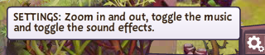

HIDE SETTINGS:Hide the settings bar./SETTINGS: Zoom in and out,toggle the music and toggle the sound effects.

ZOOM IN: Click to zoom in.

ZOOM OUT: Click to zoom out.

FULLSCREEN / EXIT FULLSCREEN

SOUND EFFECTS: Click to turn sound effects off/on.

MUSIC: Click to turn music off/on

DEFAULT TOOL:Click to switch to the default tool for maintaining your city.

ROTATE TOOL:Click to rotate your buildings and decorations.

MOVE TOOL:Click to move your buildings and decorations.

SELL TOOL:Click to sell your buildings and decorations.

STASH TOOL:Click to put an item into Storage.

鼠标在建筑上时

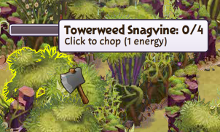 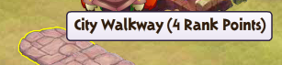 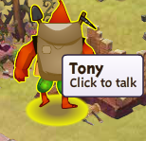

商店

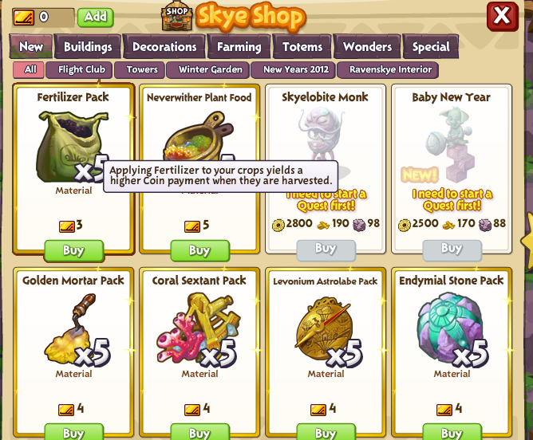

New:All , Flight Club, Towers, Winter Garden ,New Years 2012,RaRavenskye interior

Buildings:All ,Special

Decorations:All,paths,Hummingbirds

Farming:All ,Plots ,Crops

Totems:All

Wonders:ALL

Special:All,Energy,Powers,Materials,Coins,Wood&Stone

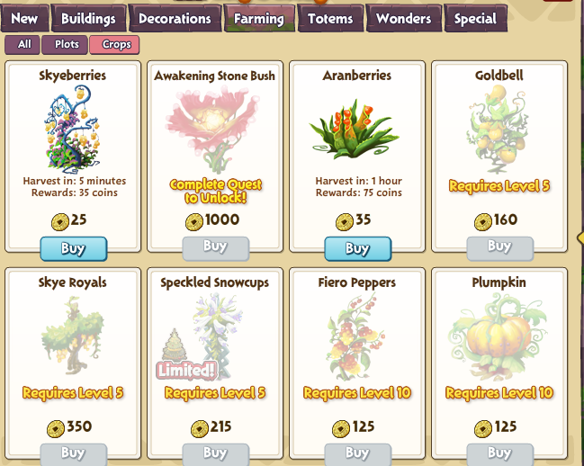

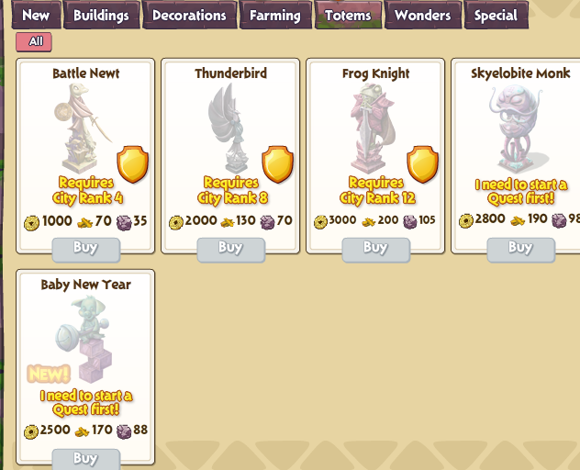 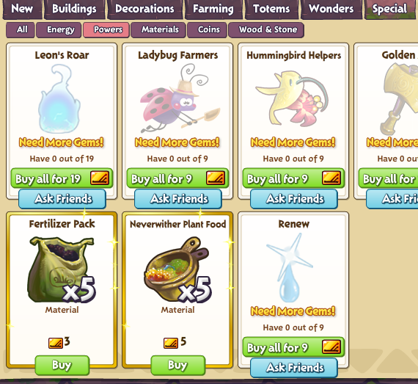

topBar:

