MyTourbook 20.2 Cheatsheet

Tours |  | Views
Ctrl + I  Ctrl + N  Ctrl + K  Ctrl + S  Ctrl + Z | Import Tours from files  Create new Tour/Event  Search Tours  Save modified tour  Undo tour modifications | Ctrl + Shift + C  Ctrl + Shift + S  Alt + Shift + Q, L  Ctrl + Shift + P | Calendar  Statistics  Error Log  Preferences
General Navigation & Mnemonics |  | Photos View
Mnemonics give the ability to navigate quickly between menus by pressing specific keys. |  | Alt + Left  Alt + Right  Ctrl + Shift + H | History Backward  History Forward  Show Navigation History
Alt + {Key} - Pressing the Alt key at any time will display the available mnemonics as seen below. Pressing subsequently any highlighted keys will trigger the associated action.

Examples:
Alt + N will open the New menu
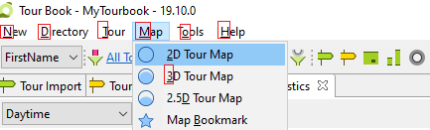
Alt + M, 3 will open the 3D Tour Map located in the Map menu

