Assignment
IF_ELSE
- WAP to enter 2 number and print the largest number
- WAP to enter 3 number and print the largest number
- Input monthly sale of employee and give bonus of 10% if sale is more than 50000 otherwise bonus will be 0
- WAP to enter 2 number and print the largest number
- WAP to enter 3 number and print the largest number
- Input Age of person and print whether the person is eligible for voting or not
- WAP to enter any number and check it is even or odd
- WAP to enter any age and check it is teenager or not
- WAP to enter monthly sale of Salesman and give him commission i.e. if the monthly sale is more than 500000 then commision will be 10% of monthly sale otherwise 5%
- WAP to input any year and check it is Leap Year or Not
- WAP to Input any number and print Absolute value of that number
- WAP to input any number and check it is positive or negative number
- Input temperature of water and print its physical state
- Input 3 side of triangle and print the type of triangle –
- Equilateral, Scalene, Isosceles
- Program to calculate and print roots of a quadratic equation: ax2+bx+c=0(a!=0)

- 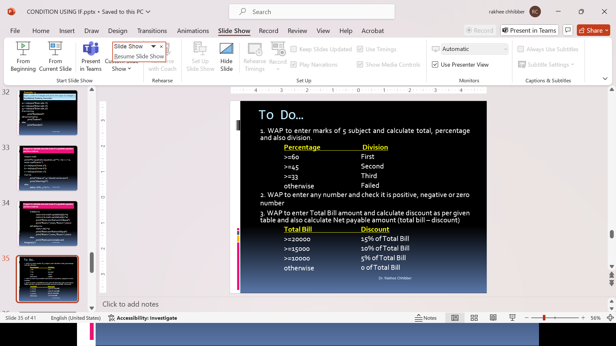

- 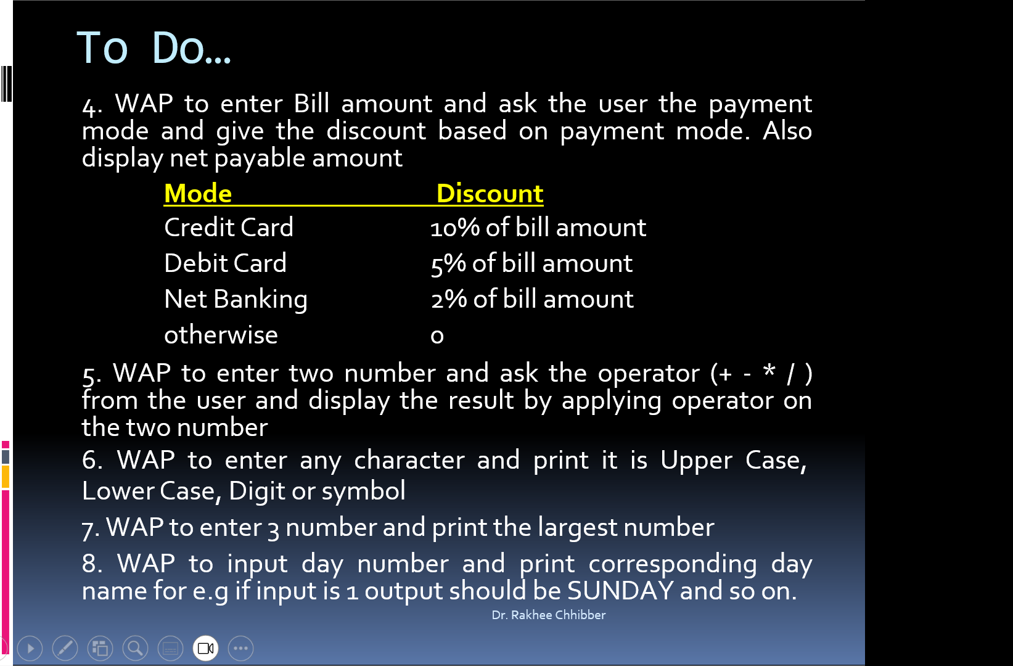

- WAP to check entered year is leap year or not
- Program to read three numbers and prints them in ascending order

