To Do List

Implemented using Splay Tree

Done By
1.Mytreyan 2022115102

- Task Class: Represents a task with attributes like ID, description, priority, and status (done/not done). It provides methods to mark a task as done and display task details.
- SplayTree Class: A templated class representing a self-adjusting binary search tree using the splay operation. It's used to efficiently store and manipulate Task objects based on their priority.
- ToDoList Class: Manages a list of tasks using a SplayTree data structure. It provides methods to add tasks, mark tasks as done, remove tasks, display all tasks, and get the most prioritized task.
Done By
2. Abishek 2022115309

- ToDoListGUI Class: Inherits from Gtk::Window and creates a GUI for the To-Do List application. It includes buttons for adding tasks, marking tasks as done, removing tasks, displaying tasks, and getting the most prioritized task. Each button click triggers a corresponding action, such as opening dialogs for user input or displaying task information.
- Main Function: Creates an instance of the Gtk::Application, initializes the ToDoListGUI window, and runs the application.

Output:
To Do List Window:
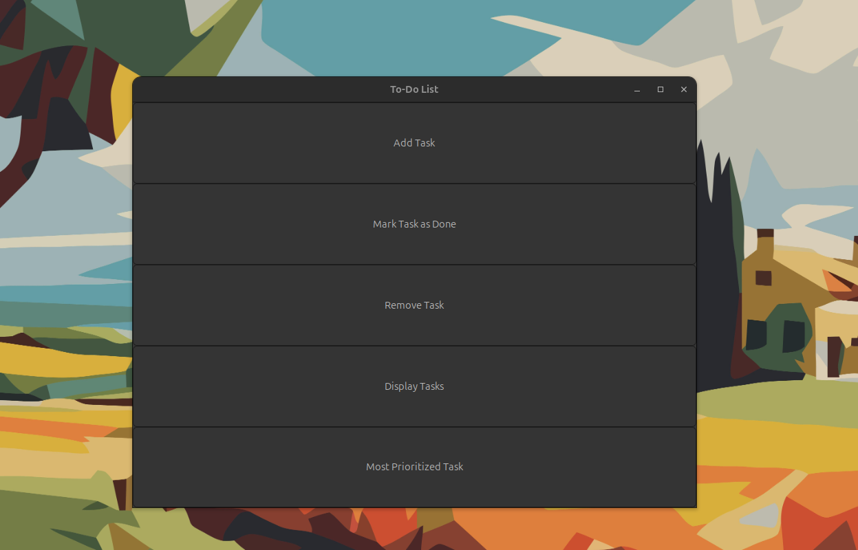

Adding a Task:
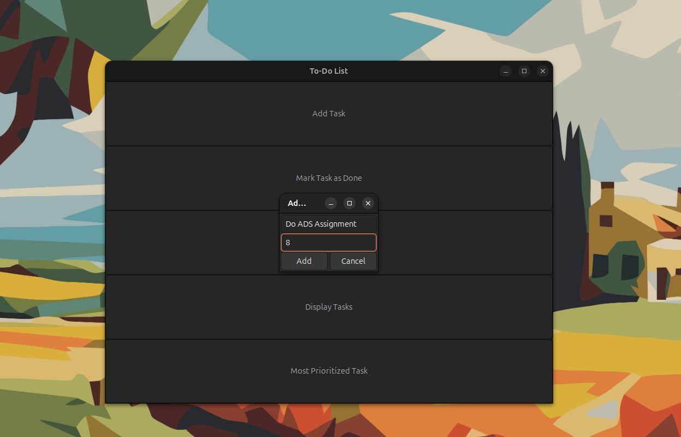

Displaying Task:
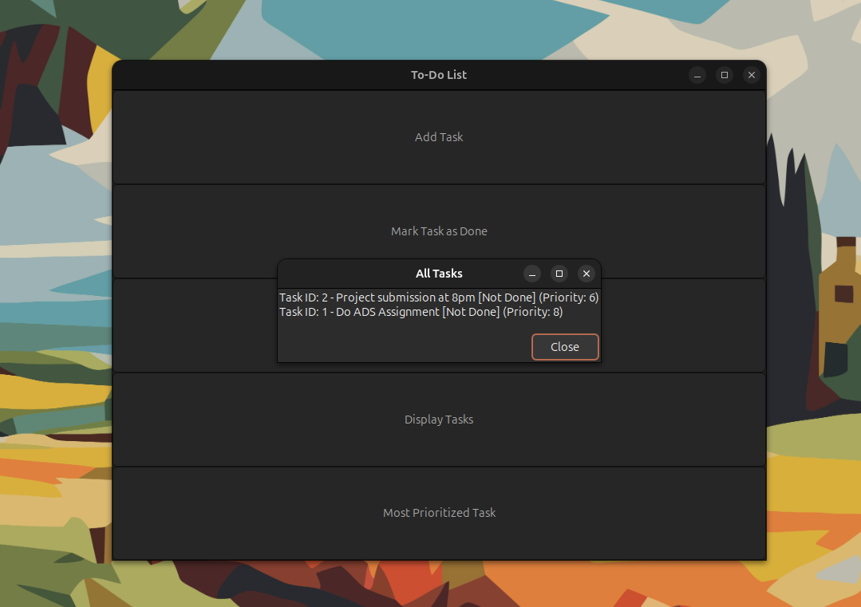

Mark a Task as Done:
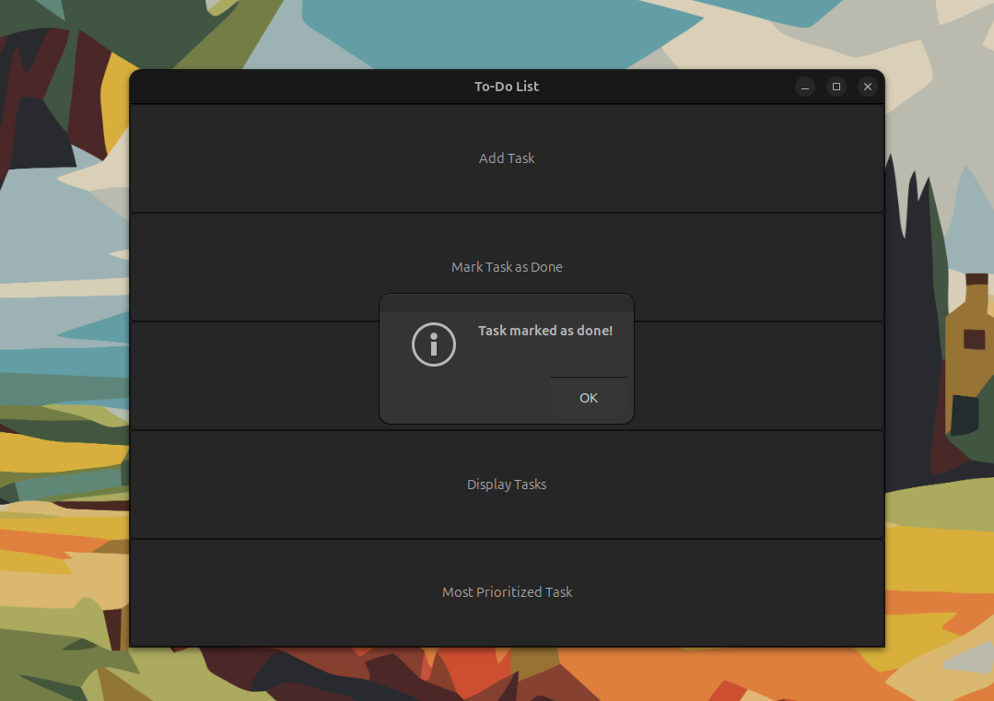

Remove a Task:
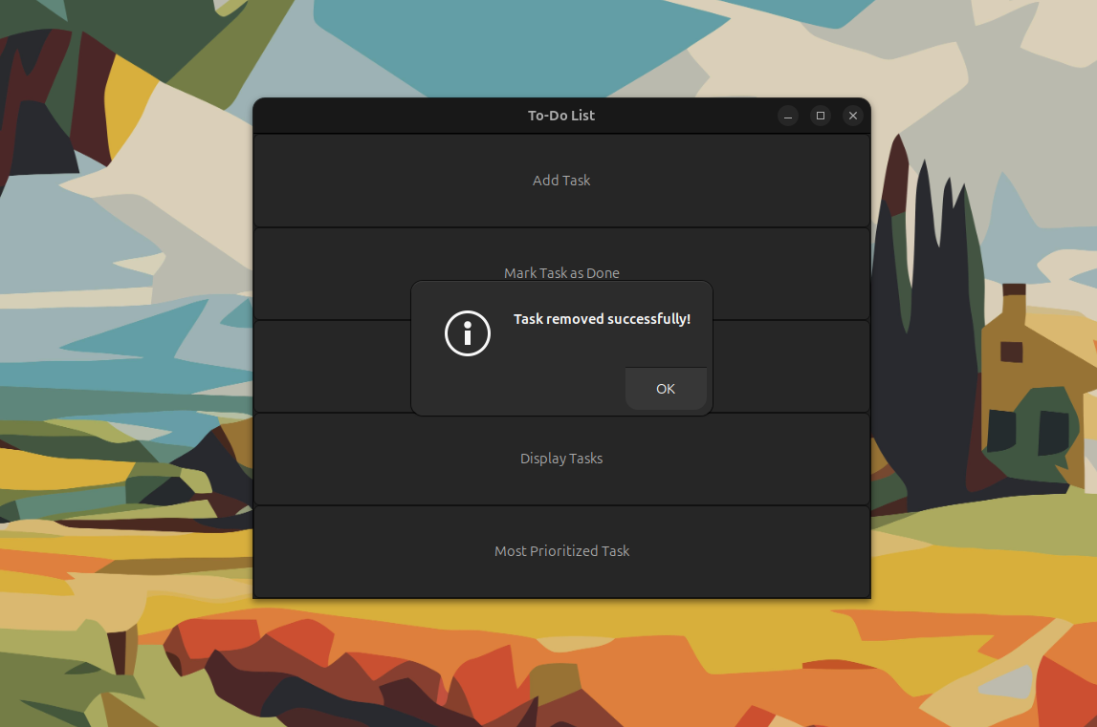

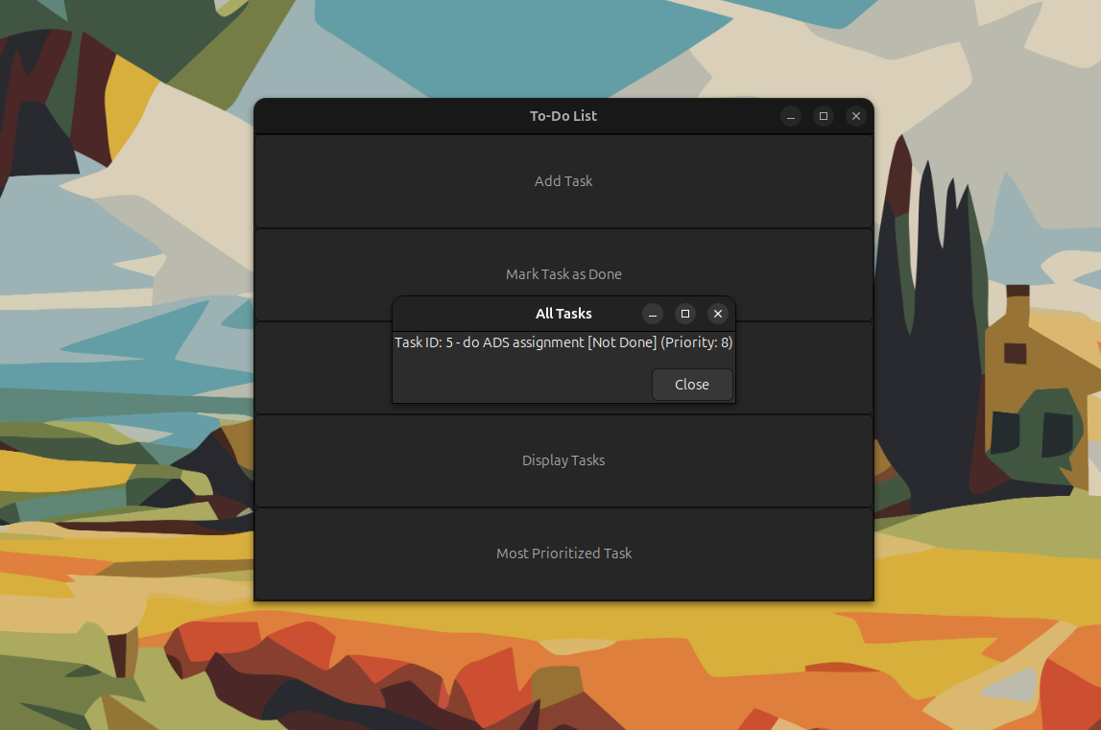

Most prioritized Task:
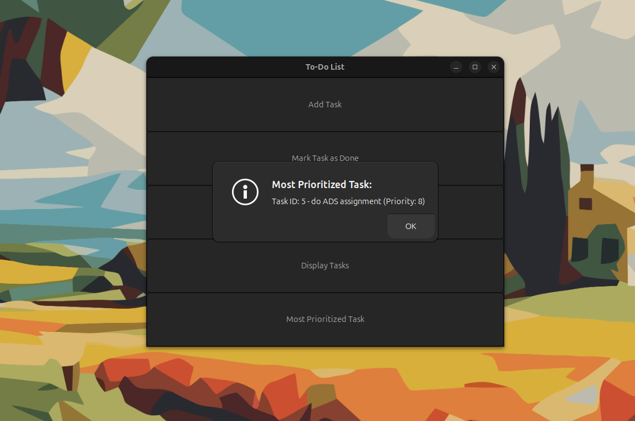

Team Members:
Mytreyan 2022115102
Abishek 2022115309

