Expert System

Medisch expert systeem

Mustafa Yücesan (500769574) & Mohamed el hadiyen (500777214)

2020

Table of Contents

Introduction 2

Queries 3

Do I have disease X? 3

Does disease Y contain a common symptom that occurs with every disease included in this system? 4

Can disease Y lead to another disease? 5

Since I know the unique symptom and the possible diseases I have, would I have disease X or disease Y? 6

What medicine are available for a specific disease? 7

What diseases can this medicine be used for? 7

# Introduction

An expert system has been made in Prolog, which is a programming language for logic. This expert system is a medical one as it concerns diseases. You can check which disease you are likely to have based on symptoms the user has confirmed. You can ask if a disease contains common symptoms, can ask if you have a certain disease, you can ask if one disease leads to another, you can ask what disease is likely given unique symptoms and ask if a disease contains common symptoms. You can also check for medicine for a disease.

# Queries

Below are all the queries with their rules of inference and rationale with explanation of the source code. Next to that there will be instructions for using the query.

## Do I have disease X?

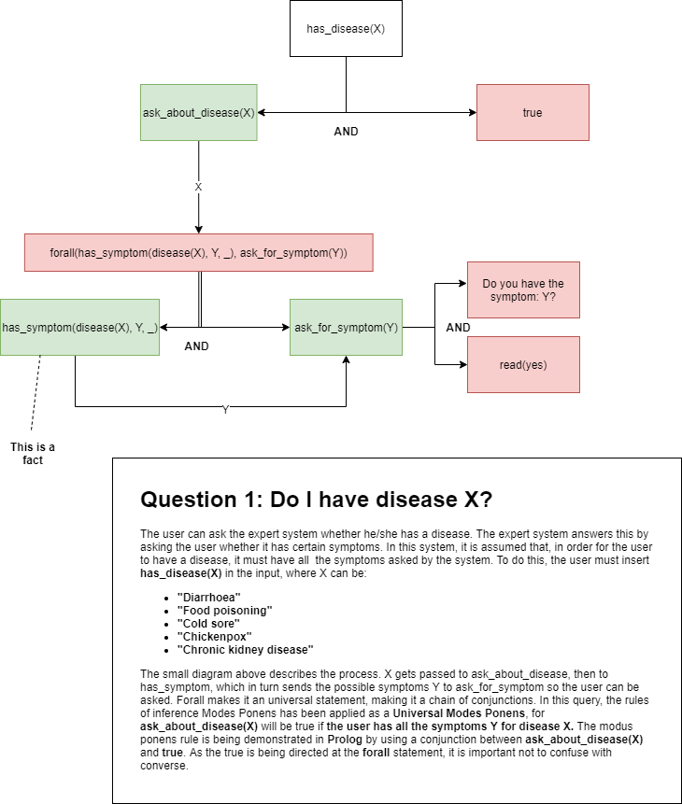

## Does disease Y contain a common symptom that occurs with every disease included in this system?

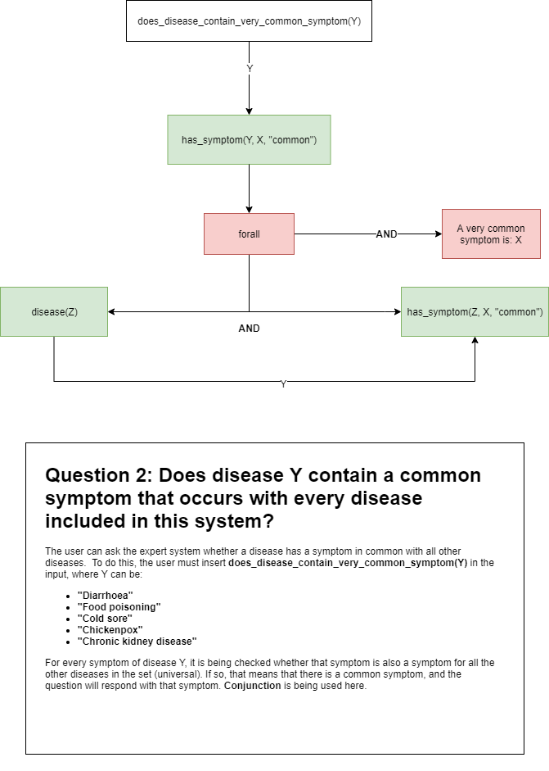

## Can disease Y lead to another disease?

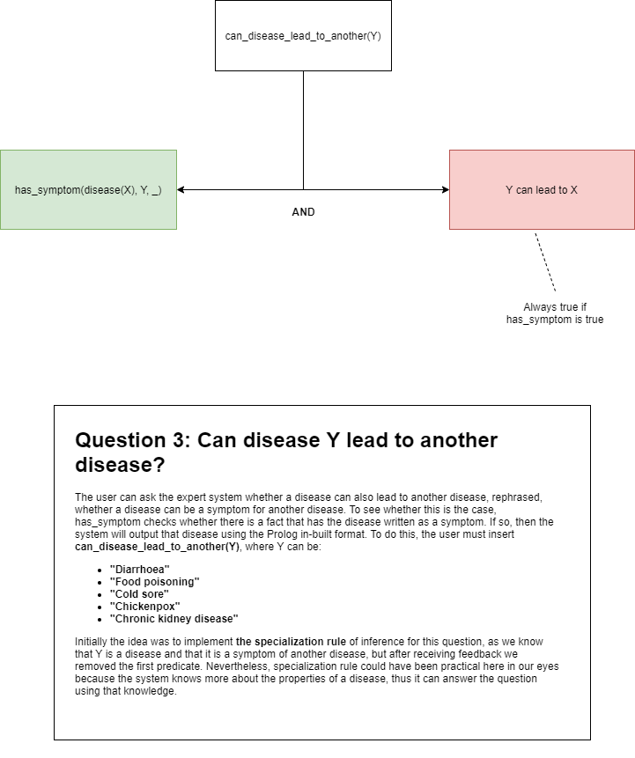

## Since I know the unique symptom and the possible diseases I have, would I have disease X or disease Y?

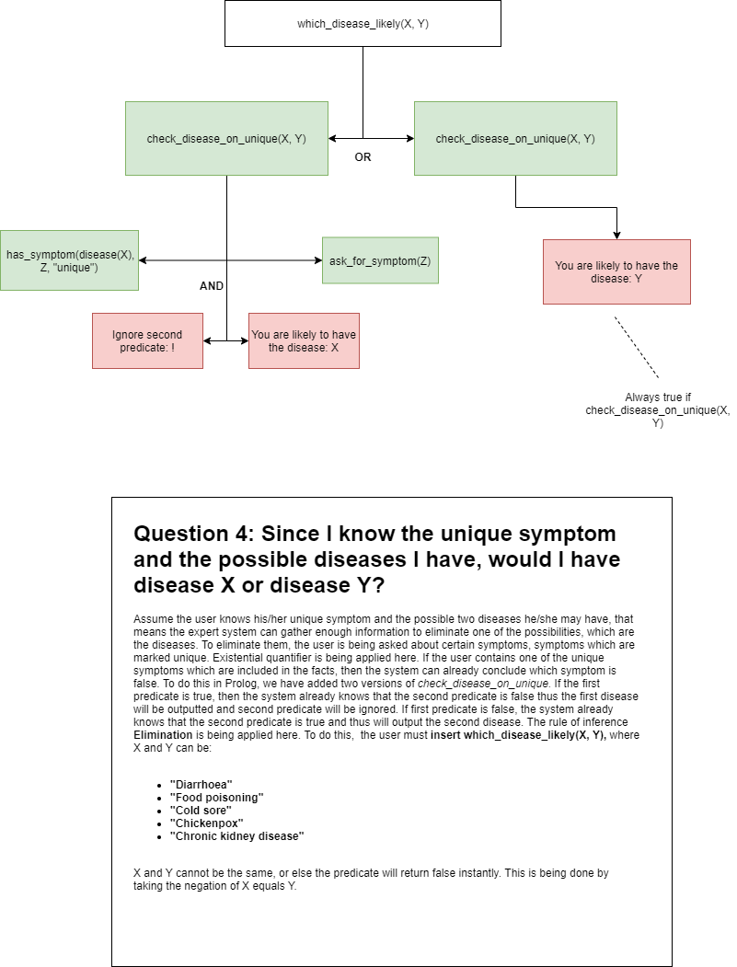

## What medicine are available for a specific disease?

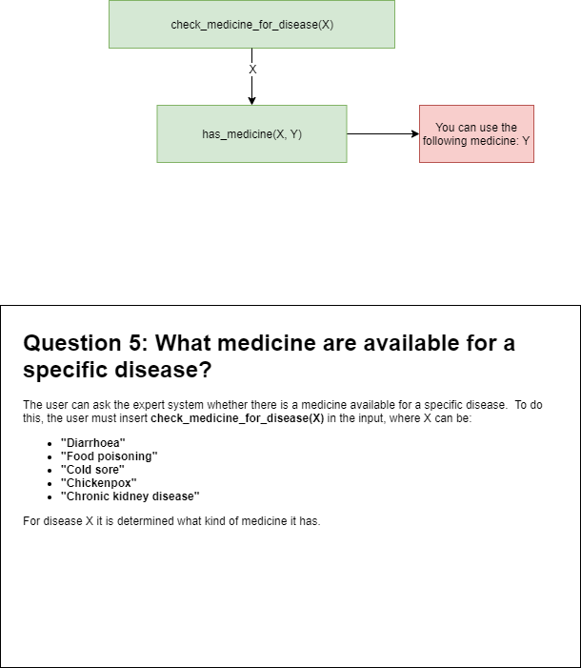

## What diseases can this medicine be used for?

