Three conclusions about Kickstarter campaigns given the provided data:

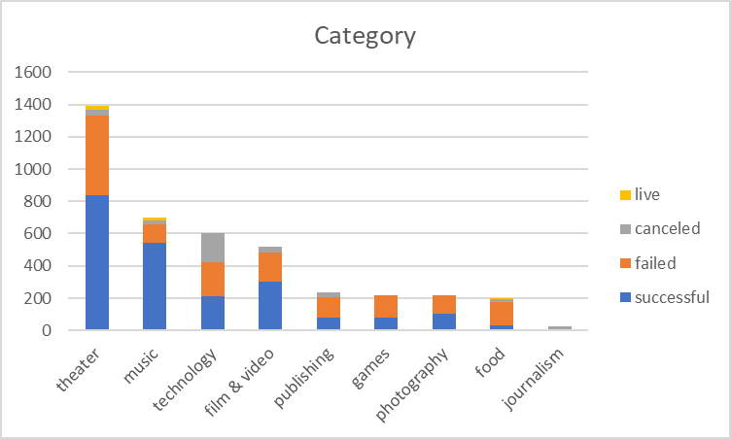

The most successful campaigns involved entertainment: theater, music, film & video. Technology had a larger number of failure to campaigns held.

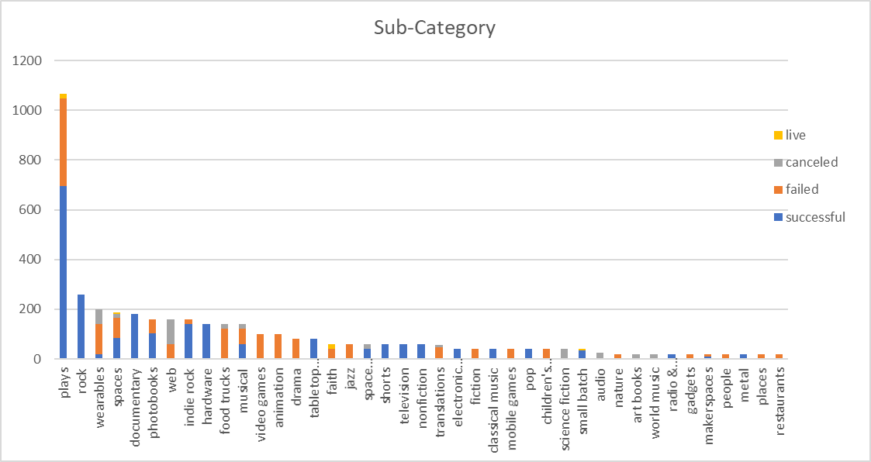

Most held campaign was plays but rock has 100% success rate

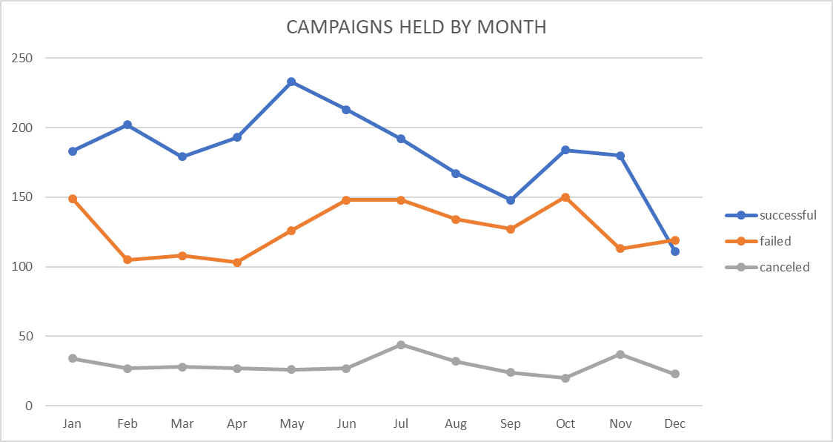

Spring & Summer has the high chance of being successful.

Some limitations of the data is:

* Some goals were entered as 1 which would make any pledge successful
* Does not factor other that would have made the campaign a success or failure like venue, right target audience.
* What is the source of the dataset and were there any filters applied?
* Since campaigns were held in multiple countries what measure is the goal and pledge fields. Currency, attendance?

Other possible tables/graphs would include:

* Percent of campaigns held verses state
* Length of campaign vs state
* Compare any campaigns held more than once