2. Nature of Aging and Lifespan

*Age-related diseases or conditions* drastically increase in incidence and severity with age. Age-related diseases such as cancer, heart disease, stroke, arthritis, and Alzheimer's disease are each common but not universal in older people while rare or even essentially non-existent in young people. *Age-related conditions* are more universal and include loss of strength and muscle mass, reduction of sensory capabilities such as vision, hearing, smell, taste, and balance, appearance changes such as changes in skin and hair, and reduced immune response. "Death of old age" could be considered a universal fate of those that escape specific age-related diseases.

We can use the term *lifetime* to refer to the time a particular individual lives. Lifetimes of billions of humans have been recorded (it is carved into their tombstones). *Lifespan* is the length of a typical lifetime in the absence of any external limitations such as predators, food supply, infectious diseases, harsh environmental conditions, or habitat such as might exist under *zoo conditions.* Lifespan is *internally limited* in most complex species.

The chart below shows U.S. deaths in a starting population of 100,000 vs. age for 1933, 1999, and 2017 based on information from the Human Mortality Database.

Here are some highlights shown by the chart: We can see the dramatic improvement in public health between 1933 and 1999 including reductions in infant mortality, childhood mortality, and adult mortality before age 76.

Between 1999 and 2017 we can see an increase in mortality between the ages of 24 and 37 due to an increase in suicides and drug overdose deaths. Deaths between ages 56 and 88 decreased between 1999 and 2017 because of medical and health care improvements in this age

5

range. Of course, deaths eventually decline to zero because there is nobody in the starting population left to die.

Notice the extremely low childhood mortality between age 2 and age 13 in the more recent data.

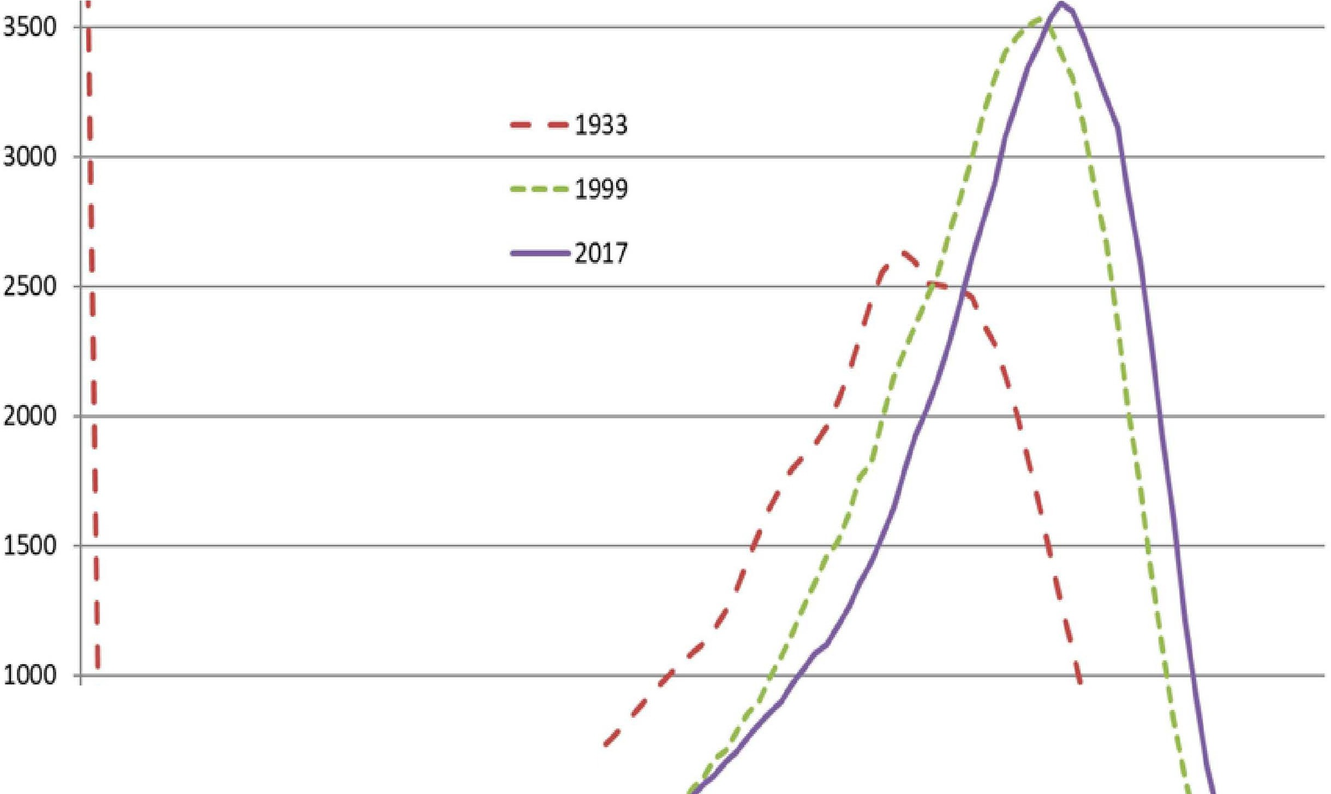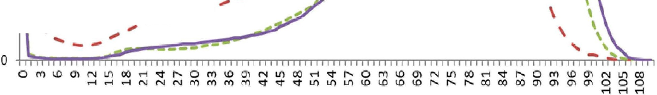

4500

4000

..,.A-Dealbs-fronl-llll-Ca .00,000-¥8..Age-ai--Dealu--------

in 1933,1999,and 2017

- Human Mortality Database -

- -..

500 ------- -; --+-+--

\

\

'

*Figure 1 US.A Deaths vs. Age in 1933, 1999, and 2017*

6

# Key Observations Concerning Aging

Modem aging theories attempt to accommodate and explain a number of key observations concerning senescence in humans and other animals:

1. **Immediate causes of different diseases are different.** It is widely agreed that the immediate causes of the many different age-related diseases and conditions are different and that different treatments directed at the different causes have been effectively developed and deployed in many cases. The causes (and treatments) of cancer are different from heart disease, etc. Different types and even stages of cancer have different treatments.
2. **Similarity of symptoms.** Mammal species exhibit similar but not identical symptoms of aging. Dogs and humans share cancer, heart disease, stroke, cataracts, deafness, weakness, and other symptoms of human aging despite having grossly different lifespans.
3. **Synchronization of symptoms.** In any given species, the symptoms of aging (age-related diseases and conditions) appear on a similar age-schedule. They are clearly related to each other because they have a common cause (aging) that produces the vast majority of cases.
4. **Huge variation in lifespan.** Internally determined lifespans of different species vary enormously between biochemically and physically similar species, more than 200:**1** in mammals (between some mice and some whales), more than 1300:1 in fish (from weeks to centuries.)
5. **Aging appears to be a trait.** Aging closely resembles an inherited organism design characteristic that has been determined by the evolution process (a *trait).*
   1. Like many other traits, aging and lifespan vary greatly between biochemically and physically similar species.
   2. Like many other traits, aging and lifespan are highly related to other traits possessed by the same

7

species. Example: aging is highly related to reproduction. A species that died of old age or even was significantly degraded prior to reaching reproductive maturity would not make evolutionary sense.

1. **Maintenance and repair.** Unlike vehicles, sewing machines, and exterior paint, living organisms have extensive internal capabilities for preventing or repairing damage such as caused by injuries, infections, or day-to­ day wear and tear. Wounds heal, infections are combatted, hairs, skin cells, and other lost items are replaced.

We know that the many age-related diseases and conditions have a common cause: aging or time-since-birth. The trillion-dollar question: Is biological aging, *per se,* a *treatable* condition, like a disease? Do the many different age-related diseases have *treatable* common causes?

# Age Related Diseases

The following pie charts illustrate data from the U.S. Centers for Disease Control and Prevention (CDC) National Center for Health Statistics and show leading causes of death for various age-groups in the U.S. in 2017. In these charts chronic lower respiratory diseases (CLRD) include chronic bronchitis, chronic obstructive pulmonary disease (COPD), emphysema, bronchiectasis, and asthma.

8

Stroke 0_6 Influenza and pneumonia 0_7

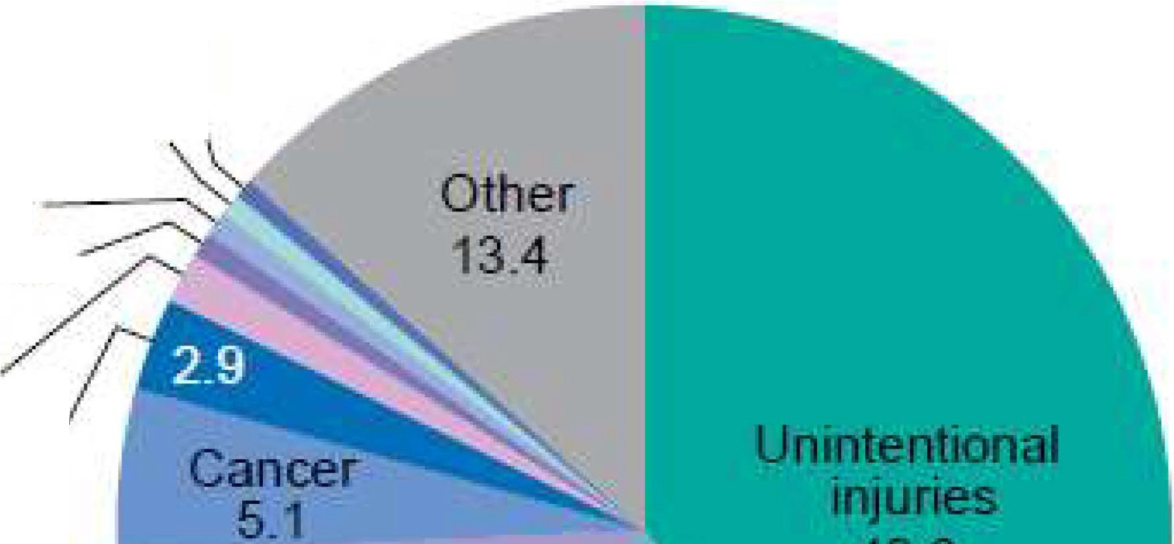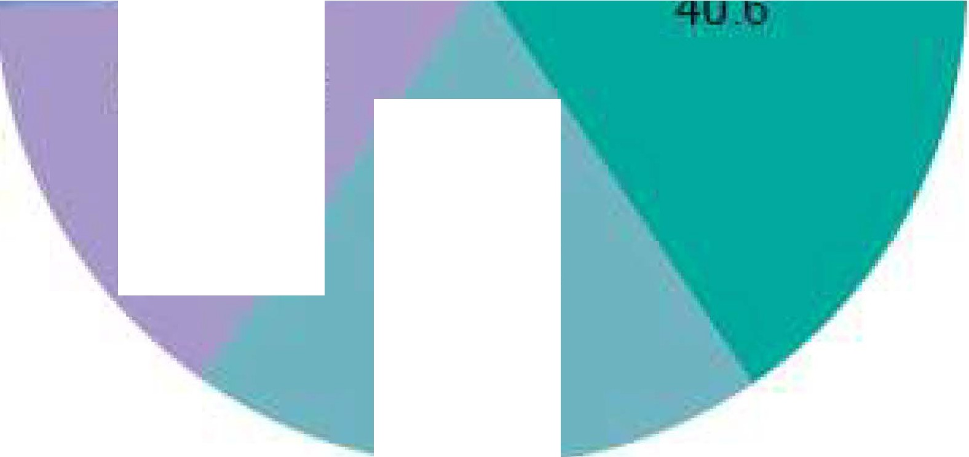

CLRD 0_7

Diabetes 0_8 Congenital malformations 1._5

Heart disease

Ages 10-24

Homicide

**14-4**

**Suicide**

**19-2**

*Figure 2 Causes of Death for Different Age Groups in the US. in 2017 (CDC 5 illus.)*

For people in the 10 to 24-year-old age-group, 74 percent of deaths were caused by injuries, suicide, or homicide. Aging does not appear to be a factor in the very low mortality in this group shown in the mortality curves.

9