MP1: Familiarization with the Tools

Due Time: Refer to the course web-site

Objectives
Verify that we are able to:
- Work with Unity Shaders and Materials
- Create and customize a shader
- Send customization data to the Shaders during runtime
- Name and clean up a Unity project for submission

Approach
You will demonstrate your ability to work with the Unity editor by creating a project with a sphere and a capsule. Both of theses primitive should be rendered with the 552_MP1_Material.

CSS_MP1_Material must:
- Shader: A simple shader that output a constant color
- Color: The color must be under user control

Shader:
- File name: 552_Shader.shader
- Category: 552_Shaders
  - Shaders are organized into categories where in the Inspector window it is easier to find the shader you want to associate with a material. The following screenshot shows your shader should be found under the 552_Shaders category.
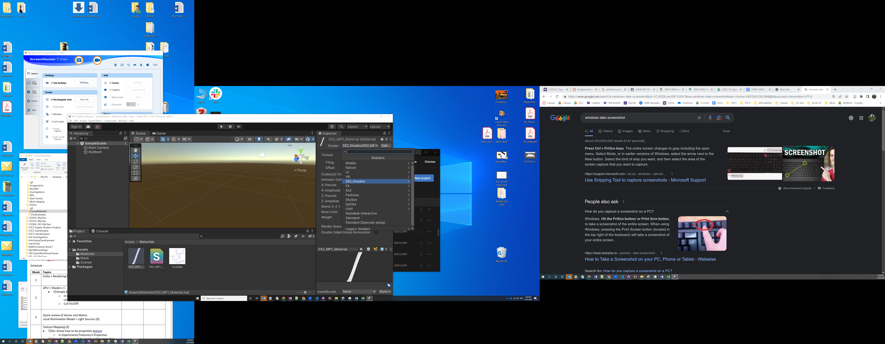

- Vertex Shader:
  - Program Name: VertexProgram
  - Name of datatype when program is called: DataFromVertex
  - Name of datatype for the output of the program: DataForFragmentShader
  - You must perform the proper transformations by calling the HLSL function mul(). In order words, you cannot call the UnityObjectToClipPos() macro.

- Fragment Shader:
  - Program Name: FragmentProgram
  - Name of datatype when program is called: DataForFragmentShader
  - Name of datatype for the output of the program: OutputFromFragmentShader
  - Output the constant color specified by the user.

Credit Distribution
 |  |  |  |  | Credits
1 | Settings in Unity
 |  | Material name: 552_MP1_Material |  |  | 1
 |  | Shader file name: 552_Shader |  |  | 1
 |  | Customized UI category: 552_Shaders |  |  | 2
2 | Shader customization
 |  | Working with no useless line of code |  |  | 10
 |  | Vertex shader program name |  |  | 1
 |  | Fragment shader program name |  |  | 1
3 | Vertex shader
 |  | Explicit mul() to transform vertices |  |  | 5
 |  | Datatype name for input and output |  |  | 2
4 | Fragment shader
 |  | Able to customize resulting color |  |  | 5
 |  | Datatype name for input and output |  |  | 2
5 | Scene Setup
 |  | Two primitives with your material |  |  | 5
6 | Submission
 |  | Proper project name |  |  | 2
 |  | Four folders in submission |  |  | 3
 |  |  |  | Total | 40

This programming assignment counts 3% towards your final grade for this class.

