Web GL Build Configuration

# When trying to run your web-GL build, if you encounter this error

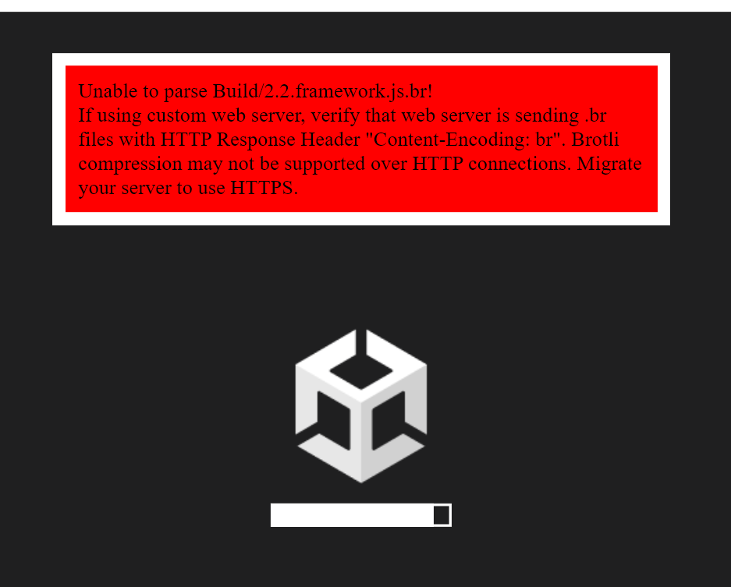

Take a look at [this discussion](https://forum.unity.com/threads/solved-webgl-build-error-unable-to-parse-build-file-name-framework-js-br.1102759/). Before building, click ***Player Settings …*** on the pop-up window, click on ***Player*** and under ***Publishing Settings***look for ***Compression Format***, set this to ***Disabled*** as indicated in the following:

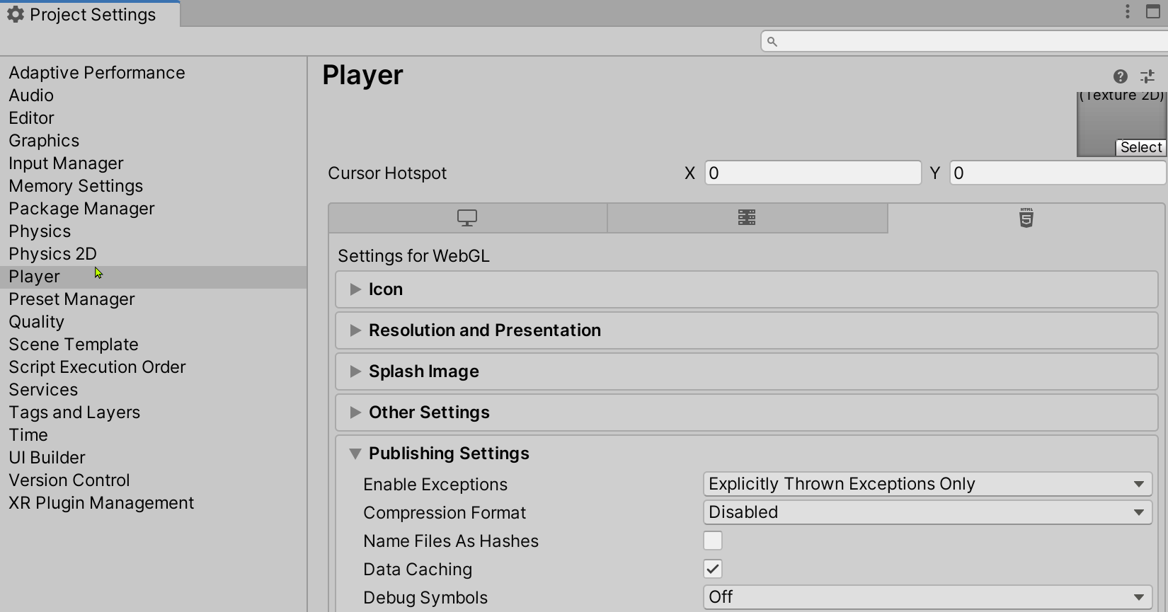

This new setting solved the problem form me.