Unity Help Page

Download/Installation
- Unity version: work with the latest, all examples in class are based on 6000.3.11f1 (LTS: Long Term Support releases):
- Download+Install: follow this link https://unity3d.com/unity/qa/lts-releases , scroll down to find our version and install. In China, here is a better link https://unity.cn/releases/lts/, any LTS version should be good, e.g., 1.8.4.
- Modules to install:
  - IDE: I will be using Visual Studio Code (VSC). You are free to use anything IDE you like, the default IDE for Unity is Microsoft Visual Studio Community, which works very well also.
  - WebGL Build Support: Please make sure to install this module for our playtesting (for part-2 of this class will be based on WebGL builds. Additionally, if you are running on a Mac, please also install Windows Build Support such that you can build for PC EXE and the TA can run your assignment submissions.
  - Documentation: I would advise installing this as well.

Debugging
- Here is the official documentation on debugging with C#.
- VSC Debugger from Unity has been deprecated. I use Debug.Log() (like cout) for debugging.

Begin working with Unity
Tutorials, go over this yourself after (or before) class:
- Get started with Unity Hub
- https://learn.unity.com/tutorials under the Level tab, select Foundational and Beginner and take a view of the tutorial videos.
- Documentations: https://docs.unity3d.com/Manual/index.html
  - Scripting: https://docs.unity3d.com/ScriptReference/
  - Shader: https://docs.unity3d.com/Manual/SL-Reference.html

!!WARNING!!
DO NOT attempt to upgrade your Unity during this class, FOR ANY REASON. Once downloaded, once working, DO NOT follow new releases!!

Trouble shoot: Q&A
to upgrade
- WebGL build configuration
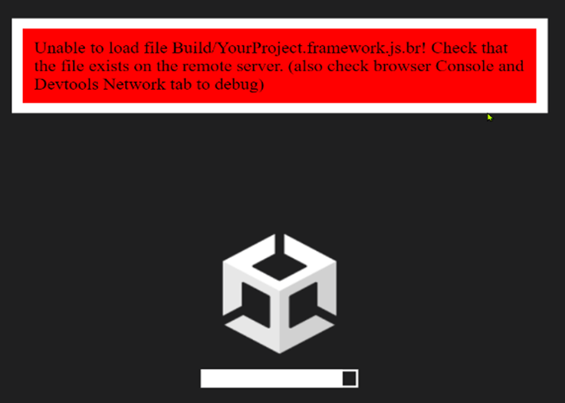

your

Problems Q&A
- WebGL build configuration
  - When trying to run your web-GL build, if you encounter this error:

  - This new setting solved the problem form me. Take a look at this discussion. Before building, click Player Settings on the pop-up window, click on Player and under Publishing Settings look for Compression Format, set this to Disabled as indicated in the following:
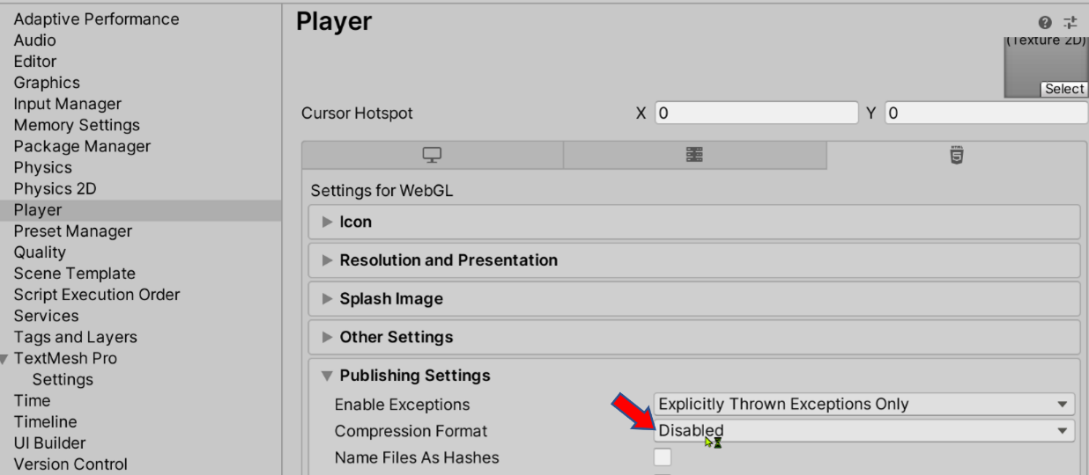
- Missing Unity API Intellicence: there may be a few things that are wrong:
  - Check for Package installed:
    - Windows->Package Manager
    - Under Packages: look under “Unity Registry”, then scroll down to install
      - BOTH: “Visual Studio Editor” and “Visual Studio Code Editor”
  - Visual Studio Code: if you are using VSC, make sure to install the Unity extension from Microsoft. Make sure to follow through with updating the Package Manager.
  - Default editor setting: Edit->Preferences->External Tools->External Script Editor, make sure this is set to your default IDE.
  - First time opening the project: Assets->Open C# Project
- UI option missing from create menu: You need to add the UnityEngine.UI package (Windows->PackageManager [Packages: Unity Registry], search for Unity UI

