Developer to Architect

1) The Software Architect's Role in the Enterprise 1

General problems / points with the legacy applications 1

Who is Software Architect? 3

Wikipedia says…. 4

Described by Rebecca Grinter article: System Architecture, Product Designing and Social Engineering describe architect is… 4

Architect Skills: What is an Architect expected to be skilled at? 7

# The Software Architect's Role in the Enterprise

## General problems / points with the legacy applications

When the legacy application is already designed, we have general below questions such as…

* Current state or positions of your application
* Siloed (any software that functions on its own to solve a problem) Design

[Architecture of the design]

* Application is in use or no-use
* Poor design
* Why application needs to re-design?
* Same discussion over and over
* No time
* No resource
* Need to design newly

Etc…

* Redesign of the application is difficult
* Sometimes we found the solution, but we can’t implement them due to time constraint or business doesn’t see the benefits

## Who is Software Architect?

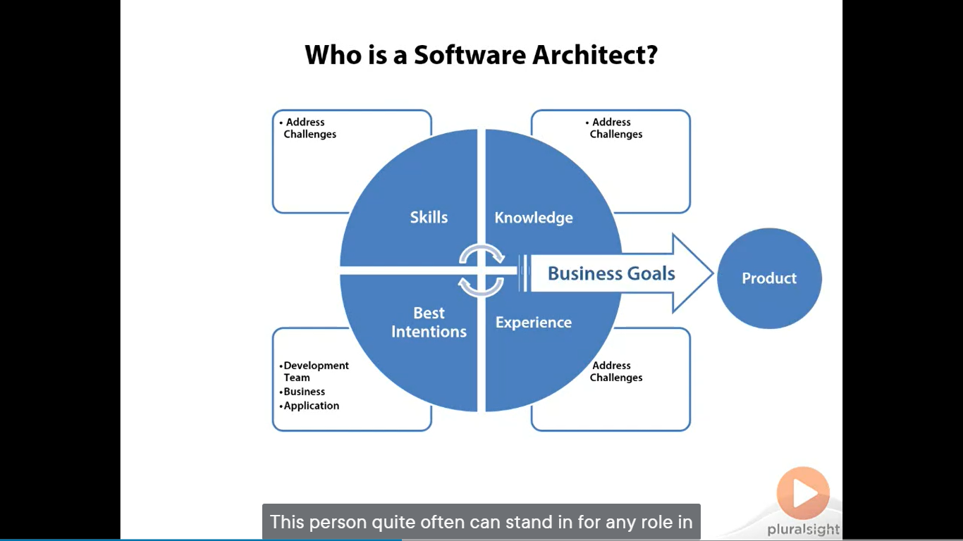

* the person/persons in our team that mitigates (eases) these above challenges
* is with the skills, the knowledge, and the experience to address the challenges an application will encounter before, during and after construction
* he/she has a best intension of a development team, the business any application in mind.
* This person has the knowledge & skills to take a project from an abstract set of goals to really

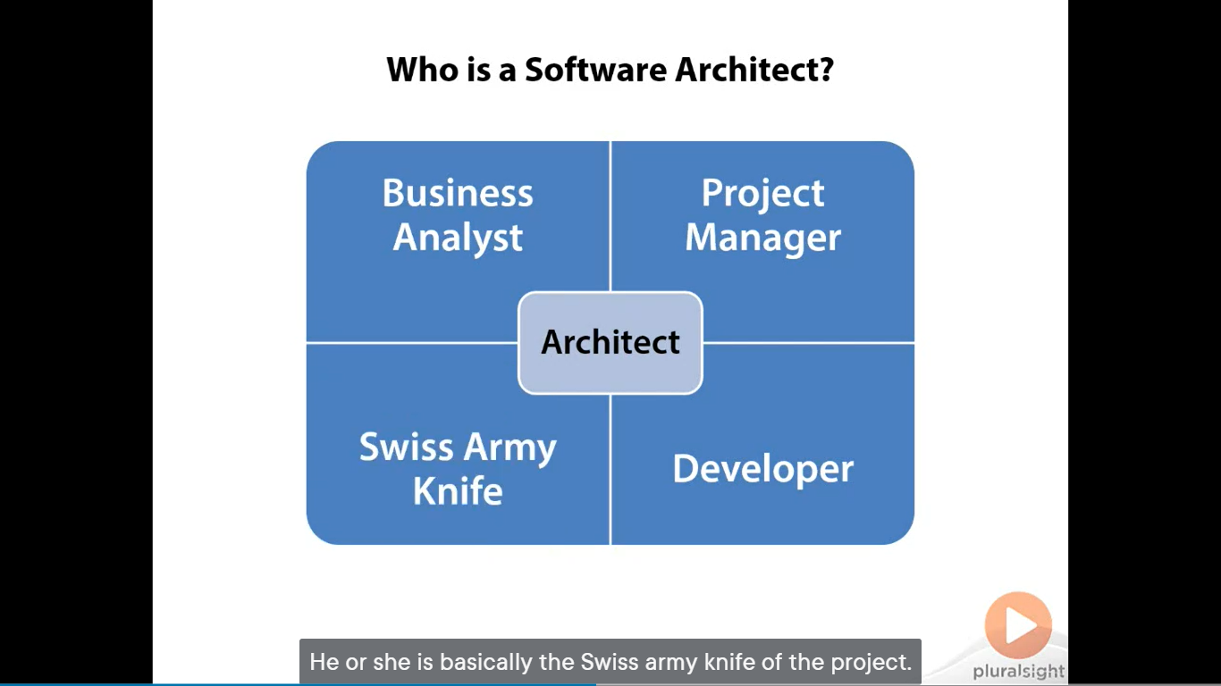

* The person quite often can stand for an y role in in the project from Business Analyst, Project Manager to Developer
* Is available for any gaps on the project no matter what skill is needed
* Is committed to the success of the project no matter what curves technical or otherwise are thrown at it
* Is basically the swiss army knife of the project

### Wikipedia says….

“a computer programmer who makes high-level design choices and dictate technical standards, tools and platforms”

### Described by Rebecca Grinter article: System Architecture, Product Designing and Social Engineering describe architect is…

* “the architect is not only a Master Technologies but a Master Collaborator responsible not only for designing the solution but making sure the solution is accepted and supported by all groups in the organization”
* “architects work in ways that allow them to accomplish their dual mission of designing technically possible and organizationally feasible products.

They bring people from all over the corporation in to consult on their technical knowledge and at the same time learn about other group’s properties and schedules.

The architects present their work to different groups to ensure that the solutions are attractive to build, buy and sell.

Finally, they continually look outside the company to align their work with standards agencies and competitors.

All of this necessary design work, without it, solution might work, but could not be built or sold”

**Design Software’s**

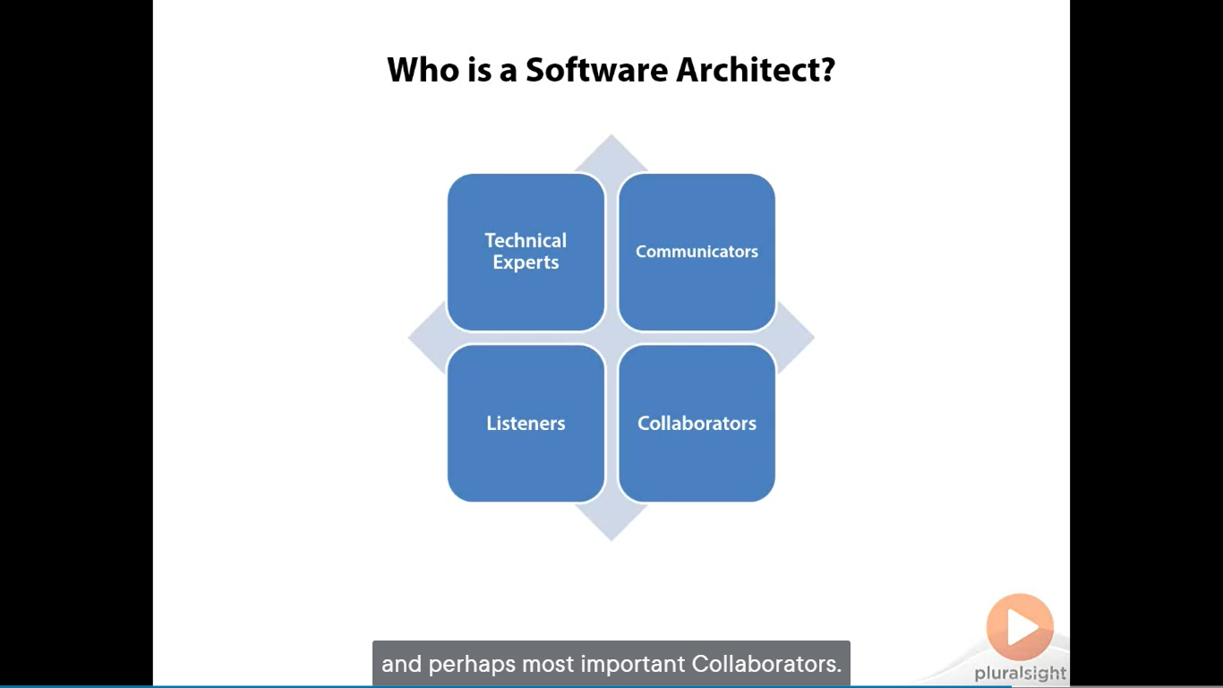

* Software designing is a highly complex task requiring architects to not only be Technical Experts but also be effective Communicators, Listeners, and most important Collaborators
* Effective architects recognize that the software delivery solution doesn’t begin and end with design.

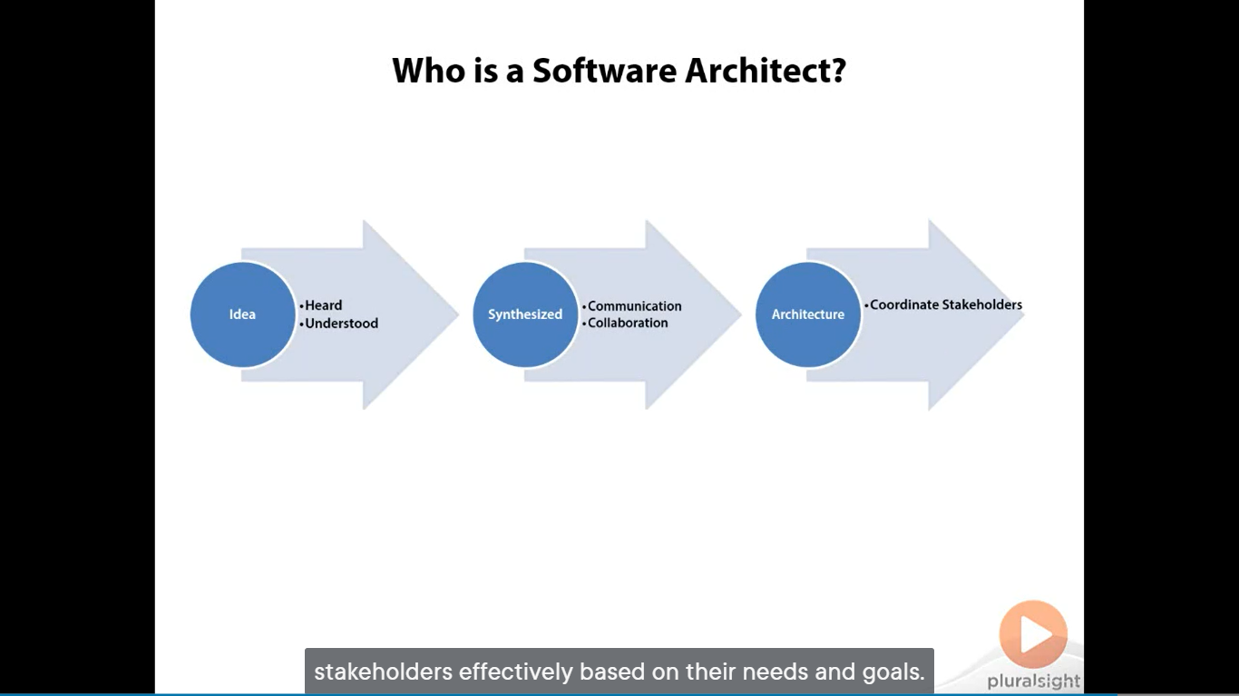

* It’s begins with abstract idea that must first be heard and understood and finally synthesized into an architecture through communication and collaboration across the organization.
* The architect must be co-ordinates with each group of stakeholders effectively based on their needs and goals.

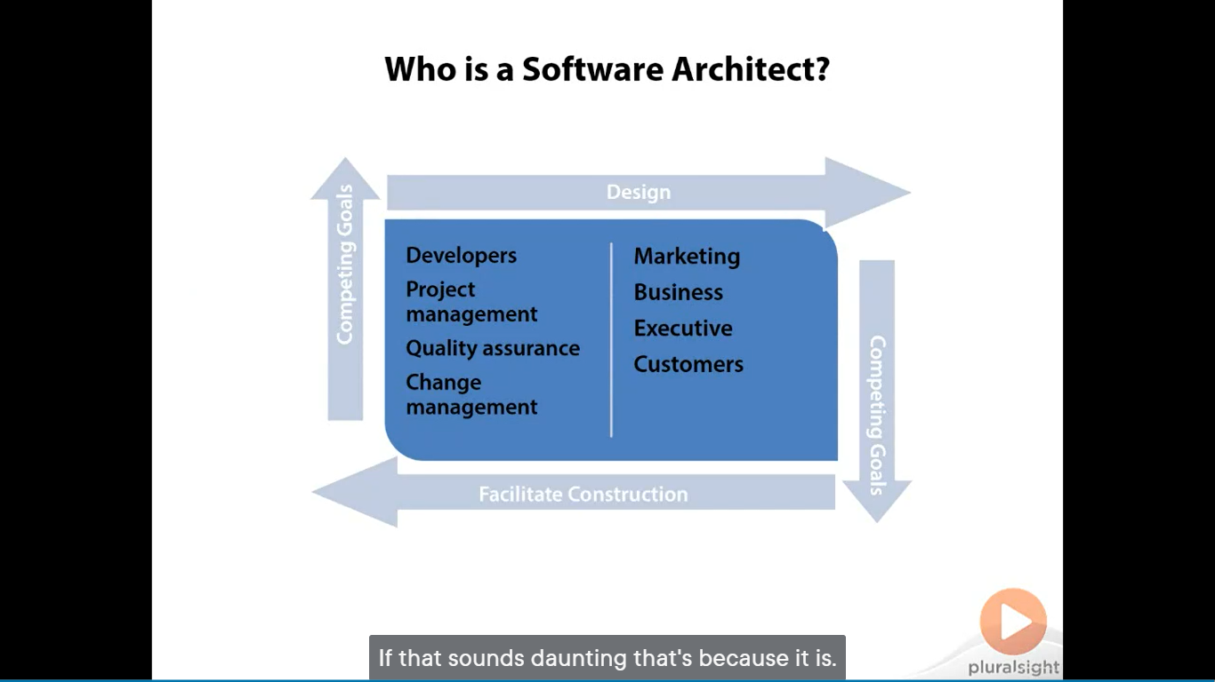

* Stakeholders includes Developers, Marketing, Business, Project management, Quality assurance, change management, Executive and customers many of which all have competing goals.
* The role of the architect is to collaboratively work with all the groups involved to agree on a design and facilitate construction of the solution.

## Architect Skills: What is an Architect expected to be skilled at?

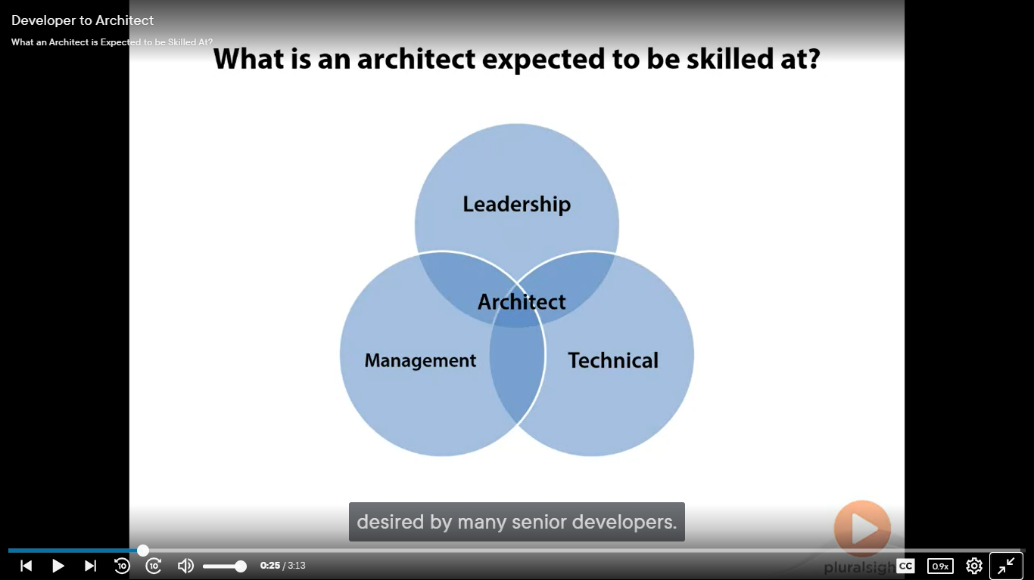

* The architect skill set is a function of Technical, Management and Leadership skills, skills not always possessed and often not even desired by many senior developers

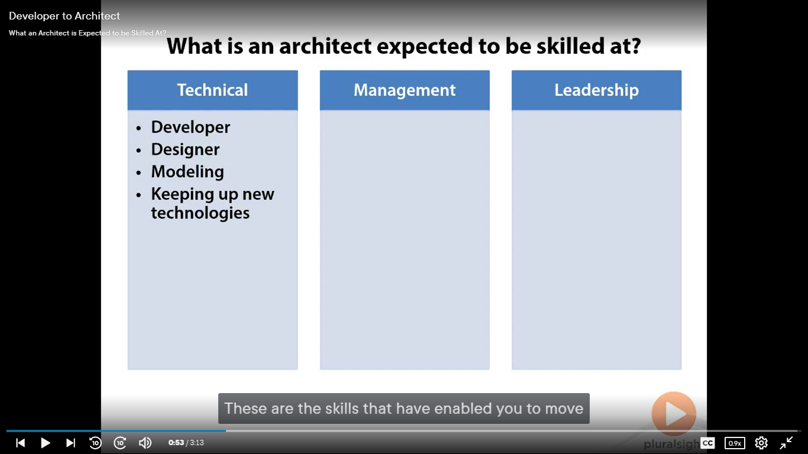

* As an architect, he/she will be expected to master several technical skills like development, design, modelling and keeping up with new technologies, which difficult / crucial for architects to up to date with new technologies.

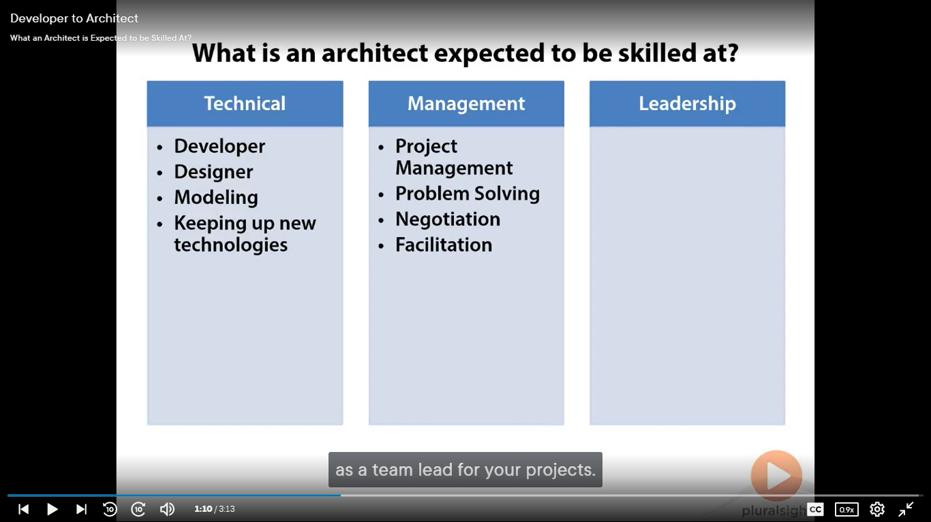

* Architect needs to be update and expand the hard skills like Project Management, Problem Solving, Negotiation, Facilitation to name a few.
  + This management skills will help you in your new role as a team lead for your projects

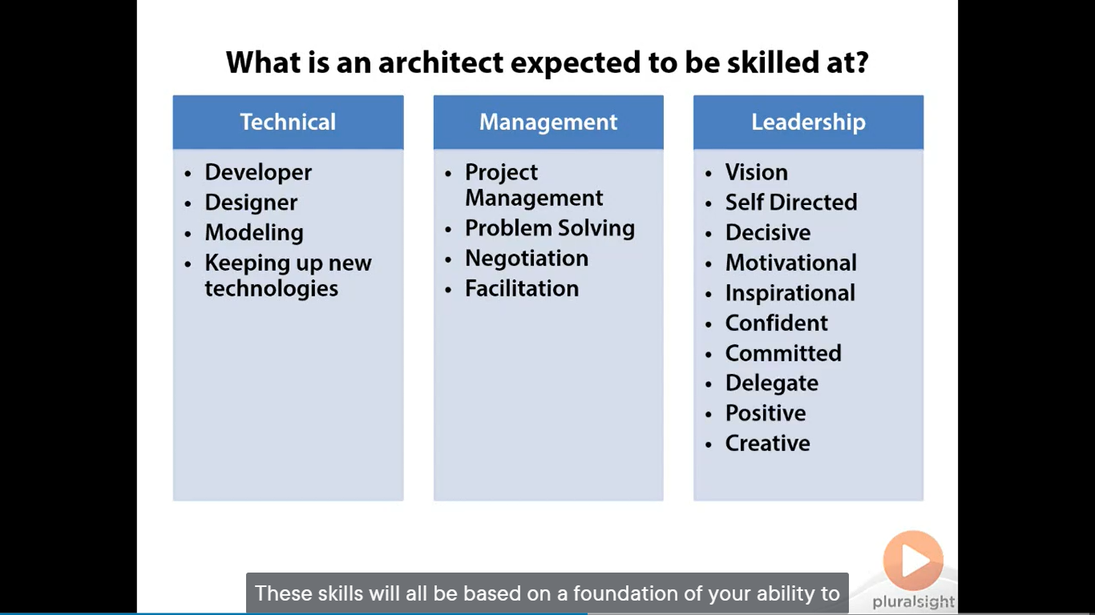

* Additional skills that may be less experienced with are those of a good leader
* As an architect the entire team, not just technical will look to you for answer and direction.
* A good leader can be able to form and communicate a Vision, Self-directed, Decisive, Motivational, Inspirational, Confident, Committed, has the ability to Delegate, Positive, and Creative

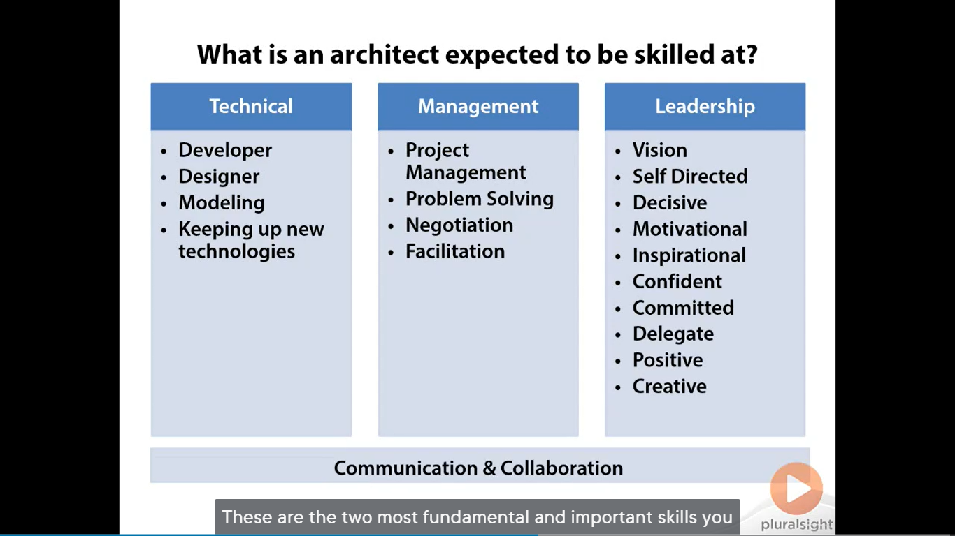

* Communication and Collaboration are two most fundamental and important skill you must process to be an effective architect

### How can we improve to be an effective architect?

* Reading Books
* Podcasts
* Classes on management and leadership
* By observing & learn from the managers in organizations that are real leaders
  + How they communicate with others
  + How they treat the people
  + How they respond to them