



Friday, 15-11-2024
IT-212
Database Systems
Lecture-01
Dr. Muhammad Asif Khan
Assistant Professor
Department of Computer Science & IT
Sarhad University of Science and Information Technology, Peshawar
About the Course
•  •  •  •  •  •  • | Course Title: |  | Database Systems
•  •  •  •  •  •  • | Course Code: |  | IT-212
•  •  •  •  •  •  • | Credit Hours: |  |  | 3-1
•  •  •  •  •  •  • | Program: |  | BS (CS/SE)
•  •  •  •  •  •  • | Pre-requisite: |  | Programing and Data structures concepts
•  •  •  •  •  •  • | Semester / Sections: 3rd  Textbooks:
•  •  •  •  •  •  • | 1. | Database System Concepts by Abraham Silberschatz, Henry F. Korth, and S.
Sudarshan. (Latest Edition).
2. Fundamentals of Database Systems by Ramez Elmasri and Shamkant B. Navathe. (Latest Edition).
• Reference Books:
1. Database Management Systems" by Raghu Ramakrishnan and Johannes Gehrke
2. SQL and Relational Theory: How to Write Accurate SQL Code" by C.J. Date
IT-212: Database Systems | 2
1

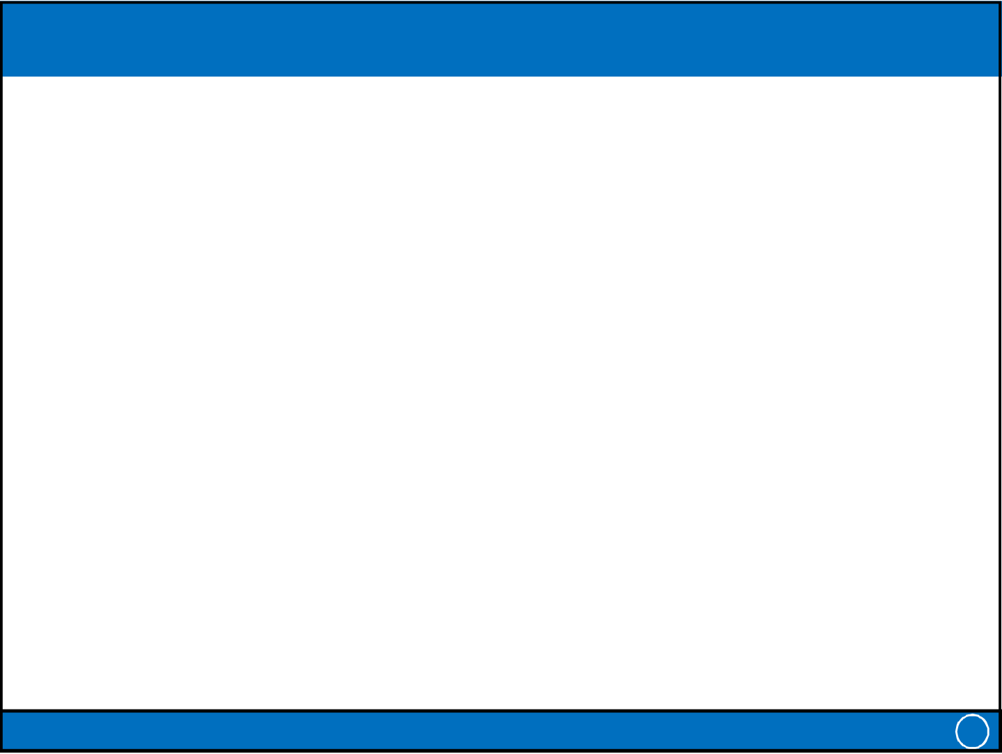
Friday, 15-11-2024
Course Description
• This course provides a comprehensive introduction to database systems, focusing on foundational principles and real-world applications.
• Students will explore essential concepts such as data modeling, relational databases, and SQL, along with advanced topics like transaction management, normalization, and database security.
• The course is designed to build practical skills in database design, implementation, and management, preparing students to work with databases in various environments.
IT-212: Database Systems 3
Course Objectives
• Upon completing this course, students will be able to:
1. Understand the fundamental concepts and architecture of database systems.
2. Develop skills in database design, including data modeling and normalization techniques.
Write and execute SQL queries for data retrieval, insertion, update, 3.
and deletion.
4. Apply principles of transaction management and concurrency control to ensure data integrity.
5. Implement security and access control mechanisms for database protection.
IT-212: Database Systems 4
2

Friday, 15-11-2024
Learning Outcomes
1. Describe the role and importance of database systems in various applications.
2. Design and normalize databases to maintain data integrity and reduce redundancy.
3. Use | SQL | to | interact | with | databases, | retrieving | and
manipulating data efficiently.
4. Manage transactions, handle concurrency issues, and recover from failures.
5. Ensure database security and manage user access to sensitive information.
6. Analyze and solve real-world problems using a well-designed database solution.
IT-212: Database Systems 5
Course Contents at a Glance (1)
• Introduction to Database Concepts
• Database Environment
• The Relational Model
• Relational Algebra
• SQL: Data Definition
• SQL: Data Manipulation
• Database Planning, Design, and Administration
• Fact-Finding Techniques
IT-212: Database Systems 6
3

Friday, 15-11-2024
Course Contents at a Glance (2)
• Entity-Relationship Model
• Enhanced E-R Model
• Normalization
• Conceptual, Logical, and Physical Database Design
• Transaction Management
• Backup
• Security
IT-212: Database Systems 7
Today’s Topics
• Some common uses of database systems
• Characteristics of file-based systems
• Problems with file-based approach
• The Database (DB)
• Database Management System (DBMS)
• Typical functions of a DBMS
• Major components of the DBMS environment
• Personnel involved in the DBMS environment
• Advantages and disadvantages of DBMSs
• History of the development of DBMSs
IT-212: Database Systems 8
4

Friday, 15-11-2024
Examples of Database Applications
• Student Management Systems
• Customer Relationship Management (CRM)• Inventory Management Systems
• Healthcare Management Systems
• Financial and Banking Systems
• E-commerce Platforms
• Human Resource Management Systems (HRMS)• Social Media Platforms
• Library Management Systems
• Logistics and Supply Chain Management
IT-212: Database Systems 9
Manual Filing Systems
• A manual file system is a traditional way of organizing and managing data without computers, relying entirely on physical files and folders.
• This system typically involves paper documents stored in filing cabinets, folders, or binders and is organized using a specific method (e.g., alphabetically, by date, or by category).
• For example, a manual file system might work for a small business or library.
IT-212: Database Systems 10
5

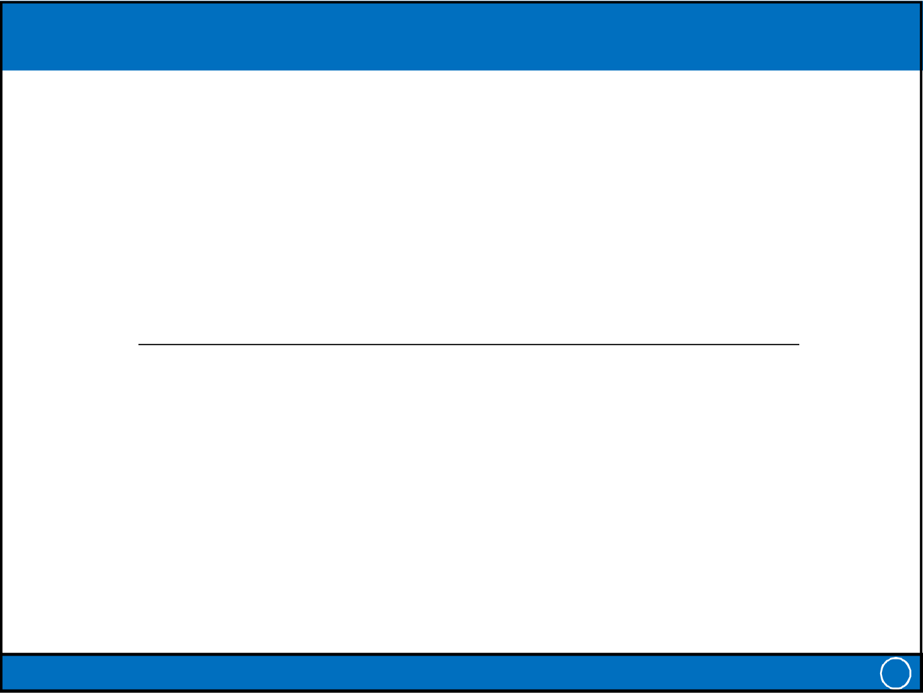
Friday, 15-11-2024
File-Based Systems (1)
• A file-based system is an older way of managing data
by storing it in flat files on the file system rather than
using a database management system (DBMS).
– Library Management System (File-Based Example): In a
simple file-based library management system, data is
organized using flat files, with different files storing
different types of information. For example;
IT-212: Database Systems 11
File-Based Systems (2)
• Books File:
– Stores information about each book in the library, such as title, author, ISBN, and publication date.
– Each line might represent a single book, separated by delimiters like commas or tabs.
• Members File:
– Stores member information, like member ID, name, contact details, and membership status.
• Transactions File:
– Tracks books borrowed by members, with information such as the book ID, member ID, issue date, and return date.
• Staff File:
– Keeps records of library staff, including staff ID, name, position, and contact information.
IT-212: Database Systems 12
6

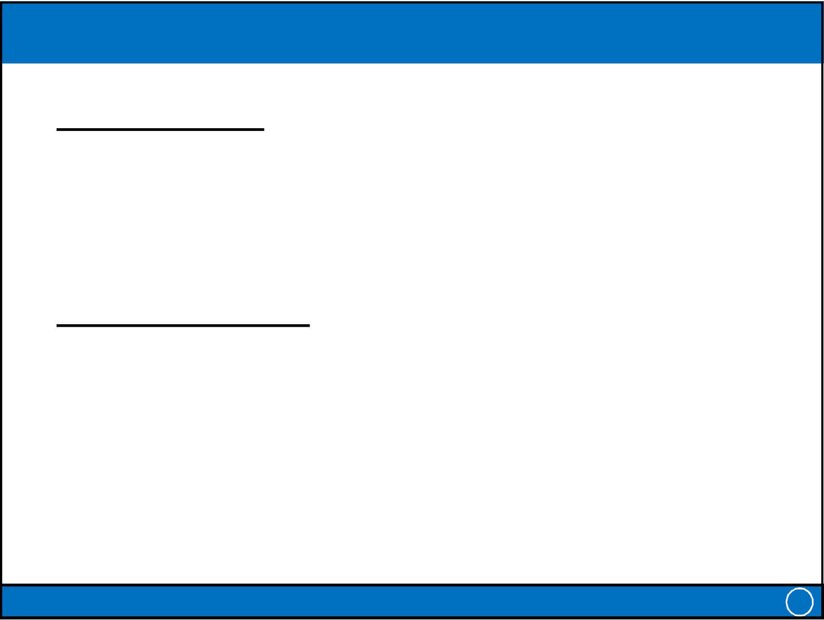
Friday, 15-11-2024
File-Based Systems (3)
• Early attempt to Computerize the manual filing
system
• Collection of application programs that perform
services for the end users (e.g. reports).
• Each program defines and manages its own data.
• Consider PropHome example for file-based systems
– Sales Department : responsible for selling and renting of
properties
– Contract Department: responsible for handling lease
agreements
IT-212: Database Systems 13
File-Based Systems (4)
Sales Department
• PropertyForRent: (propertyNo, street, city, postcode, type, rooms, rent)
• Client: (clientNo, firstName, lastName, telNo, preftype, maxRent)
• PrivateOwner: (ownerNo, firstName, lastName, address, telNo)
Contract Department
• Lease: (leaseNo, propertyNo, clientNo, rent , paymentMethod, deposit,
paid, rentStart, rentFinish, duration)
• | PropertyForRent: (propertyNo, street, city, postcode, type, rooms, rent) | 14
• | Client: (clientNo, firstName, lastName, telNo, preftype, maxRent) | 14
• | IT-212: Database Systems | 14
7

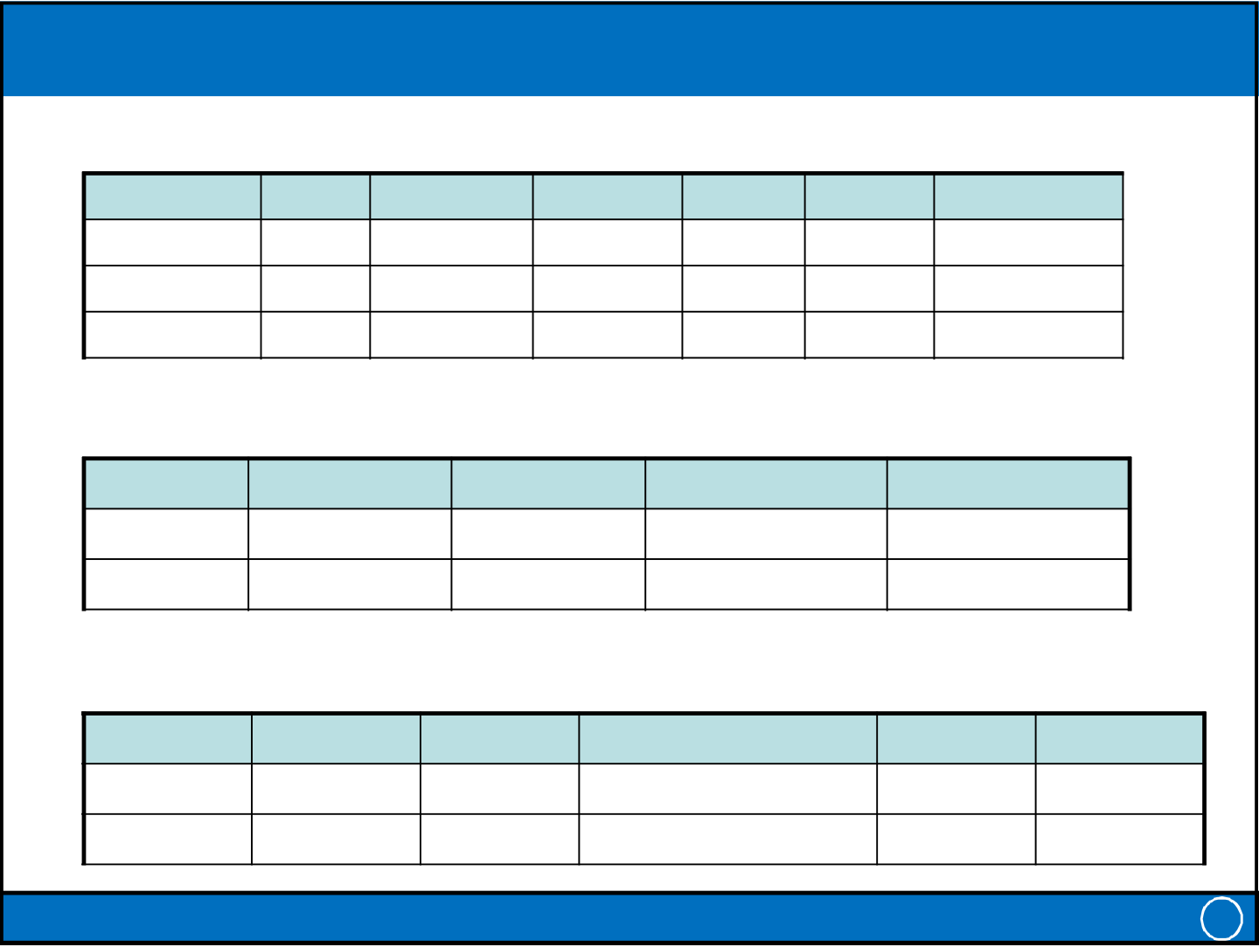
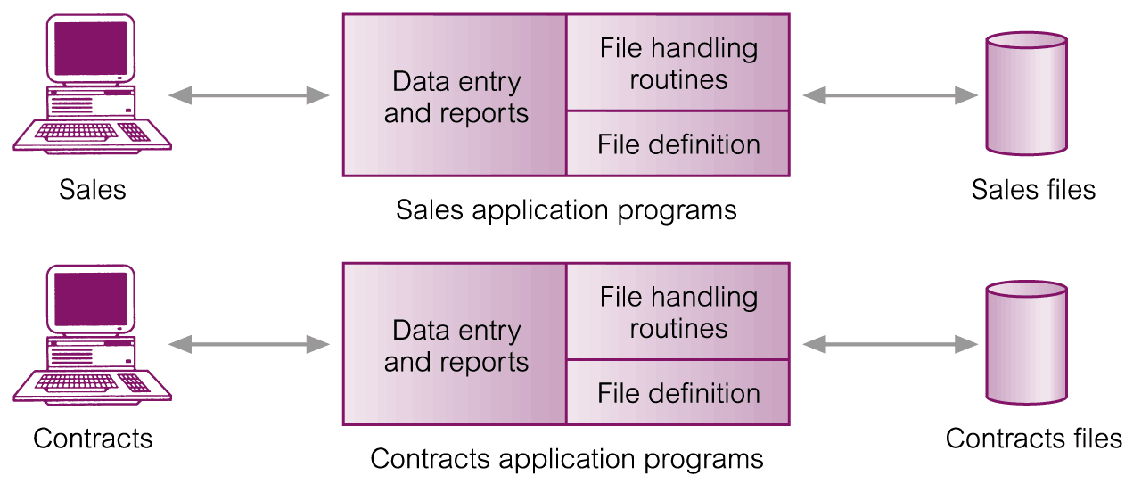
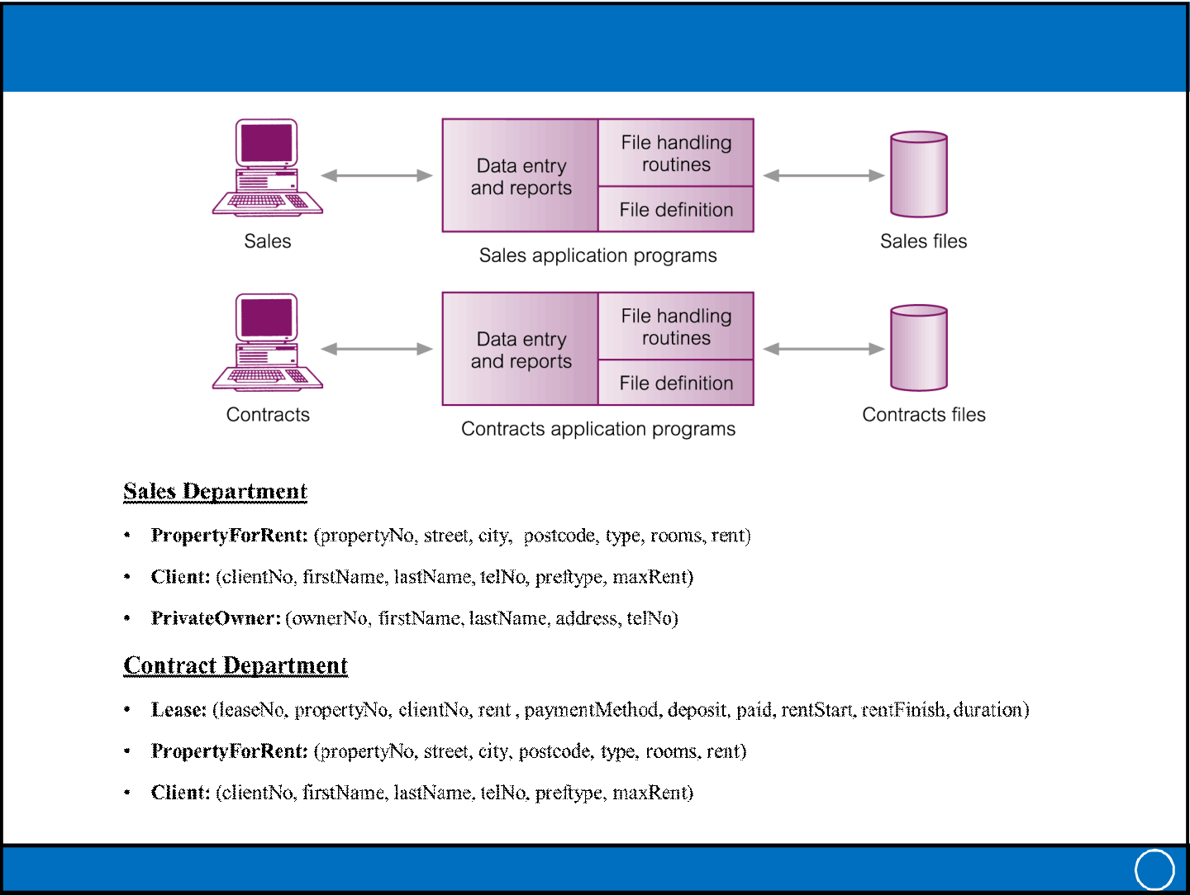
Friday, 15-11-2024
File-Based Systems (5)
PropertyForRent
propertyNo | street | city | postcode | type | rooms | Rent_PKR
PA14 | … | Peshawar | … | House | 6 | 65K
PL94 | … | Lahore | … | Flat | 4 | 40K
PG45 | … | Mardan | … | Flat | 3 | 35K
PrivateOwner
ownerNo | firstName | lastName | address | telNo
C-46 | Aslam | Khan | Karachi | 021-8235579
C-87 | Jahan | Bakht | Lahore | 042-5698342
Client
clientNo | firstName | lastName | telNo | prefType | maxRent | 15
CR76 | Salman | Akram | 091-1234567 | Flat | 50K | 15
CR56 | Abid | Jamal | 051-1204589 | Flat | 35K | 15
CR56 | Abid | IT-212: Database Systems |  | Flat | 35K | 15
File-Based Processing
IT-212: Database Systems 16
8

Friday, 15-11-2024
Limitations of a File-Based System (1)
• Separation and isolation of data
– Each program maintains its own set of data.
– Users of one program may be unaware of potentially useful data held by other programs.
• Duplication of data
– Decentralized approach taken by each department.
– Same data is held by different programs.
– Wasted space and potentially different values and/or different formats for the same item.
• Data dependence
– File structure is defined in the program code.
• Incompatible file formats
– Programs are written in different languages, and so cannot easily access each other’s files.
IT-212: Database Systems 17
Limitations of a File-Based System (2)
• Fixed Queries of application programs
– Programs are written to satisfy particular functions.
– Any new requirement needs a new program.
• Data Inconsistency
– Changes in one file (like change in address) won’t update in related
files.
• Poor Scalability and Performance
– As the number of files grows, searching and retrieving data becomes
slower.
IT-212: Database Systems 18
9

Friday, 15-11-2024
Why Database Approach?
• Because:
– Definition of data was embedded in application programs, rather than
being stored separately and independently.
– No control over access and manipulation of data beyond that imposed
by application programs.
• Result:
– The Database and Database Management System (DBMS).
IT-212: Database Systems 19
Database
• A structured collection of data that is stored and accessed electronically.
– Characteristics: Organized, easily accessible, and manageable
• Shared collection of logically related data, and a description of this data, designed to meet the information needs of an organization.
– Logically related data comprises entities, attributes, and relationships of an organization’s information.
• Metadata provides description of data to enable program-data independence.
IT-212: Database Systems 20
10

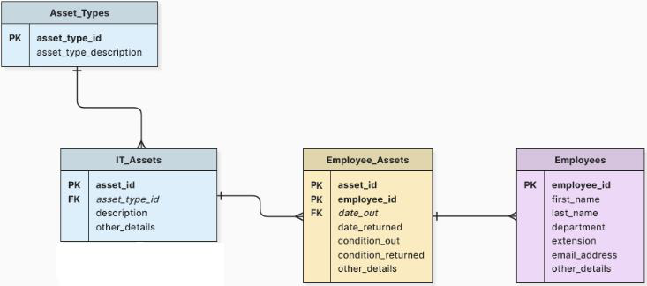
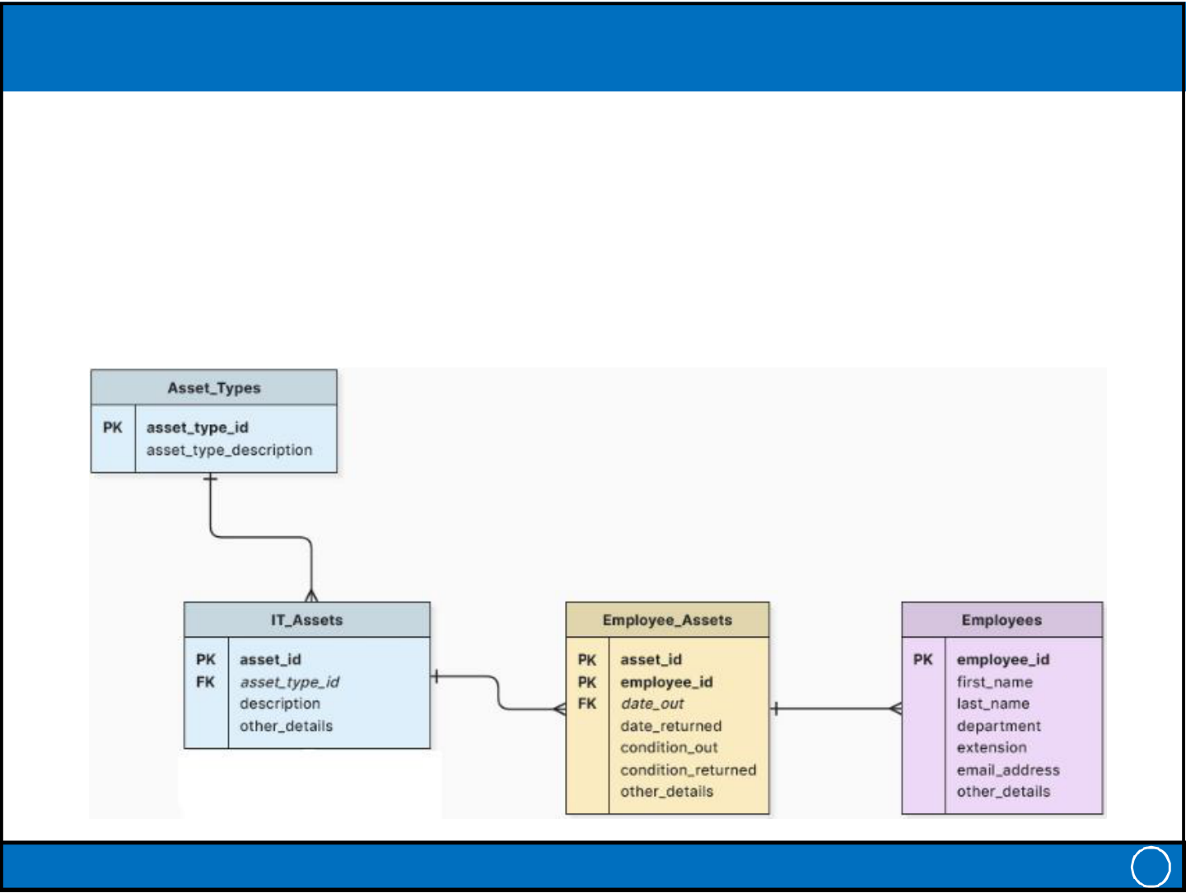
Friday, 15-11-2024
Importance of Database
1. Data management
– Efficiently store, retrieve, and manage data.
2. Decision-making
– Supports business intelligence and analytics.
3. Automation
– Enables applications to operate smoothly and efficiently
• Large organizations (e.g., NADRA) rely on database to manage vast amounts of information.
• Real-World Examples of Databases
– E-commerce: Amazon’s product database.
– Social Media: Facebook’s user data.
– Healthcare: Electronic health records (EHR) systems
IT-212: Database Systems 21
Components of a Database
• Tables: Structured data organized in rows and columns.
• Relationships: How tables interact with each other.
• Schema: The framework how data is organized
IT-212: Database Systems 22
11

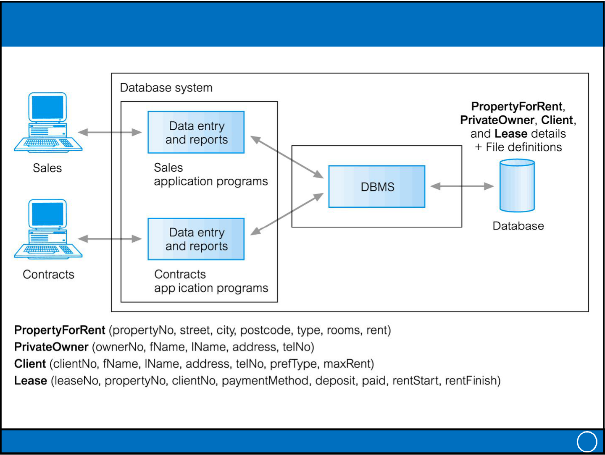
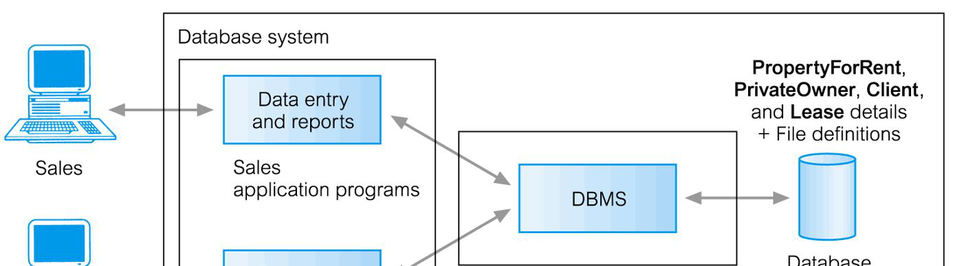
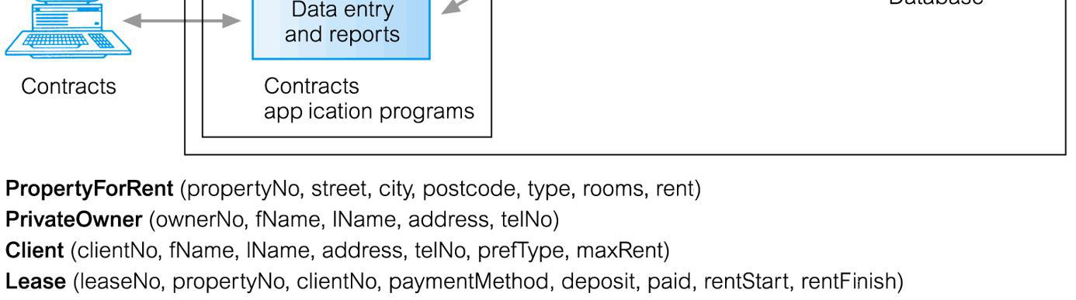
Friday, 15-11-2024
Database Management System (DBMS) (1)
• A software system that enables users to define, create, maintain, and control access to the database.
– Examples: | MySQL, | Oracle | Database, | Microsoft | SQL | Server,
MongoDB
• DBMS Functions
– Data Definition & Organization: Defining data structures and types.– Data Manipulation: CRUD operations (Create, Read, Update, Delete).– Data Security: Protecting data from unauthorized access.
– Backup and Recovery: Ensuring data integrity and availability– Concurrency Control
• (Database) application program: A computer program that interacts with database by issuing an appropriate request (SQL statement) to the DBMS.
IT-212: Database Systems 23
Database Management System (DBMS) (2)
IT-212: Database Systems 24
12

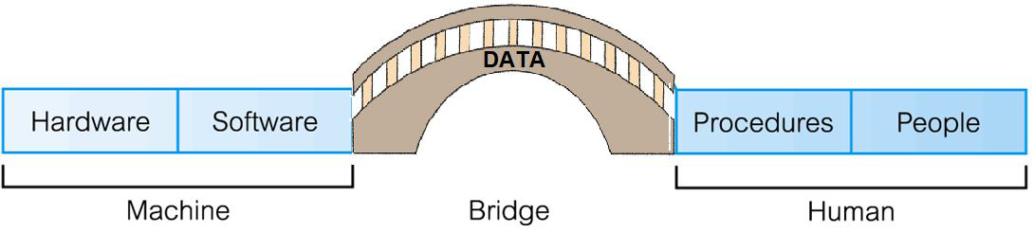
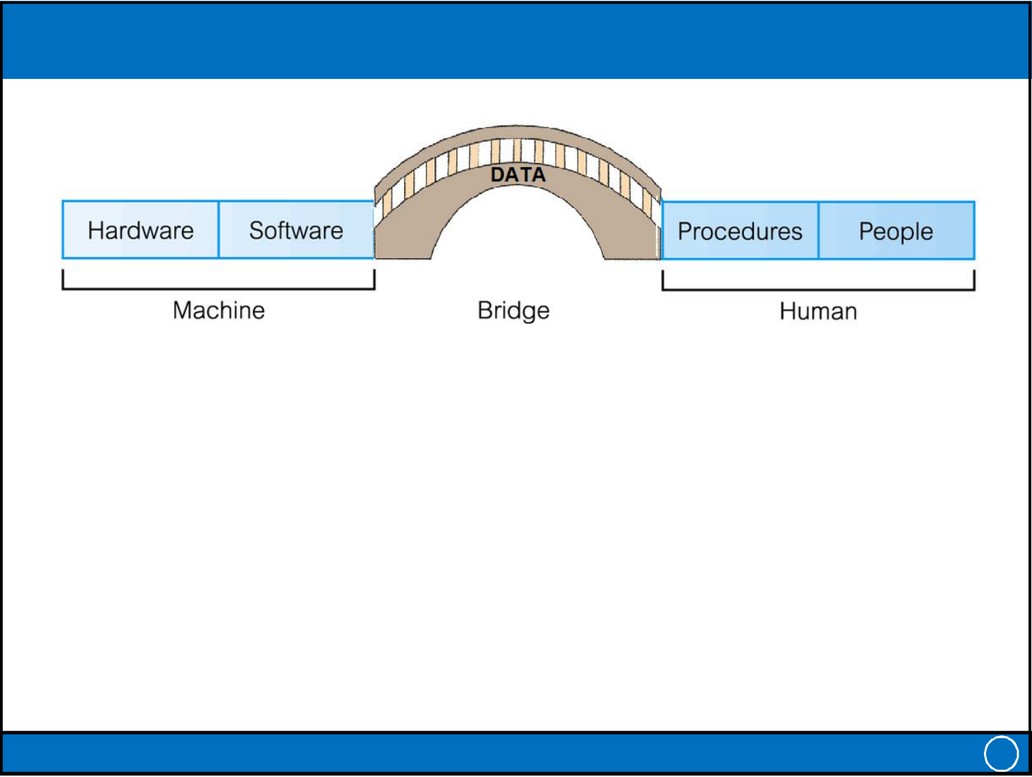
Friday, 15-11-2024
Components of DBMS Environment
• Hardware: Can range from a PC to a network of computers.
• Software: DBMS, operating system, network software (if necessary) and also the application programs.
• Data: Used by the organization and a description of this data called the schema.
• Procedures: Instructions and rules that should be applied to the design and use of the database and DBMS.
• | People: Users of the system. | 25
• | IT-212: Database Systems | 25
DBMS Generations
1st Generation: File-Based Systems (1960s)
– Data stored in flat files; no DBMS.
– Manual data management; prone to redundancy and inconsistency.
2nd Generation: Hierarchical and Network Models (1970s) – Hierarchical Model: Tree-like structure (e.g., IBM IMS).
– Network Model: Graph-based relationships (e.g., CODASYL DBTG).– Improved structure but rigid and complex querying.
3rd Generation: Relational DBMS (1980s–Present)
– Data stored in tables; SQL for manipulation.
– Normalization, ACID properties, and indexing.
– Examples: Oracle, MySQL, SQL Server.
4th Generation: Post-Relational & Modern DBMS (2000s–Present) – NoSQL: Unstructured data (e.g., MongoDB).
– Cloud Databases: Scalable and managed services (e.g., BigQuery).
– Hybrid Models: Multi-model support (e.g., Cosmos DB).
– Trends: AI-driven optimization, big data integration, distributed systems.
IT-212: Database Systems 26
13

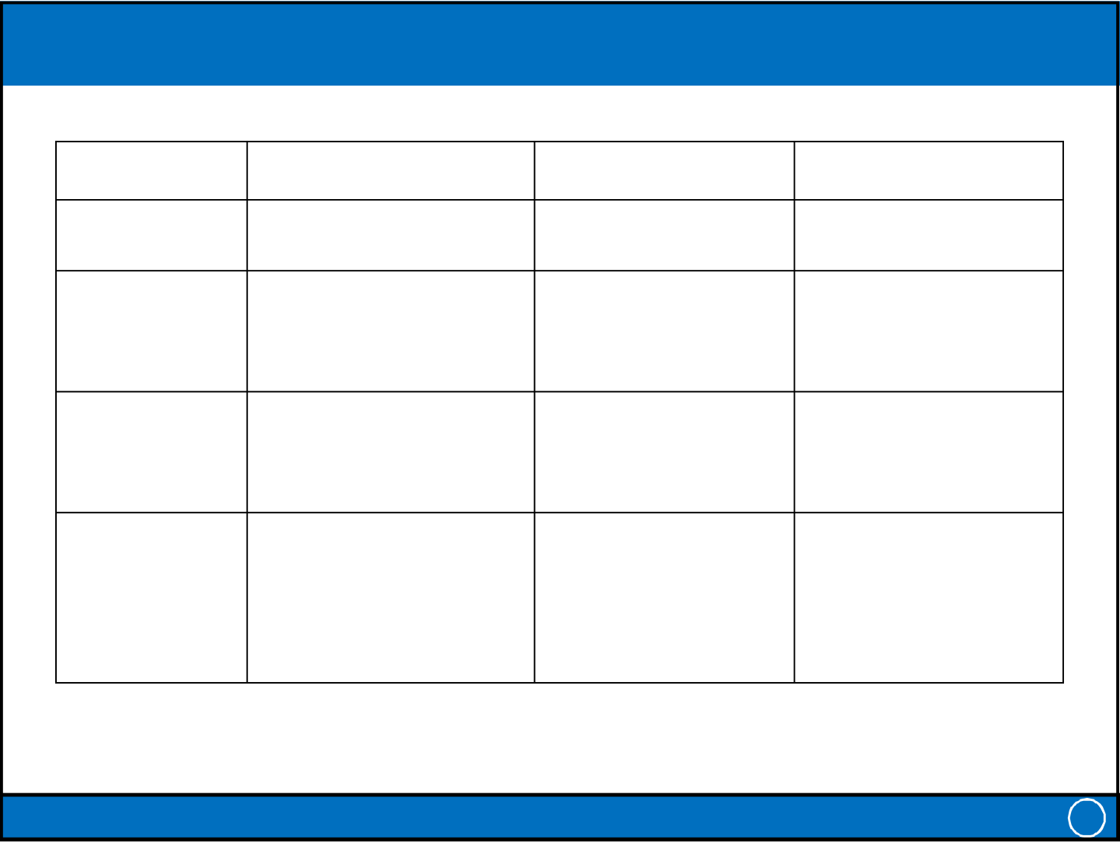
Friday, 15-11-2024
Summary of DBMS Generations
Generation | Key Technology | Focus | Examples | 27
1st Generation | File-based systems | Basic data storage | COBOL file systems | 27
(1960s)
2nd Generation | Hierarchical & Network | Structured data | IMS, | 27
(1970s) | Models | management | CODASYL DBTG | 27
3rd Generation | Relational DBMS | Standardized, | Oracle, MySQL, | 27
(1980s–Present) | Relational DBMS | robust data | SQL Server | 27
4th Generation | NoSQL, Cloud, Hybrid, AI-driven | Scalability, flexibility MongoDB, BigQuery, Cosmos DB |  | 27
(2000–Present) | NoSQL, Cloud, Hybrid, AI-driven |  |  | 27
(2000–Present) | IT-212: Database Systems |  |  | 27
Advantages of DBMSs
• Control of data redundancy
• Data consistency
• More information from the same amount of data
• Sharing of data
• Improved data integrity (constraints)
• Improved security (authentication, rights)
• Enforcement of standards (data formats, naming conventions, documentation etc.)
• Improved backup and recovery services
IT-212: Database Systems 28
14

Friday, 15-11-2024
Disadvantages of DBMSs
• Complexity
• Size (disk space for DBMS)
• Cost of DBMS
• Additional hardware costs
• Cost of conversion
• Performance
• Higher impact of a failure
IT-212: Database Systems 29
SQL: The Language of Databases
• SQL – Structured Query Language (SQL) for managing and manipulating databases.
– Key Operations: SELECT, INSERT, UPDATE, DELETE
• Major Components:
1. Data definition language (DDL).
• Permits specification of data types, structures and any data
constraints.
• All specifications are stored in the database.
2. Data manipulation language (DML).
• General enquiry facility (query language) of the data.
IT-212: Database Systems 30
15

Friday, 15-11-2024
The Database Approach
• Controlled access to database may include:
– A security system
• Which prevents unauthorized users accessing the database
– An integrity system
• Which maintains the consistency of stored data
– A concurrency control system
• Which allows shared access of the database
– A recovery control system
• Which restores the database to a previous consistent state in case of hardware or software failure
– A user-accessible catalog
• Which contains description of the data in the database
IT-212: Database Systems 31
Views
• Allows each user to have his or her own view of the database.
• A view is essentially some subset of the database.
• Advantages:
– Reduce complexity
– Provide a level of security
– Provide a mechanism to customize the appearance of the database
– Present a consistent, unchanging picture of the structure of the
database, even if the underlying database is changed
IT-212: Database Systems 32
16

Friday, 15-11-2024
Roles in the Database Environment
• Data Administrator (DA)
– Database planning
– Development and maintenance of standards, policies and procedures• Database Administrator (DBA)
– Physical realization of the database
– Physical database design and implementation
– Security and integrity control
– Maintenance of the operational system
– Ensuring satisfactory performance of the applications for users• Database Designers (Logical and Physical)
• Application Programmers
• End Users (naive and sophisticated)
IT-212: Database Systems 33
History of Database Systems (1)
1. Early Database Concepts (1950s–1960s)
– File-Based Systems:
• In the 1950s, computers were first used for data storage in file systems. • Data was stored in flat files, requiring extensive programming to retrieve specific information.
• File systems were rigid, lacked a clear structure, and were prone to redundancy and inconsistency.
– Navigational Databases:
• By the late 1960s, hierarchical and network database models emerged, improving the organization of data.
• Hierarchical Model: Data was organized like a tree (parent-child relationships). Example: IBM's Information Management System (IMS) in 1966.
• Network Model: Allowed more flexible relationships than the hierarchical model (e.g., CODASYL DBTG, 1969).
– CODASYL: Conference on Data Systems Languages,
– DBTG: Data Base Task Group
IT-212: Database Systems 34
17

Friday, 15-11-2024
History of Database Systems (2)
2. Relational Database Era (1970s)
– Edgar F. Codd's Relational Model (1970):
• Codd, | working | at | IBM, | proposed | the | relational | database | model,
introducing the concept of organizing data into tables (relations).
• Data manipulation was based on mathematical set theory and predicate logic.
• Key ideas included normalization to eliminate redundancy and ensure data integrity.
– First Relational Database Management Systems (RDBMSs): • IBM's System R was the first prototype.
• Oracle (1979) became the first commercial RDBMS, followed by products like IBM's DB2 and Microsoft's SQL Server.
3. Emergence of SQL (Structured Query Language)
– SQL was developed as part of IBM's System R and became the standard language for relational databases.
– | In 1986, SQL was standardized by ANSI and later ISO. | 35
– | IT-212: Database Systems | 35
History of Database Systems (3)
4. The Rise of Object-Oriented Databases (1980s–1990s) – With advancements in object-oriented programming, Object-Oriented Database Management Systems (OODBMSs) emerged.
– These databases supported complex data types, inheritance, and encapsulation.
– Popular systems included ObjectStore and Versant.
5. Client-Server and Distributed Databases (1990s)
– The client-server model gained popularity, allowing multiple users to access centralized databases.
– Distributed Databases:
• Data was distributed across multiple locations, but users could access it as if it were stored in one place.
• This improved scalability and fault tolerance.
IT-212: Database Systems 36
18

Friday, 15-11-2024
History of Database Systems (4)
6. NoSQL and Big Data (2000s)
– NoSQL Databases:
• Designed to handle unstructured and semi-structured data.
• Offered high scalability, flexibility, and performance for web-scale applications. Examples: MongoDB, Cassandra, and Redis.
– Big Data and Hadoop:
• The explosion of data led to the development of frameworks like Hadoop for distributed storage and processing of massive datasets.
7. Cloud Databases and Database as a Service (2010s– Present)
– Cloud-Based Databases:
• Databases moved to the cloud, offering flexibility, scalability, and reduced maintenance.
• Examples: Amazon RDS, Google Cloud Spanner, and Azure SQL Database.
– Database as a Service (DBaaS):
• | Providers | manage the database infrastructure, allowing users to | focus on
development.
IT-212: Database Systems 37
History of Database Systems (5)
8. Current Trends
– AI-Driven Databases:
• AI is now being used for query optimization, data analytics, and database
self-management.
– Blockchain Databases:
• Emerging as a way to ensure secure, tamper-proof transactions and
decentralized data storage.
– Hybrid and Multi-Model Databases:
• Support for combining relational, document, and graph models in a single
system (e.g., ArangoDB, Cosmos DB).
IT-212: Database Systems 38
19

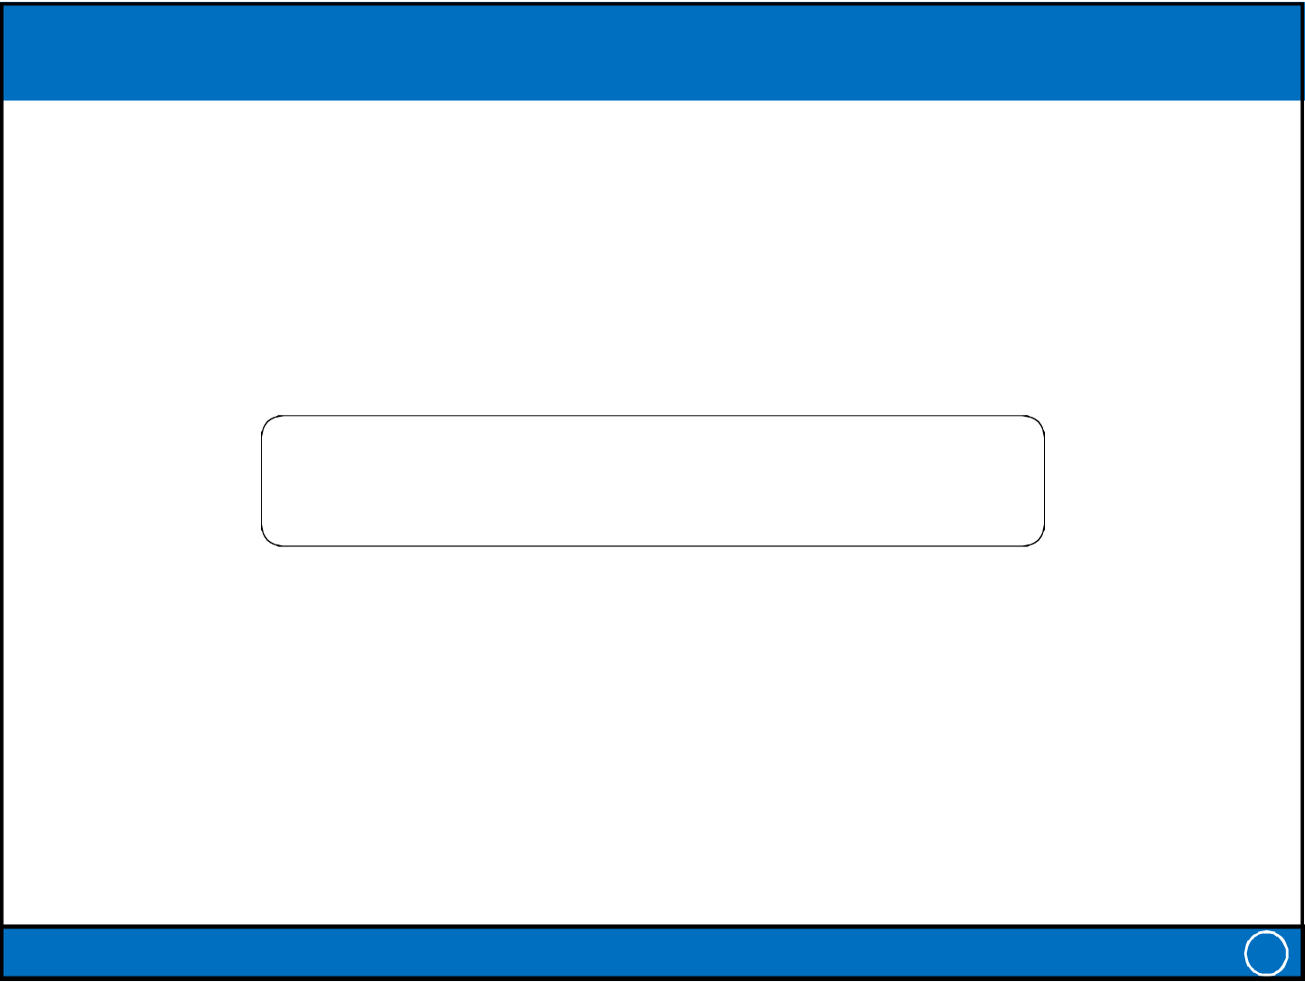
Friday, 15-11-2024
Summary
• Some common uses of database systems
• Characteristics of file-based systems
• Problems with file-based approach
• The Database (DB)
• Database Management System (DBMS)
• Typical functions of a DBMS
• Major components of the DBMS environment• Personnel involved in the DBMS environment• Advantages and disadvantages of DBMSs• History of the development of DBMSs
IT-212: Database Systems 39
THANK YOU
IT-212: Database Systems 40
20

