



Wednesday, 27-11-2024
IT-212
Database Systems
Lecture-02
Dr. Muhammad Asif Khan
Assistant Professor
Department of Computer Science & IT
Sarhad University of Science and Information Technology, Peshawar
Last Lecture Summary
• Some common uses of database systems
• Characteristics of file-based systems
• Problems with file-based approach
• The Database (DB)
• Database Management System (DBMS)
• Typical functions of a DBMS
• Major components of the DBMS environment
• Personnel involved in the DBMS environment
• Advantages and disadvantages of DBMSs
• History of the development of DBMSs
IT-212: Database Systems | 2
1


Wednesday, 27-11-2024
Today’s Topics
• Data Models and Their Categories
• History of Data Models
• Schemas, Instances, and States
• Structure of Relational Databases
• Database Schema
• ANSI-SPARC Three-Level Architecture
• Schemas (Three-Level Architecture)
• Mappings
• Data Independence
IT-212: Database Systems 3
Data Models
• Data Model:
– A set of concepts to describe the structure of a database, – the operations for manipulating these structures, and – certain constraints that the database should obey.
• Data Model Structure and Constraints:
– Constructs are used to define the database structure
– Constructs typically include elements (and their data types) as well as groups of elements (e.g. entity, record, table), and relationships among such groups
– Constraints specify some restrictions on valid data;
– Constraints must be enforced at all times
IT-212: Database Systems 4
2

Wednesday, 27-11-2024
Categories of Data Models
• Conceptual (high-level, semantic) data models:
– Provide concepts that are close to the way many users perceive data.
• (Also called entity-based or object-based data models.)
• Physical (low-level, internal) data models:
– Provide concepts that describe details of how data is stored in the computer.
• Implementation (representational) data models:
– Provide concepts that fall between the above two, used by many commercial DBMS implementations (e.g. relational data models used in many commercial systems).
IT-212: Database Systems 5
Schemas and Instances
• Database Schema:
– The description of a database.
– Includes descriptions of the database structure, data types, and the
constraints on the database.
• Schema Diagram:
– An illustrative display of (most aspects of) a database schema.
• Schema Construct:
– A component of the schema or an object (entity) within the schema,
e.g., STUDENT, COURSE.
• Instance: The collection of data and information that the
database stores at any particular moment.
– The term instance is also applied to individual database components,
e.g. record instance, table instance, entity instance
IT-212: Database Systems 6
3

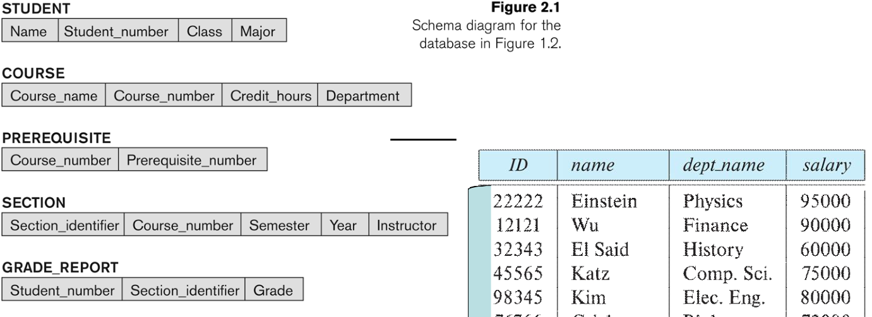
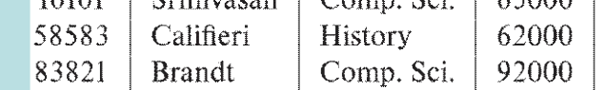
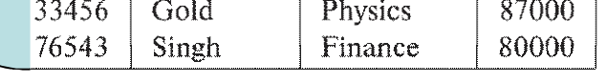
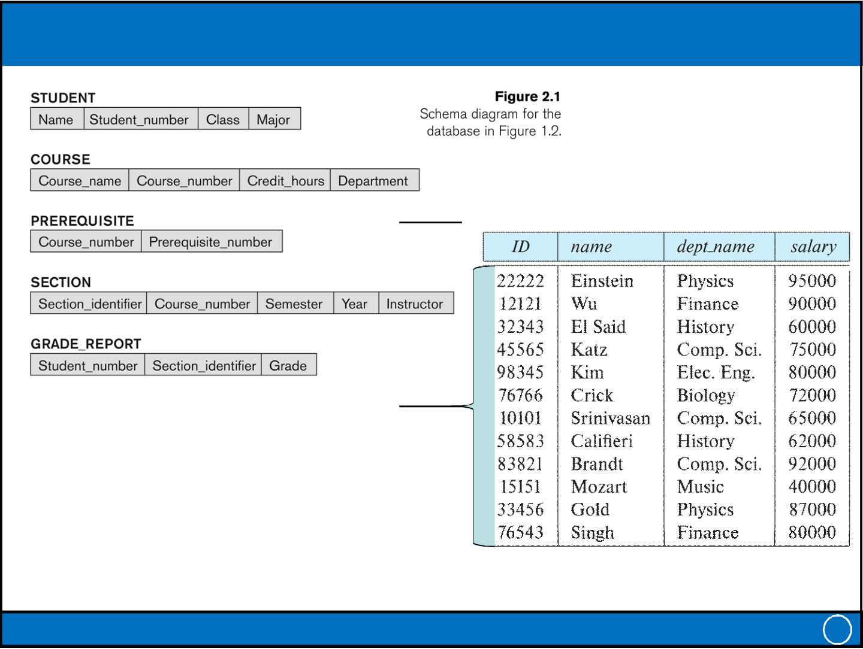
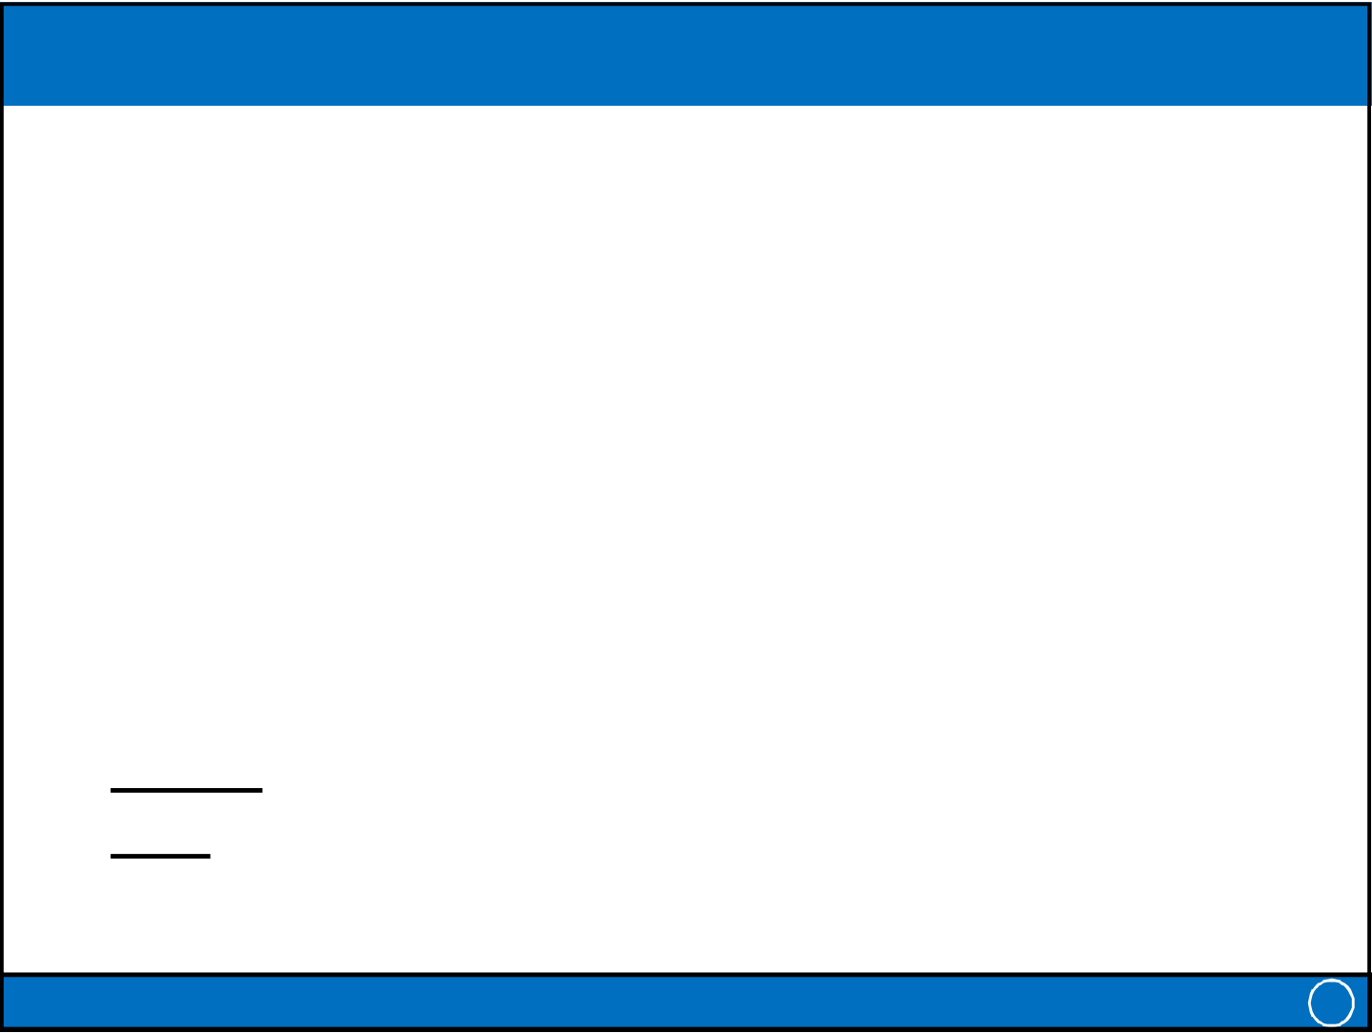
Wednesday, 27-11-2024
Example of a Database Schema
Schema: instructor (ID, name, dept_name, salary)
Book: Ramez Elmasri and Shamkant B. Navathe | Instance
Book: Silberschatz, Korth and Suda
IT-212: Database Systems 7
Database State, Distinction, Intension, Extension
• Database State:
– The actual data stored in a database at a particular moment in time. – This includes the collection of all the data in the database.
• Initial Database State:
– Refers to the database state when it is initially loaded into the system.
• Valid State:
– A state that satisfies the structure and constraints of the database.
• Distinction
– The database schema changes very infrequently.
– The database state changes every time the database is updated. • Schema is also called intension.
• State is also called extension.
IT-212: Database Systems 8
4

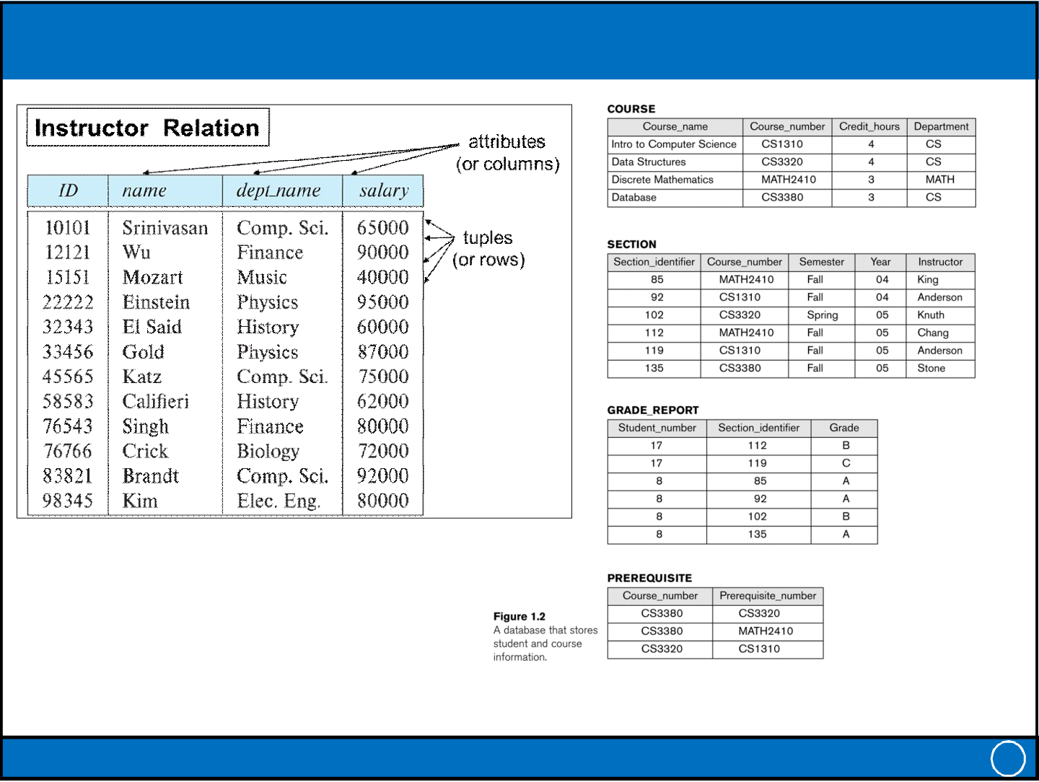
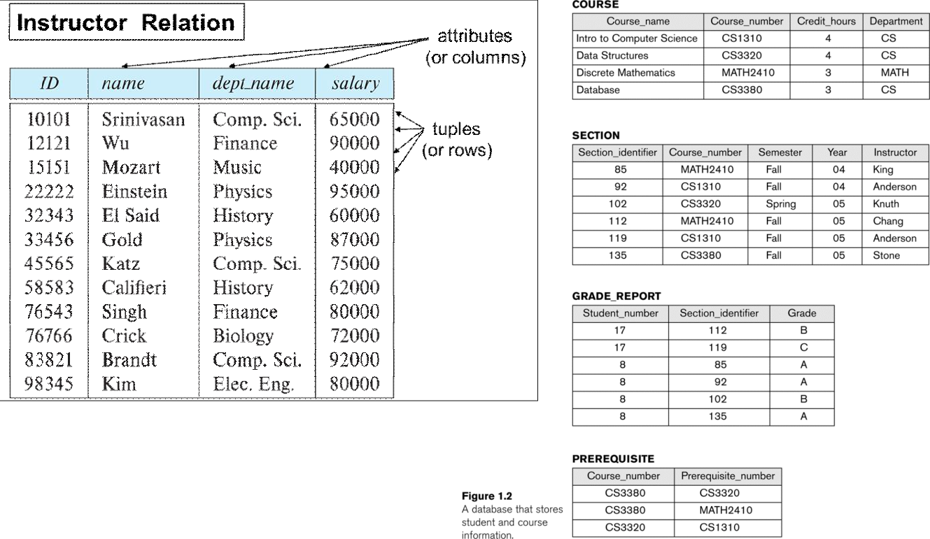
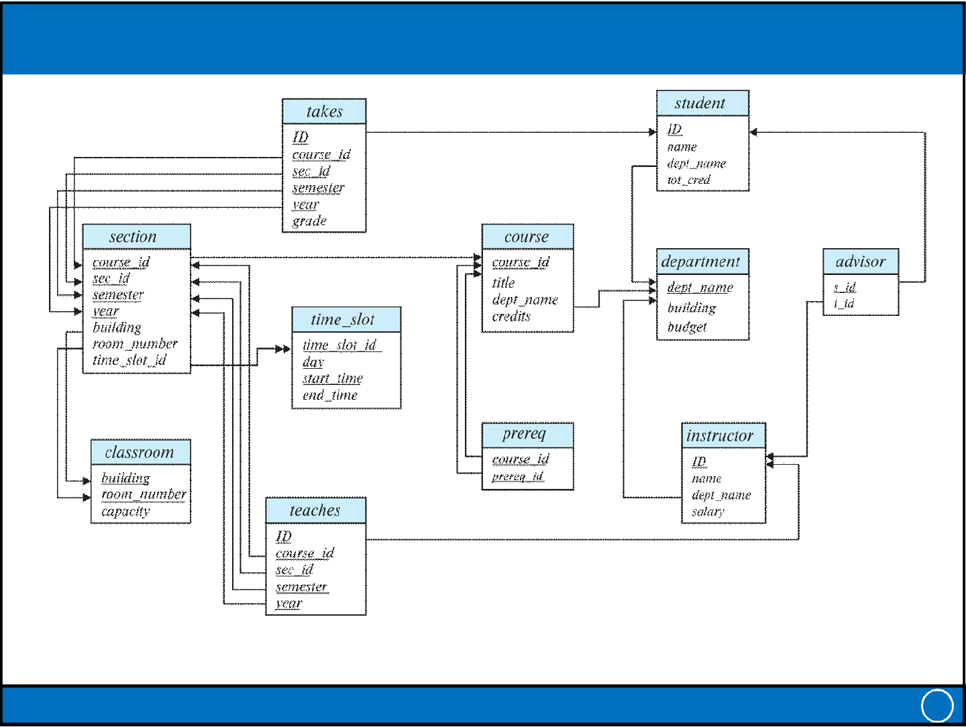
Wednesday, 27-11-2024
Example of a database state
Book: Silberschatz, Korth and Suda
Book: Ramez Elmasri and Shamkant B. Navathe
IT-212: Database Systems 9
Schema Diagram for University Database
Book: Silberschatz, Korth and Suda
IT-212: Database Systems 10
5

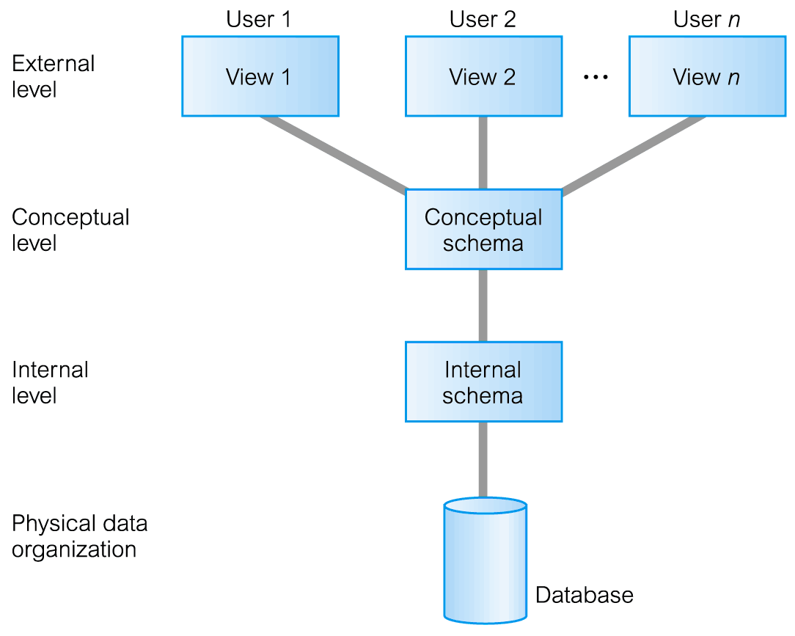
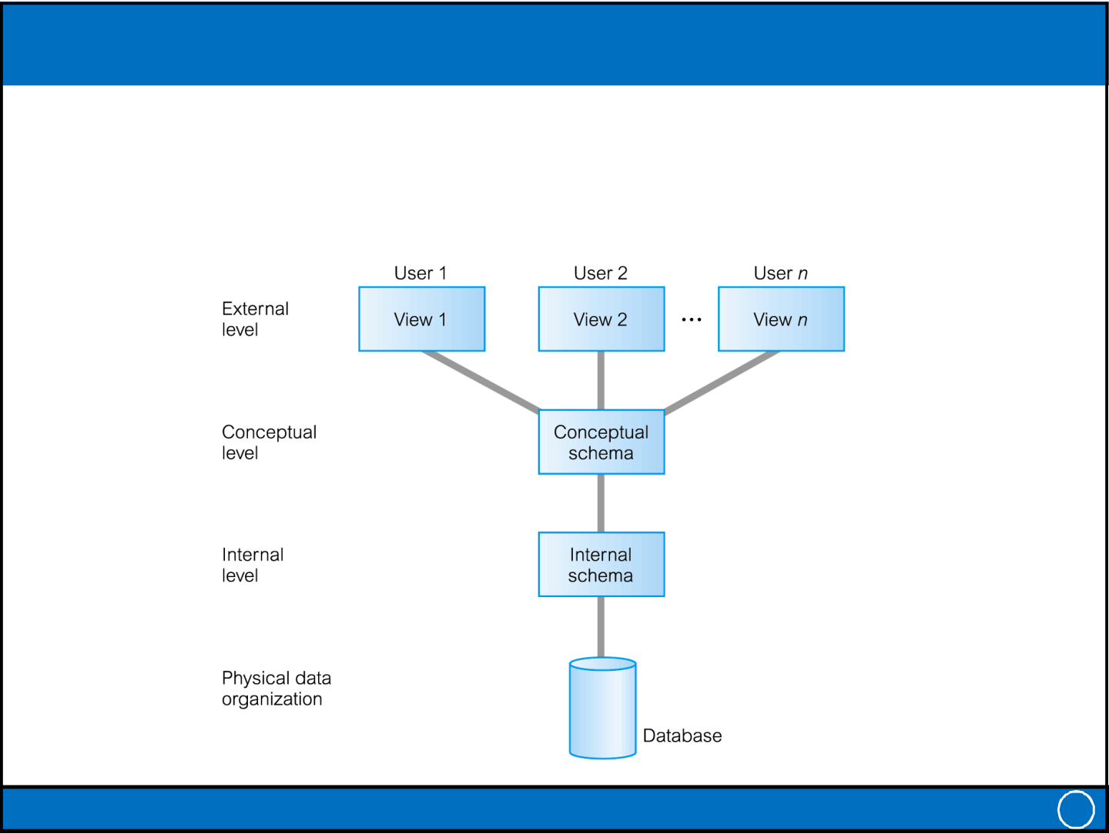
Wednesday, 27-11-2024
Three-Level / Schema Architecture
Objectives:
– All users should be able to access same data but have a different customized view.
– A user’s view is protected from changes made in other views– Users should not need to know physical database storage details.
– DBA should be able to change database storage structures without affecting the users’ views
– Internal structure of database should be unaffected by changes to physical aspects of storage
– DBA should be able to change conceptual structure of database without affecting all users
IT-212: Database Systems 11
ANSI-SPARC Three-Level Architecture (1)
• ANSI-SPARC: American National Standards Institute, Standards Planning And Requirements Committee
– An abstract design standard for a DBMS, first proposed in 1975.
IT-212: Database Systems 12
6

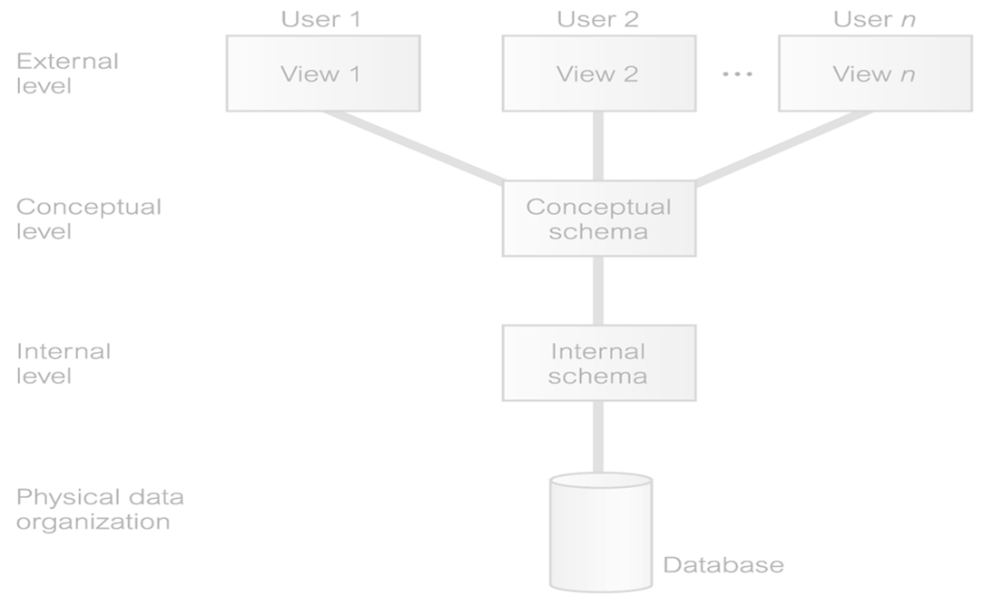
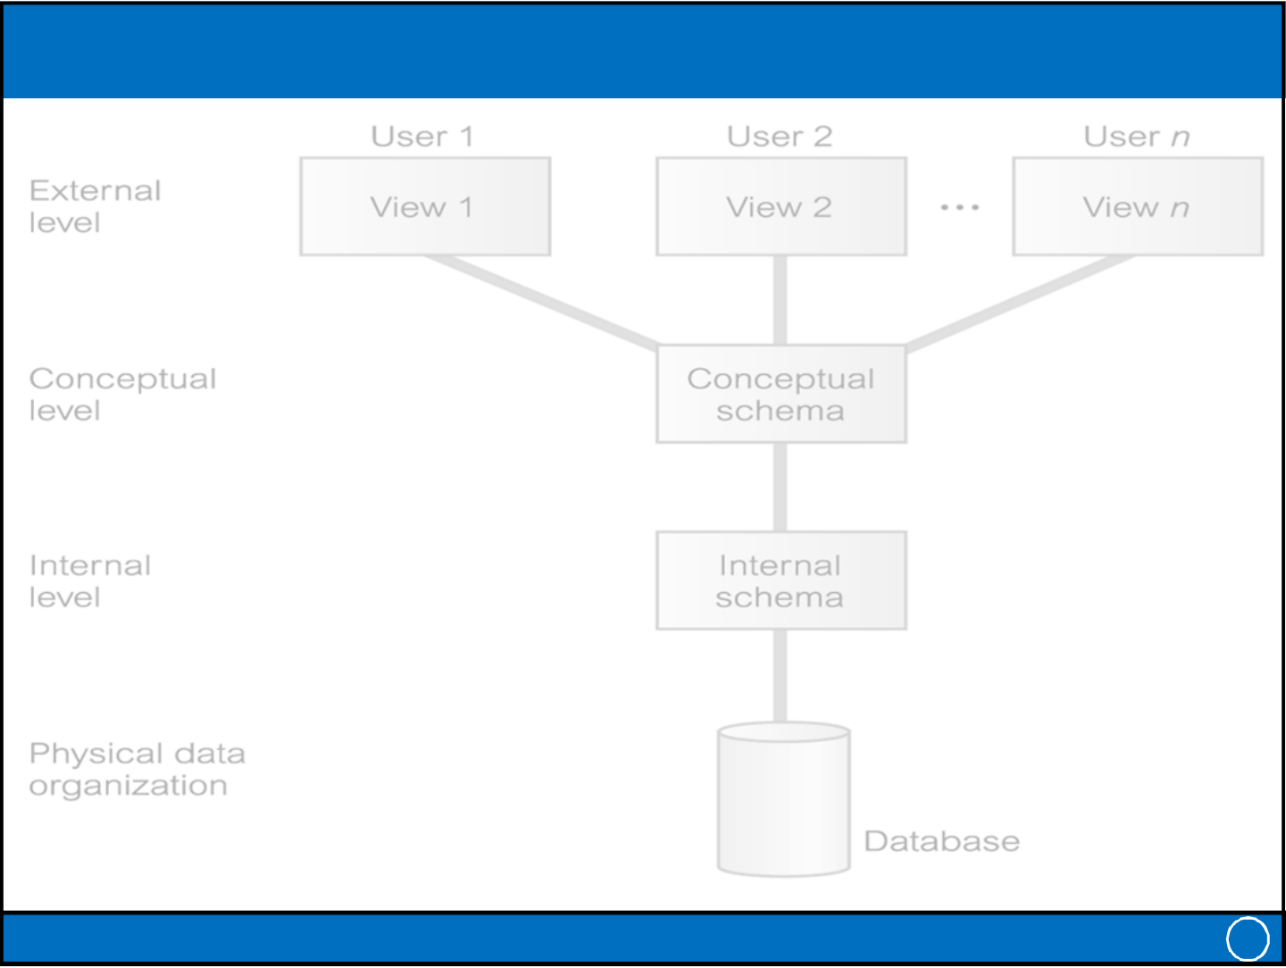
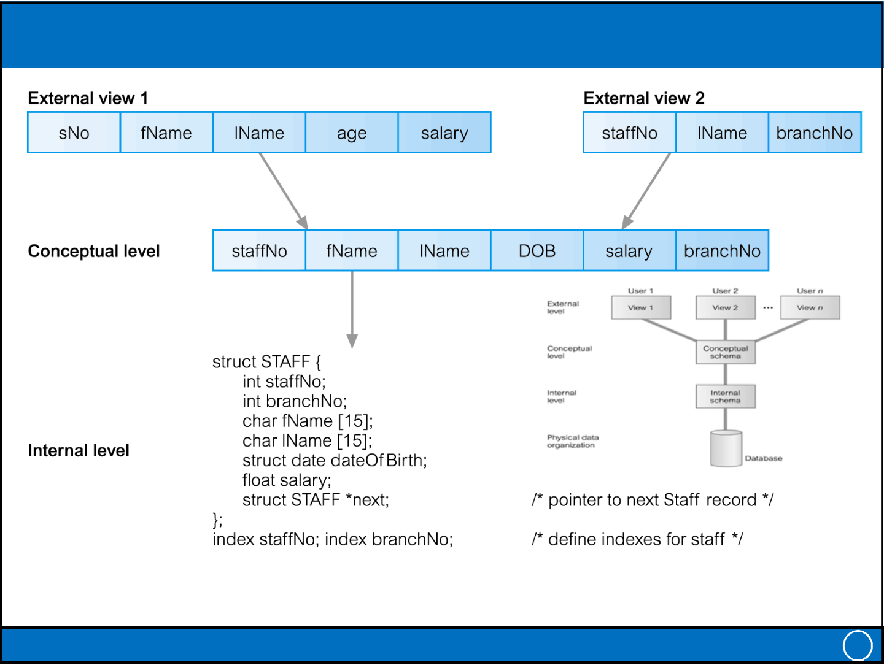
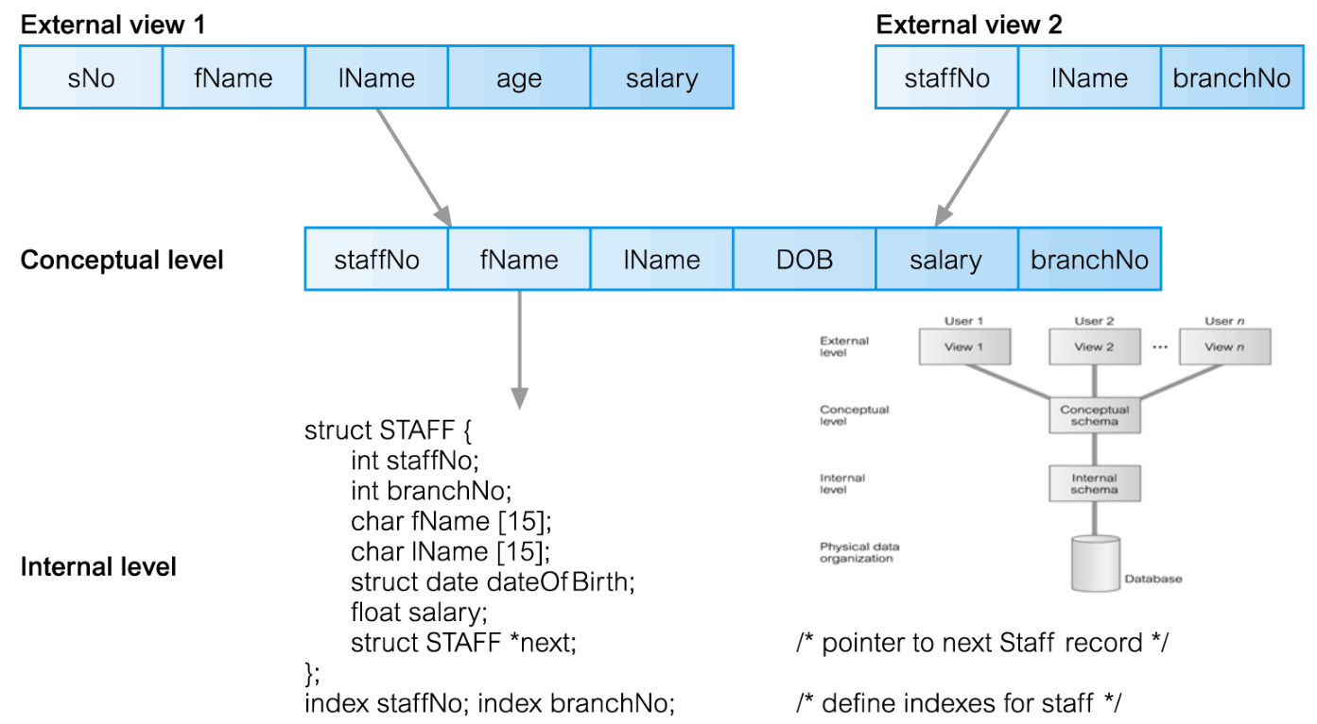
Wednesday, 27-11-2024
ANSI-SPARC Three-Level Architecture (2)
• External Level
– Users’ view of the database
– Describes that part of database that is relevant to a particular user
– Different views may have different representation of same data (e.g. different date formats, age derived from DOB etc.)
• Conceptual Level
– Describes what data is stored in database and relationships among the data – Along with any constraints on data
– Independent of any storage considerations
• Internal Level
– Physical representation of the database on the computer
– Describes how the data is stored in the database
– physical implementation of the database to achieve optimal runtime performance and storage space utilization
– Data structures and file organizations used to store data on storage devices – Interfaces with the operating system access methods to place the data on the storage devices, build the indexes, retrieve the data, and so on
IT-212: Database Systems 13
ANSI-SPARC Three-Level Architecture (3)
IT-212: Database Systems 14
7

Wednesday, 27-11-2024
Schemas (Three-Level Architecture)
• External Schemas
– Also called subschemas
– Multiple schemas per database
– Corresponds to different views of data
• Conceptual Schema
– Describes all the entities, attributes, and relationships together with integrity constraints
– Only one schema per database
• Internal Schema
– A complete description of the internal model, containing the definitions of stored records, the methods of representation, the data fields, and the indexes and storage structures used
– Only one schema per database
IT-212: Database Systems 15
Mappings (1)
• The DBMS is responsible for mapping between these three types
of schema:
– The DBMS must check that each external schema is derivable from the
conceptual schema, and it must use the information in the conceptual
schema to map between each external schema and the internal schema
• Types of mappings
– Conceptual / Internal mapping
– External / Conceptual mapping
IT-212: Database Systems 16
8

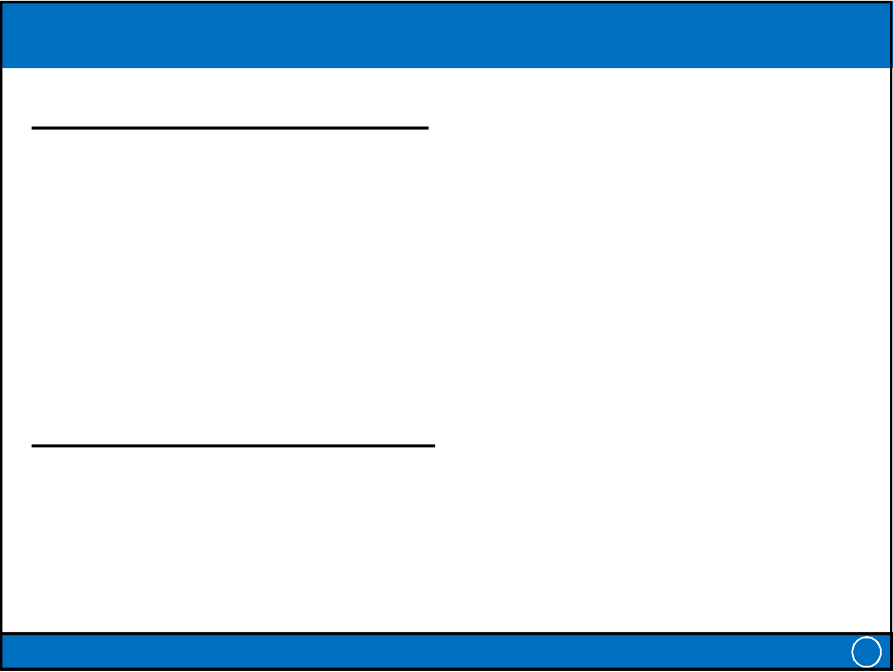
Wednesday, 27-11-2024
Mapping (2)
Conceptual / Internal Mapping
• Enables the DBMS to
– Find the actual record or combination of records in physical storage that constitute a logical record in the conceptual schema,
– Together with any constraints to be enforced on the operations for that logical record
– It also allows any differences in entity names, attribute names, attribute order, data types, and so on, to be resolved
External / Conceptual Mapping
• Enables the DBMS to
– Map names in the user’s view on to the relevant part of the conceptual schema
IT-212: Database Systems 17
Data Independence
• Logical Data Independence
– Refers to immunity (freedom) of external schemas to changes in conceptual schema
– Conceptual schema changes (e.g. addition/removal of entities)
– Should not require changes to external schema or rewrites of application programs
• Physical Data Independence
– Refers to immunity of conceptual schema to changes in the internal schema – Internal schema changes (e.g. using different file organizations, storage structures, storage devices etc.)
– Should not require change to conceptual or external schemas
IT-212: Database Systems 18
9

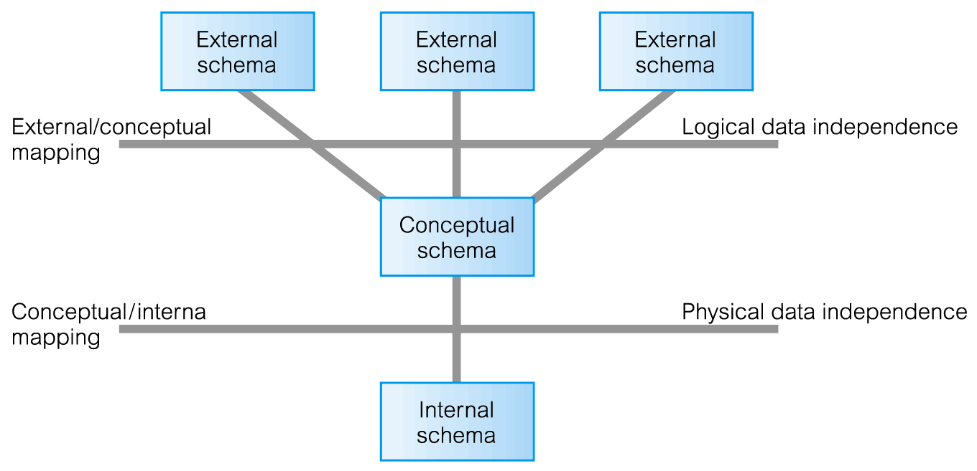
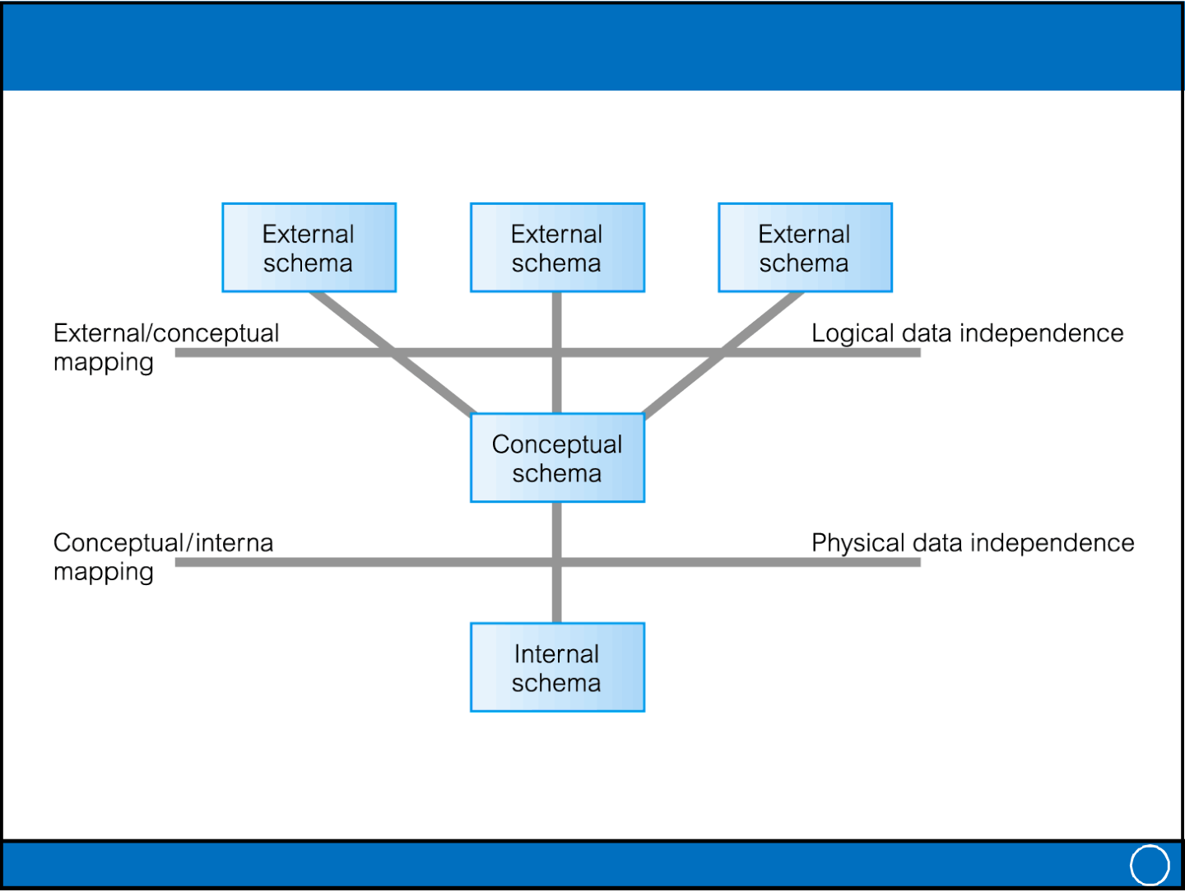
Wednesday, 27-11-2024
Data Independence and the ANSI-SPARC Three-Level Architecture
IT-212: Database Systems 19
Summary
• Data Models and Their Categories
• History of Data Models
• Schemas, Instances, and States
• Structure of Relational Databases
• Database Schema
• ANSI-SPARC Three-Level Architecture
• Schemas (Three-Level Architecture)
• Mappings
• Data Independence
IT-212: Database Systems 20
10

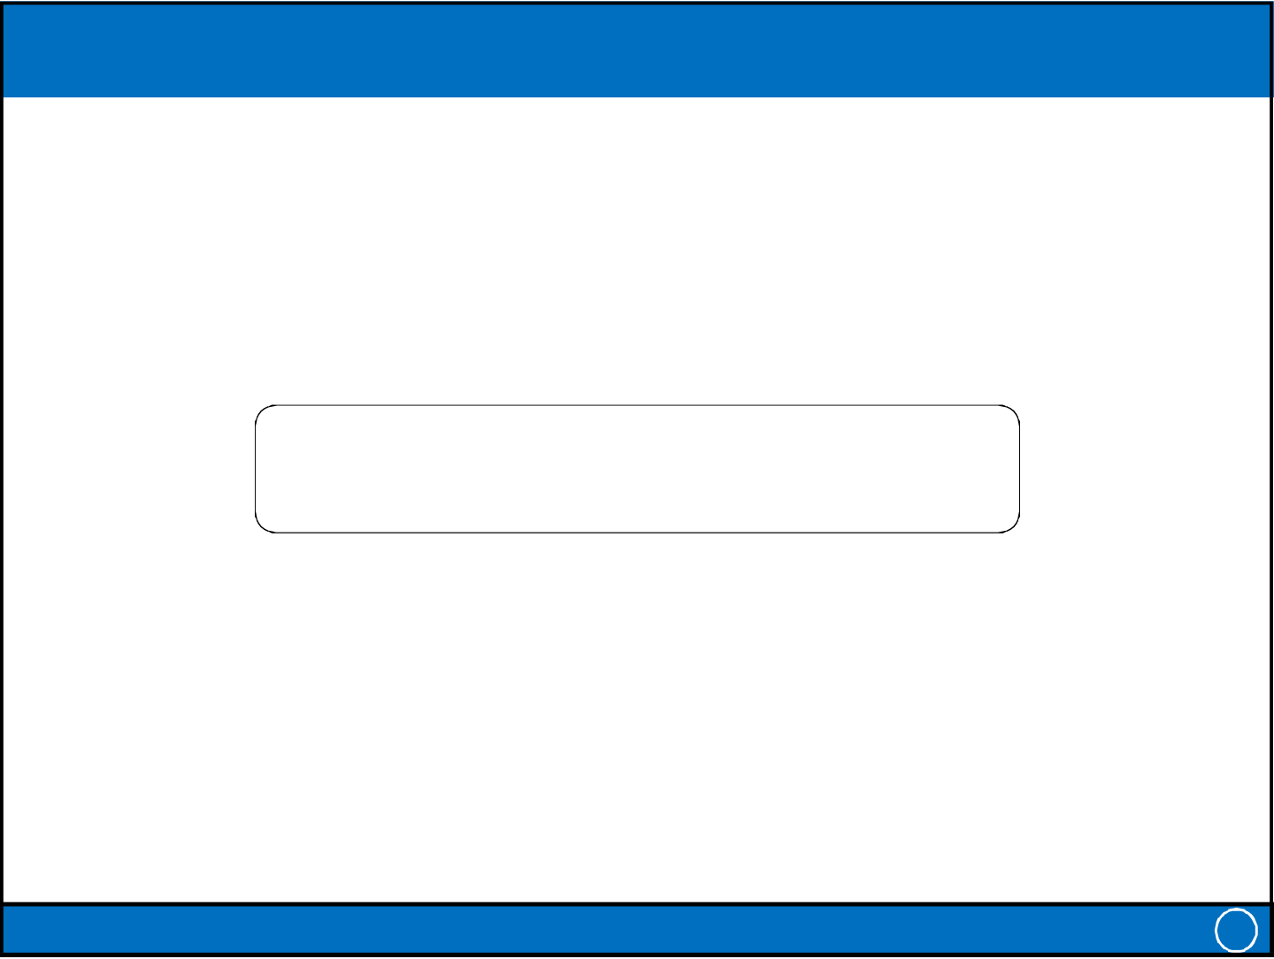
Wednesday, 27-11-2024
THANK YOU
IT-212: Database Systems 21
11

