SENTINEL
High-Level Design & Architecture Document
Technical Proposal Deliverable
Gujarat Police Innovation Challenge 2026

Integration Diagram

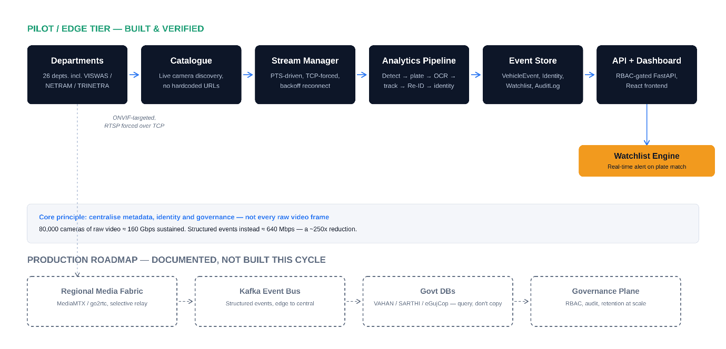

Workflow Diagram
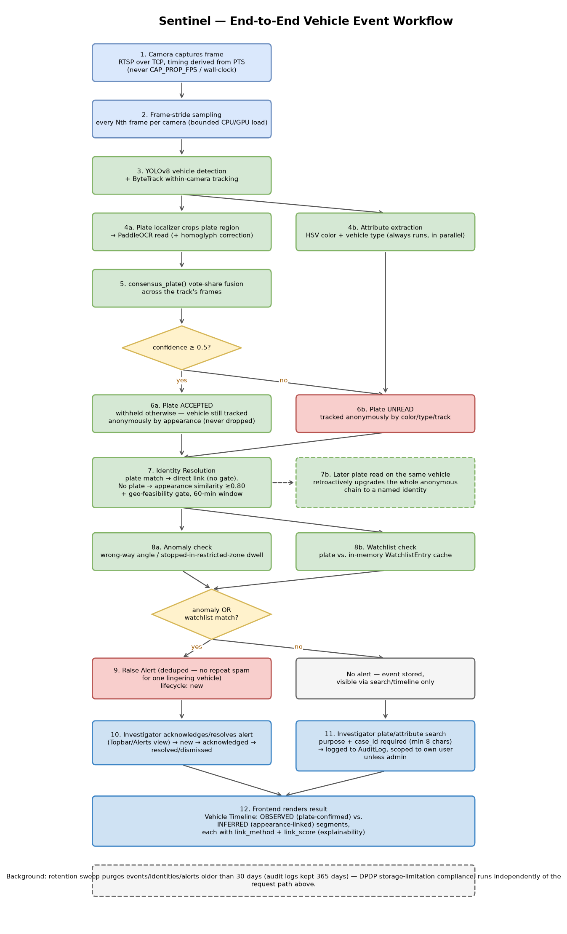

System Architecture ( module 1 + module 2 )

