SENTINEL
Technical Proposal, High-Level Design (HLD)
Gujarat Police Innovation Challenge 2026, Document 2, Phase 1 Submission
Structured against the organizer's own HLD checklist, section by section.

1. Overall Solution Architecture
Sentinel follows a Model 1 plus Model 2 hybrid architecture. Model 1 is a centralised camera registry, GIS mapping, and governance layer. Model 2 adds direct, middleware-free unified viewing and metadata analytics across departmental systems. Model 3, VMS federation, and a scoped Model 4 pilot slice are built as additional bonus scope, sequenced after the mandatory pair is complete. Existing departmental systems, including VISWAS, NETRAM, TRINETRA, or any other departmental VMS, are never replaced. Sentinel connects alongside them.
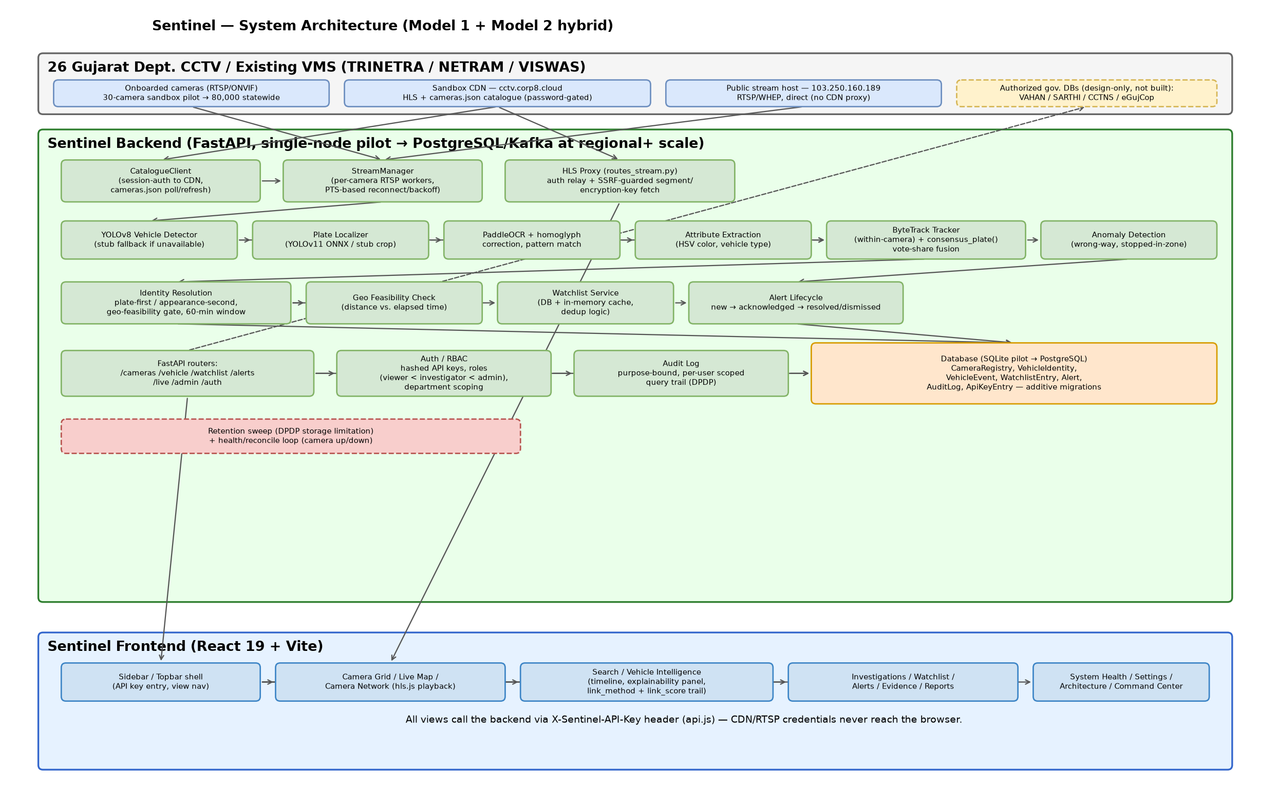
Figure 1. Sentinel high-level system architecture.
The component flow runs top to bottom. A catalogue and discovery client polls each department's camera source. A stream manager opens one worker per live camera. A sampled-frame analytics pipeline performs detection, ANPR, tracking, and identity resolution. Results are persisted to an event store, using SQLAlchemy and PostgreSQL-ready models, that feeds the watchlist engine, the purpose-bound search API, and the React frontend, covering the GIS map, live view, movement timeline, watchlist, and registry operations. At statewide scale, this same shape extends to an edge, regional, and central tier split, detailed in Section 7.

2. Heterogeneous Camera, NVR, and VMS Integration Approach
Cameras are discovered from a live catalogue rather than hardcoded, so camera identity and availability can change without a code change. Two ingestion paths are supported. The first is direct RTSP, forced over TCP for reliability. The second is real ONVIF Profile S/T discovery, using a WS-Discovery probe and the Media GetStreamUri call. This is the same device-abstraction standard that multi-vendor platforms such as Genetec Security Center and Milestone XProtect build their own vendor support on. A camera is tagged by owning department independent of protocol or vendor, which lets Model 1's registry act as the common index every other model sits on top of.
Resilience is built in rather than assumed. Reconnection uses an exponential backoff from two seconds up to a thirty-second cap, never a tight retry loop, and an explicit tracker-state reset runs on any stream discontinuity, whether a recording loop point or a genuine disconnect, so a scene cut never silently produces corrupted motion data. Private and commercial CCTV, such as societies, malls, and businesses, use the identical onboarding path, tagged to the owning entity with its explicit consent. This is currently a design-only capability, since no private feed exists in the sandbox to demonstrate it against.

3. Live Stream Ingestion, Processing, and Management Architecture
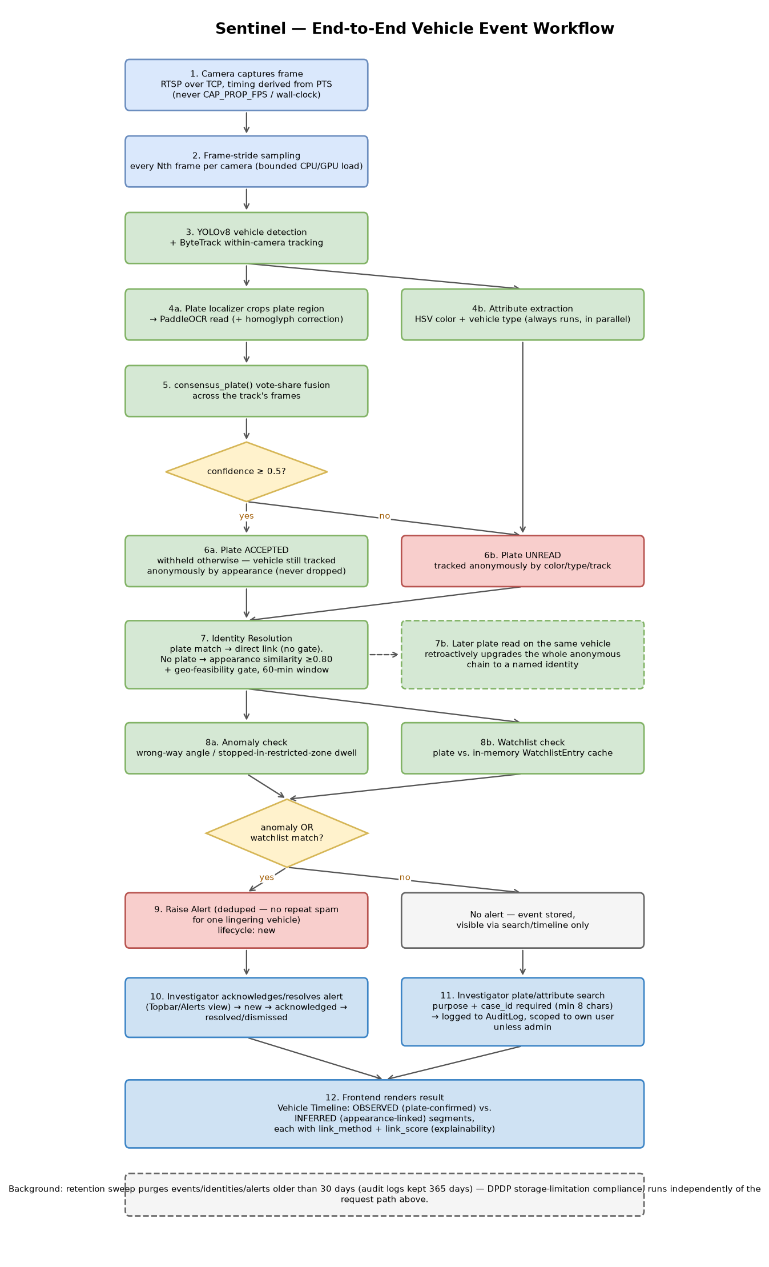
Figure 2. End-to-end analytics workflow.
One worker thread is managed per live camera and reconciled against the catalogue on an interval. Workers open for newly live cameras and close for cameras no longer present, so load tracks what is actually being processed rather than a fixed camera list. Frame sampling, every Nth frame and configurable, bounds inference cost per camera. Resolution and frame rate differ per camera and are read from catalogue metadata rather than assumed uniform. Every frame carries a presentation timestamp used for all within-stream timing and velocity math. Wall-clock arrival time is deliberately never trusted, since a gateway can replay a buffered group of pictures faster than real time on connect.
Camera health is tracked separately from analytics health, because a camera can stream perfectly while its analytics silently fail. This is a real failure mode found and fixed during development, when a library version mismatch made every detection call fail while stream connectivity kept reporting as healthy. Both states are now surfaced independently so this cannot be hidden behind a single healthy status.

4. CCTV-to-Watchlist Integration and Real-Time Alert Correlation
Every persisted vehicle event with a resolved plate is checked against the watchlist, covering stolen, wanted, blacklisted, and suspect categories, at write time. A match creates an alert immediately, polled by the frontend's alerts panel. Alerts follow a governed lifecycle: new, then acknowledged, then resolved, with dismissed as a false positive reachable from either state. Only the transitions declared in an explicit state table are permitted, and an illegal transition is rejected by the API rather than silently accepted. Each transition records who made it and when, so the accountability trail is auditable, not just the initial alert.
Critically, an alert is gated on the triggering event's own evidence class, not on an identity's best-ever evidence. This fix followed an independent review that found a LEAD-ONLY, appearance-only sighting could otherwise trigger a full-confidence alert by inheriting an unrelated earlier plate confirmation of the same identity. It is the concrete mechanism that keeps a weak inference from silently becoming a high-confidence match downstream. Production integration targets for the watchlist itself are Gujarat's own systems, including VAHAN, SARTHI, eGujCop, and CCTNS, AFIS, and NAFIS, under a query, don't copy principle: Sentinel queries on demand rather than mirroring these databases locally.

5. AI-Powered Video Analytics Approach

ANPR, Object Detection, and Vehicle Tracking
The pipeline runs in stages: vehicle detection with YOLOv8, plate localisation with a fine-tuned YOLOv11 plate detector, enhancement through grayscale, CLAHE, and upscaling, then OCR with PaddleOCR, including multi-line-plate joining and bounded homoglyph correction. This is followed by regex pattern validation, including Bharat-series plates and a 36-code state and union-territory whitelist, and finally temporal consensus voting across sampled frames. A within-camera tracker, ByteTrack, associates repeated OCR attempts with one physical vehicle. It is never presented as cross-camera tracking.
Real result, reproduced on live sandbox footage | Status
Plate `GJ19BR3000`, camera `cam06`, 6 of 6 consecutive samples | VERIFIED
Confidence range across the 6 samples | 0.917 to 0.977
Fleet-wide read rate across the 30-camera set | Low and inconsistent, disclosed

Person and Vehicle Attribute Tracking
Colour, vehicle type, and dimensions are captured as investigator search clues rather than as proof of identity on their own. Motion attributes such as dwell time, speed proxy, and direction are derived from the tracked bounding-box path over the presentation timestamp. These are image-plane metrics, not calibrated kilometres per hour, and they drive wrong-way and stopped-in-zone anomaly alerts.

Cross-Camera Identity Resolution
A plate-first, appearance-second resolver assigns every sighting to one of three evidence tiers.
Tier | Basis | Exportable as evidence?
CONFIRMED | Plate read and validated on this sighting | Yes
PROBABLE | Within-camera continuity from a confirmed sighting | No, requires review
LEAD ONLY | Appearance or inference only | No, disabled in code

Measured on the accumulated pilot database, this gave 6 CONFIRMED and 12,251 LEAD-ONLY events out of 12,257 total. The appearance-only signal was independently measured at a 41.87 percent false-positive rate on confirmed-different-vehicle pairs, which is why LEAD-ONLY links are never presented as a tracked identity.

Facial Recognition Systems: Evaluated and Deliberately Excluded
FRS is not built, for two specific, cited reasons rather than a generic privacy objection. The first is accuracy. NIST's Face Recognition Vendor Test Part 3, NISTIR 8280, found up to a 7,200-fold variation in false-positive rate across demographic groups for some algorithms, and Delhi Police's own 2018 submission to the Delhi High Court put a deployed FRS system's accuracy at 2 percent. The second is legal exposure. The DPDP Act 2023 exempts law-enforcement processing under Section 17, but biometric identification done wrong risks a wrongful-identification incident before any accuracy or bias evaluation has been performed. A real code seam, DeliberatelyExcludedFaceRecognizer, enforces this exclusion in the running system, not only in this document. If a department later mandates FRS with its own validated, bias-audited model, this is the point it would plug into.

6. Alert Generation and Notification Workflow
Prioritisation. Alerts are differentiated by evidence class at the point of generation. A CONFIRMED plate match is never visually or operationally equal-weighted with a LEAD-ONLY appearance match, which mitigates automation bias, the risk of an operator rubber-stamping a high-volume feed without scrutiny.
Visualisation. The Alerts panel polls every five seconds and renders each alert's evidence tier, link method, and time gap inline, so an operator sees why an alert fired, not only that it did.
User interaction. Every state transition, whether acknowledging, resolving, or dismissing an alert as a false positive, is a deliberate, attributable human action. No route in the system auto-dispatches an officer or auto-confirms an identity. Marking an alert as a false positive is itself a first-class, audited action, and it is the concrete expression of this proposal's principle that AI output is a lead, not evidence.

7. Scalability, Interoperability, Security, and Performance for Approximately 80,000 Cameras

Scalability
Full central raw-video ingestion is not a credible target at this scale. Eighty thousand cameras at roughly 2 Mbps each works out to about 160 Gbps sustained and roughly 1.7 petabytes per day. Sentinel's design instead centralises structured events, not raw video. Detection, ANPR, and tracking run at the edge, emitting only the plate, timestamp, camera ID, and embedding vector to the central plane, which is projected at roughly 640 Mbps for the same camera count. This is an architectural projection from the pilot's measured per-stream cost on around thirty cameras, not a completed load test at full scale. That test was deliberately not attempted this cycle.

Interoperability
A vendor-neutral, normalised event schema is the integration surface for any ANPR system, RTSP or ONVIF camera, or departmental VMS API, so no department is required to replace its existing system to participate. ONVIF Profile S/T is the preferred discovery path where available, and direct RTSP remains supported where it is not.

Security
- Department-scoped RBAC with object-level authorization, not role-only.
- Purpose-bound, audited search, where every query logs the authenticated user, stated purpose, and case ID.
- Raw RTSP and WHEP credentials never reach the browser or application logs.
- SSRF-hardened ONVIF discovery, where device-supplied addresses are validated against loopback, link-local, and multicast targets before use.
- Enforced data retention in code, with a thirty-day default for vehicle data and 365 days for audit logs, rather than policy on paper.
- Evidence integrity through a SHA-256 hash of every evidence crop at write time, never recomputed to look clean at export.

Evidence Integrity and Section 63-Oriented Export
Each stored evidence crop is hashed with SHA-256 immediately after it is written, and that hash is never recomputed afterward. A later mismatch is reported explicitly rather than silently healed. A production stamp records the concrete detector, OCR, and re-identification class names in force at capture time, so a stub component and a real model never look identical on the same evidence record. Export of an evidence package is gated to CONFIRMED events only, requires a stated investigative purpose, and is audit-logged before the artefact is produced.
Wording throughout this proposal and the running system is deliberately conservative: "Section 63-oriented", referring to Section 63 of the Bharatiya Sakshya Adhiniyam, 2023, which governs the admissibility of electronic evidence, rather than "court admissible" or "Section 63 compliant". This project has not had legal review of the operating procedure around the system, and only qualified legal counsel can determine whether a package produced this way is admissible in a given case.

Performance
A real-time watchlist check occurs at event-write time, not in a batch job, so the alerts panel reflects a match within its five second poll interval. Rate limiting, applied per API key or IP address on a fixed window, protects every route except health checks from abuse without requiring new infrastructure.

8. Technical Prerequisites, Assumptions, and Departmental Information Requirements
Onboarding a department's cameras does not require replacing that department's VMS or granting Sentinel any control over it. Only the following is required, per camera or camera group.
- A reachable stream URL and protocol: an RTSP URL, or preferably ONVIF discoverability on Profile S/T, on the department's network.
- Network reachability from the Sentinel ingestion point to the camera or VMS, through a routed path or an explicit firewall allowance.
- Credentials scoped to viewing and streaming only, on a least-privilege basis, never admin or configuration access.
- Stable camera identity and metadata: camera ID, install location and GPS coordinates, owning department, and camera type.
- Make, model, and resolution, if known, since these feed directly into the camera ANPR-suitability scoring rather than being guessed.
- For a private or commercial camera, the same fields plus the entity's explicit written consent to onboard.
- For Model 3-style federation with another department's own VMS, that VMS's own event or metadata export mechanism, whether API, webhook, or batch export.
Explicitly not required from a department:
- No migration off, or reconfiguration of, the department's existing VMS storage, recording, or playback. Sentinel connects alongside it.
- No cloud or internet connectivity requirement if the department's network is on-prem or air-gapped.
- No requirement to standardise on ONVIF if RTSP is already available.
One open assumption is stated rather than hidden. Legacy-fleet credential rotation across many departments' real cameras, with mixed Basic, Digest, or proprietary-token authentication, is not addressed by the current pilot, which connects to one sandbox with one access token. A statewide rollout needs a per-camera, per-department credential store with rotation support. This is a real operational prerequisite that has not yet been designed in detail.

