**2023 HiMCM**

Problem A - Dandelions: Friend? Foe? Both? Neither?

**Team: 14229**

**Summary**

先写入侵物种的定义 曹成伟

An invasive species is an introduced, nonnative organism (disease, parasite, plant, or animal) that begins to spread or expand its range from the site of its original introduction and that has the potential to cause harm to the environment, the economy, or to human health. ([What is an invasive species and why are they a problem? | U.S. Geological Survey (usgs.gov)](https://www.usgs.gov/faqs/what-invasive-species-and-why-are-they-problem#:~:text=An%20invasive%20species%20is%20an%20introduced%2C%20nonnative%20organism,the%20environment%2C%20the%20economy%2C%20or%20to%20human%20health.))

再写本文的研究目的 我和曹成伟

我来写研究方法

**Key words**

**Menu**

1. **Introduction1**

**1.1 Harmfulness of Invasive Species2**

**1.2 Significance of the Model in this Research3**

1. **Establishment and Conclusions of Dandelion Dissemination Model4**

**2.1 Problem Statement and Explanation of Dandelion Dissemination Mechanism5**

**2.1.1 Dissemination Methods of Dandelions6**

**2.1.2 Dandelions in the Ecosystems6**

**2.2 Part 1: Population Prediction Model6**

**2.2.1 Basic Assumptions6**

**2.2.2 Variable Table6**

**2.2.3 Model Construction6**

**2.2.4 Result of Predicting the Population6**

**2.3 Part 2: Location Distribution Prediction Model6**

**2.3.1 Basic Assumptions6**

**2.3.2 Variable Table6**

**2.3.3 Model Construction6**

**2.3.4 Conclusion6**

1. **Establishment and Testing of Impact Factor Model4**

**3.1 Refining the Problem and Defining the Impact Factor8**

**3.2 Variable Table6**

**3.3 Model Construction6**

**3.4 Model Testing6**

**3.4.1 Dandelion Testing6**

**3.4.2 Invasive Species 1 Testing6**

**3.4.1 Invasive Species 2 Testing6**

**3.5 Conclusion6**

1. **References List4**
   * + 1. **Introduction**
   1. **Harmfulness of Invasive Species**

With no natural predators, invasive species can proliferate and cause a lot of ecological and economic damage where they have invaded. Invasive species can [threaten the biodiversity of an ecosystem](https://greentumble.com/why-is-biodiversity-important-to-ecosystems/), especially if native species are outcompeted or entirely driven to extinction. As our global natural environment continues to undergo damage and development around the world, the disturbed and deteriorating ecosystems are now becoming increasingly vulnerable to invasion by invasive species. In disturbed ecosystems, introduced invasive species can take advantage of niches that have been opened up that were previously occupied by native species.( [Why Are Invasive Species a Problem? | Greentumble](https://greentumble.com/why-are-invasive-species-a-problem#google_vignette)) The direct threats of invasive species include preying on native species, outcompeting native species for food or other resources, causing or carrying disease, and preventing native species from reproducing or killing a native species' young. There are indirect threats of invasive species as well. Invasive species can change the food web in an ecosystem by destroying or replacing native food sources. The invasive species may provide little to no food value for wildlife. Invasive species can also alter the abundance or diversity of species that are important habitat for native wildlife. Aggressive plant species like kudzu can quickly replace a diverse ecosystem with a monoculture of just kudzu. Additionally, some invasive species are capable of changing the conditions in an ecosystem, such as changing soil chemistry or the intensity of wildfires. ([Invasive Species | National Wildlife Federation (nwf.org)](https://www.nwf.org/Educational-Resources/Wildlife-Guide/Threats-to-Wildlife/Invasive-Species))

An invasive species can be any kind of living organism—an amphibian (like the cane toad), plant, insect, fish, fungus, bacteria, or even an organism’s seeds or eggs—that is not native to an ecosystem and causes harm. An invasive species does not have to come from another country. For example, lake trout are native to the Great Lakes, but are considered to be an invasive species in Yellowstone Lake in Wyoming because they compete with native cutthroat trout for habitat. ([Invasive Species | National Wildlife Federation (nwf.org)](https://www.nwf.org/Educational-Resources/Wildlife-Guide/Threats-to-Wildlife/Invasive-Species))

* 1. **Significance of the Model in this Research**
     + 1. **Establishment and Conclusions of Dandelion Dissemination Model**
  2. **Significance of the Model in this Research**

In the first question, it mentions "predict the spread of dandelions", which is a very broad question that can be approached from various angles. The term "spread" can be predicted in multiple aspects. Considering this, the first question can be divided into two aspects: predicting the population and predicting the distribution location; It is essential to elaborate on the relevant characteristics of dandelions. Below, we will explain the dissemination methods of dandelions and their interaction with ecosystems.

* + 1. **Dissemination Methods of Dandelions**

钟安媛画图+曹成伟解释

The structure of the seed of dandelions enabled themselves to spread in great efficiency and help the colonies of dandelions to thrive. Many of characteristics of its seed contributes to the seed dispersal, including its light weight, which is about 0.34 mg (seeds produced in summer) to 0.54 mg (seeds produced in spring)([Role of post-dispersal seed and seedling predation in establishment of dandelion (Taraxacum agg.) plants - ScienceDirect](https://www.sciencedirect.com/science/article/abs/pii/S0167880909001765)). The most representative characteristic of the dandelions is the pappus on the top of its seed, whose unique structure is able to help dandelion seeds travel for miles under ideal conditions. Using long-exposure photography and high-speed imaging, the researchers discovered that a kind of stable air bubble known as a vortex ring remained a fixed distance from the seeds. Experiments with silicon disks of varying porosity that imitated the aerodynamics of a dandelion pappus suggested the circular geometry and airy nature of the pappus is tuned precisely to stabilize these vortex rings, helping them deliver four times more drag than a solid disk with the same area. ([The secret physics of dandelion seeds (bt8.net)](http://nature.01.bt8.net/articles/d41586-018-07103-8)). Furthermore, a single dandelion could produce up to 150 seed heads per year that each produces 250 seeds ([Dandelion | CALS (cornell.edu)](https://cals.cornell.edu/weed-science/weed-profiles/dandelion)). With such advanced seed structure made for spreading and such a large scale of seed production, dandelion seeds seem to be destined to disperse in a large scale.

However, a 2003 study at the University of Regensburg in Germany found that 99.5 per cent of dandelion seeds land within 10 meters of their parent. That’s because the seed falls at about 30cm per second and dandelions only grow about 30cm high. Each seed could merely travel one second before it lands. ([How far can dandelion seeds travel? - BBC Science Focus Magazine](https://www.sciencefocus.com/nature/how-far-can-dandelion-seeds-travel)). To make things worse, in normal agricultural conditions, only a few survive to the next season (Stewart-Wade et al. 2002).  The overwhelming majority of seedlings come from recently dispersed seeds (Hacault & Van Acker 2006)( [Emergence timing and control of dandelion (Taraxacum officinale) in spring wheat | Weed Science | Cambridge Core](https://www.cambridge.org/core/journals/weed-science/article/abs/emergence-timing-and-control-of-dandelion-taraxacum-officinale-in-spring-wheat/CEB041C63863DEA943FFCAFC8A0DA135)).  In one experiment, a majority of seeds were consumed by ground beetles within 2 to 3 weeks after shedding, but the 2-4% of viable seeds that remained were sufficient to maintain high soil populations (Honek et al. 2005)( [Post‐dispersal predation of Taraxacum officinale (dandelion) seed - HONEK - 2005 - Journal of Ecology - Wiley Online Library](https://besjournals.onlinelibrary.wiley.com/doi/full/10.1111/j.1365-2745.2005.00987.x)).  In another experiment recording the fate of dandelion seeds shed in spring, 29 to 48% of seeds became nonviable, 35 to 44% were consumed by ground beetles, 5 to 25% were consumed as seedlings by slugs, and only 2 to 13% survived as seedlings (Honek et al. 2009)( [Role of post-dispersal seed and seedling predation in establishment of dandelion (Taraxacum agg.) plants - ScienceDirect](https://www.sciencedirect.com/science/article/abs/pii/S0167880909001765)). ([Dandelion | CALS (cornell.edu)](https://cals.cornell.edu/weed-science/weed-profiles/dandelion)). However, it is these factors that balanced the population size and spread of the species.

Different conditions greatly affect the distance of dandelion’s seed dispersal. Among all factors, climate factors, including humidity; wind intensity; air temperature affects the long-distance dispersal of dandelion seeds. According to ([Dandelion Seed Dispersal: The Horizontal Wind Speed Does Not Matter for Long‐Distance Dispersal ‐ it is Updraft! - Tackenberg - 2003 - Plant Biology - Wiley Online Library](https://onlinelibrary.wiley.com/doi/abs/10.1055/s-2003-44789)) long-distance dispersal of seeds of herbaceous species with falling velocities < 0.5 - 1.0 ms-1 is mainly caused by convective updrafts. The greater these updrafts are, the further are dandelion seeds dispersed. In addition, (doi:10.1098/rspb.2009.0693) found that the amount of long-distance dispersed seeds generally increased under the scenario of +3℃ warming. Furthermore, according to [Moisture‐Dependent Morphing Tunes the Dispersal of Dandelion Diaspores by Madeleine Seale, Oleksandr Zhdanov, Cathal Cummins, Erika Kroll, Michael Blatt, Hossein Zare‐Behtash, Angela Busse, Enrico Mastropaolo, Ignazio Maria Viola, Naomi Nakayama :: SSRN](https://papers.ssrn.com/sol3/papers.cfm?abstract_id=3334428) by changing the shape of the pappus when wet, detachment from the parent plant is greatly reduced and seed falling velocities are increased with a significant change in velocity deficit behind the seed. We suggest that this may be a form of informed dispersal maintaining LDD in dry conditions, while spatiotemporally directing short-range dispersal toward beneficial wetter environments.

* + 1. **Dandelions in the Ecosystems**

钟安媛画图+曹成伟解释

Dandelion probably originated in Europe (Holm et al. 1997) [World Weeds: Natural Histories and Distributions. L. Holm, J. Doll, E. Holm, J. Pancho, and J. Herberger J. Wiley, New York. 1,129 p. + xv, 1997. Cloth. ISBN 0471-04701-5, $195. | Weed Technology | Cambridge Core](https://www.cambridge.org/core/journals/weed-technology/article/abs/world-weeds-natural-histories-and-distributions-l-holm-j-doll-e-holm-j-pancho-and-j-herberger-j-wiley-new-york-1129-p-xv-1997-cloth-isbn-0471047015-195/2DB7DFED27DFFD7429B38731B0BB257A) but spread through Eurasia and North America prior to human agriculture.  It occurs throughout the U.S.A. and Canada, up to nearly 65° N, and is considered both native and introduced throughout North America (USDA Plants, Stewart-Wade 2002) [The biology of Canadian weeds. 117. Taraxacum officinale G. H. Weber ex Wiggers (cdnsciencepub.com)](https://cdnsciencepub.com/doi/10.4141/P01-010).   European settlers introduced dandelion very early during the colonization of New England. Therefore, dandelions have for long played an important role in the ecosystem.

They play a crucial role in the reproduction of many plant species by providing a source of nectar and pollen for bees and other pollinating insects, especially during the early spring when few other plants are in bloom. ([Dandelion: Foraging for culinary and medicinal use - BritishLocalFood](https://britishlocalfood.com/dandelion/))([The Benefits Of Dandelions: How These Weeds Help Our Environment | ShunCy](https://shuncy.com/article/are-dandelions-good-for-the-environment))  They are as well beneficial in facilitating healthy soil. They are able to restore soil mineral content. This in turn produces more nutrient dense fruits, vegetables, and other crops. This is especially important in areas where soil has been degraded of essential minerals from industrial farming practices. ([Dandelion Benefits Biodiversity, Soil and Your Health – Mother Earth News](https://www.motherearthnews.com/natural-health/dandelion-benefits-biodiversity-and-health-zbcz1905/))

However, the presence of dandelions might be extremely detrimental to the local ecosystem when it becomes an invasive species.  When native dandelions are mixed with attractive invasives, natives may suffer from reduced seed set because invasives deprive natives of pollinators or because pollinators frequently move between species, resulting in interspecific pollen transfer. ([An invasive dandelion unilaterally reduces the reproduction of a native congener through competition for pollination - PubMed (nih.gov)](https://pubmed.ncbi.nlm.nih.gov/19153768/)).

* 1. **Part 1: Population Prediction Model**
     1. **Basic Assumptions**

In the context of this revised question, it is assumed that dandelions exist within a complete ecosystem, and they interact with the ecosystem to varying degrees. This assumption allows the model to better simulate the spread of dandelions in reality. To align with this concept, the following basic assumptions were used in constructing the population prediction section of the model:

Initially, there is only one dandelion, and it is in the stage of "dandelion puff"; it is located at the center of the one-hectare open land.

ach dandelion produces a fixed quantity of seeds every month, and these seeds have a certain germination rate.

There are no human activities or interventions within the predicted time frame of the model.

Dandelion seed dispersion and growth are influenced by macro climate conditions.

Dandelion growth is affected by seasonal factors, with the growth rate varying monthly due to seasonal changes.

Dandelion seed dispersion and growth are influenced by humidity.

Dandelion seed dispersion and growth are affected by other animals and plants within the ecosystem.

The one-hectare land considered in the model has a certain environmental carrying capacity.

After establishing the aforementioned basic assumptions, we have defined the following variable table.

谁在这帮我写一段儿过渡段

* + 1. **Variable Table**

|  |  |
| --- | --- |
| Variable | Description |
|  | Current month's dandelion population |
|  | Intrinsic growth rate |
|  | Environmental carrying capacity |
|  | Seeds produced per dandelion per month |
|  | Germination rate of seeds |
|  | Impact of plant competition |
|  | Impact of animal competition |
|  | Constant positive impact of animals |
|  | Climate factor |
|  | Seasonal factors |
|  | Humidity factor |
|  | Competition factor |

* + 1. **Model Construction**

After breaking down the problem, we are prepared to address it by using the population growth models. Our initial consideration is to establish the model based on the exponential growth model below, which represents , the population of dandelions at time .

In this scenario, resources were assumed to be infinite. However, the simulated situation should take place within an ecosystem with limited resources and space. Therefore, we have incorporated the concept of environmental carrying capacity.

The addition of the model allows for a reduction in the growth rate of dandelions as they approach the upper limit of the carrying capacity. In the reality, the carrying capacity may not have a significant impact on the growth rate of dandelions because they do not occupy resources and space in the same way animals do (which the carrying capacity is often used for). Nevertheless, the inclusion of the environmental carrying capacity variable still serves the purpose of preventing over-prediction and indirectly simulating competition pressure among dandelions in later stages.

Due to the monthly forecasting approach, where the simulation result should be captured once every month and need to incorporate additional variables, we have decided to discretize the continuous problem. We have transformed the continuous model into a form suitable for computing over discrete time intervals. The converted equation is as follows, where represents the population in the th month:

Next, we begin to incorporate other influencing factors. The first ones we have included are climate factors. We introduce climate factor and seasonal factor to account for the impact of climate and seasons on dandelion propagation. After adjustments, the growth rate is modified as follows:

Dandelions use seeds to reproduce, so it is essential to involve the quantity of seeds produced per month and their germination rate in the model. We have incorporated the average number of seeds produced per dandelion per month, denoted as , and the germination rate of seeds, denoted as . The number of newborn dandelions added to the population of the last month is determined by:

Finally, we incorporate all competitive factors, including plant-to-plant competition, animal competition with dandelions (we believe that considering inter-species competition within the scope of the current model is unnecessary), and the continued positive impact of animals (even though animals can consume seeds, the presence of any animal is still advantageous for the dispersal of dandelion seeds). These factors are denoted as , and . Competitive factors reduce the effective growth rate, while the animal impact factor increases the seed production process.

Combining all the factors mentioned above, we have obtained the final model:

This model can predict the population of dandelion for each subsequent month, taking into account the intrinsic growth rate, environmental carrying capacity, climate influence, seasonal variations, seed production, germination rate, competition between species, and animal impacts.

Based on the earlier explanation of the principle of dandelion propagation, we have assigned values to the variables. According to the previous information, one dandelion can produce up to 150 seed heads per year, with each seed head producing 250 seeds. Therefore, the average number of seeds produced per month is 3125 seeds. Additionally, considering the previous materials, we have set the seed survival rate to be 4%.

Since the seasonal factor changes every month, it will be discussed later. Besides the seasonal factor, we have assigned values for the following variables:

|  |  |  |  |
| --- | --- | --- | --- |
| Variable: | Value: Temperate | Value: Frigid | Value: Tropical |
|  | 0.05 | 0.03 | 0.08 |
|  | 1000 | 800 | 1200 |
|  | 3125 | 3125 | 3125 |
|  | 0.04 | 0.02 | 0.03 |
|  | 0.05 | 0.03 | 0.07 |
|  | 0.05 | 0.03 | 0.07 |
|  | 1.2 | 1.1 | 1.3 |
|  | 1.0 | 0.8 | 1.2 |
|  | random(0, 1) | random(0, 1) | random(0, 1) |
|  | random(0, 1) | random(0, 1) | random(0, 1) |

In a temperate environment, all influencing factors are relatively moderate. Dandelions have a moderate growth rate; the land's carrying capacity is moderate; germination rate is consistent with the default value; competition among plants and animals is also at a moderate level. Considering dandelions' attractiveness to early spring pollinators, this enhances seed dispersal rates.

In a tropical environment, dandelion growth rates are higher, a richer variety of animals can aid in more effective seed dispersal, but a richer environment also brings fiercer competition, along with higher levels of plant hindrance to seed dispersal. Humidity is higher in temperate regions.

In a frigid environment, the natural growth rate is lower, competition among animals and plants is also lower, and frigid environments are typically drier with lower air humidity.

Again, considering all factors above, we have developed seasonal factors for each month in the three temperature zones. Their values are as follows:

|  |  |  |  |
| --- | --- | --- | --- |
| Month | : Temperate | : Frigid | : Tropical |
| 1 | 0.7 | 0.3 | 1.1 |
| 2 | 0.7 | 0.3 | 1.1 |
| 3 | 0.8 | 0.4 | 1.1 |
| 4 | 0.9 | 0.5 | 1.1 |
| 5 | 1.0 | 0.6 | 1.0 |
| 6 | 1.0 | 0.7 | 1.0 |
| 7 | 1.0 | 0.8 | 1.0 |
| 8 | 0.9 | 0.7 | 1.0 |
| 9 | 0.8 | 0.6 | 1.1 |
| 10 | 0.8 | 0.5 | 1.1 |
| 11 | 0.7 | 0.4 | 1.1 |
| 12 | 0.7 | 0.3 | 1.1 |

* + 1. **Result of Predicting the Population**

In this solution for the first question, we conducted simulations of dandelion population dispersal in different climatic zones (temperate, tropical, and frigid) using a carefully designed mathematical model. We considered a variety of influencing factors, including intrinsic population growth rate, environmental carrying capacity, seed production and germination rate, seasonal variations under different climate conditions, and competition between animals and plants. These factors were meticulously quantified and assigned values to ensure that the model accurately reflects population dynamics in the real world.

Through this approach, our aim is to uncover potential dispersal patterns of dandelions in different environmental conditions and how they are influenced by climate conditions and other environmental factors. Below is the presentation of the results:

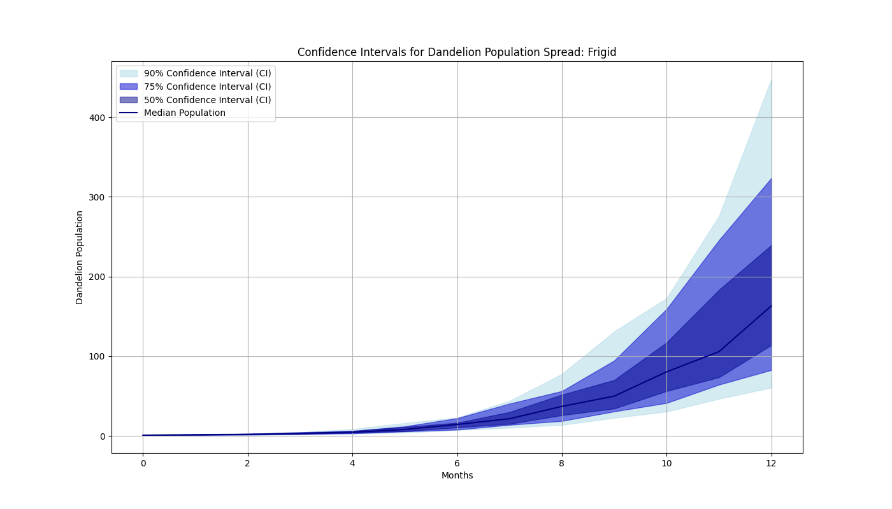

Raw Results

|  |  |  |  |  |
| --- | --- | --- | --- | --- |
| Month | Median | 90% CI | 75%CI | 50%CI |
| 1 | 1.64 | [1.21, 1.64] | [1.21, 1.64] | [1.21, 1.64] |
| 2 | 1.99 | [1.47, 2.69] | [1.47, 2.69] | [1.47, 2.69] |
| 3 | 3.44 | [1.83, 4.67] | [2.47, 4.66] | [2.54, 3.45] |
| 6 | 14.84 | [7.46, 23.12] | [7.92, 22.40] | [10.72, 21.16] |
| 12 | 163.90 | [63.96, 450.42] | [84.60, 324.61] | [114.77, 240.90] |

Processed Results (Rounded to the nearest integer)

|  |  |  |  |  |
| --- | --- | --- | --- | --- |
| Month | Median | 90% CI | 75%CI | 50%CI |
| 1 | 2 | [1, 2] | [1, 2] | [1, 2] |
| 2 | 2 | [1, 3] | [1, 3] | [1, 3] |
| 3 | 4 | [2, 5] | [2, 5] | [3, 3] |
| 6 | 15 | [7, 23] | [8, 22] | [11, 21] |
| 12 | 164 | [64, 450] | [85, 323] | [115, 241] |

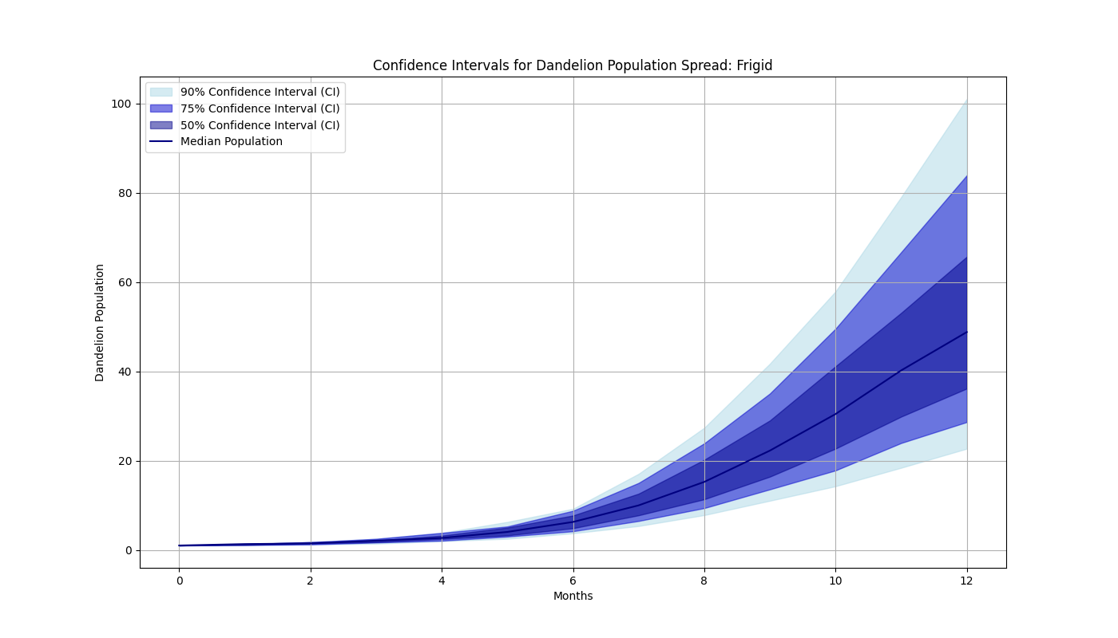

Raw Results

|  |  |  |  |  |
| --- | --- | --- | --- | --- |
| Month | Median | 90% CI | 75%CI | 50%CI |
| 1 | 1.32 | [1.11, 1.32] | [1.11, 1.32] | [1.11, 1.32] |
| 2 | 1.46 | [1.23, 1.75] | [1.23, 1.75] | [1.46, 1.74] |
| 3 | 2.08 | [1.40, 2.49] | [1.67, 2.49] | [1.75, 2.09] |
| 6 | 6.27 | [3.73, 9.21] | [4.18, 8.77] | [4.86, 7.71] |
| 12 | 48.79 | [22.67, 101.00] | [28.64, 83.91] | [36.14, 65.67] |

Processed Results (Rounded to the nearest integer)

|  |  |  |  |  |
| --- | --- | --- | --- | --- |
| Month | Median | 90% CI | 75%CI | 50%CI |
| 1 | 1 | [1, 1] | [1, 1] | [1, 1] |
| 2 | 1 | [1, 2] | [1, 2] | [1, 2] |
| 3 | 2 | [1, 3] | [2, 3] | [2, 2] |
| 6 | 6 | [4, 9] | [4, 9] | [5, 7] |
| 12 | 49 | [23, 101] | [29, 84] | [36, 66] |

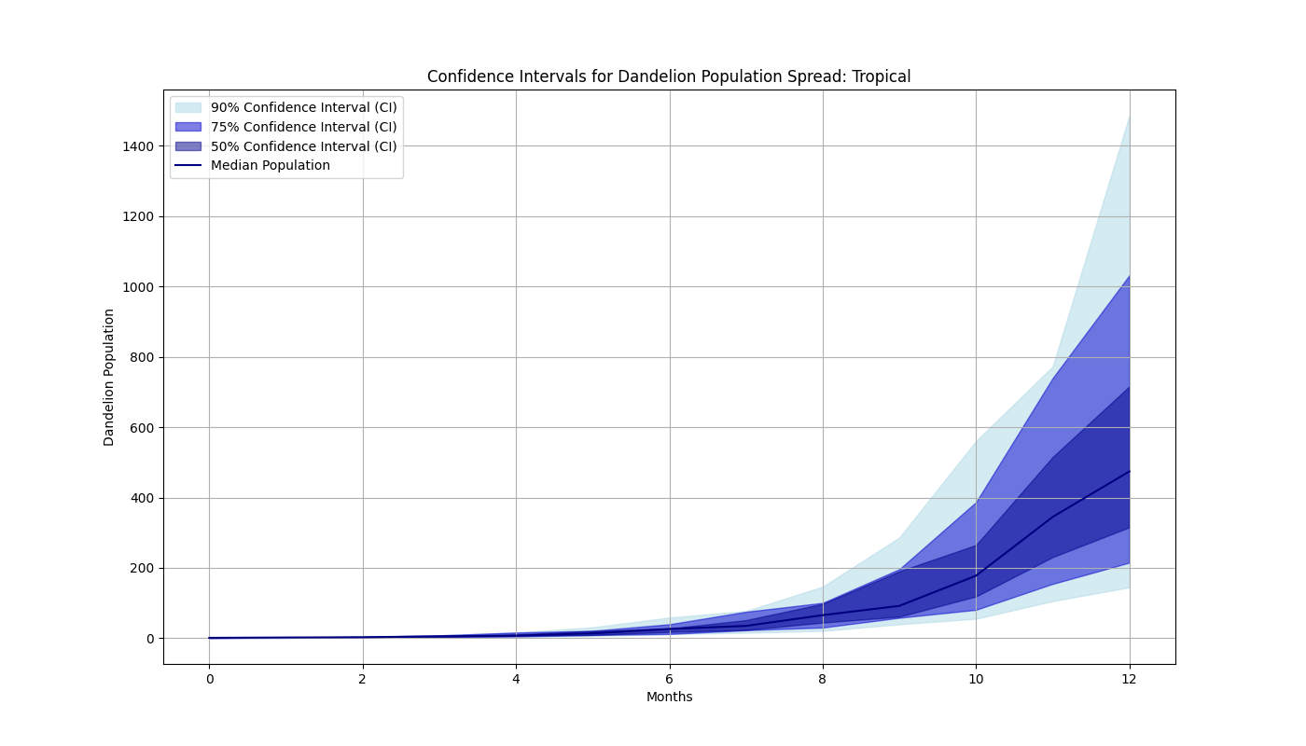

Raw Results

|  |  |  |  |  |
| --- | --- | --- | --- | --- |
| Month | Median | 90% CI | 75%CI | 50%CI |
| 1 | 2.00 | [1.13, 2.01] | [1.33, 2.01] | [1.34, 2.01] |
| 2 | 2.68 | [1.78, 4.03] | [1.78, 4.03] | [2.67, 4.02] |
| 3 | 5.35 | [2,38, 8.09] | [3.56, 8.06] | [3.58, 5.38] |
| 6 | 26.19 | [11.66, 58.67] | [11.94, 39.65] | [17.79, 27.59] |
| 12 | 474.35 | [144.70, 1485.97] | [214.92, 1032.10] | [315.49, 716.07] |

Processed Results (Rounded to the nearest integer)

|  |  |  |  |  |
| --- | --- | --- | --- | --- |
| Month | Median | 90% CI | 75%CI | 50%CI |
| 1 | 2 | [1, 2] | [1, 2] | [1, 2] |
| 2 | 3 | [2, 4] | [2, 4] | [3, 4] |
| 3 | 5 | [2, 8] | [4, 8] | [4, 5] |
| 6 | 26 | [12, 59] | [12, 40] | [18, 28] |
| 12 | 474 | [145, 1486] | [215, 1032] | [315, 716] |

We conducted simulation experiments using a probabilistic forecasting approach, with each scenario simulated 100,000 times (Computer Configuration: CPU: 13th Gen Intel(R) Core(TM) i7-13700KF; RAM: 128GB 4000Mhz). We did not consider whether the results in the model are integers. Since the number of plants must be integers, we processed the results by rounding them. In each prediction, humidity and competition environment were randomly selected and combined. The large number of random simulations allows the model to cover a wide range of possible humidity and competition levels that may occur, thereby enabling the prediction results to encompass various natural environments without specifying precise humidity and competition values.

Our results indicate that the temperate environment provides moderate conditions for dandelions to grow steadily, but there is no occurrence of rapid expansion at a particular time point. The frigid environment exhibits limitations on dandelion propagation. The tropical environment offers relatively favorable growth conditions for dandelions and has the potential for rapid expansion once dandelion populations reach a certain threshold. Additionally, within each temperature zone, the range of population numbers that may occur at different times is extensive. This phenomenon is due to the outcomes of different combinations of competition conditions and humidity levels. If humidity is suitable and the competition level is just right for dandelion development, their numbers can experience significant growth.