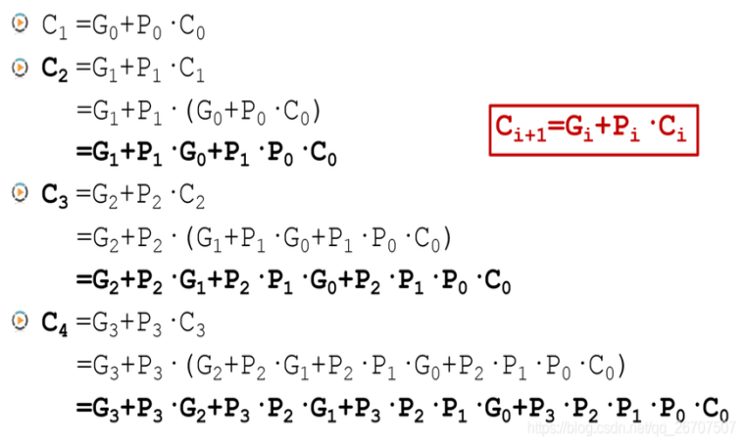

半加器真值表

|  |  |  |  |
| --- | --- | --- | --- |
| A | B | S | C |
| 0 | 0 | 0 | 0 |
| 0 | 1 | 1 | 0 |
| 1 | 0 | 1 | 0 |
| 1 | 1 | 0 | 1 |

半加器结果 $S = A⊕B, C = AB$

全加器真值表

|  |  |  |  |  |
| --- | --- | --- | --- | --- |
| A | B | C | S | Co |
| 0 | 0 | 0 | 0 | 0 |
| 0 | 0 | 1 | 1 | 0 |
| 0 | 1 | 0 | 1 | 0 |
| 0 | 1 | 1 | 0 | 1 |
| 1 | 0 | 0 | 1 | 0 |
| 1 | 0 | 1 | 0 | 1 |
| 1 | 1 | 0 | 0 | 1 |
| 1 | 1 | 1 | 1 | 1 |

全加器结果 $S = A ⊕B ⊕ C ,Co=AB+AC+BC$

not真值表

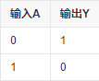

and真值表

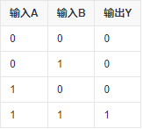

or真值表

