

eZ Publish examen extension

User Guide

version 0.1-ENG

1 Introduction
The examen extension makes it possible to create a wide variety of exams with conditional elements to add or remove exam questions or groups of questions depending on an answer to a question. Other options will allow the questions to appear in random order and determine what kind of information is displayed on the results page.

There are essentially three different types of exams that are possible, which will be automatically determined:

Survey – one question, multiple answers, no result statistics. This will only show a graph of the percentage of respondents to a particular question with the total counts for each answer and each question.

Simple test – Less than 10 questions, no conditions and no page breaks. All of the questions will be displayed on the same page and the entire exam is submitted in one go.

Complicated test – This is an exam with more than 10 questions, at least one condition or with pagebreaks. This will display as many questions as possible on one page depending on whether or not a pagebreak is hit (or the 10 question limit). The complicated test can not be displayed in random order (although randomness can be set on a group level). Note that this starts by displaying the contents of the introduction attribute and the first question(s) is/are not displayed until the testee presses submit on that page.

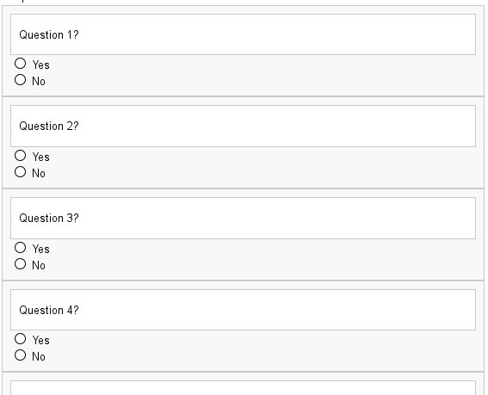

2 Creating an Exam
To create an exam select the exam class from the “Create new” drop-down on the backend:
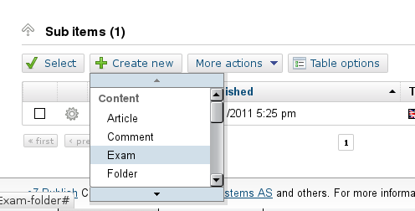
The title and the intro attributes are required. These are the fields that will be displayed in the line view of a search result depending on how your system is set up. The intro attribute will also be displayed above the first question for a simple exam or survey and on the first page before an the first question for a complicated exam.

There are several options that determine how the exam will be displayed or how the results will be displayed:

- Mode – This will allow customized results (nice mode). This will need templates to be created for each mode. This is really for advanced users and will require additional template work. See the section titled “Using Mode”

- Start Date – This is date at which people can start taking the exam.

- End Date – This is the date at which people can no longer take the exam.

- Random – If the exam has no conditions or page breaks, then the order in which the elements (questions,groups,text) are displayed will be in random order. Beware that this may not be what you want if there is a text block involved.

- Retest – allows testees to retake the exam once if they do not pass the first time around.

- Show Correct Answers – this shows the correct answers on the results page.

- Save results – If this is not set, statistics will not be saved.

- Statistics – If this is not set the average and high scores will not be displayed.

- Pass threshold – If this is not set, it is assumed that the object is a survey.

Note: While editing an exam there will be no error checking for the sanity of the exam elements as long as only drafts are saved. When the object is published, then error checking will be enforced and an exam will not be published until all the issues have been dealt with. Such as, an exam must have at least one question and each question must have at least two answers, an exam with a pass threshold must have one (and only one) correct answer set for each answer.

3 Exam Elements
There are four elements that can be added to an exam for the “Exam attributes” attribute. These are the elements that make up the exam – a question, a text field, a group and a pagebreak. The following buttons on the edit page can be used to add elements (the last button is used to update the priority to determine the order):
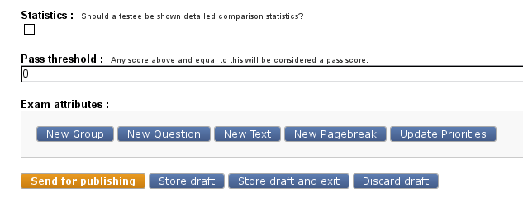
Each of the elements – depending on the type will also have a button to remove the element, set randomness or change the order of the elements. Note: priority works on a group level so that an element cannot be prioritized out of a group.

Group:
A group will allow multiple questions to be asked as a distinct unit – such as if you have a verbal section of an exam and then a math section of an exam. Each section can be its own group and those questions will be asked as a group. If the random object attribute is checked, then the order in which the groups are displayed will be random (as long as this is not overridden by conditions). If the random element attribute is checked then the elements that are members of the group will be displayed randomly – but only if there are no pagebreaks in the group. Also be careful with text elements and random – since a text element will also be displayed randomly unless it is a condition – which is usually not desirable.

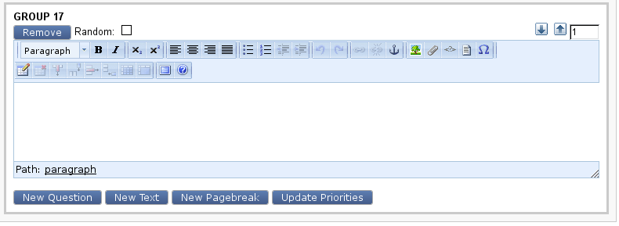
Elements – question, text and pagebreak – can be added to a group using the buttons at the bottom of the group box. The text area of a group (if it contains content) will be displayed above the first question of the group on the front end.
Question:
The backbone of any exam is of course the questions. The random checkbox here determines whether or not the answers to the question will be displayed randomly. Take note, when entering the exam do not have the correct answers always in the same position (i.e. on top) because a clever test taker could then determine that pattern by looking at the input fields of the form – as in, if the correct answers are always on top, they will always have the smallest number.

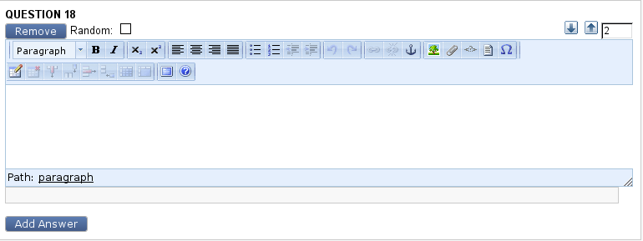
To add answers use the “Add Answers” button on the bottom of a question:
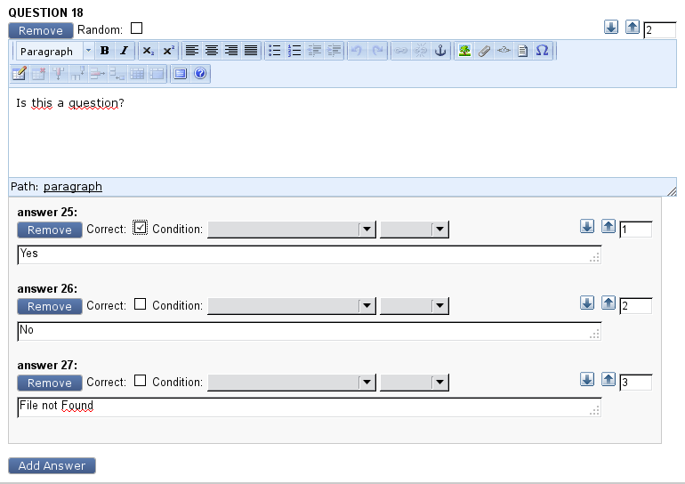
Answers can trigger conditions determining the content of the exam. See the “Answer Conditions” section for more information. Note: the question text field is a xmlblock field, but the answer text field is a textblock. There can be but one correct answer.
Text:
A text block is to add information fields that will be displayed between answers (as long as the exam is not random) or displayed depending on the conditions of an answer. A text block can also be displayed in the results as a condition – which is useful to add a link or more information for a user depending on how they answered a question.
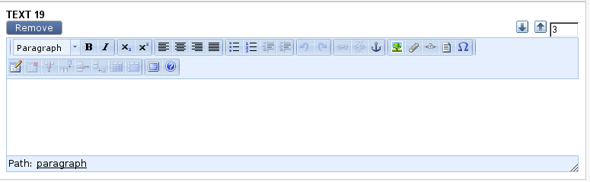
Pagebreak:
A pagebreak is only useful for an exam that is not random and if a pagebreak is present (and not the last element of the exam) this will override the random object attribute. It allows the format for the exam to be determined exactly – such as if you want three questions on one page and then one question on another page and then two questions on yet another page, this can be done with well-placed pagebreaks.

4 Answer conditions

The conditions of an answer is determined by two drop-downs available for each answer – one to choose the type of condition

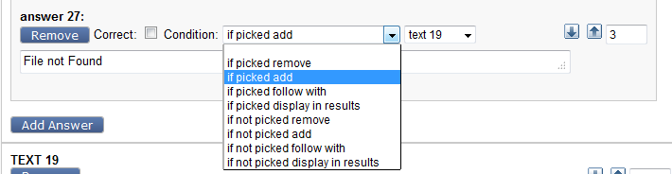

and the second to choose the element that the condition applies to:
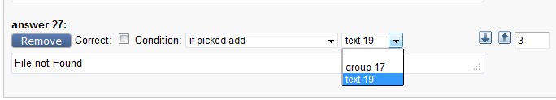

These are the available condition types:

- If [not] picked remove – when this condition is met, the element is removed from the exam if it hasn't already been displayed.
- If [not] picked add – when this condition is met, the element is added to the exam. It will not be a part of the exam unless the condition is met.
- If [not] picked follow with – when this condition is met, the element order is rearranged so that the element is the next to be displayed. Overrides random on the object or group level.
- If [not] picked display in results – when this condition is met, the element is displayed as part of the results. This applies to text elements only.

Note: The element drop-down list will display all available elements – the sanity of the choices in combination will not be checked until the exam object is published – which means it is possible to choose an incorrect element. Such as, if the condition is “display in results” it should only apply to text elements, this will not be checked until publish.

5 Condition example

Here is an example of a text element (Text 19) being added to an exam if an answer (answer 27) is chosen:

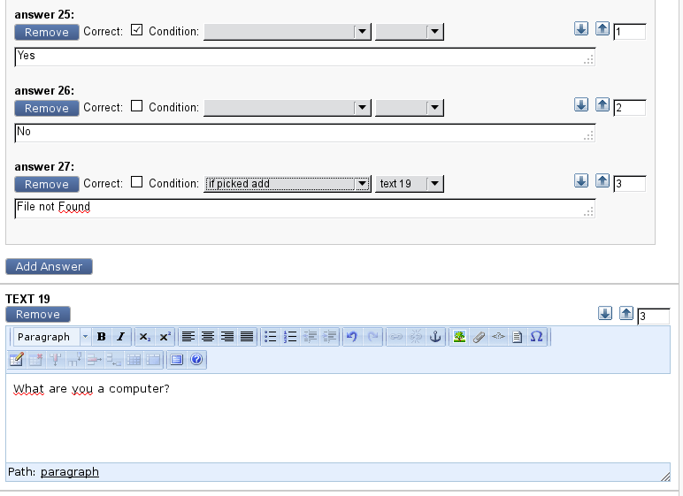

5 Results

When you have completed an exam, depending on the exam attribute selections, you will see something like this:

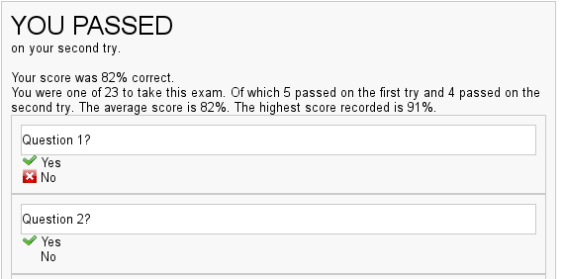
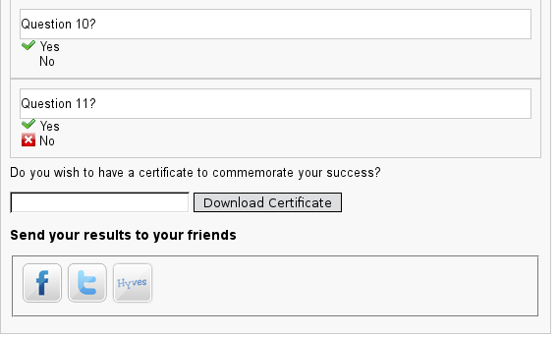

Or if the testee did not score higher than the pass threshold attribute, depending on the options, this will be displayed:

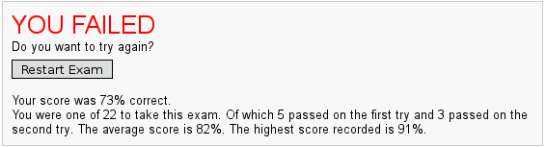

A survey will have a different output:

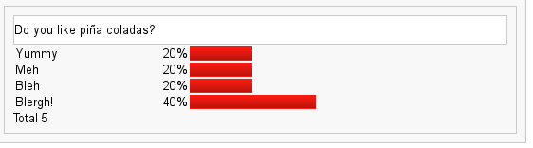

7 Backend Administration tab

On the backend, an additional tab has been added to aid in administering the exam objects. Going to this tab will display an overview of all exams:

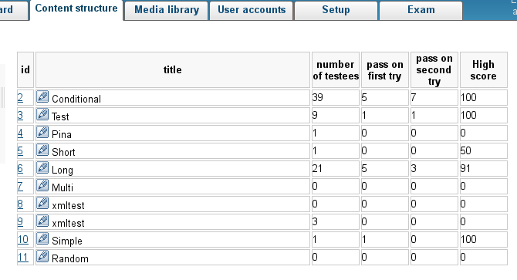
Clicking the link of the exam number will show the detailed statistics of an exam:

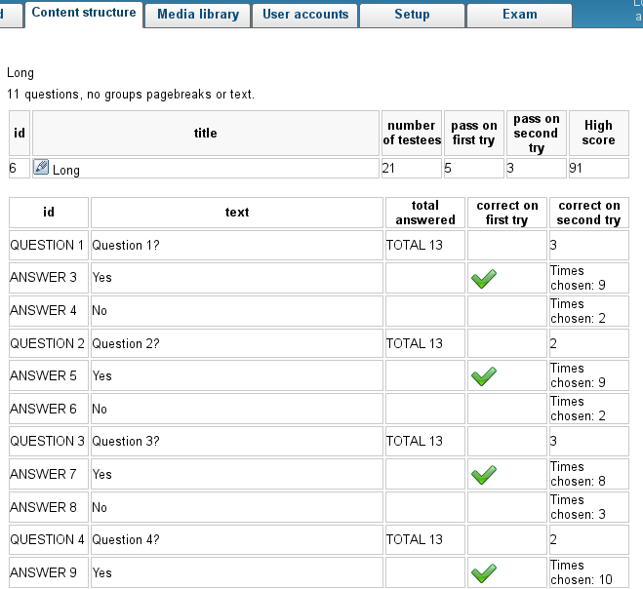

8 Using Mode
To use the special mode attribute requires command-line access and edit ability to create a set of templates different from the default set. These templates will have to be created in the extension/examen/design/standard/templates/examen/results directory. This directory must be the same name as the mode entered in the text field for the attribute. The templates in this directory will be used instead of those that are in the results/default directory.

Appendix A Installation

- Unpack the archive and place the 'examen' folder in the
'extension' folder.

- Open /settings/override/site.ini.append.php and add the examen
extension to the list of active extensions.

[ExtensionSettings]
ActiveExtensions[]=examen
- run the php/bin/ezpgenerateautoloads.php -e script or regenerate the autoloads from the backend.
- Load the new database tables. Go to extension/examen/msyql

Appendix B Criteria
• Completely in eZ Publish
• Simple edit interface anyone with the bare minimum of eZ Publish knowledge should be able to set up an exam.
• Old exams should be always be available. Results should be simple and should be available on the site.
• The exam should have a re-exam option.
• There should be no minimum or maximum number of questions.
• Questions should be able to be grouped and should be able to be displayed randomly by group.
• Questions and answers should be optionally displayed randomly.
• Answers should have the option of a condition.
• Pagebreaks should be available for a group.
• Questions and textblocks should be xmlfields to allow rich text.
• Questions should be able to be added or removed depending on conditions.
• At the end of the exam if the testee scored better than the pass threshold, the option of a downloadable certificate should be available.
• The testee should optionally be able to see the correct answers for the answers that the got wrong.
• The score of a testee should optionally be comparable to the other test takers (average score, high score)
• Each exam should store detailed statistics which should optionally be available to the testee.
• If the score is lower than the pass threshold, and sorry message will be displayed and the option to retake the test – if that option is available. The results of the first and second tries should be collated separately.
• The testee should be able to optionally upload the results to social media sites. (Twitter, Facebook, Hyves).

