Title of the Document

<XYZ Project Functional Specification Document>
Author: <Ian.su>
Last Updated: <2015-03-05-11:04>

Document History
Date | Author | Summary of Change | Note
<Table of Contents>

Overview 4
Use Case Diagrams 4
Use Case Scenarios 5
UC001 <Create IT Request> 5
Non-functional Requirements 6
System Installation Requirements 6
Runtime Requirements 7
I18N and L10N Requirements 7
Documentation Requirements 7
Other Non-functional Requirement 7

Overview
At present ，because of the examination need to spend a lot of manpower to prepare papers and consume a large amount of paper.
Rearranging examination's room will take a lot of time.
The correction of examination paper will take a large part of the teacher's time.
Now more and more people have own computer, tests will be carried out in a computer.

Use Case Diagrams

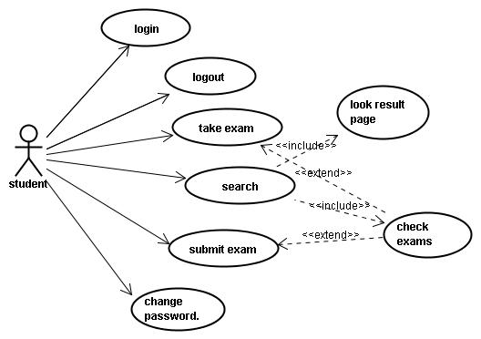

Use case id | Use case name
UC001 | login

Use Case Scenarios

UC001 <Create IT Request>
Brief: User user name and password to log in

Actor: student,teacher,SysAdmin,ContentAdmin

Pre-condition: There is a engineer logged in system successfully

Mock Up UI:
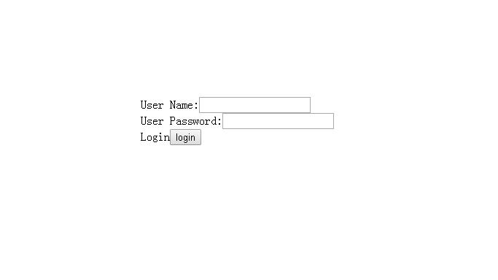
Diagram 1

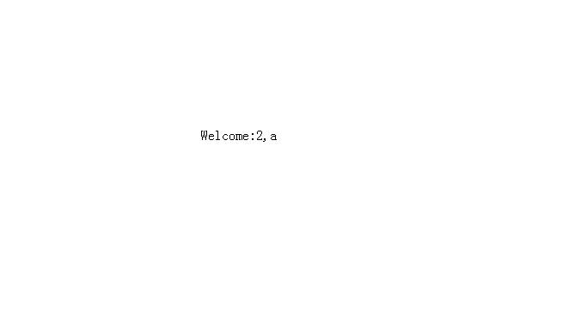
Diagram 2

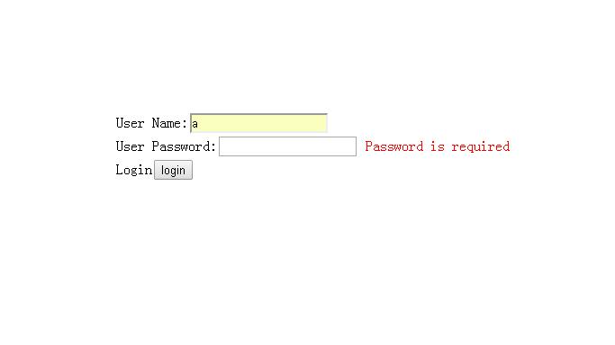

Diagram 3

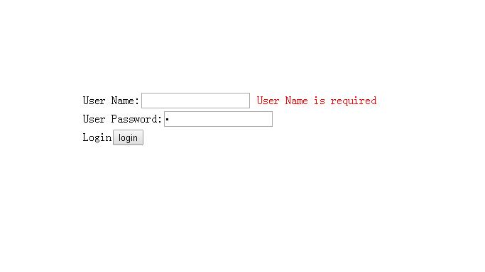

Diagram 4

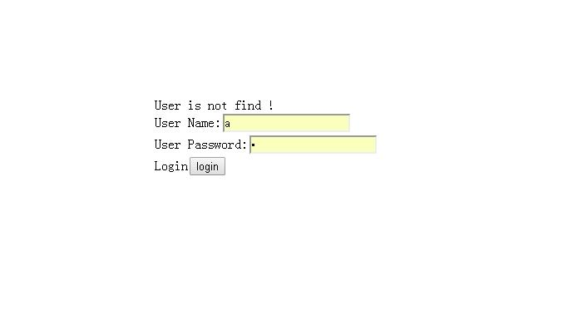

Diagram 5

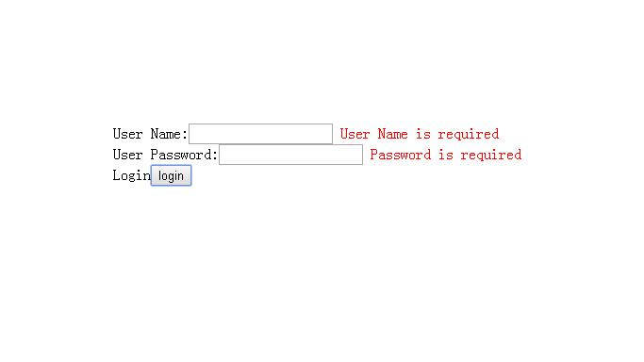
Diagram 6

General Workflow:

User Operation | System Response
1: User open webpage | 2:System open Diagram 1
3: User write name and password | 4:Verifying user name and password  4.1:verification succeeded  Diagram 2  4.2:Input password error  Diagram 5  4.3:Input name error  Diagram 5
5 User not write name and password | 6:Verifying user name and password  6.1:verification not succeeded  Diagram 6
7: User not write name but write password | 8:Verifying user name and password  8.1:verification not succeeded  Diagram 3
9: User write name but not write password | 10:Verifying user name and password  10.1:verification not succeeded  Diagram 4
Comment:
validate data
please describe validate data rule

Non-functional Requirements
Each requirement should have unique ID for cross reference purposes (NFR0001, NFR0002, etc.)

System Installation Requirements
NFR0001. Hard Disk: 512M
NFR0002. CPU: 1.7ghz single core.
NFR0003. Support platform: windows ,Linux

Runtime Requirements
NFR0004. Java runtime environment.
NFR0005. RAM:1GB
NFR0006. Hard Disk:256M

I18N and L10N Requirements
NFR0007. Support language: Chinese, English.

Documentation Requirements
What does this component require from the Technical Publication team?
Does this require a user manual, samples, reference manual, quick start guide, online help, context sensitive help, etc.?

Other Non-functional Requirement
You can add section here to describe what you think is necessary here. Such as security requirements, performance requirements, legal requirements, industry protocol/standard, etc.

