项目背景与目的
背景介绍：本公司（PX Analytiks）是一家专注于帮助企业与机构成功管理项目（Project Management）、变革计划（Change Initiatives）及数字化转型（Digital Transformations）的咨询公司。根据国际项目管理协会（PMI）的研究表明，仅有30%的项目能够被成功交付。本研究采用以数据驱动（Data-driven）的市场调研方式，聚焦于英国政府认可的九家Tier 1银行在进行数字化转型项目时，相关科技岗位员工在公开招聘点评网站Glassdoor上发布的公司评价信息，尤其关注员工反馈中的正面（Pros）与负面（Cons）评价。
分析目标：通过分析上述科技岗位员工的Glassdoor公开评价数据，挖掘银行业数字化转型过程中员工体验的关键洞察，以独特的分析视角吸引银行系统的高层管理者对本公司服务的关注和兴趣，从而促成进一步的业务合作与交流。
九大Tier 1 银行：
Santander UK, Danske Bank UK, Nationwide, HSBC (UK), Lloyds Banking Group, JP Morgan, Morgan Stanley, Deutsche Bank, Citigroup
相关技术岗位人员（职位&关键词）：
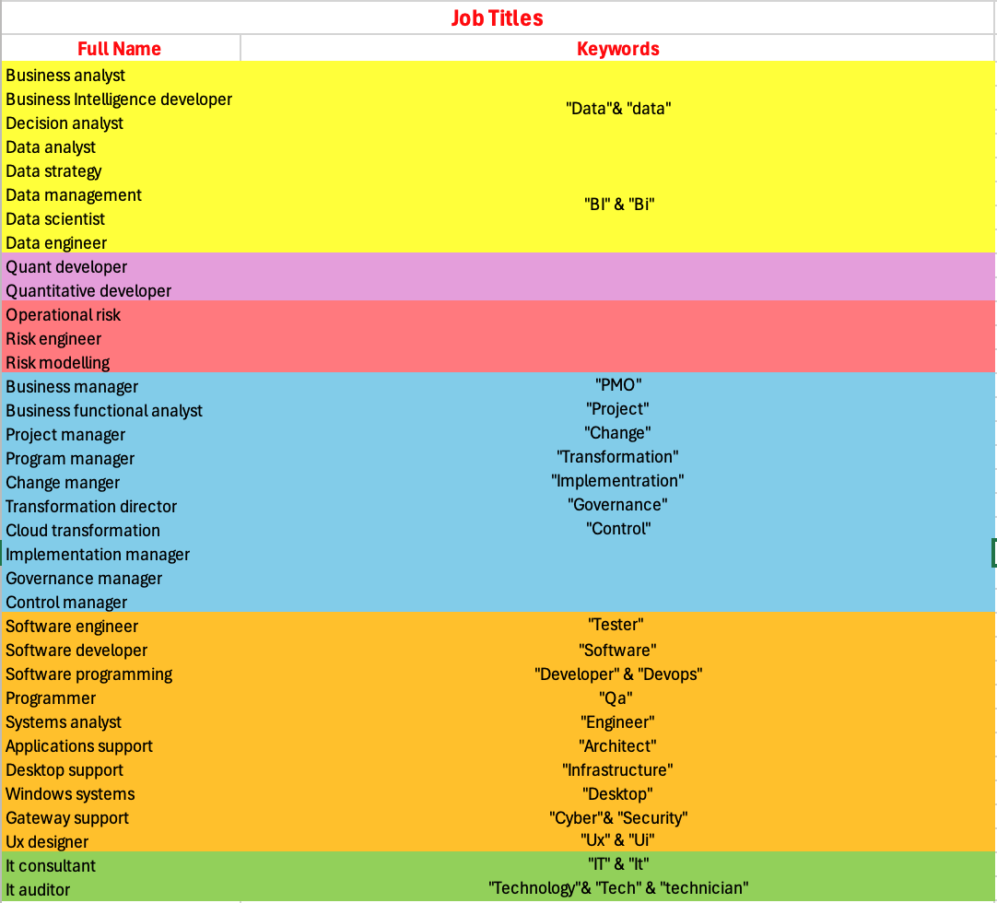

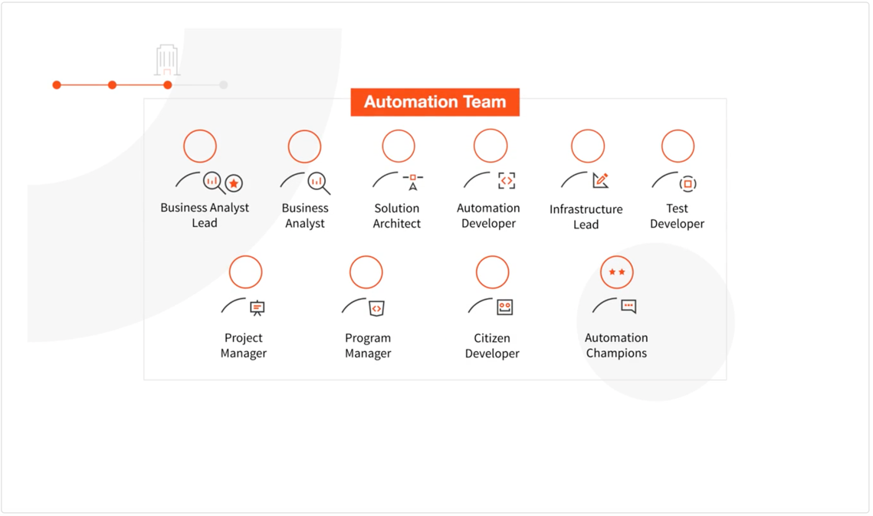

数据理解
数据来源：通过外部技术人员扒取Glassdoor网站评论底层信息，进而形成数据库。
数据概述（研究潜在重点变量已用红笔注明）：
Variable Name | Description | Variable Name after Change
companyId | 银行ID
companyName | 银行名称
companySize | 银行规模
companyUrl | 银行官网网页链接
companyLocation | 银行总部地址
com_user_id | 留言用户 ID
reviewDateTime | 用户留言时间
jobTitle | 留言用户具体岗位名称
isCurrentJob | 是否为 current employee（T/F）
LengthOfEmployment | 在该银行就职时间（年份）
EmploymentStatus | 职位信息（全职regular/ part time）
location | 用户地址（城市，大部分缺失国家）
ratingOverall | 评价：Overall（0-5）
ratingWorkLifeBalance | 评价：Work-Life Balance （0-5）
ratingCultureAndValues | 评价：Culture & Values （0-5）
ratingDiversityAndInclusion | 评价：Diversity & Inclusion（0-5）
ratingCareerOpportunities | 评价：Career Opportunities （0-5）
ratingCompensationAndBenefits | 评价：Compensation & Benefits （0-5）
ratingSeniorLeadership | 评价：管理层（0-5）
summary | 用户留言标题
advice | 给银行的建议
pros | 相关优点
cons | 相关缺点
ratingRecommendToFriend | 评价：是否推荐亲友就职该银行
ratingCeo | 评价：CEO
ratingBusinessOutlook | 评价：商业前景
countHelpful | 留言评论有帮助
countNotHelpful | 留言评论无帮助

数据初步探索（初步可视化想法）：
- 地理位置分布的世界地图，类似下图（或考虑点状Bubble）：
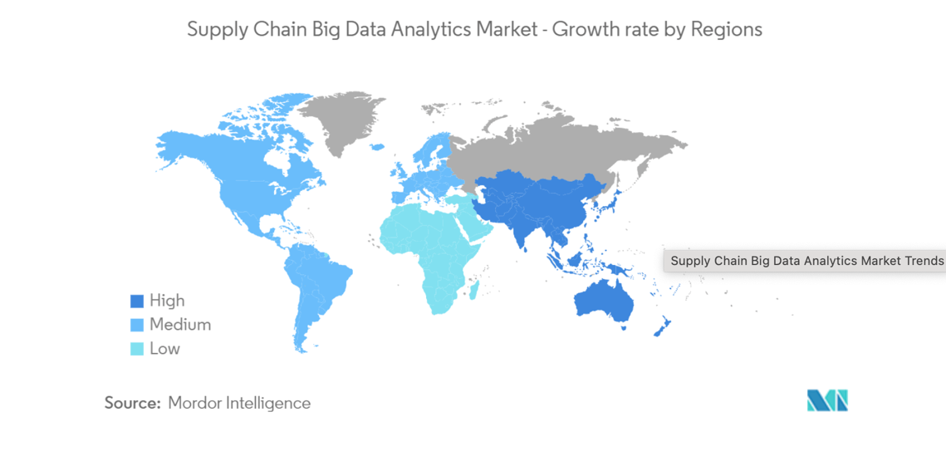
(Source: https://www.mordorintelligence.com/industry-reports/global-supply-chain-big-data-analytics-market-industry)

- Review Time 的时间轴分析（柱状/直线）：注意英国金融监管机构FCA成立于2013.04.01 – 可引入此事件前后对比！
- 大量运用饼状图反应比例（%）--显示独特视角！

数据清洗与准备
数据清洗：
- 首先将九家银行分别的CSV 文件合并
- 合并后筛选保留科技相关岗位
- 后续导入 Power BI，初步通过 Power Query Editor及Transform，完成数据清洗
特征构建：
- 针对 pros & cons 的分类 （ 初步检索：大组 ->小组 -- 关键词！）

Main Category | Sub-category | Keyword
People & Leadership | Leadership | leadership, CEO, CTO, executives, vision, inspiring, transparency, trustworthy, top management, senior management, strategic direction, executive decisions, C-suite, board of directors, corporate governance, decision-making, accountability, executive communication, roadmap, transformational leadership
 | Management | manager, supervisor, supportive, micromanagement, competence, fairness, line manager, direct supervisor, management style, manager feedback, Agile, Scrum, sprint planning, backlog prioritization, one-on-ones, performance reviews, delegation, empowerment, team alignment
 | Communication | communication, transparent, openness, clarity, information sharing, updates, announcements, listen, clear goals, effective communication, town halls, all-hands meetings, Slack/Teams culture, feedback loops, miscommunication, siloed communication
 | Team Collaboration | teamwork, collaboration, colleagues, peers, cooperation, team-oriented, support from team, camaraderie, team dynamics, cross-department, cross-functional, pair programming, code reviews, knowledge sharing, interdepartmental friction
 | Mentorship | mentorship, guidance, career coaching, advice, senior-junior relationship, mentor, career guidance, coaching, support from seniors, sponsorship, upskilling, shadowing, career pathing, junior developers
 | Employee Morale | morale, enthusiasm, motivation, engagement, employee satisfaction, happy employees, morale boost, employee spirit, energized, burnout culture, disengagement, apathy, toxic positivity
Work Environment | Company Culture | culture, inclusive, supportive environment, company values, diversity, respectful environment, ethics, values alignment, workplace atmosphere, friendly culture, psychological safety, code of conduct, clique culture, hierarchy, bureaucracy, innovation culture
 | Work-Life Balance | work-life balance, flexible hours, overtime, workload management, burnout, balance, manageable hours, flexible schedule, work-life harmony, crunch time, on-call rotations, weekend work, time-off approval, PTO usage
 | Safety & Wellbeing | safe workplace, psychological safety, physical safety, harassment, bullying, wellbeing, mental health, stress management, safety policy, cybersecurity fatigue, breach anxiety, compliance fatigue, ergonomic injuries
 | Physical Workspace | office environment, amenities, comfortable workspace, ergonomics, cleanliness, office facilities, workspace, noise level, office setup, open-plan offices, cubicles, breakout rooms, tech labs, server rooms
 | Remote Work & Flexibility | remote, hybrid, work-from-home, flexible arrangements, remote support, telecommute, virtual collaboration, home-office setup, VPN access, timezone challenges, digital nomad policies, remote stipends
 | Tools & Technology | tools, technology, software, hardware, IT support, innovation, resources, system reliability, technological infrastructure, digital solutions, legacy systems, mainframe, cloud migration, APIs, DevOps tools, outdated software, tech debt
Job & Career | Role Satisfaction | role, satisfaction, meaningful work, role clarity, responsibilities, enjoyable tasks, interesting role, fulfilling, job satisfaction, tech stack, greenfield projects, repetitive tasks, stagnation
 | Workload | workload, busy, overwhelmed, manageable workload, understaffed, workload intensity, heavy workload, task overload, stress, long hours, sprint deadlines, production incidents, firefighting, technical debt
 | Career Growth | promotion, career opportunities, advancement, internal mobility, career path, upward mobility, progression, internal promotion, growth potential, lateral moves, leadership tracks, IC (individual contributor) path
 | Learning & Development | training, development, learning opportunities, workshops, certifications, skill-building, courses, personal growth, professional development, learning environment, AWS/GCP certifications, CISSP, CFA, hackathons, conference budgets
 | Job Stability | job security, layoffs, stable employment, employment stability, downsizing, uncertainty, secure position, long-term employment, restructuring, mergers, acquisitions, outsourcing, offshoring
 | Autonomy | autonomy, independence, freedom, empowerment, decision-making freedom, self-directed, creativity allowed, ownership, self-management, micromanagement, approval chains, red tape
Compensation & Benefits | Salary | salary, pay, compensation, remuneration, wages, competitive pay, income, pay level, salary increase, bonus, pay equity, gender pay gap, location-adjusted pay
 | Pay Transparency | pay transparency, salary openness, clear pay structure, fairness in pay, salary discussions, wage equity, pay fairness, salary bands, pay secrecy
 | Health & Wellness Benefits | healthcare, medical insurance, wellness, mental health support, benefits, insurance coverage, wellbeing initiatives, employee assistance, telehealth, gym subsidies, counseling, stress leave
 | Retirement & Financial Incentives | retirement, pension, 401(k), savings plan, financial incentives, stocks, equity options, profit sharing, retirement contributions, financial security, ESPP (employee stock purchase plan), RSUs (restricted stock units)
 | Perks & Employee Recognition | perks, benefits package, gym, free meals, discounts, recognition programs, rewards, incentives, appreciation, recognition awards, spot bonuses, anniversary awards, referral bonuses
Company Operations | Processes & Systems | processes, systems, procedures, bureaucracy, efficiency, workflows, red tape, process improvement, operational efficiency, smooth operations, Agile ceremonies, Jira/Confluence, ticketing systems, CI/CD pipelines
 | Innovation & Adaptability | innovation, adaptability, change management, forward-thinking, openness to new ideas, agile, market responsiveness, flexible, innovative thinking, fintech partnerships, blockchain, AI/ML adoption, proof-of-concept projects
 | Company Stability | stability, financial health, secure company, growth trajectory, profitability, layoffs, bankruptcy, growth opportunities, market strength, funding rounds, IPO readiness, credit rating
 | Transparency & Communication | transparency, open communication, honesty, internal communications, clear messaging, openness, informed employees, updates, accountability, earnings calls, investor relations, rumor mill
 | Decision-Making Efficiency | decision-making, bureaucracy, approval speed, agile decision-making, internal politics, responsiveness, quick decisions, decision clarity, stakeholder alignment, consensus-building
Ethics & Responsibility | Integrity & Ethics | integrity, ethics, ethical, honesty, trustworthy, fairness, corporate integrity, moral standards, ethical issues, misconduct, whistleblowing, conflicts of interest, insider trading, bribery
 | Corporate Social Responsibility (CSR) | CSR, sustainability, social responsibility, community engagement, environmental initiatives, philanthropy, charitable work, responsible sourcing, ESG (environmental, social, governance), carbon footprint, green banking
 | Legal Compliance | compliance, regulatory, legal issues, adherence to laws, ethical compliance, regulations, legal standards, lawful practices, ethical guidelines, GDPR, SOX, Basel III, KYC (Know Your Customer), AML (Anti-Money Laundering), Dodd-Frank, MiFID II
Recruitment & Exit | Hiring & Onboarding | hiring, recruitment process, interview experience, onboarding, training new hires, new employee integration, recruiting practices, joining process, first impressions, technical interviews, coding tests, case studies, background checks, offer letters
 | Exit Experience | exit interview, offboarding, leaving the company, resignation process, departing employee, layoff handling, termination process, final impressions, separation, non-compete clauses, severance packages, alumni networks

数据转换：
- 针对isCurrentJob：在源数据库中，此栏内容为 True / False，不便于未来的数据库展示，改为：Current/ Former
- 针对LengthOfEmployment：在源数据库中，此LengthOfEmployment 包含 0，1，3，5，8，20，这些数字信息与 Glassdoor Review 相关信息不符，所以采用以下代码进行转换：
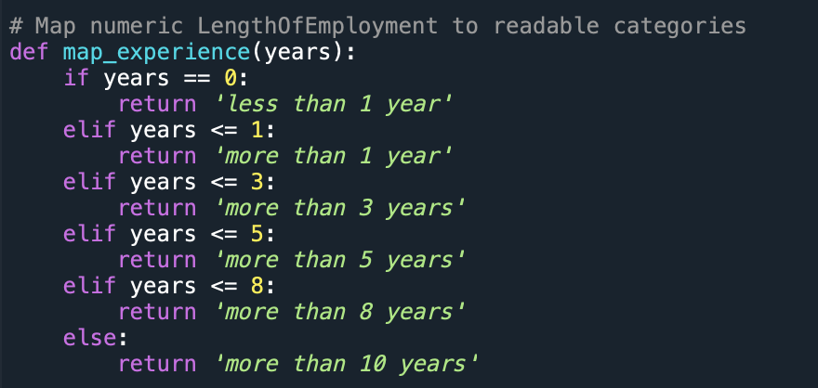

初步分析方案
1. 综合情绪倾向识别（Sentiment Orientation）
在完成对 pros 与 cons 字段的关键词主题匹配后，进一步对每条评论中出现的正面标签数与负面标签数进行比较，以识别员工对所在银行的总体主观态度。具体分类规则如下：
- 若正面标签数量 > 负面标签数量，则判定为 Positive
- 若正面标签数量 < 负面标签数量，则判定为 Negative
- 若正负标签数量相等，则判定为 Neutral
该结果将记录在新增结构化字段 Sentiment Orientation 中，用于后续的情绪结构分析、群体差异提取、可视化展示等环节。该方法在不进行复杂情感建模的前提下，仍可实现对员工满意度的初步分类与趋势分析。

2. 公司维度
- 公司关注度分析：统计各公司在样本中的点评数量
- 公司评分表现：按银行名称（companyName）分组，计算整体情绪倾向识别（Sentiment Orientation ）均值，揭示各银行在员工体验层面的相对优势与短板

3. 时间维度
- 点评量趋势分析：将reviewDateTime转换为日期格式，观察季度/年度维度上的点评数量变化，评估员工关注度随时间的波动（每年年初1至3月，金融忙季，或许点评数量会在该时段有小幅度井喷？）
- 时间段评分对比：比较不同时期员工对银行Sentiment Orientation 的均值，探索银行管理与员工满意度的演化特征。

4. 职位维度
- 岗位热度分析：按岗位名称（jobTitle）分组，统计点评数量，识别员工关注集中的技术岗位。
- 岗位满意度分析：分析不同岗位在Sentiment Orientation 上的评分差异，判断哪些岗位群体满意度更高或更低。

5. 任职情况维度
- 当前与离职员工对比：分析isCurrentJob字段中 True/False 占比，以及两者在评分维度上的差异，揭示潜在离职原因或组织管理问题。
- 任职时间影响：将LengthOfEmployment进行分组，探讨员工工龄与其评分之间的关联关系。

6. 地点维度
- 地理分布可视化：利用location字段中的城市信息构建全球分布地图（如气泡图或热力图），直观呈现各地技术员工对银行的关注与评价密度。
- 地区评分差异分析：基于可提取的国家或城市层级，进一步分析不同地理区域在员工满意度或情绪倾向方面的差异，为跨地域转型项目管理提供参照。

预期成果
- 数据看板
- 相关报告的攥写
- 处理好的数据库 （数据库后期可能会公开，column名称/内容需要清晰明了）

