Project Report

Fun Fair Ticket & Ride Management System

Submitted by
Sami Ullah
BBIS-22-35
Session 2022 – 2026

Supervised by
Umair Waqas



Department of Business Administration,
University of Sahiwal, Sahiwal

Fun Fair Ticket & Ride Management System

A project submitted to the

Department of Business Administration

In

Partial fulfillment of the requirements for the degree of Bachelor of Business Information Systems (BBIS).

By

Sami Ullah
BBIS-22-35

Internal Supervisor
Mr. Umair Waqas |  | _______________________
Lecturer
Department of Business Administration

External Examiner
___________________

Chairperson
Dr. Waris Ali |  | _______________________
Chairperson,
Department of Business Administration

COPYRIGHTS
This is to certify that the project titled “Fun Fair ERP System – Ticketing, Admission and Ride Management System” is the genuine work carried out by Sami Ullah, student of BBIS (Bachelor of Business Information Systems) of the Department of Business Administration, University of Sahiwal, Sahiwal, during the academic year 2022–2026, in partial fulfilment of the requirements for the award of the Bachelor of Business Information Systems (BBIS) degree.
This project has not previously formed the basis for the award of any degree, diploma, fellowship, or any other similar title from any university or institution.

Sami Ullah
Student Signature: __________________

DECLARATION
This is to declare that the project entitled “Fun Fair ERP System
Ticketing, Admission and Ride Management System” is an original work done by undersigned, in partial fulfilment of the requirements for the degree “Bachelors of Information Systems” at Business Administration Department, University of Sahiwal, Sahiwal.
All the analysis, design and system development have been accomplished by the undersigned. Moreover, this project has not been submitted to any other college or university.

SAMI ULLAH________________

ACKNOWLEDGEMENTS
First and foremost, we are grateful to Allah Almighty, who blessed us with the health, ability, and guidance to complete this project successfully. Nothing could have been achieved without His help.
We express our sincere gratitude to our loving parents and teachers whose support enabled us to reach this stage. We also extend our appreciation to our Head of Department, Dr. Waris Ali, and our Coordinator, Dr. Atif, for their valuable support and guidance throughout our studies.
Finally, we would like to extend special thanks to Mr. Umair Waqas for providing us with an excellent learning experience during this project. His constructive feedback inspired us to explore new ideas and techniques

DEDICATION
We would like to dedicate this accomplishment offline to our beloved and caring Parents, friends and to our teachers with the support of whom I am standing at this step of my life stairs.
We also dedicate this dissertation to Mr. Umair Waqas who has supported us throughout the process.

Table of Contents
Chapter 1: Introduction 1
1.1 Background 1
1.2 Tools and technology used 2
1.2.1 External Interface Requirements 2
1.3 Summary of Requirements ((SR) Initial Requirements) 3
1.3.1 User Account Management 3
1.3.2 Processing Data 3
1.3.3 Communication between Admin and Staff 3
1.3.4 Record Management 4
1.3.5 Reviews by student 4
1.4 Gantt Chart 5
1.5 Project / Product Feasibility Report (PFR) 5
1.5.1 Technical Feasibility 6
1.5.2 Operational Feasibility 6
1.5.3 Economic Feasibility 6
1.5.4 Schedule Feasibility 7
1.5.5 Specification Feasibility 7
1.5.6 Motivational Feasibility 7
1.5.7 Legal & Ethical Feasibility 8
Chapter 2: Literature Review 9
2.1 Introduction 9
2.2 Existing System 9
2.2.1 Eventbrite 9
2.2.2 Ticketmaster 9
2.2.3 Amusement Park Management Systems 9
2.3 Gap Analysis 10
2.4 Feasibility Study 10
2.5 Chapter Summary 10
Chapter 3: METHODOLOGY & REQUIREMENTS ANALYSIS 11
3.1 Introduction 11
3.2 Software Development Life Cycle 11
3.3 Software Specifications 11
3.4 Hardware Specifications 11
3.5 Requirement Gathering Techniques 12
3.6 Functional Requirements 12
3.7 Non-Functional Requirements 12
3.8 Use Case Modeling 12
Chapter 4: System Architecture 14
4.1 System Architecture Overview 14
4.2 Three Tier Architecture 14
4.2.1 Presentation Layer (User Interface) 14
4.2.2 Application Layer (Business Logic) 15
4.2.3 Data Layer (Database) 15
4.3 System Modules Architecture 16
4.3.1 User Management Module 16
4.3.2 Ticket Management Module 16
4.3.3 Visitor Admission Module 16
4.3.4 Ride Management Module 16
4.3.5 Reporting Module 17
4.4 System Data Flow 17
4.5 System Security Architecture 17
4.6 Architecture Benefits 18
Chapter 5: Detailed Design & Architecture 19
5.1 Introduction 19
5.2 System Design Overview 19
5.3 User Roles in the System 19
5.3.1 Administrator 19
5.3.2 Ticket Seller 20
5.3.3 Gate Operator 20
5.3.4 Ride Operator 20
5.4 System Modules Design 20
5.4.1 Authentication Module 20
5.4.2 User Management Module 21
5.4.3 Ticket Management Module 21
5.4.4 Visitor Admission Module 21
5.4.5 Ride Management Module 21
5.4.6 Reporting Module 22
5.5 Database Design 22
5.6 System Workflow 22
5.7 Advantages of the Proposed System 23
5.7.1 ER Diagram 24
5.7.2 Architectural Diagram 25
Chapter 6: Implementation & Testing 26
6.1 System Implementation 26
6.2 Module Implementation 26
6.2.1 User Management Module 26
6.2.2 Ticket Generation Module 26
6.2.3 Visitor Entry Verification Module 27
6.2.4 Ride Access Module 27
6.2.5 Reporting Module 27
6.3 System Testing 28
6.4 Unit Testing 28
6.5 Integration Testing 28
6.6 System Testing 28
6.7 Test Results 29
6.8 Summary 29
Chapter 7: Results & Discussions 30
7.1 Register Activity 30
7.2 Login Activity. 31
7.3 Visitor Home Activity 31
7.4 Ride-op Home Activity 32
7.5 Super Admin Home Activity 33
7.6 Dashboard Activity code 35
Chapter 8: Conclusion & Future Work 37
8.1 Conclusion & Scope 37
8.2 Lesson Learnt 37
8.3 Check Objectives 37
Chapter 9: References 39

LIST OF TABLE

Table 1-1 Hardware Interface 2
Table 1-2 Software Interface 2
Table 4-1 Software Specifications 11
Table 4-2 Hardware Specification 12

LIST OF FIGURE
Figure 1-1 Gantt chat 5
Figure 5-1ER-Diagram 24
Figure 5-2Architectural Diagram 25
Figure 7-1: User registration 30
Figure 7-2: Login Activity 31
Figure 7-3teacher panel 31
Figure 7-4teacher panel 32
Figure 7-5teacher panel 32
Figure 7-6teacher panel 33
Figure 7-7super admin Panel 33
Figure 7-8super admin home 34
Figure 7-9super admin home 34
Figure 7-10Dashboard code 35
Figure 7-11dashboard code2 36
Figure 7-12: Check Objectives 38

LIST OF ABBREVIATION
SR | Summary of Requirements
PFR | Project / Product Feasibility Report
OE | Operating Environment
CMS | Communication Management System
SQA | Software Quality Attributes
RMP | Risk Management Plan
FR | Function Requirement
MS | Monitoring System
FS | Feedback System
ROEP | Re-Scheduling of examination papers
ROEC | Reduction Of Extra Classes
AD | Assumptions and Dependencies

Abstract
This project presents the development of a Fun Fair ERP System, a web-based application designed to manage ticket sales, visitor admissions, and ride operations in fun fairs and amusement parks. Traditional manual systems used in many fun fairs often lead to long queues, ticket duplication, poor record management, and inefficient reporting. The proposed system provides a centralized platform that automates ticket booking, admission validation, ride management, and financial tracking. The system is developed using PHP for backend development, MySQL for database management, and Bootstrap with Admin LTE for the user interface. The ERP system follows a role-based access control (RBAC) approach where different users such as administrators, ticket sellers, gate operators, and ride operators can perform tasks according to their roles. The system improves operational efficiency, reduces manual workload, and provides accurate reports for management decision making. The project demonstrates how web-based ERP solutions can modernize event management and improve visitor experience.

Introduction
Fun fairs and amusement parks are popular entertainment events that attract a large number of visitors. Managing ticket sales, visitor entries, and ride operations manually becomes difficult as the number of visitors increases.
Many fun fairs still use paper tickets and manual records which often lead to long queues, ticket duplication, and inefficient management. With the advancement of technology, digital systems are becoming necessary to manage operations more efficiently.
The Fun Fair ERP System is a web-based solution designed to automate ticket booking, visitor admission, ride management, and reporting. The system integrates multiple operational modules into one centralized platform that helps organizers manage events efficiently.

Background
In the modern era, digital systems and web-based applications are replacing traditional manual processes in many industries. Event management and amusement parks are also adopting digital technologies to improve operational efficiency and enhance visitor experience. However, many small and medium-scale fun fairs still rely on manual systems for ticket sales, visitor admission, and ride management. These manual processes often lead to long queues, duplicate tickets, inefficient record keeping, and difficulties in managing financial transactions.
Managing a large number of visitors and multiple rides in a fun fair environment requires an organized and efficient management system. When ticket sales, visitor entries, and ride access are handled manually, it becomes challenging for event organizers to maintain accurate records and monitor operations effectively. In many cases, management also faces difficulties in generating reports related to ticket sales, visitor statistics, and revenue.
To address these challenges, a web-based Fun Fair ERP System has been proposed. This system aims to automate ticket booking, admission verification, ride management, and financial tracking within a centralized platform. The system allows authorized users such as administrators, ticket sellers, gate operators, and ride operators to perform their tasks efficiently according to their roles.
By implementing this ERP-based solution, the management of fun fairs can significantly reduce manual workload, improve operational transparency, and ensure better visitor management. The system also helps in maintaining accurate records and generating reports that support effective decision-making. Overall, the proposed system provides a reliable and efficient solution for managing fun fair operations in a modern and organized way.

Tools and technology used
The main tools and technologies used for developing this application include
- Android Studio
- Java
- XML
- Firebase
- Wi-Fi or Mobile Data
- Google API

External Interface Requirements

User Interface
- GUI along
- with meaningful
- frames and button

Hardware Interface
Hardware Environment | Core i5 3nd generation
System Configuration | RAM -4GB HDD-50GB
Operating system | Windows 7
Table 1-1 Hardware Interface

Software Interface
Front End | XML
Back End | JAVA
Table 1-2 Software Interface

Summary of Requirements ((SR) Initial Requirements)

User Account Management
In the proposed Fun Fair ERP System, different types of users must be able to access the system according to their roles. The system provides a user account management feature where authorized users such as Administrator, Ticket Seller, Gate Operator, and Ride Operator can securely log in to the system.
Each user account contains personal information including name, email, contact number, username, and password. The administrator is responsible for creating and managing user accounts in the system. Only authorized users approved by the administrator are allowed to access the system.
After successful authentication, users can log in to the system and perform tasks according to their assigned roles. For example, the ticket seller can manage ticket sales, the gate operator can verify visitor entries, and the ride operator can manage ride access.
The system also allows users to update their personal information when required. In addition, users may upload a profile picture for identification within the system. This feature helps the administrator maintain a well-organized record of all staff members working in the fun fair environment.

Processing Data
In the proposed Fun Fair ERP System, the system processes and manages data related to ticket sales, visitor admissions, ride access, and payment records. All data is stored in a centralized database which allows authorized users to access and manage information efficiently.
Ticket sellers can generate tickets for visitors, and the system automatically records the ticket information including ticket ID, price, and date of issue. Gate operators can verify tickets at the entrance, and the system records the visitor entry details. Similarly, ride operators can verify ride tickets before allowing visitors to access the rides.
The administrator has the authority to manage all system data, including ticket information, ride details, and user records. Any updates or changes in the system can only be made by the administrator to ensure data accuracy and system security.

Communication between Admin and Staff
The system provides a communication mechanism between the administrator and the staff members working in the fun fair environment. Staff members such as ticket sellers, gate operators, and ride operators can report issues, send feedback, or request assistance from the administrator through the system.
This communication feature helps maintain coordination between different roles in the system. All messages or requests are stored in the system as records, which allows the administrator to review and respond whenever necessary. This improves operational efficiency and ensures smooth management of fun fair activities.

Record Management
The administrator has full access to all records stored in the system. This includes user accounts, ticket sales data, ride details, visitor admissions, and payment transactions.
The system keeps a complete history of all operations performed within the application. These records help the management track system activities, monitor ticket sales, analyze visitor statistics, and generate financial reports.
Proper record management also ensures transparency and accountability in the overall management of fun fair operations.

Reviews by student
The system also allows visitors or staff members to provide feedback regarding the services and operations of the fun fair. After purchasing tickets or experiencing rides, visitors may submit feedback or suggestions to help improve the overall experience.
This feedback helps the management understand visitor satisfaction levels and identify areas that require improvement. All feedback is stored in the system and can be reviewed by the administrator for further decision-making.

Gantt Chart
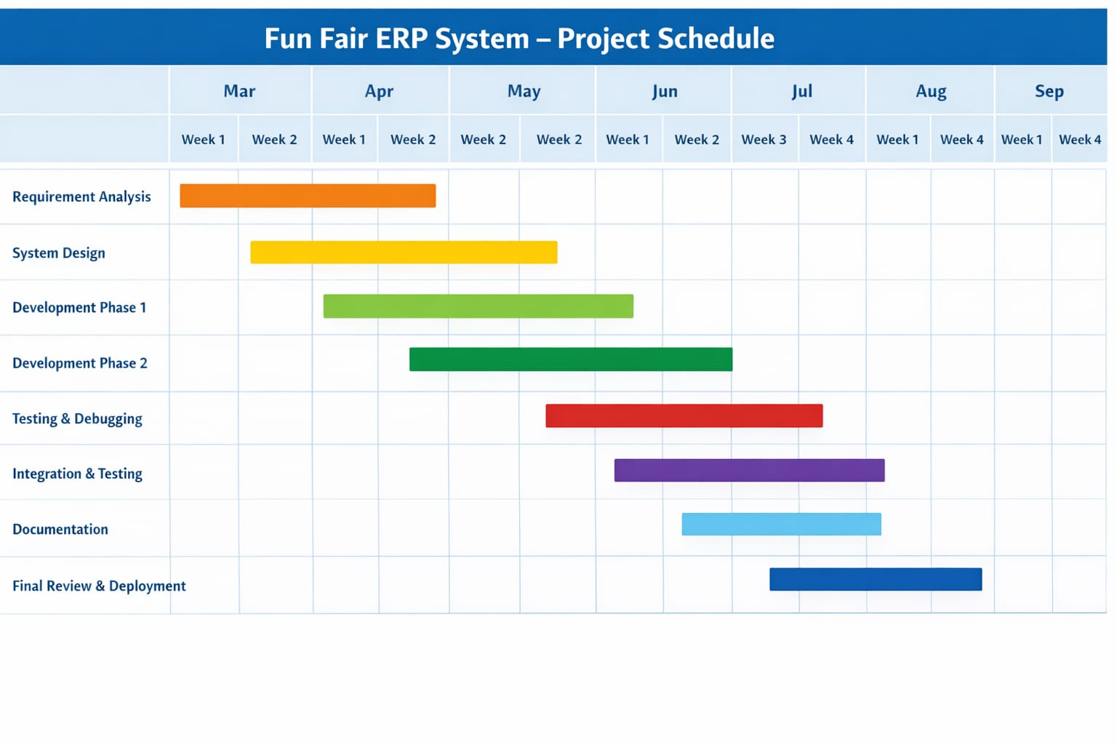
Figure 1-1 Gantt chat

Project / Product Feasibility Report (PFR)
Before the development of any software system, it is important to conduct a feasibility study to determine whether the proposed system is practical and beneficial. The feasibility study evaluates different aspects of the project including technical, operational, economic, and legal considerations.
A feasibility report has been prepared for the Fun Fair ERP System – Ticketing, Admission and Ride Management System, addressing the following feasibilities:
- Technical Feasibility
- Operational Feasibility
- Economic Feasibility
- Schedule Feasibility
- Specification Feasibility
- Information Feasibility
- Motivational Feasibility
- Legal and Ethical Feasibility

Technical Feasibility
The technical feasibility of the project determines whether the required technology and technical skills are available to develop and implement the system successfully.
The proposed Fun Fair ERP System is developed using commonly used web technologies including PHP for backend development, MySQL for database management, and Bootstrap with AdminLTE for the user interface. These technologies are widely available and easy to implement.
The development environment includes tools such as XAMPP for local server setup and Visual Studio Code as the development editor. Since the project uses open-source technologies, the development process becomes easier and cost-effective.
Based on the available technical resources and knowledge, the development of the Fun Fair ERP System is technically feasible.

Operational Feasibility
Operational feasibility evaluates how well the proposed system will work in a real-world environment and whether the users will be able to operate it easily.
The Fun Fair ERP System is designed to assist administrators, ticket sellers, gate operators, and ride operators in managing the operations of a fun fair efficiently. The system provides a user-friendly interface that allows staff members to perform their tasks easily.
The administrator can manage user accounts, rides, tickets, and system reports. Ticket sellers can generate tickets for visitors, gate operators can verify visitor entries, and ride operators can manage ride access.
This system helps reduce manual workload, improves coordination among staff members, and provides better management of fun fair activities.

Economic Feasibility
Economic feasibility evaluates the cost involved in developing and implementing the system compared to the expected benefits.
The proposed Fun Fair ERP System does not require expensive hardware or proprietary software. The system is developed using open-source technologies which significantly reduces development costs.
Cost Estimates
- Computer or Laptop: Rs. 50,000 (existing resource)
- Internet Connection: Rs. 6,000 (6 months)
- Software Tools: Free (Open Source)
Total Estimated Cost: Rs. 6,000 – Rs. 10,000 (Approx.)
Benefits
The system will help fun fair management reduce manual paperwork, improve ticket management, and provide accurate financial tracking. It will also save time and improve the overall efficiency of event operations.

Schedule Feasibility
Schedule feasibility determines whether the project can be completed within the planned time frame.
The development of the Fun Fair ERP System was planned using a project schedule represented through a Gantt chart. The project activities include requirement analysis, system design, development, testing, and documentation.
Each phase of the project was assigned a specific timeline to ensure timely completion. The project team aims to complete the system within the allocated academic deadlines.

Specification Feasibility
Specification feasibility evaluates whether the system requirements are clearly defined and achievable.
The requirements of the Fun Fair ERP System are clearly identified including ticket management, visitor admission verification, ride management, user management, and reporting features.
The system is designed to provide reliable and accurate information to the management and staff. All functional components required for the system will be implemented by the end of the project.

Motivational Feasibility
Motivational feasibility refers to the willingness and enthusiasm of the development team to complete the project successfully.
The Fun Fair ERP System is developed as a Final Year Project, and the project team is highly motivated to complete the system according to the project requirements. Continuous guidance from the project supervisor helps maintain focus and ensures that the project progresses smoothly.
Proper task allocation and time management help the team stay motivated and achieve project milestones successfully.

Legal & Ethical Feasibility
Legal and ethical feasibility ensures that the system complies with legal regulations and ethical standards.
The Fun Fair ERP System uses open-source technologies which do not violate any copyright or licensing policies. All software tools used in the project are legally available for development purposes.
Additionally, the system respects user privacy and stores only the necessary information required for system operations. No personal data is misused, ensuring that the system follows ethical standards in data handling.

Literature Review

Introduction
The literature review discusses existing systems used for ticket management, amusement park operations, and event management. It also highlights their limitations and the need for improved ERP solutions.

Existing System

Eventbrite
- Eventbrite is an online event management and ticketing platform that allows users to create events and sell tickets online.
- Advantages:
- Easy event creation
- Online ticket booking
- Limitations:
- Expensive for small events
- Limited ride management features

Ticketmaster
Ticketmaster is a global ticket sales platform used for concerts and large events.
Advantages:
- Secure ticket distribution
- Large-scale support
- Limitations:
- Complex setup
- Not suitable for small fun fairs

Amusement Park Management Systems
Some amusement parks use internal systems to manage rides and tickets.
Advantages:
- Ride monitoring
- Visitor tracking
Limitations:
- Expensive infrastructure
- Requires specialized hardware

Gap Analysis
Existing systems focus mainly on ticket booking but lack integrated ride management and admission validation systems suitable for small fun fairs.
The proposed Fun Fair ERP System addresses these gaps by providing:
- Integrated ticket and ride management
- Simple web interface
- Cost-effective implementation

Feasibility Study
Technical Feasibility
The project uses widely available technologies such as PHP, MySQL, and Bootstrap.
Economic Feasibility
The system uses open-source tools which reduces development cost.
Operational Feasibility
The system is easy to use and requires minimal training for staff.

Chapter Summary
This chapter reviewed existing ticket management systems and identified gaps in current solutions. The proposed system aims to overcome these limitations by providing an integrated ERP platform.

METHODOLOGY & REQUIREMENTS ANALYSIS

Introduction
This chapter explains the methodology used in the development of the Fun Fair ERP System and describes the functional and non-functional requirements of the system.

Software Development Life Cycle
The project follows the Waterfall Model of the Software Development Life Cycle.
Phases include:
- Requirement Analysis
- System Design
- Development
- Testing
- Deployment
The waterfall model is suitable because the project requirements are clearly defined.

Software Specifications
Operating System | Android version 5.1
Language Tools | Android studio, xml, java,
Database Language | Firebase
Table 4-1 Software Specifications

Hardware Specifications
Processor | 1.6 GHz
RAM | 8GB
Hard disk drive | 298GB
Table 4-2 Hardware Specification

Requirement Gathering Techniques
Requirements were gathered through:
- Observation of fun fair operations
- Analysis of existing ticketing systems
- Discussion with potential users

Functional Requirements
Examples:
- The system shall allow users to login securely.
- The system shall allow administrators to manage events.
- The system shall allow ticket sales staff to generate tickets.
- The system shall validate visitor entry.
- The system shall record ride usage.

Non-Functional Requirements
- Security
- Performance
- Reliability
- Scalability
- Usability

Use Case Modeling
Actors:
- Admin
- Salesperson
- Gate Operator
- Ride Operator
- Visitor
Use cases include:
- Login
- Manage Tickets
- Validate Entry
- Manage Rides
- Generate Reports

System Architecture

System Architecture Overview
System architecture defines the overall structure of the system including system components, data flow, and interaction between different modules. The proposed Fun Fair ERP System – Ticketing, Admission and Ride Management System follows a three-tier architecture model which separates the system into different layers to improve performance, maintainability, and scalability.
The system architecture mainly consists of the following layers:
- Presentation Layer (User Interface)
- Application Layer (Business Logic)
- Data Layer (Database Management)
Each layer performs a specific role in the overall working of the system.

Three Tier Architecture
The Fun Fair ERP System is designed using a three-tier architecture which divides the system into three major components.

Presentation Layer (User Interface)
The presentation layer is the front-end part of the system which interacts directly with users. It provides the graphical interface through which users perform different operations.
The interface of the Fun Fair ERP System is developed using Bootstrap framework and AdminLTE template to provide a responsive and user-friendly interface.
Different users interact with the system through dashboards and forms. The presentation layer includes:
- Login Page
- Admin Dashboard
- Ticket Seller Dashboard
- Gate Operator Dashboard
- Ride Operator Dashboard
- Ticket Generation Forms
- Ride Verification Interface
- Reports and Statistics Pages
This layer sends user requests to the application layer and displays the results returned from the system.

Application Layer (Business Logic)
The application layer is responsible for processing the system logic and managing all operations of the application. This layer handles the communication between the user interface and the database.
The Fun Fair ERP System uses PHP (Native PHP) as the server-side programming language to implement system functionality.
The application layer performs the following operations:
- User authentication and authorization
- Ticket generation and management
- Visitor entry verification
- Ride access verification
- Staff management
- Report generation
- Data validation and processing
All system rules and operational logic are implemented in this layer to ensure proper functioning of the system.

Data Layer (Database)
The data layer is responsible for storing and managing all system data. The Fun Fair ERP System uses MySQL database for managing data storage.
The database stores all the important records including:
User accounts (Admin, Ticket Seller, Gate Operator, Ride Operator)
- Ticket information
- Visitor entry records
- Ride details
- Ride access records
- Payment and ticket sales data
- Visitor feedback
The database ensures that data is stored securely and can be retrieved whenever required.

System Modules Architecture
The Fun Fair ERP System is divided into several modules. Each module performs specific tasks in the system.

User Management Module
This module manages all system users. The administrator can create, update, and delete user accounts. Different roles are assigned to users to control system access.
User roles include:
- Administrator
- Ticket Seller
- Gate Operator
- Ride Operator
The administrator manages permissions for each user in the system.

Ticket Management Module
The ticket management module is responsible for generating and managing visitor tickets.
Ticket sellers can generate tickets for visitors through the system. Each ticket contains important details such as:
- Ticket ID
- Ticket price
- Date and time
- Visitor entry status
All ticket sales are recorded in the system for financial tracking.

Visitor Admission Module
The visitor admission module is used by gate operators to verify visitor tickets before allowing entry to the fun fair.
Gate operators scan or verify the ticket ID through the system. Once the ticket is verified, the visitor entry is recorded in the database.
This module helps prevent duplicate entries and ensures controlled access to the event.

Ride Management Module
This module manages rides available in the fun fair. The administrator can add, update, or remove ride information from the system.
Ride operators verify ride tickets before allowing visitors to access specific rides. The system records ride usage data which helps the management analyze ride popularity and usage statistics.

Reporting Module
The reporting module generates different reports related to system activities. These reports help the administrator monitor fun fair operations.
The system can generate reports such as:
- Ticket sales report
- Visitor entry report
- Ride usage report
- Revenue summary report
These reports help management make better operational decisions.

System Data Flow
The system follows a structured data flow process:
- User logs into the system through the login interface.
- The application layer verifies the login credentials from the database.
- After authentication, the user accesses the system dashboard according to their role.
- The user performs operations such as generating tickets, verifying entries, or managing rides.
- The application layer processes the request and stores or retrieves data from the database.
- The processed information is displayed to the user through the interface.
This structured data flow ensures that the system operates efficiently and securely.

System Security Architecture
Security is an important aspect of the system architecture. The Fun Fair ERP System implements several security measures to protect system data and user access.
The security features include:
- Role-based access control (RBAC)
- Secure login authentication
- Input validation
- Session management
- Protected database access
These security mechanisms ensure that only authorized users can access the system and perform operations according to their assigned roles.

Architecture Benefits
The proposed architecture provides several benefits:
- Improved system organization
- Easy maintenance and updates
- Better scalability for future expansion
- Secure data management
- Efficient system performance
By using a layered architecture, the system becomes more flexible and easier to manage.

Detailed Design & Architecture

Introduction
Detailed design describes the internal structure of the system and explains how different modules interact with each other to perform system operations. The purpose of detailed design is to provide a clear understanding of system components, database structure, modules, and workflows.
The proposed Fun Fair ERP System – Ticketing, Admission and Ride Management System is designed to automate the management of ticket sales, visitor admission, ride operations, and reporting within a fun fair environment. The system ensures that all operations are properly organized and recorded in the database.

System Design Overview
The system is developed using a modular design approach where the application is divided into different functional modules. Each module is responsible for handling specific tasks in the system.
The system is developed using the following technologies:
• Frontend: HTML, CSS, Bootstrap, AdminLTE
• Backend: PHP (Native PHP)
• Database: MySQL
• Server Environment: XAMPP
The system architecture allows different users to access the system according to their assigned roles.

User Roles in the System
The Fun Fair ERP System supports multiple user roles to manage different operations of the system.

Administrator
The administrator has full control over the system. The admin is responsible for managing users, rides, tickets, and system reports.
Admin responsibilities include:
• Creating and managing staff accounts
• Managing ride information
• Monitoring ticket sales
• Viewing visitor statistics
• Generating reports

Ticket Seller
Ticket sellers are responsible for selling tickets to visitors. They use the system to generate tickets and record ticket sales.
Ticket seller operations include:
• Generating visitor tickets
• Recording ticket price and ticket details
• Viewing ticket sale records

Gate Operator
Gate operators verify tickets before allowing visitors to enter the fun fair.
Their responsibilities include:
• Verifying ticket ID
• Recording visitor entry
• Preventing duplicate entries

Ride Operator
Ride operators control access to rides within the fun fair. They verify whether a visitor has permission to use a specific ride.
Ride operator responsibilities include:
• Verifying ride tickets
• Allowing visitors to access rides
• Recording ride usage

System Modules Design
The system is divided into several modules that handle different operations.

Authentication Module
The authentication module manages login and access control of the system. Users must enter valid credentials to access the system.
Key features include:
• Secure login system
• Role-based access control
• Session management

User Management Module
This module allows the administrator to manage all system users.
Functions include:
• Add new users
• Edit user details
• Delete user accounts
• Assign roles to users
This module ensures that only authorized staff members can access the system.

Ticket Management Module
The ticket management module is used for generating and managing tickets.
Functions include:
• Creating visitor tickets
• Recording ticket price
• Assigning ticket ID
• Maintaining ticket sales records
This module helps keep track of all ticket transactions during the event.

Visitor Admission Module
This module is responsible for controlling visitor entry into the fun fair.
Functions include:
• Ticket verification
• Recording visitor entry
• Preventing duplicate entry
This ensures that only valid ticket holders can enter the event.

Ride Management Module
This module manages rides available in the fun fair.
Functions include:
• Adding ride information
• Updating ride details
• Recording ride usage
Ride operators verify tickets before allowing visitors to access rides.

Reporting Module
The reporting module provides statistical and financial reports for management.
Reports generated by the system include:
• Daily ticket sales report
• Visitor entry report
• Ride usage report
• Revenue report
These reports help administrators monitor system performance.

Database Design
The system database is designed to store all operational data of the fun fair.
The main database tables include:
• Users Table
• Tickets Table
• Visitor Entry Table
• Rides Table
• Ride Access Table
• Feedback Table
Each table stores specific information required for system operations.

System Workflow
The system workflow explains how different system components interact during operations.
- User logs into the system.
- System verifies credentials from the database.
- User accesses the dashboard according to their role.
- Ticket seller generates tickets for visitors.
- Gate operator verifies tickets at entry.
- Ride operator verifies ride access.
- All operations are recorded in the database.
- Administrator can generate reports and monitor system activities.

Advantages of the Proposed System
The Fun Fair ERP System provides several advantages over manual management.
• Reduces manual paperwork
• Improves operational efficiency
• Provides accurate ticket records
• Enhances visitor management
• Generates useful reports for decision making
The system helps the fun fair management organize event operations more efficiently.

ER Diagram
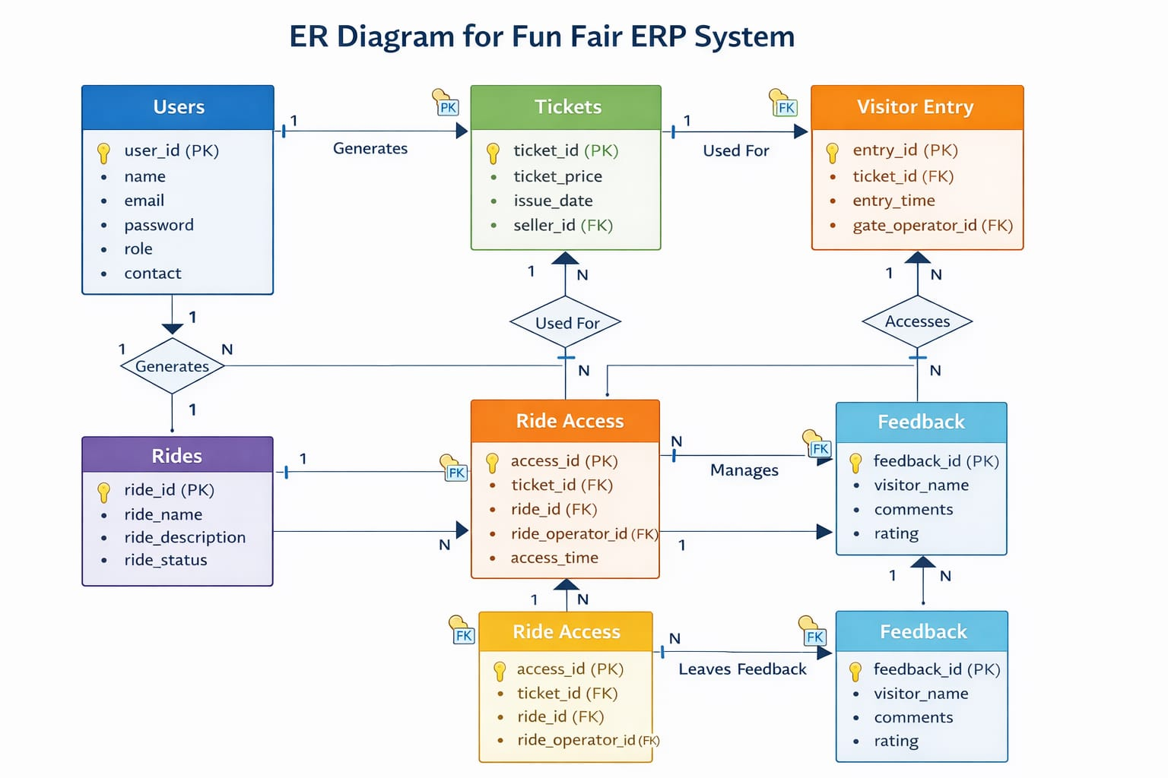
Figure 5-1ER-Diagram

Architectural Diagram
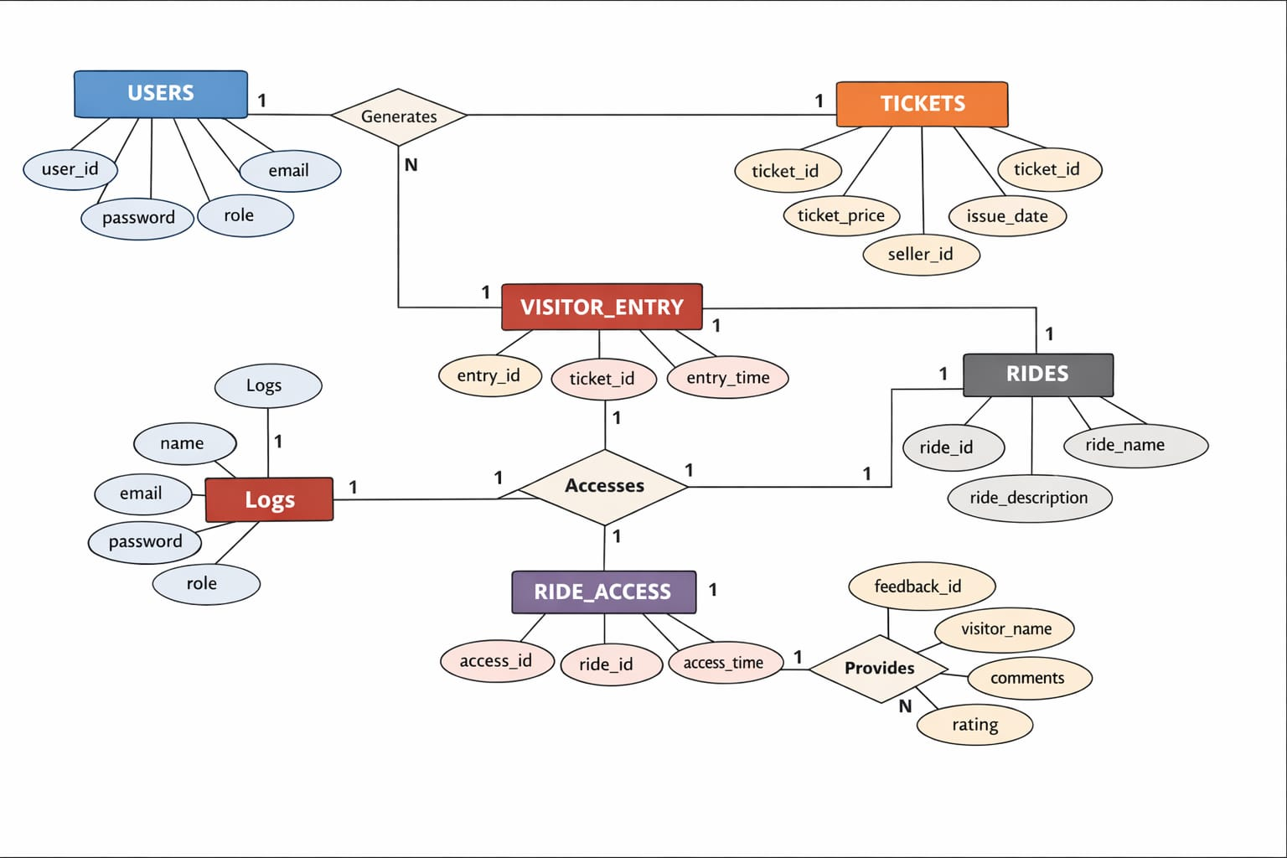
Figure 5-2Architectural Diagram

Implementation & Testing

System Implementation
System implementation is the phase where the designed system is converted into a working application. In this phase, the Fun Fair ERP System was developed using the selected technologies and tools. The implementation involved coding of different modules, database creation, and integration of all system components.
The system was implemented using the following technologies:
- Programming Language: PHP (Native PHP)
- Frontend Framework: Bootstrap
- Admin Template: AdminLTE
- Database: MySQL
- Server Environment: XAMPP
The development process included creating database tables, developing user interfaces, implementing business logic, and connecting the system with the database to perform various operations.

Module Implementation
The Fun Fair ERP System consists of several modules which were implemented step by step during development.

User Management Module
This module was implemented to manage system users. The administrator can create new user accounts and assign roles such as Ticket Seller, Gate Operator, and Ride Operator.
The module includes the following functionalities:
- User registration
- User login and authentication
- Role-based access control
- Update and delete user accounts
This module ensures that only authorized users can access the system.

Ticket Generation Module
The ticket generation module was implemented for ticket sellers to create tickets for visitors. The system generates a unique ticket ID for each visitor.
The module performs the following tasks:
• Generate ticket for visitors
• Store ticket details in the database
• Record ticket price and issue date
• Maintain ticket sales records
This module helps manage ticket sales efficiently.

Visitor Entry Verification Module
This module was developed to verify visitor tickets at the entry gate. Gate operators use this module to check the validity of the ticket before allowing entry.
The module performs the following functions:
• Verify ticket ID
• Record visitor entry time
• Prevent duplicate entry
• Store entry data in the database
This module ensures secure and controlled entry of visitors.

Ride Access Module
The ride access module allows ride operators to verify whether a visitor has access to a specific ride.
The module performs the following operations:
• Verify ride ticket
• Allow visitor to access ride
• Record ride access time
• Store ride usage information in the database
This module helps track ride usage and maintain proper records.

Reporting Module
The reporting module was implemented to provide useful reports for the administrator. These reports help monitor system activities and business performance.
The system can generate reports such as:
• Ticket sales report
• Visitor entry report
• Ride usage report
• Daily revenue report
These reports assist management in making better operational decisions.

System Testing
System testing is an important phase in software development. It ensures that the system works correctly and meets the project requirements.
Different testing techniques were used to verify the functionality of the Fun Fair ERP System.

Unit Testing
Unit testing was performed to test individual modules of the system separately. Each module such as user management, ticket generation, and ride verification was tested independently to ensure correct functionality.
Errors and bugs identified during testing were corrected before integrating the modules into the system.

Integration Testing
Integration testing was conducted after combining all modules of the system. This testing ensured that different modules interact properly with each other.
For example:
• Ticket generation module was tested with the database
• Visitor entry module was tested with ticket verification
• Ride access module was tested with visitor records
This testing ensured smooth data flow between system components.

System Testing
System testing was performed to check the complete system functionality. The system was tested under different scenarios to ensure it performs all required operations correctly.
The following aspects were tested:
• User login and authentication
• Ticket generation and storage
• Visitor entry verification
• Ride access management
• Report generation
All features were tested successfully and the system performed according to the project requirements.

Test Results
The testing results showed that the Fun Fair ERP System operates effectively and meets the intended objectives. All modules function properly and data is stored and retrieved accurately from the database.
The system provides a reliable and efficient solution for managing ticketing, visitor admission, and ride access operations in a fun fair environment.

Summary
In this chapter, the implementation and testing of the Fun Fair ERP System were discussed. The system was successfully developed using PHP, Bootstrap, AdminLTE, and MySQL database. Different modules were implemented and tested to ensure proper functionality.
The testing process confirmed that the system performs efficiently and fulfills the requirements defined in earlier phases of the project.

Results & Discussions
The Fun Fair ERP System is a web-based application developed to manage ticketing, visitor entry, and ride access in a fun fair. The system allows different users such as Administrator, Ticket Seller, Gate Operator, and Ride Operator to perform their tasks through a secure login.
This project was developed as part of our academic learning. Due to limited time and experience, some advanced features could not be implemented. However, the system successfully performs the main functions and helps manage fun fair operations more efficiently.

Register Activity
Firstly, system users can register in the application through the administrator. After registration, users such as Ticket Seller, Gate Operator, and Ride Operator can log in to the system using their assigned username and password to perform their respective tasks.
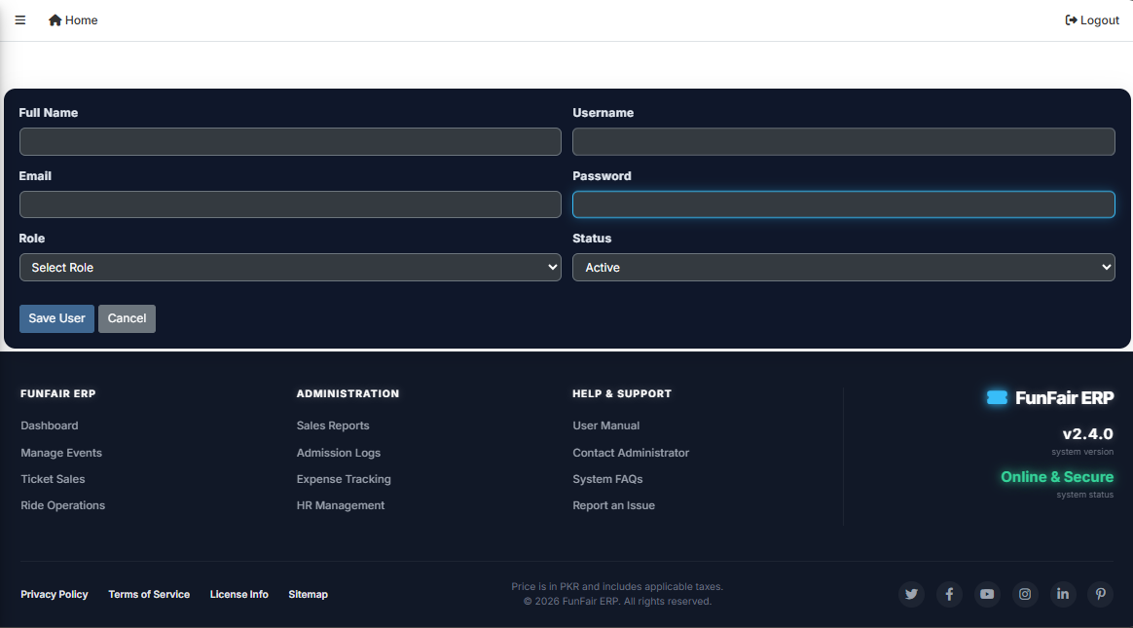
Figure 7-1: User registration

Login Activity.
All user (Superadmin/Visitor) can login username or password in Application.
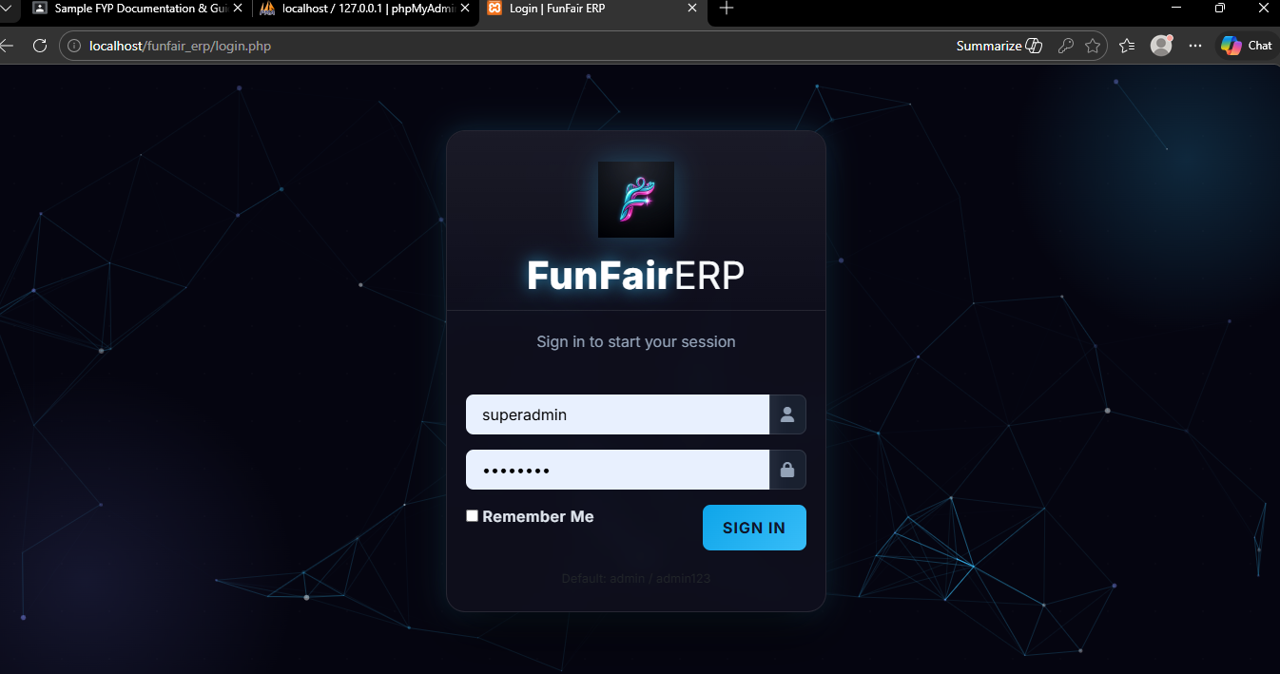
Figure 7-2: Login Activity

Visitor Home Activity
visitor Interface.
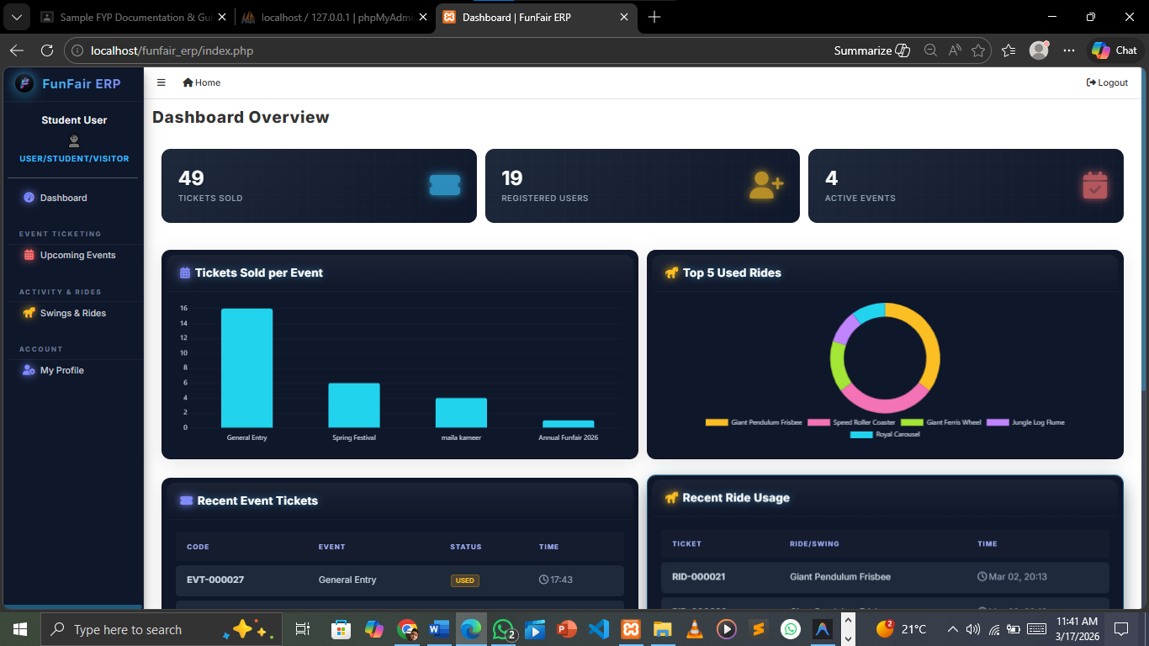
Figure 7-3teacher panel
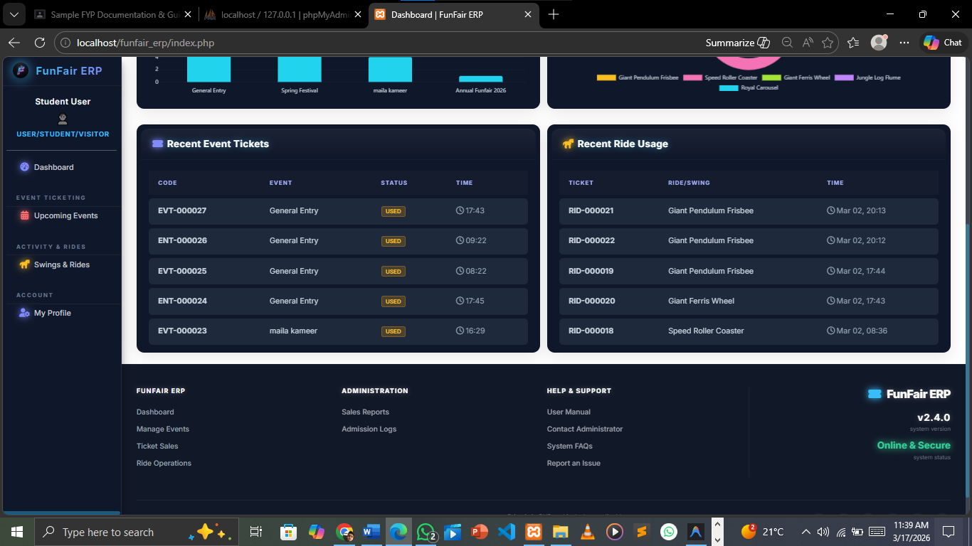
Figure 7-4teacher panel

Ride-op Home Activity
Ride-op Interface.
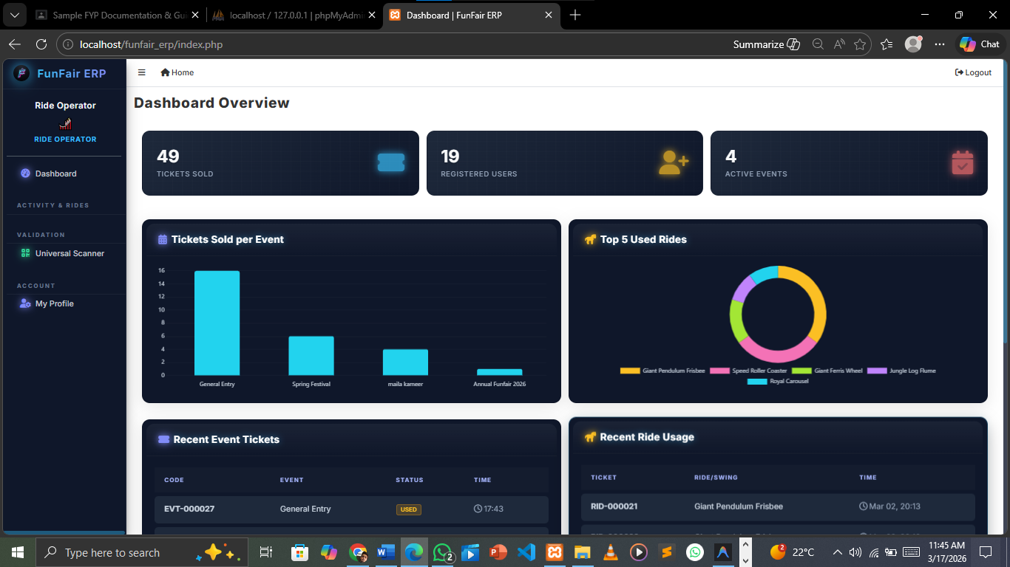
Figure 7-5teacher panel
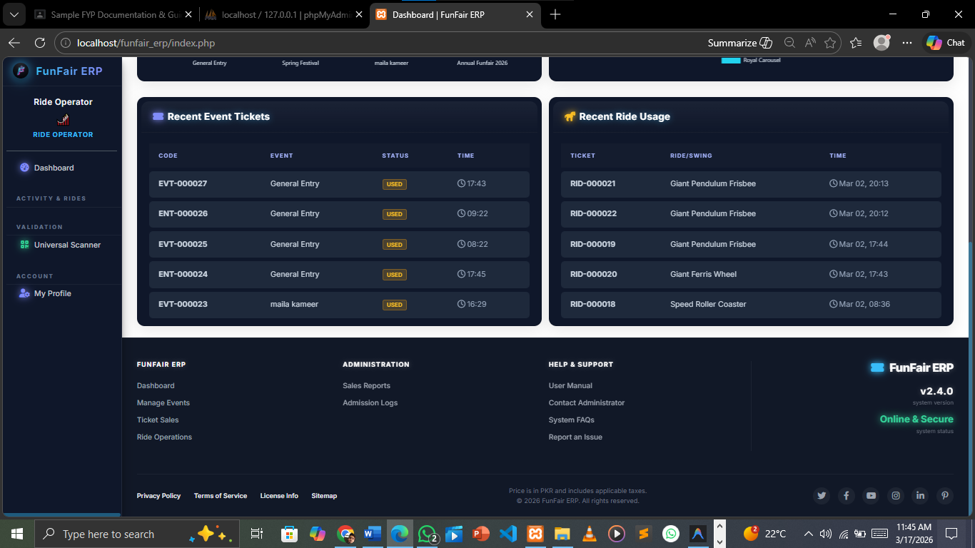
Figure 7-6teacher panel

Super Admin Home Activity
Super Admin Interface.
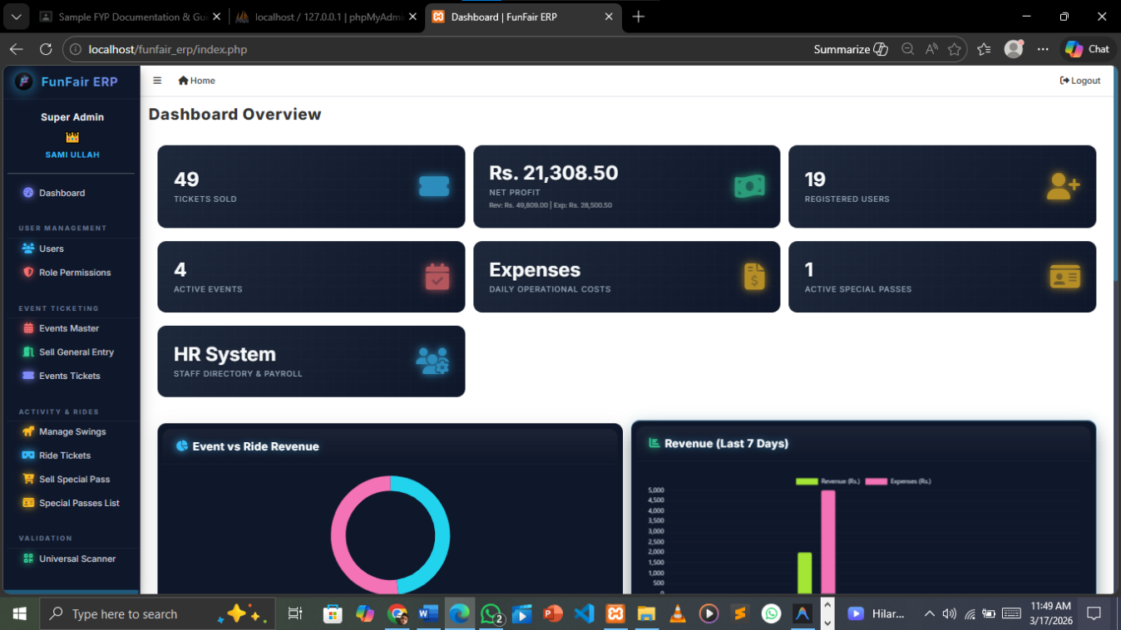
Figure 7-7super admin Panel
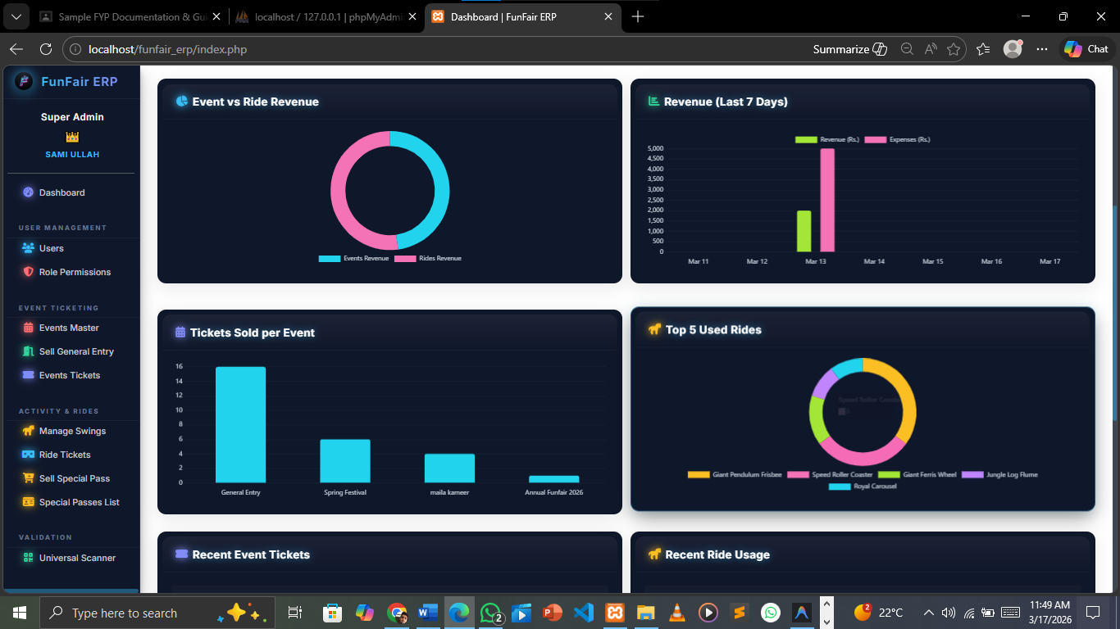
Figure 7-8super admin home
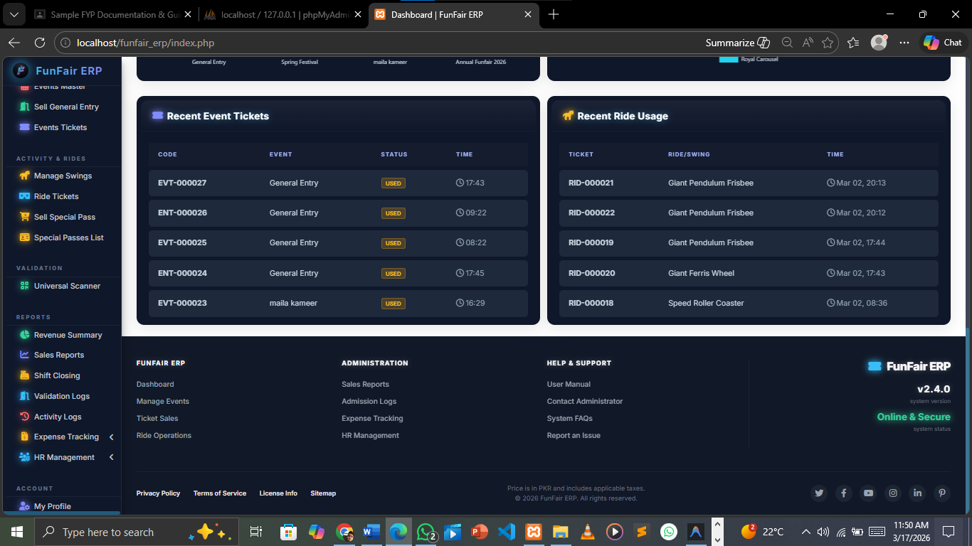Figure 7-9super admin home

Dashboard Activity code
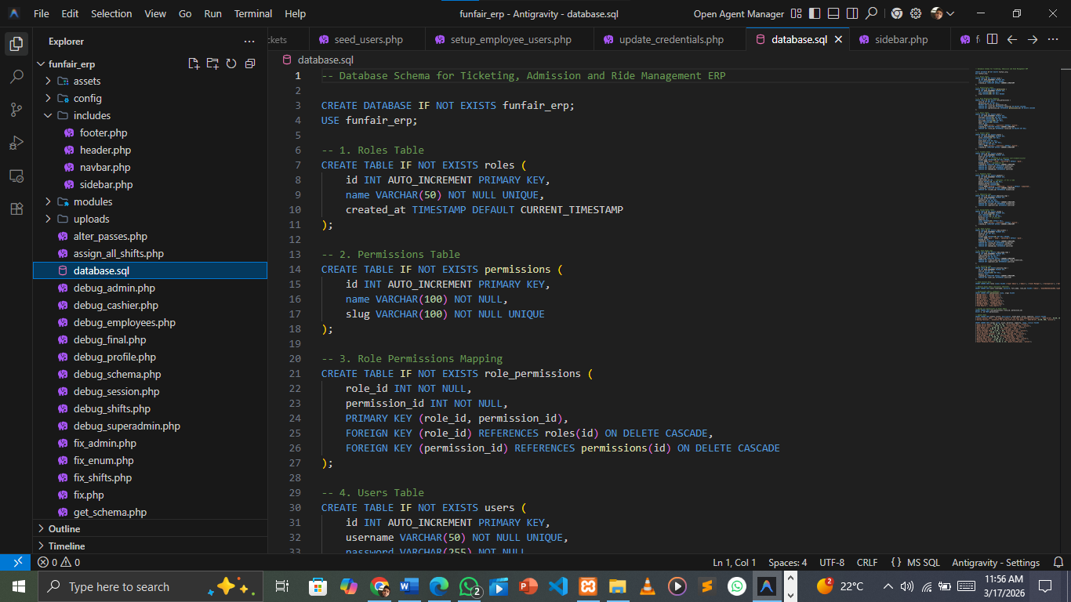
Figure 7-10Dashboard code
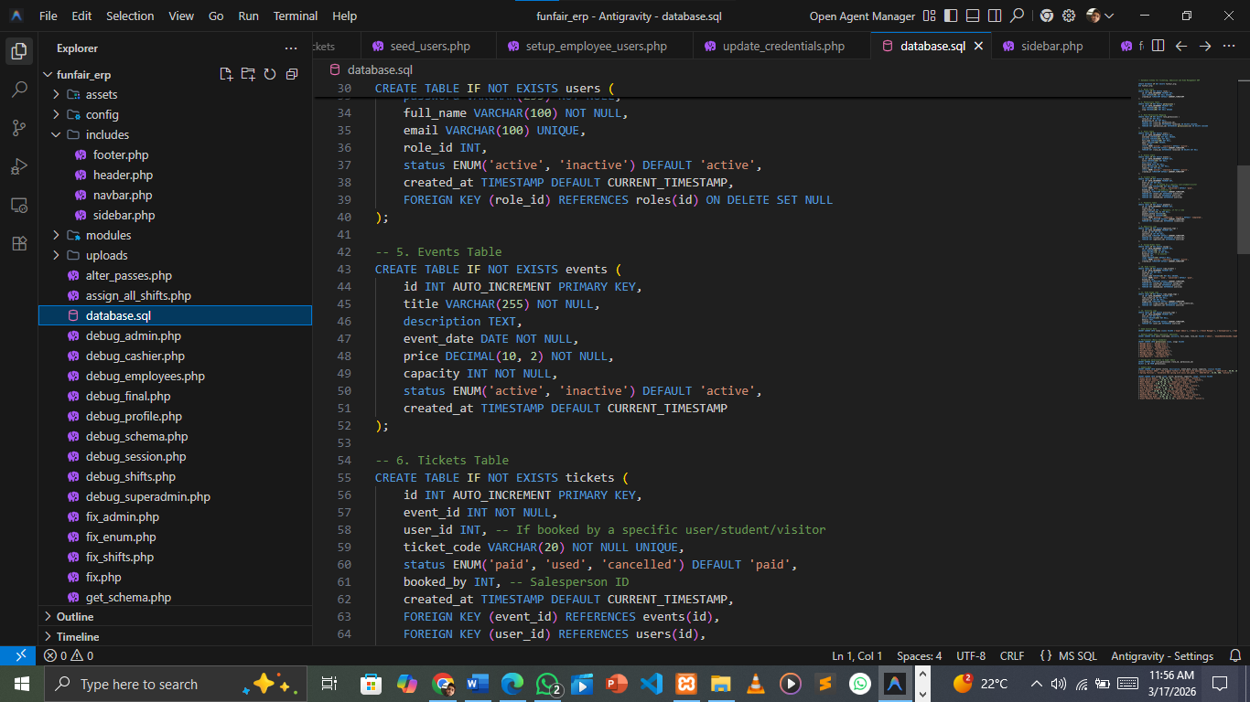
Figure 7-11dashboard code2

Conclusion & Future Work

Conclusion & Scope
The Fun Fair ERP System was developed to manage ticketing, visitor entry, and ride access in a fun fair environment. The system helps reduce manual work and makes the management process faster and more organized.
In the traditional system, most tasks are performed manually which can lead to errors and difficulty in maintaining records. The proposed system stores all data in a digital database, making it easier to manage tickets, visitors, rides, and reports. The administrator can control the whole system while other staff members can perform their tasks through their respective dashboards.
The system successfully achieves the main objectives of the project and provides a simple and efficient solution for fun fair management.
In the future, the system can be improved by adding features such as online ticket booking, QR code ticket verification, mobile application support, and advanced reporting tools.

Lesson Learnt
• Learned how to work effectively in a team.
• Learned about web development using PHP, MySQL, Bootstrap, and AdminLTE.
• Learned how to design and manage databases.
• Learned how to develop and integrate different system modules.
• Learned how to test and debug a software system.

Check Objectives
Objectives | Complete
Study existing systems and tools related to the project.
Select suitable technologies for system development.
Design system interface and database.
Develop the main modules of the application.
Integrate the application with the database.
Test the system functionality.
Figure 7-12: Check Objectives

References
[1] Pressman, R. S. Software Engineering: A Practitioner’s Approach. McGraw-Hill Education.
[2] Sommerville, I. Software Engineering. Pearson Education.
[3] Welling, L., & Thomson, L. PHP and MySQL Web Development. Addison-Wesley.
[4] Bootstrap Documentation – https://getbootstrap.com
[5] AdminLTE Dashboard Template – https://adminlte.io
[6] MySQL Official Documentation – https://www.mysql.com
[7] PHP Official Documentation – https://www.php.net

