Project Report

University Course Management System
_______________________________________________________

Submitted by
M. Abdullah
BBIS-22-45
Session 2022 – 2026

Supervised by
Umair Waqas



Department of Business Administration,
University of Sahiwal, Sahiwal

University Course Management System

A project submitted to the
Department of Business Administration
In
Partial fulfillment of the
requirements for the
degree of
Bachelor of Business Information Systems (BBIS).

By

M. Abdullah
BBIS-22-45

Internal Supervisor
Mr. Umair Waqas |  | _______________________
Lecturer
Department of Business Administration

External Examiner
___________________

Chairperson
Dr. Waris Ali |  | _______________________
Chairperson,
Department of Business Administration

COPYRIGHTS
This is to certify that the project titled “University Library Management System Title ” is the genuine work carried out by M.Abdullah , student of BBIS of Business Administration Department, University of Sahiwal, Sahiwal during the academic year 2022-26, in partial fulfillment of the requirements for the award of the Bachelor of Business Information System’s degree, and that the project has not previously formed the basis for the award of any other degree, diploma, fellowship, or any other similar title.

M. Abdullah
Student Signature: __________________

DECLARATION
This is to declare that the project entitled “ University Library Management ” is an original work done by undersigned, in partial fulfillment of the requirements for the degree “Bachelors of Business Information Systems” at Business Administration Department, University of Sahiwal, Sahiwal.
All the analysis, design and system development have been accomplished by the undersigned. Moreover, this project has not been submitted to any other college or university.

M. Abdullah________________

ACKNOWLEDGEMENTS
First and foremost, we are grateful to Allah Almighty, who blessed us with the health, ability, and guidance to complete this project successfully. Nothing could have been achieved without His help.
We express our sincere gratitude to our loving parents and teachers whose support enabled us to reach this stage. We also extend our appreciation to our Head of Department, Dr. Waris Ali, and our Coordinator, Dr. Atif, for their valuable support and guidance throughout our studies.
Finally, we would like to extend special thanks to Mr. Umair Waqas for providing us with an excellent learning experience during this project. His constructive feedback inspired us to explore new ideas and techniques

DEDICATION
We would like to dedicate this accomplishment offline to our beloved and caring Parents, friends and to our teachers with the support of whom I am standing at this step of my life stairs.
We also dedicate this dissertation to Mr. Umair Waqas who has supported us throughout the process.

Table of Contents
Chapter:01 Introduction xii
1.1 Background xii
1.2 Problem Statement xii
1.3 Project Objectives xiii
1.4 System Architecture & Technical Specifications xiii
1.4.1 Architectural Hierarchy xiii
1.4.2 Tools and Technologies xiv
Chapter:02 System Analysis xv
2.1 Requirements Gathering xv
2.2 Functional Requirements xv
2.2.1 Administrative & Librarian Module xv
2.2.2 Teacher Module xv
2.2.3 Student Module xvi
2.3 Non-Functional Requirements xvi
2.4 System Feasibility Study xvii
Technical Feasibility: xvii
Operational Feasibility: xvii
Economic Feasibility: xvii
2.5 Use Case Analysis xvii
Chapter:03 System Design xviii
3.1 System Architecture xviii
3.2 Use Case Diagram xviii
3.3 Entity Relationship Diagram (ERD) xix
3.4 Data Flow Diagram (DFD) xix
3.4.1 Level 0 (Context Diagram) xix
3.4.2 Level 1 DFD xx
3.5 Database Design xx
Chapter 4 xxii
System Implementation xxii
4.1 Overview xxii
4.2 System Environment xxii
4.2.1 Hardware Requirements xxii
4.2.2 Software Requirements xxii
4.3 System Modules xxii
4.4 System Working xxiii
4.4.1 Login Page xxiii
4.4.2 Admin Dashboard xxiii
4.4.3 Course Management xxiv
4.4.4 Create New Course xxv
4.4.5 Manage Department xxv
4.4.6 Enroll Student xxvi
4.4.7 Mark Attendance xxvi
4.4.8 Attendance Report xxvii
4.4.9 Create New Assignment xxvii
4.4.10 Assignment Details xxviii
4.4.11 View Enrollments xxviii
4.4.12 Student Dashboard xxix
4.4.13 Teacher Dashboard xxix
4.4.14 Database Implementation xxx
4.5 Testing xxx
4.6 Summary xxxi
Chapter 5 Security and Advanced Features xxxii
5.1 User Authentication xxxii
5.2 Role-Based Access Control xxxii
5.3 Course and Enrollment Security xxxiii
5.4 Assignment and Submission Management xxxiii
5.5 Attendance Monitoring xxxiii
5.6 Grade Management Security xxxiv
5.7 Access Logs and Activity Tracking xxxiv
5.8 Data Security and Validation xxxiv
5.9 Backup and Recovery xxxv
5.10 System Evaluation xxxv
Chapter 6 Results and Discussion xxxvi
6.1 Results xxxvi
6.2 Discussion xxxviii
Chapter 7 Conclusion and Future Work xl
7.1 Conclusion xl
7.2 Future Work xli
7.3 Final Remarks xlii
Chapter 8 References xliii

LIST OF FIGURES

Figure 3.1 use case management xviii
00-2 xviii
Figure-0-3.2 Entity Relationship Diagram xix
Figure 4.14 Database xxx

LIST OF ABBREVIATION
SR | Summary of Requirements
PFR | Project / Product Feasibility Report
OE | Operating Environment
CMS | Communication Management System
SQA | Software Quality Attributes
RMP | Risk Management Plan
FR | Function Requirement
MS | Monitoring System
FS | Feedback System
ROEP | Re-Scheduling of examination papers
ROEC | Reduction Of Extra Classes
AD | Assumptions and Dependencies

Abstract
The University Course Management System is an innovative web-based application developed to modernize and streamline academic administration within a university department. In contemporary educational settings, manual record-keeping for complex course structures often results in data redundancy, scheduling conflicts, and significant administrative delays. This project aims to replace these outdated manual processes with a centralized, automated platform that ensures high levels of data accuracy and operational efficiency.The system incorporates a robust architecture that facilitates essential academic functions, including Course Registration, Teacher Allocations, Student Enrollment, and Automated Grading and Statistics. A key feature of the application is its role-based access control, which provides tailored dashboards for Admins, Teachers, and Students, allowing each user to interact with the system according to their specific requirements. Furthermore, the system includes an integrated Alert System to keep users updated on academic milestones and attendance status.Developed using PHP and MySQL with a professional AdminLTE interface, the system ensures secure authentication and quick retrieval of information from a centralized database. By minimizing manual workloads and reducing the likelihood of human error, the University Course Management System significantly enhances the overall productivity and academic management of the institution.

Introduction
This chapter provides a comprehensive foundation for the University Course Management System, detailing the background, the core problems it aims to solve, and the architectural framework required for its implementation.

Background
In the current digital era, educational institutions are rapidly transitioning from manual administrative methods to integrated software solutions to maintain institutional excellence. The University of Sahiwal, specifically the Department of Business Administration, manages a complex web of academic data that requires high precision.
As the department grows, the volume of students, faculty members, and diverse course offerings increases significantly. Relying on traditional paper registers or isolated spreadsheets often leads to administrative delays. This project introduces a centralized platform designed to unify these fragmented processes into a single, cohesive system built on PHP and MySQL.

Problem Statement
The existing manual or semi-automated systems within the department face several critical issues that hinder academic productivity:

Inefficient Data Silos:
Information regarding student details, teacher assignments, and course statistics is often stored in disconnected formats, leading to redundancy.

Manual Tracking Overhead:
The process of monitoring student attendance and academic progress requires significant manual labor from staff.

Delayed Communication:
Without an integrated alert system, students and faculty do not receive real-time updates regarding academic milestones or overdue requirements.

Risk of Data Loss:
Physical records and non-centralized digital files are vulnerable to damage, loss, or unauthorized tampering.

Project Objectives
The primary goal of this system is to automate the core academic functions of the department. The specific objectives include:

Centralizing Academic Data:
Storing all student, teacher, and course information in a unified database for quick retrieval.

Enhancing Role-Based Access:
Providing distinct interfaces for Students, Teachers, and Librarians/Admins to ensure data security.

Improving Monitoring & Reporting:
Implementing logic that generates real-time statistics and academic reports.

Facilitating Real-Time Updates:
Developing an automated alert system to notify users of important academic changes.

System Architecture & Technical Specifications
The system follows a structured client-server architecture to ensure reliability and performance across the university network.

Architectural Hierarchy
The system is designed with a linear data flow that connects the following entities as depicted in the architectural design:
- Students: Access the system to view personal details, enrolled course info, and unique identification.
- Teachers: Manage student academic records, course details, and unique teacher IDs.
- Librarians/Administrators: Oversee the alert system, update student/teacher info, and manage overall system maintenance.
- Server & Database: The central hub where all logic is processed and data is securely stored.

Tools and Technologies
To maintain a professional "Executive Minimalism" aesthetic, the following stack is utilized:
- Back-End: PHP for robust server-side logic and backend processing.
- Database: MySQL for structured and secure data storage.
- Front-End: AdminLTE (HTML, CSS, JavaScript) for a clean, professional navy-and-white dashboard interface.
- Environment: XAMPP serves as the local server environment fdevelopment and testing

System Analysis
This chapter focuses on the detailed analysis of the University Course Management System. It defines the specific needs of the users, the functional boundaries of the software, and the operational constraints required to ensure the system performs effectively within the Department of Business Administration.

Requirements Gathering
The requirements for this system were identified by analyzing the current manual academic workflows and the architectural needs of the department. The primary goal is to ensure that the flow of data between Students, Teachers, and the Central Server is seamless and secure.

Functional Requirements
Functional requirements define the core processes that the system must perform. Based on the system architecture, the requirements are categorized by user roles:

Administrative & Librarian Module
- User Management: The ability to create, update, and deactivate accounts for Students and Teachers.
- Course Cataloging: Administering the master list of courses, including course codes, titles, and credit hours.
- System Configuration: Managing department-wide settings and database backups.
- Alert Management: Configuring and triggering system-wide notifications and alerts.

Teacher Module
- Course Assignment: Viewing and managing courses assigned to them for the current semester.
- Student Enrollment Tracking: Accessing the list of students registered in their specific classes.
- Performance Statistics: Inputting grades and viewing analytical data regarding student progress.
- Attendance Management: Maintaining a digital log of daily student presence.

Student Module
- Course Registration: Accessing the portal to register for available courses.
- Academic Profile: Viewing personal identification details and enrollment history.
- Notification Center: Receiving real-time alerts regarding class schedules, marks, or administrative updates.

Non-Functional Requirements
Non-functional requirements define the quality attributes and constraints of the system:
- Security: High-level encryption for user passwords and role-based access to prevent unauthorized data entry.
- Reliability: The system must ensure data consistency between the Server and the MySQL Database.
- Performance: The interface (AdminLTE) must load quickly and handle multiple concurrent requests during peak registration periods.
- Usability: A clean, "Executive Minimalism" design to ensure that users with varying levels of technical expertise can navigate the system easily.

System Feasibility Study

Technical Feasibility:
The use of PHP and MySQL is ideal as these technologies are well-supported, open-source, and compatible with the university's existing XAMPP environment.

Operational Feasibility:
The system mirrors existing academic hierarchies (Student-Teacher-Admin), making it easy for the department to adopt without extensive retraining.

Economic Feasibility:
Development costs are minimal as the project utilizes open-source tools and existing hardware within the computer lab.

Use Case Analysis
The interaction between the users and the system is governed by specific use cases. The Server acts as the intermediary that processes requests from the front-end and interacts with the Database to provide the necessary output, such as statistics or alert triggers.

System Design
This chapter details the architectural and logical design of the University Course Management System. It translates the requirements identified in Chapter 02 into technical blueprints, including the system’s data flow, user interactions, and database structure.

System Architecture
The system follows a three-tier architecture consisting of the Presentation Layer (AdminLTE Interface), the Application Layer (PHP Logic), and the Data Layer (MySQL Database). This structure ensures that the Server can efficiently process requests from Students and Teachers while maintaining data integrity.

Use Case Diagram
The Use Case Diagram illustrates the interactions between the system's actors and its core functions. It defines the boundaries of what each user can perform.
- Admin: Manages users (Teachers/Students), assigns courses, and views system-wide statistics.
- Teacher: Records student attendance, updates grades, and views course alerts.
- Student: Registers for courses, views academic profile, and receives system notifications.
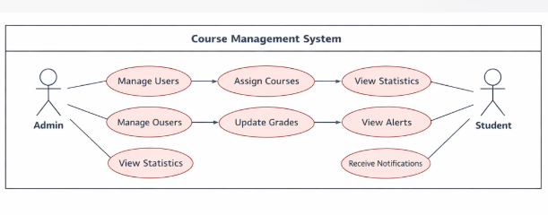
Figure 3-1: use case management

Entity Relationship Diagram (ERD)
The ERD defines the logical structure of the database. It shows how different entities like Courses, Students, and Teachers relate to one another.
- Student Table: Stores unique Student ID, name, and contact details.
- Teacher Table: Stores Teacher ID, department, and assigned courses.
- Course Table: Contains Course ID, Title, Credit Hours, and Semester info.
- Enrollment Table: Acts as a bridge between Students and Courses to track registrations.
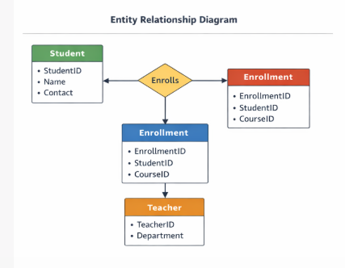
Figure-3-3.2 Entity Relationship Diagram

Data Flow Diagram (DFD)
The DFD visualizes how information moves through the system, from the initial user input to storage in the database.

Level 0 (Context Diagram)
This diagram shows the system as a single process, interacting with external entities. Students, Teachers, and Admins send data (login, registration, grades) to the Course Management System, which then returns processed information (reports, alerts, schedules).

Level 1 DFD
This level breaks down the main process into sub-processes:
- Authentication: Validating user credentials.
- Course Management: Handling the addition and allocation of academic courses.
- Academic Tracking: Processing attendance and grading data.
- Reporting & Alerts: Generating statistics and sending notifications to the server.
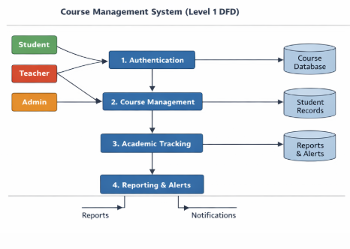
Figure -3.3 (DFD)

Database Design
The database is built using MySQL with a focus on normalization to prevent data redundancy. Key tables include:
- users: Manages authentication and role-based access levels.
- courses: Stores the master list of all academic offerings.
- enrollments: Logs which students are attending which classes.
- grades: Records the academic performance and statistics for each student.

High-Level Sequence Flow (Interaction Architecture)
This sequence maps how information travels across the system's three-tier architecture: the Presentation Layer (AdminLTE), the Application Layer (PHP), and the Data Layer (MySQL).
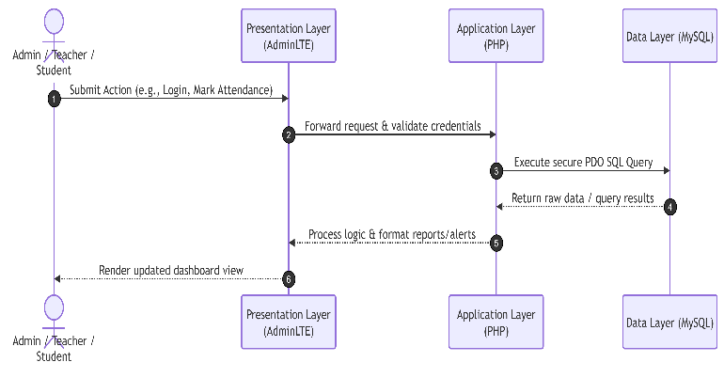
Figure 3.4 High Level Sequence
2. High-Level Activity Life Cycle
This flowchart tracks the functional stages of the system, starting from authentication and branching into the specific role-based tasks.
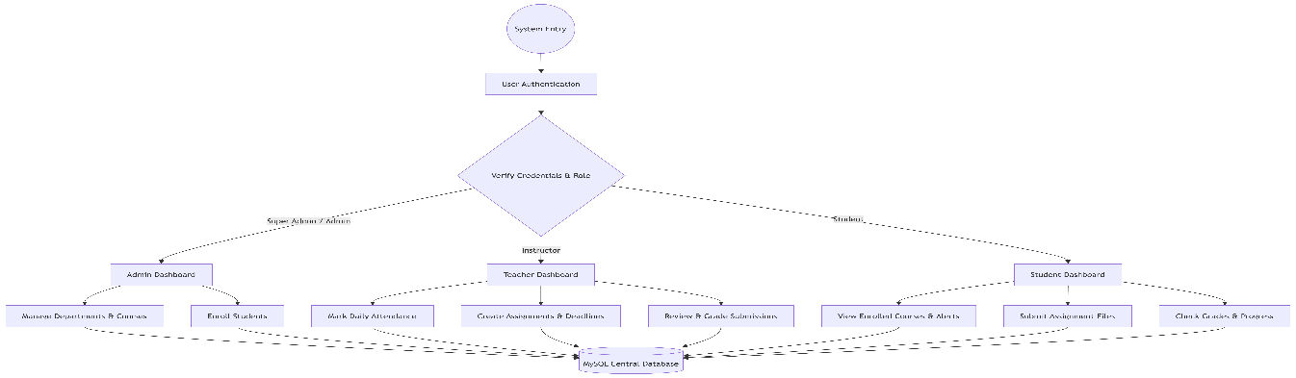
Figure 3.5 High level Activity Life Cycle

System Implementation

Overview
This chapter explains the implementation and functionality of the Course Management System. The system is developed as a web-based application to facilitate academic management activities within an educational institution. It provides separate interfaces for administrators, teachers, and students to manage courses, attendance, assignments, and enrollments efficiently.

System Environment

Hardware Requirements
Processor: Core i3 or above
RAM: 4 GB or above
Storage: 50 GB Available Space
Operating System: Windows 10/11

Software Requirements
• Front End: HTML, CSS, JavaScript
• Back End: PHP
• Database: MySQL
• Server: XAMPP
• Interface Framework: AdminLTE

System Modules
The system consists of the following modules:
• User Authentication Module
• Dashboard Module
• Course Management Module
• Department Management Module
• Student Enrolment Module
• Attendance Management Module
• Assignment Management Module
• Student Portal
• Teacher Portal

System Working

Login Page
The login page is the entry point of the system. Users provide their username and password to access the application. The system validates the credentials and redirects users to their respective dashboards according to their assigned roles.

Figure 4.1 Login page

Admin Dashboard
The Admin Dashboard provides a centralized overview of the entire system. It displays important information related to courses, departments, enrollments, assignments, and users. The dashboard helps administrators monitor academic activities and manage system operations efficiently.
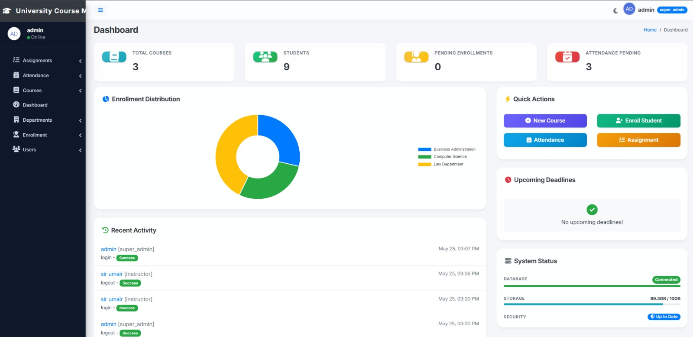
Figure 4.2 Admin Dashboard

Course Management
The Course Management module allows administrators to manage academic courses. Users can view available courses, update course information, and maintain course records within the system.
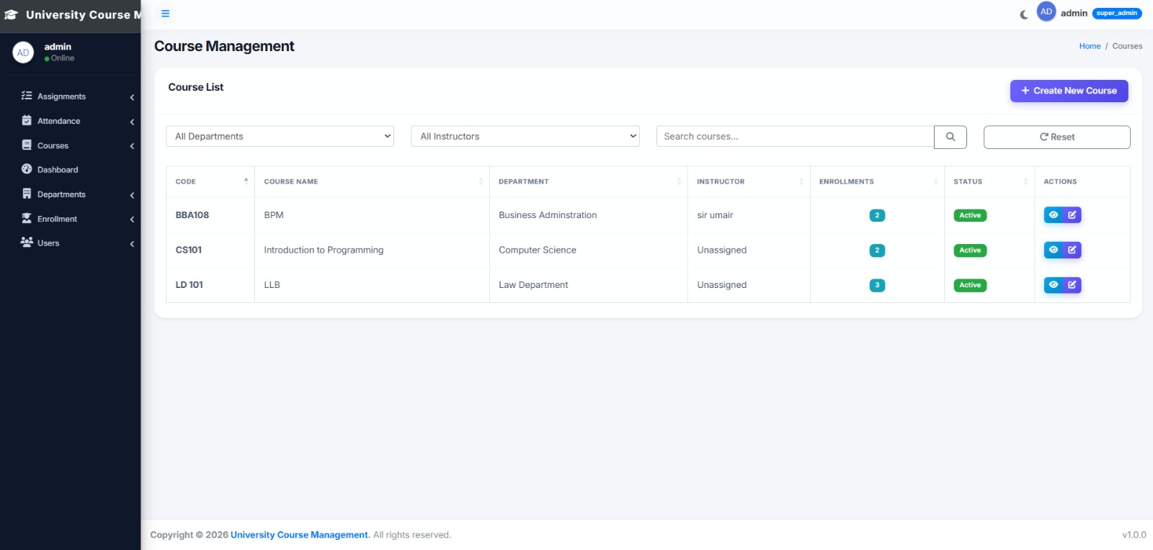Figure 4.3 Admin Dashboard

4 Create New Course
This page allows administrators to create new courses by entering course-related information. Newly created courses are stored in the database and become available for student enrollment and academic activities.
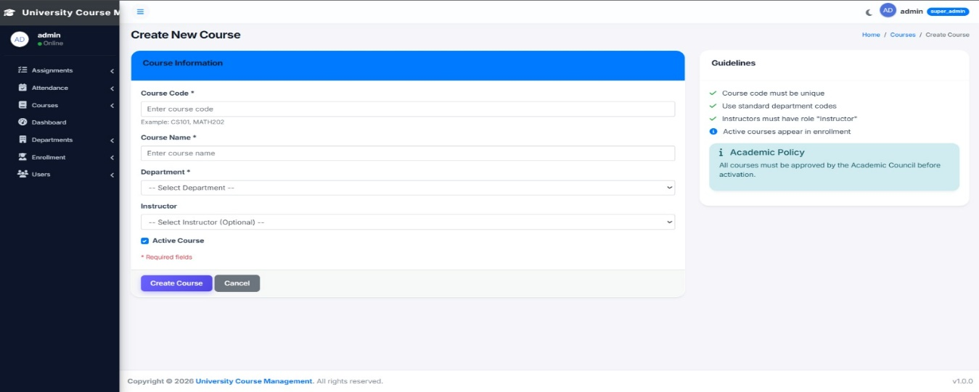
Figure 4.4 New Course

Manage Department
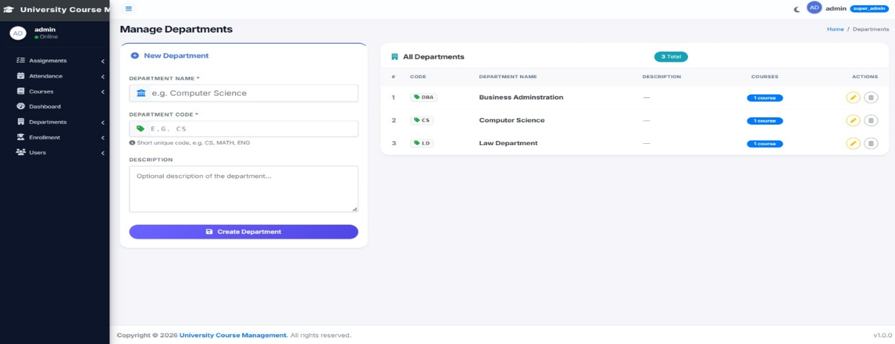The Department Management page allows administrators to create and manage academic departments. Departments help organize courses and academic records according to institutional requirements.
Figure 4.5 Manage Department

Enroll Student
The Student Enrollment module allows administrators to enroll students in available courses. The system maintains enrollment records and establishes the relationship between students and courses.
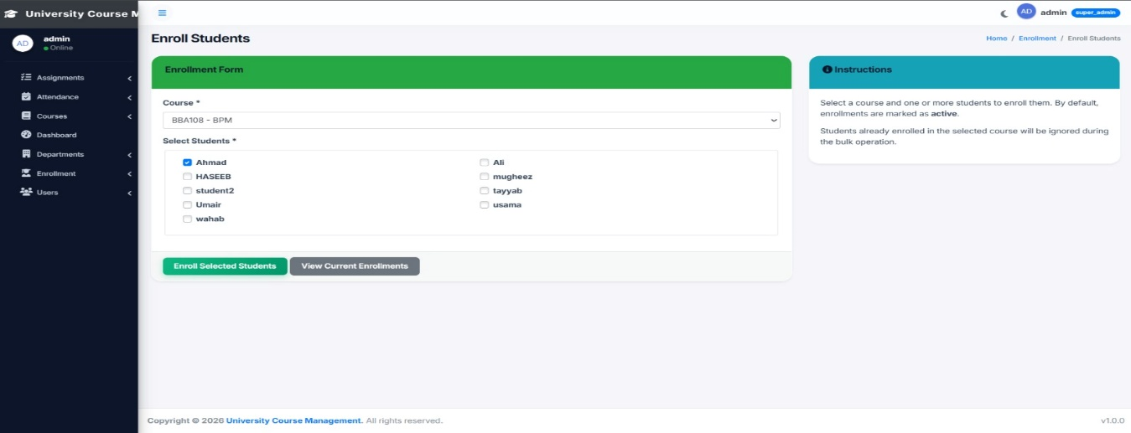
Figure 4.6 Enroll Student

Mark Attendance
The attendance module enables teachers to record student attendance for specific courses. Attendance records are stored electronically, improving accuracy and reducing manual paperwork.
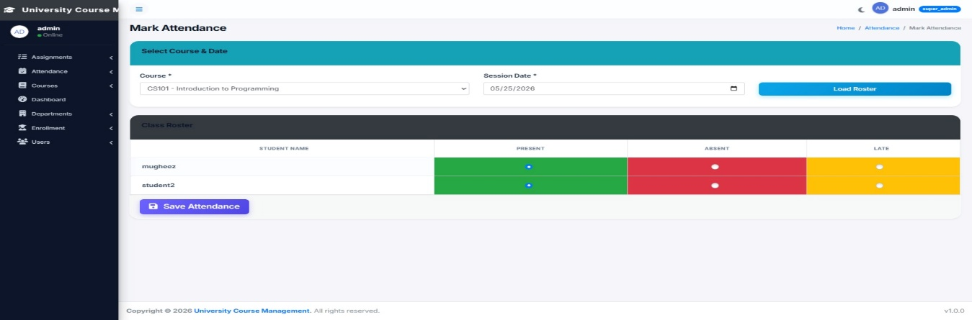
Figure 4.7 Mark Attendance

Attendance Report
The Attendance Report page provides a summary of student attendance records. Administrators and teachers can review attendance statistics and monitor student participation in academic activities.
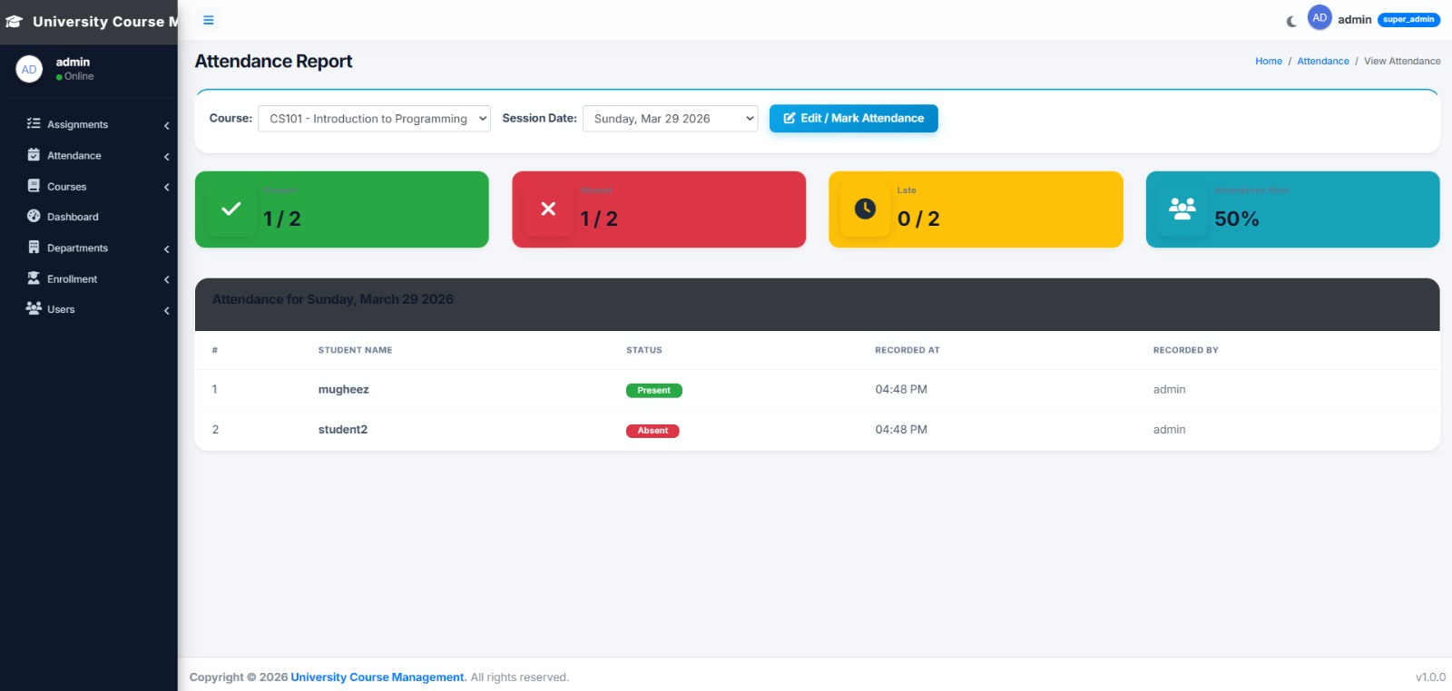
Figure 4.8 Attendance Report

Create New Assignment
This module allows teachers to create assignments for their courses. Assignment details such as title, description, and submission deadline can be entered and published for students.
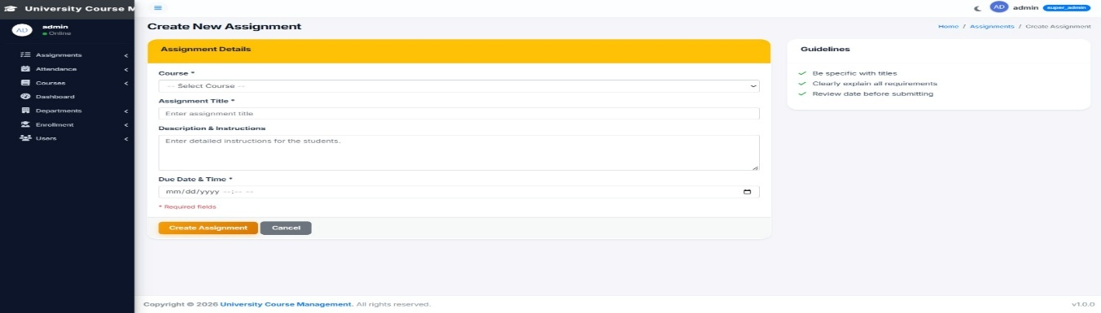
Figure 4.9 Create Assignment

Assignment Details
The Assignment Details page displays complete information regarding assignments. Students and teachers can view assignment descriptions, deadlines, and related academic information.
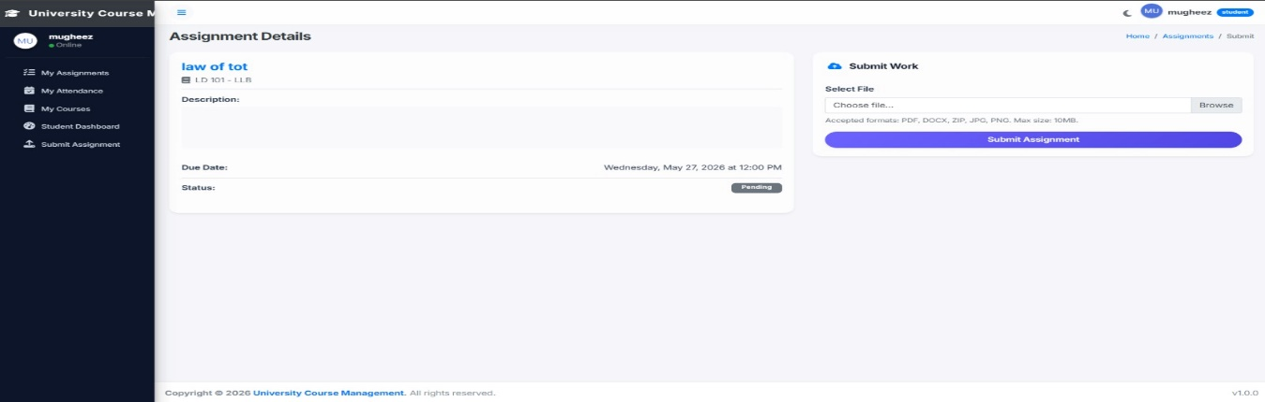
Figure 4.10 Assignment Detail

View Enrollments
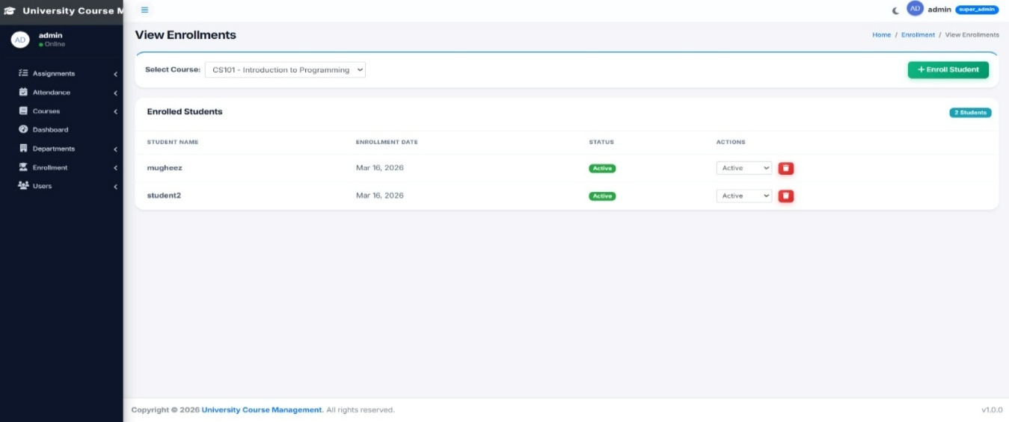
This page displays all student enrollment records. Administrators and teachers can review which students are enrolled in specific courses and monitor enrollment activities.

Figure 4.11 View Enrollment

Student Dashboard
The Student Dashboard provides students with access to their academic information. Students can view enrolled courses, attendance records, assignment details, and other course-related information through a single interface.
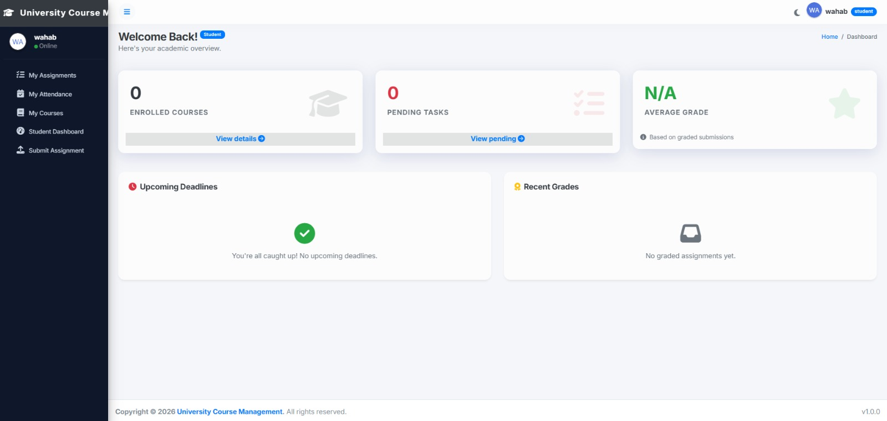
Figure 4.12 Student Dashboard

Teacher Dashboard
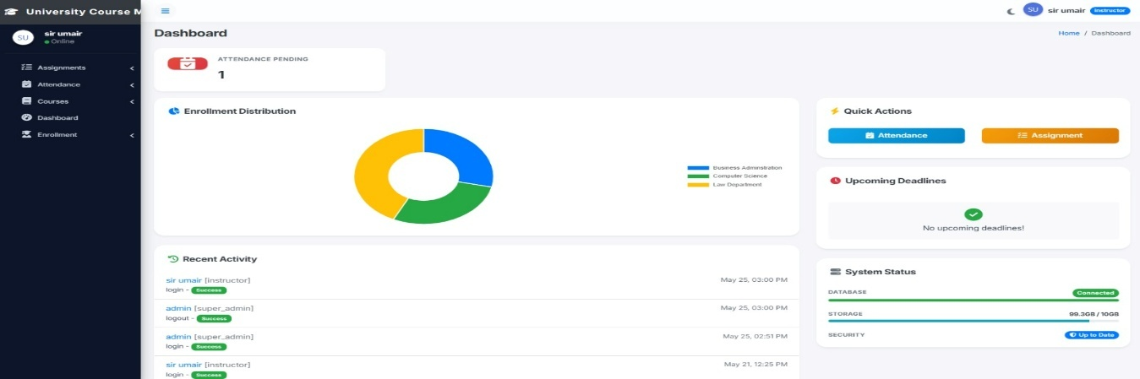
The Teacher Dashboard provides instructors with tools to manage their academic responsibilities. Teachers can access attendance records, assignments, enrolled students, and course information from this dashboard.

Figure 4.13 Teacher Dashboard

Database Implementation
The system uses a MySQL database for storing academic and administrative information. The database contains tables for users, courses, departments, enrollments, attendance records, assignments, grades, and system management.
All tables are linked using primary and foreign keys to ensure data consistency and integrity.
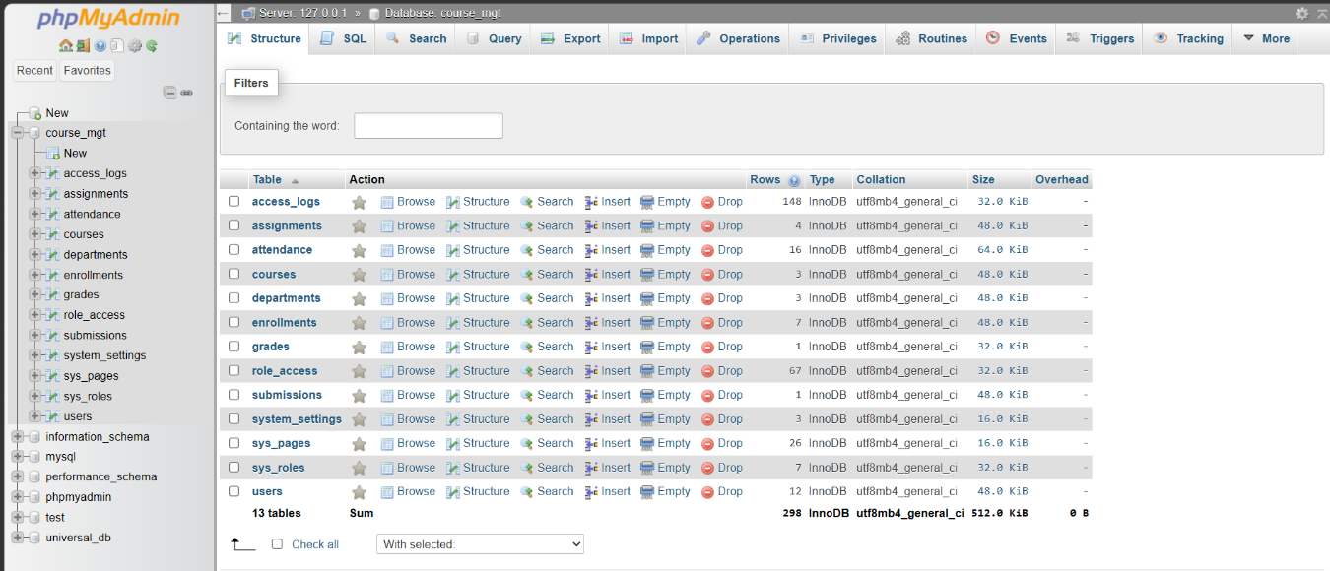
Figure 4.5-14 Database

Testing
The system was tested to verify its functionality and reliability. The following tests were performed:
- Login validation testing
- Course management testing
- Student enrollment testing
- Attendance marking testing
- Attendance report verification
- Assignment creation testing
- Dashboard functionality testing
- Database testing
- Error handling testing
The results confirmed that all modules perform according to system requirements.

Summary
The Course Management System was successfully implemented using PHP, MySQL, Bootstrap, and AdminLTE. The system automates academic management processes including course management, student enrollment, attendance tracking, and assignment management. The implementation improves efficiency, reduces manual workload, and provides a structured platform for academic administration.

Security and Advanced Features

User Authentication
The Course Management System implements a secure authentication mechanism to verify user identities before granting access to the system. Every user must provide a valid username and password to log into the application. The authentication process ensures that only authorized users can access system resources and perform assigned operations.
The login system protects sensitive academic information and prevents unauthorized access to course, student, and grading records.

Role-Based Access Control
The system implements Role-Based Access Control (RBAC) to manage user permissions efficiently. Each user is assigned a specific role that determines the modules and functionalities they can access.
Super Admin
• Full access to all system modules
• Manage users and roles
• Configure system settings
• Monitor system activities
Admin
• Manage departments and courses
• Manage student and instructor records
• View reports and system information
Instructor
• Manage course attendance
• Create assignments
• Review submissions
• Assign grades to students
Student
• View enrolled courses
• Submit assignments
• View attendance records
• Check grades and academic progress
This access control mechanism improves security and prevents unauthorized modification of academic records.

Course and Enrollment Security
The system ensures that only authorized users can create, update, or delete course information. Enrollment records are maintained securely, and students can only access courses in which they are enrolled.
This feature prevents unauthorized course registration and protects academic information from misuse.

Assignment and Submission Management
The Assignment Management module allows instructors to create assignments and define submission deadlines. Students can submit assignments through the system, while instructors can review and evaluate submitted work.
The system maintains secure records of all assignment submissions, ensuring data integrity and preventing unauthorized modifications.

Attendance Monitoring
The attendance module records student attendance accurately and securely. Only authorized instructors can mark or update attendance records.
Attendance information is stored in the database and can be accessed for academic evaluation and reporting purposes.

Grade Management Security
The Grade Management module protects student academic results from unauthorized access and modification. Only instructors and authorized administrators can update grades.
Students are allowed to view their grades but cannot modify any academic records. This ensures fairness, transparency, and academic integrity.

Access Logs and Activity Tracking
The system maintains detailed access logs for monitoring user activities. Information such as user identity, accessed pages, performed actions, and timestamps are recorded automatically.
The audit logs help administrators:
• Monitor user activities
• Detect unauthorized actions
• Investigate security incidents
• Maintain accountability
This feature improves transparency and overall system security.

Data Security and Validation
The system uses secure database operations and input validation techniques to protect stored information. User inputs are validated before processing to reduce the risk of invalid or malicious data.
Security measures include:
• Input validation
• Secure database connectivity using PDO
• Controlled access permissions
• Session management
• Protected authentication process
These measures help maintain the integrity, confidentiality, and reliability of system data.

Backup and Recovery
The Course Management System supports database backup procedures to minimize the risk of data loss. Regular backups can be generated and stored securely for future recovery.
In case of system failure, hardware issues, or accidental data deletion, administrators can restore information using available backup files.
This ensures business continuity and protects valuable academic records.

System Evaluation
The Course Management System significantly improves academic management by automating traditional administrative processes. The implementation of course management, enrollment tracking, attendance recording, assignment handling, grading, and role-based access control enhances efficiency and accuracy.
The system reduces manual workload, minimizes human errors, improves data accessibility, and provides a secure platform for managing academic activities.
Overall, the system successfully meets the requirements of modern educational institutions and provides a reliable solution for course management operations.

Results and Discussion

Results
The Course Management System (CMS) was successfully developed and implemented to automate academic and course-related activities within an educational institution. The system provides a centralized platform for managing courses, departments, enrollments, attendance, assignments, submissions, grades, and user records.
After implementation and testing, the system produced significant improvements in efficiency, accuracy, and academic record management.
The major results achieved by the system are as follows:

Improved Course Management
The system allows administrators to create, update, and manage courses efficiently. Academic departments and courses are maintained in a structured database, reducing administrative workload and improving record organization.

Efficient Enrollment Process
Students can be enrolled in courses systematically, and enrollment records are stored electronically. This eliminates manual registration errors and provides accurate enrollment tracking.

Automated Attendance Management
Attendance records can be maintained digitally by instructors. The automated attendance process improves accuracy, reduces paperwork, and enables quick retrieval of attendance reports.

Effective Assignment Handling
Instructors can create assignments and define submission deadlines through the system. Students can submit their work online, making the assignment process more organized and transparent.

Secure Grade Management
The grading module allows instructors to evaluate student performance efficiently. Academic results are stored securely and can be accessed whenever required.

Enhanced User Management
The implementation of role-based user management ensures that every user accesses only authorized functionalities according to their assigned role.

Activity Monitoring
The access log module records system activities and user actions. This feature improves accountability and helps administrators monitor system usage effectively.

Improved Data Accuracy
Since all records are stored in a centralized database, duplicate entries and manual record-keeping errors are significantly reduced. Data consistency and integrity are maintained throughout the system.

Faster Information Retrieval
The system provides quick access to academic information including courses, enrollments, attendance records, assignments, submissions, and grades. This improves decision-making and operational efficiency.
Overall, the Course Management System provides a reliable, secure, and efficient platform for managing academic operations.

Discussion
The developed Course Management System successfully fulfills the objectives identified during the system analysis and requirement gathering phases. All core modules have been implemented and integrated effectively to support academic management activities.
The role-based access control mechanism ensures that different categories of users interact with the system according to their responsibilities. Administrators manage institutional data, instructors handle academic activities, and students access learning-related information.
Compared to traditional manual methods, the automated system provides several advantages:
• Reduced administrative workload
• Improved operational efficiency
• Faster processing of academic records
• Better data organization and accessibility
• Enhanced security and access control
• Reduced human errors
• Improved transparency and accountability
The attendance, assignment, submission, and grading modules work together to create a complete academic management environment. These modules simplify routine tasks and improve communication between instructors and students.
The implementation of database-driven record management ensures consistency and reliability of stored information. Furthermore, the access logging mechanism increases transparency by maintaining records of user activities.
The system demonstrates how modern web technologies can be used to automate educational processes and improve institutional productivity. The overall performance of the application confirms that the proposed solution is practical, scalable, and suitable for academic environments.
The successful implementation and testing of the Course Management System prove that it can effectively support the management of courses, students, instructors, and academic records while maintaining security, accuracy, and usability.

Conclusion and Future Work

Conclusion
The Course Management System was designed and developed to provide a complete web-based solution for managing academic activities within an educational institution. The system successfully automates various administrative and academic processes including course management, department management, student enrollment, attendance tracking, assignment handling, submission management, grade recording, and user administration.
The implementation of the system has significantly improved the efficiency and accuracy of academic operations by replacing traditional manual procedures with an automated digital platform. The centralized database ensures secure storage of information while reducing data redundancy and maintaining consistency across all modules.
The integration of role-based access control enhances security by ensuring that users can access only the functionalities relevant to their assigned roles. Administrators can manage institutional records, instructors can perform academic activities, and students can access their learning-related information in a controlled environment.
The attendance, assignment, grading, and enrollment modules work together to create a comprehensive academic management system that supports both teaching and learning processes. The access log functionality further improves accountability by maintaining records of user activities throughout the system.
The project demonstrates the practical application of web technologies, database management systems, and software engineering principles in solving real-world educational management problems. The successful testing and implementation of the system confirm that it meets its intended objectives and provides a reliable solution for academic institutions.
In conclusion, the Course Management System offers an efficient, secure, scalable, and user-friendly platform that improves academic administration, reduces manual workload, and enhances overall institutional productivity.

Future Work
Although the Course Management System is fully functional and meets current requirements, several enhancements can be implemented in the future to further improve its capabilities and user experience.
The following future improvements are recommended:

Mobile Application Development
A dedicated mobile application for Android and iOS platforms can be developed to allow students and instructors to access the system from their smartphones and tablets.

Email and Notification System
Email notifications and in-system alerts can be integrated to notify users about assignment deadlines, attendance updates, grade announcements, and important academic events.

Online Examination Module
An online examination and quiz management module can be added to support digital assessments, automated grading, and performance analysis.

Learning Material Management
A digital learning resource module can be introduced to allow instructors to upload lecture notes, presentations, videos, and study materials for students.

Student Performance Analytics
Advanced analytics and reporting features can be implemented to provide insights into student performance, attendance trends, and academic progress.

QR Code Attendance System
A QR Code–based attendance mechanism can be integrated to simplify attendance recording and reduce manual effort.

Multi-Campus Support
The system can be extended to support multiple campuses, departments, and academic branches under a single platform.

Cloud-Based Deployment
Cloud hosting can be adopted to improve scalability, reliability, remote accessibility, and disaster recovery capabilities.

API Integration
RESTful APIs can be developed to integrate the system with other educational platforms such as Learning Management Systems (LMS), Student Information Systems (SIS), and third-party services.

Artificial Intelligence Features
Artificial Intelligence and Machine Learning techniques can be incorporated to provide intelligent recommendations, performance predictions, and personalized learning support for students.

Final Remarks
The Course Management System successfully addresses the challenges associated with manual academic management processes. By providing automation, security, accessibility, and centralized data management, the system contributes to improved educational administration and academic efficiency.
With future enhancements and continuous development, the system has the potential to evolve into a comprehensive educational management platform capable of supporting the growing needs of modern academic institutions.

References
AdminLTE. (2025). AdminLTE v3.2 control panel template [Bootstrap Dashboard]. https://adminlte.io
Apache Friends. (2025). XAMPP Apache + MariaDB + PHP + Perl development environment (Version 8.2) [Computer software]. https://www.apachefriends.org
Bootstrap. (2023). Bootstrap front-end framework (Version 4.6) [Software library]. https://getbootstrap.com/docs/4.6/
The MySQL Development Team. (2024). MySQL database management system (Version 8.0) [Computer software]. Oracle Corporation. https://www.mysql.com
The PHP Documentation Group. (2025). PHP: Hypertext preprocessor (Version 8.3) [Programming language]. https://www.php.net
The PHP Documentation Group. (2025). PHP data objects (PDO) extension [Software module]. https://www.php.net/manual/en/book.pdo.php

