https://github.com/facebook/create-react-app

**READYMADE BOILER PLATE WITH THE BASIC REACT APP with REDUX:**

https://github.com/codewithbernard/react-redux-boilerplate

**FOR THIS EXAMPLE - USE MY GIT:  
 YOUR FIRST REACT AND REDUX APP with API CALL:** https://github.com/mz75/React_Redux_Axios_BoilerPlate

**BASIC STEPS TO FOLLOW – TOTAL 8 STEPS:**

**1. INSTALL THE NORMAL REDUX PACKAGES + THUNK**

**(THUNK IS THE DISPATCHER) & AXIOS AXIOSTHROUGH NPM**

a. ***Install React App***:

npx create-react-app my-app

// **Reference:** https://github.com/facebook/create-react-app#create-react-app-

b. ***Install Redux, Thung & axios :***

npm install --save redux react-redux redux-thunk

// **Reference**: https://github.com/gaearon/redux-thunk#redux-thunk

npm install --save axios

// **Reference**: https://www.npmjs.com/package/axios#installing

You need a chrome plugin called “ExtensionAllow-Control-Allow-Origin” for out of domain ajax calls.

// **Reference**: https://chrome.google.com/webstore/detail/allow-control-allow-origi/nlfbmbojpeacfghkpbjhddihlkkiljbi

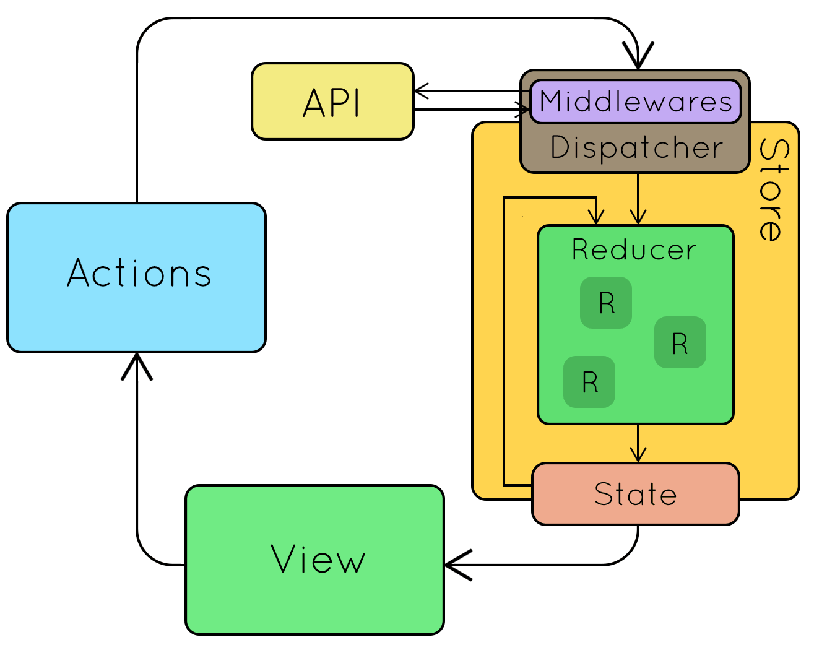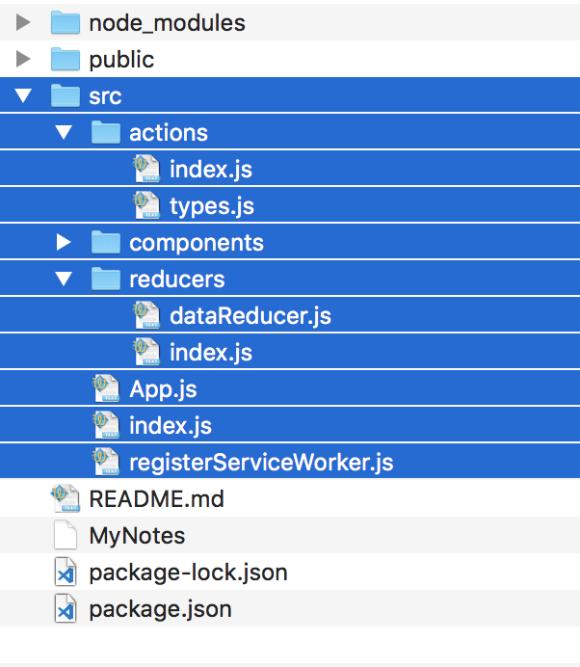

**2. CREATE FOLDERS IN THE SRC FOLDER AKA ROOT FOLDER:**

1. actions (The folder where you call the APIs – in our example)

**DETAILS:**

This folder must have a file called **‘index.js’**,   
This **‘index.js’** is the file where you will make the **API calls** and   
check your **self-defined data types** by calling the **‘types.js’** file   
(important: **‘types.js’** only returns a name against an alias – check file).

1. reducers (The folder where you perform actions on APIs – in our example)

**DETAILS:**

This folder must have a file called **‘index.js’** this is the record/collection of all reducers.

1. components (For normal react components – not used in our example)

**DETAILS:**

This folder has all your components you normally write in React

**3. MAKE BASIC CHANGES INTO YOUR ROOT FOLDER’S INDEX.JS FILE (THE ROOT FOLDER VERSION)**

// NPM TIP: To add npm package run npm install --save <package_name>

// Default – No change

**import React from "react";**

// Default – No change

**import ReactDOM from "react-dom";**

// Default – No change

**import App from "./App";**

// Default – No change

**import registerServiceWorker from "./registerServiceWorker";**

// NEW: Call the Provider COMPONENT using ‘react-redux’ -

// This component provides your app with 'store'

**import { Provider } from "react-redux";**

// NEW: Check the redux diagram–we need to create a store & apply middlewear

// 'createStore'& 'applyMiddleware' are ‘functions’ that we are able to call once import them from redux.

// GENERALL RULE: If the first letter is capital than its likely to be a component and in other cases its likely to be a function or a variable.

**import { createStore, applyMiddleware } from "redux";**

// NEW: calling directory will automatically look for index.js & this is a file which imports other reducers and merge them. Mainly in our example it is “DataReducer.JS”

**import reducers from "./reducers";**

// NEW: Importing reduxThunk [which is the Dispatcher aka middlewear part]

**import reduxThunk from "redux-thunk";**

// NEW: Finally initiating the store and passing reducers plus middlewear as reduxThunk – because it’s a dispatcher.

**const store = createStore(reducers, applyMiddleware(reduxThunk));**

// Default – No change

**ReactDOM.render(**

// NEW: Wrap the lone <App /> tag with <Provider store={store}> passing the store as attribute.

**<Provider store={store}>**

**<App />**

**</Provider>, document.getElementById("root")**

**);**

**registerServiceWorker();**

**ACTIONS FOLDER CHANGES:**

**4. INDEX.JS IS TO BE CREATED INSIDE THE ACTIONS FOLDER.**

**DETAILS:**

This is the file where you will call your main APIs using axios

Here is a sample of the file code with details:

// Calling a typical alias/object self-defined data type from types.js inside actions folder.

**import { FETCH_DATA } from "./types";**

// Calling a axios using axios – for calling unhosted external API   
// Here you will require the help from that chrome plug-in for calling external API as it allow you to do that.

// Common import for both **shortcut** or **longcut** code.

**import axios from "axios";**

// **Shortcut** of the code

// **NOTE**– If you find this difficult to understand. I have a longcut version under this.

**export const fetchData = () => async dispatch => {**

**const res = await axios.get("https://swapi.co/api/people");**

**dispatch({**

**type: FETCH_DATA,**

**payload: res.data.results**

**});**

**};**

// **Longcut** of the code

// **NOTE**– If you find shortcut difficult to understand.

**export const fetchData = () => {**

**return async dispatch => {**

**const res = await axios.get("https://swapi.co/api/people");**

**console.log(res);**

**};**

**};**

**5. TYPES.JS IS TO BE CREATED INSIDE THE ACTIONS FOLDER.**

**DETAILS:**

This is the file where for creating aliases for self-defined data types, returning a (const) variable only.

Here is a sample of the file code with details:

// Plain strings for types

**export const FETCH_DATA = "FETCH_DATA";**

**REDUCERS FOLDER CHANGES:**

**6. DATAREDUCER.JS IS TO BE CREATED INSIDE THE REDUCERS FOLDER.**

**DETAILS:**

Here is a sample of the file code with details:

// Calling a typical alias/object self-defined data type from types.js inside actions folder.

**import { FETCH_DATA } from "../actions/types";**

// state is passed as an array although it should be obj along with ‘action’.

// we expect returned state to be an Array obj – hence.

// IMPORTANT: here we are exporting a function, and this is an example of arrow function and that function have one switch statement which evaluate the action type

**export default (state = [], action) => {**

**switch (action.type) {**

**case FETCH_DATA:**

**return action.payload;**

**default:**

**return state;**

**}**

**};**

**7. INDEX.JS IS TO BE CREATED INSIDE THE REDUCERS FOLDER.**

**DETAILS:**

This is the file where you will combine all your reducers, but we have only one in our example “dataReducer.js”

Here is a sample of the file code with details:

// Calling reducers, you have just created. So that you don’t need to call them individually, but we have only one here ‘dataReducer.js’

**import dataReducer from "./dataReducer";**

// For combining all reducers by using redux, you need to import the object first by using redux.

**import { combineReducers } from "redux";**

**export default combineReducers({**

// Assigning the key value and returning it back after combining.

**data: dataReducer**

**});**

**OTHERS:**

8. **RUN APPLICATION**

**DETAILS:**

Write using terminal (inside the “react-redux-boilerplate” folder)

**npm start**