Zaenuddin | Test Engineer
Zaenuddin | 087776452385

Basic Programming
1. Integer, Float, Decimal data types
2. Char, Varchar, Text data types
3. 113
4. 2
5. 3566GoldenStreetMiami

Flaky Test.
1. A flaky test is a test which could fail or pass for the same configuration. Such behavior could be harmful to developers because test failures do not always indicate bugs in the code.
A ﬂaky test is an analysis of web application code that fails to produce the same result each time the same analysis is run. Whenever new code is written to develop or update computer software, a web page or an app,
Flaky tests can be caused by various factors
- an issue with the newly-written code
- an issue with the test itself
- some external factor compromising the test results

2. Usually, I write with console.log code and view console in GoogleChrome/Firefox, then, I was checked kind of DOM Element in Javascript, such as : identify element div, or td, etc

and I see description status code response like : 400/403 from this website https://httpstatus.io/http-status-codes

3. The first step, I will see, how the shape dan behaviour from the captcha,
and then if the captcha showing picture and requested to guessing like who has the correct picture must be same with the instruction,
if not match, captcha should be rejected to return login/submit the form and moreover kick the group cause its machine detected not human

The second step, if the captcha showing calculation number such as (divided, addition,substraction) I will input with sum up about with this number,
if the correct answer, system can grant access to menu as login, if wrong system will be rejected cause detected its machine, and cannot calculated number be in the form of picture

Essay Question Topic
1. Create Automation test script (action.js)

a. Method GET
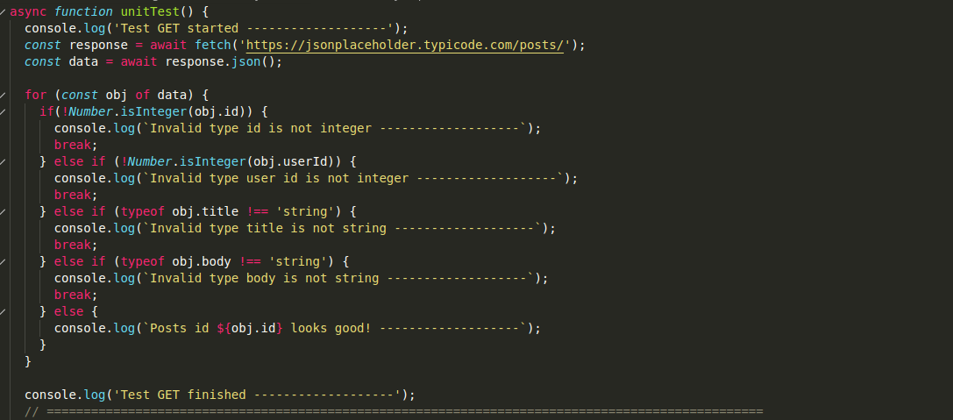

b. Method POST
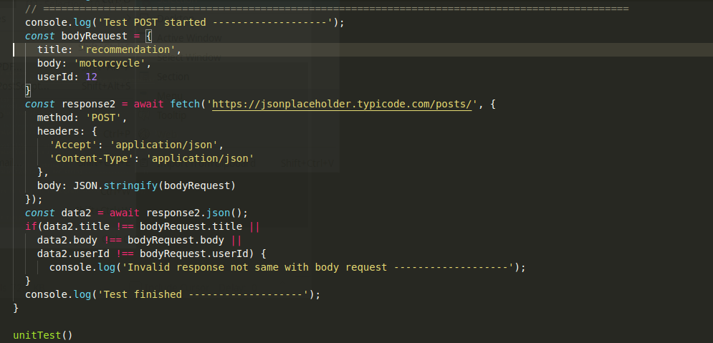

2. This Automation test script Using Selenium Web Driver, with java language
a. Register (register.java)
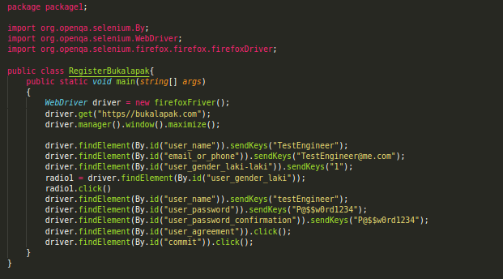

b. Login (login.java)
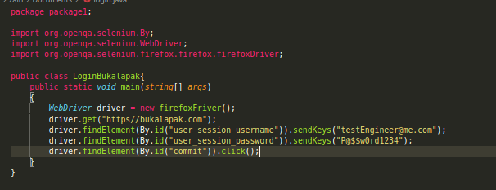

c. Add To Cart (addToCart.java)
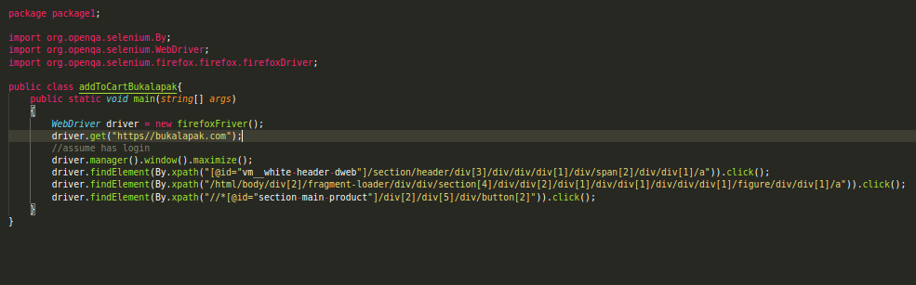
d. Search Product (searchProduct.java)
