Tech Requirements , by Widget/Viz

By Kamran Rahman

## Activity Feed

No mockup has been created for activity feed, but it will essentially show the last 20 reported incidents on our dashboard. The existing endpoint below can be used for this feed:

/shootings/last20

## Area Chart

For visualizations below, it would be good to have the following endpoint:

* /count/brutality/time/all
* Responses should include.
  + Count of incidents by Month/Year (expressed as a format of YYYY-MM) for all data

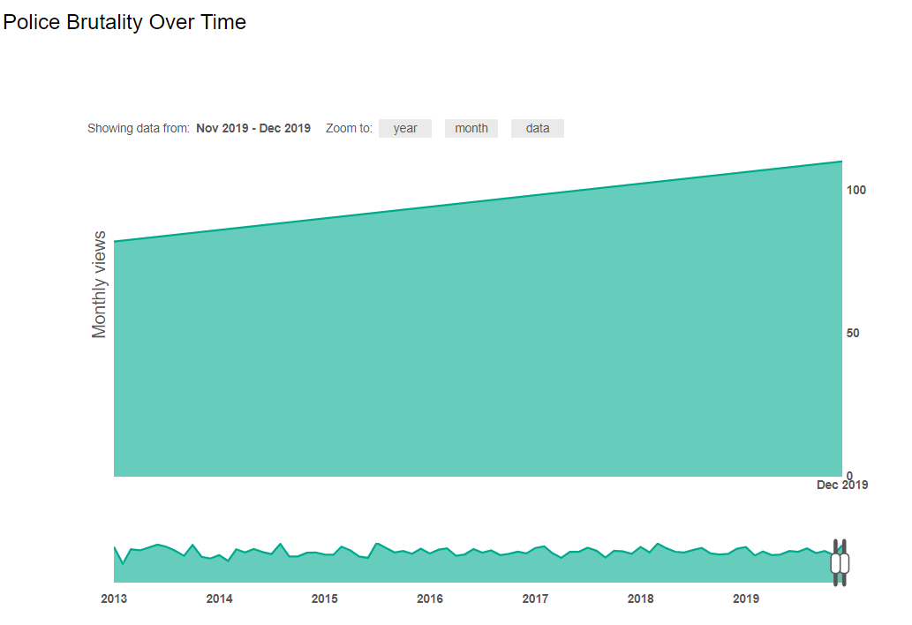

## Bar Chart

For visualizations below, it would be good to have the following endpoint:

* /count/brutality/[count of all incidents per state for all time]
* Responses should essentially contain key:pair values for state:count of incidents. Below is an example of what the data would look like for a state
  + {"name":"CA","value":1186}

