## Linux Systems Administration –

### Scenario
In the previous class activities, you acted as system administrator in order to troubleshoot a malfunctioning server.

The senior administrator was quite pleased with your work. Now, they would like you to prepare another server to replace this server. You are tasked with completing the steps below to prepare a new server.

### Lab Environment
Log into your local virtual machine. Use the following credentials:

- Username: `sysadmin`
- Password: `cybersecurity`

In order to get started with your tasks, you will need to open the Terminal within your Ubuntu VM. If you are unsure how to do it, within your Ubuntu VM, do the following:

- Open the Linux terminal by pressing Ctrl+Alt+T for Windows users or Ctrl+Options+T for Mac users.

- Alternatively, press Windows+A or Command+A for Mac users, then type "Terminal" in the search bar and select the Terminal icon (not the Xfce Terminal icon).

### Instructions

As you solve each step below, please fill out the [Submission File](SubmissionFile.md). This will be your homework deliverable.

For each of the following steps, you will need to run the correct command and confirm the results.

#### Step 1: Ensure Permissions on Sensitive Files

The `/etc/` directory is where system configuration files exist. Start by navigating to this directory with `cd /etc/`.

Inspect the file permissions of each of the files below. This should have already been completed in the activity, but let's double check!
If they do not match the descriptions, please update the permissions.

1. Permissions on `/etc/shadow` should allow only `root` read and write access.
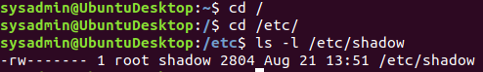

2. Permissions on `/etc/gshadow` should allow only `root` read and write access.
3. Permissions on `/etc/group` should allow `root` read and `write` access, and allow everyone else `read` access only.
4. Permissions on `/etc/passwd` should allow `root` read and `write` access, and allow everyone else `read` access only.

- **Hints:**

- Run the following command to view the file permissions: `ls -l <file>`

- If permissions need to be changed or modified, use the `chmod` command.

#### Step 2: Create User Accounts

This step asks you to set up various users. These commands do not require you to be working from a specific directory.

1. Add user accounts for `sam`, `joe`, `amy`, `sara`, and `admin`
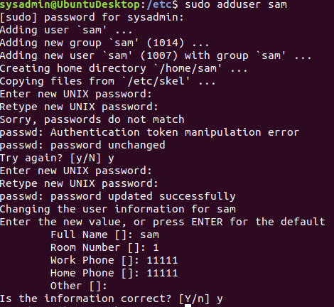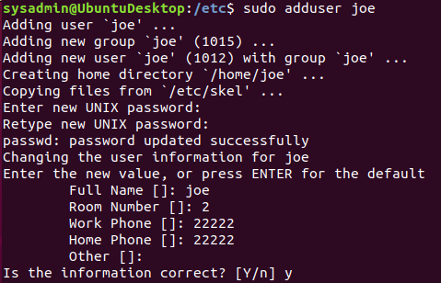

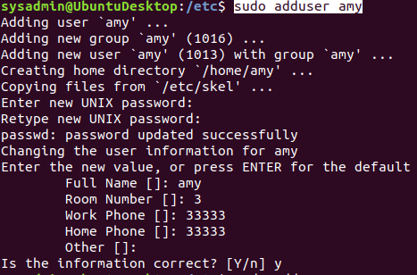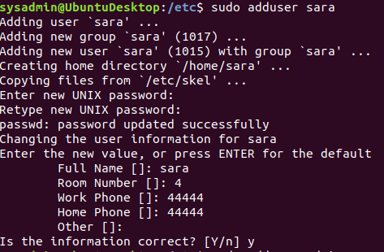

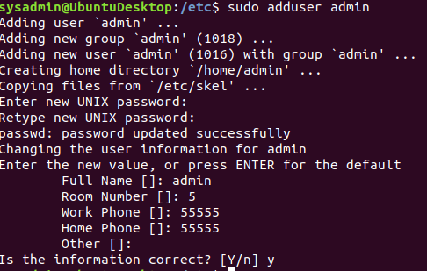

- **Hint:** In order for users to be added to the system, you need to run the command with `sudo`.

2. We want to make sure that only the `admin` user has general `sudo` group access. This requires a command that will allow user modifications.
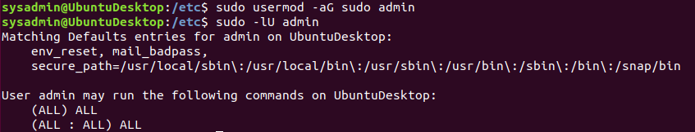

#### Step 3: Create User Group and Collaborative Folder

Now we want to execute the commands to fully set up a group on our system.

This requires us to create a group, add users to it, create a shared group folder, set the group folder owners for these shared folders.

1. Add the group `engineers` to the system. 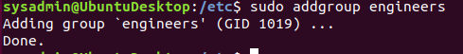

2. Add users `sam`, `joe`, `amy`, and `sara` to the managed group. This will be similar to how you added `admin` to the `sudo` group in the previous exercise.
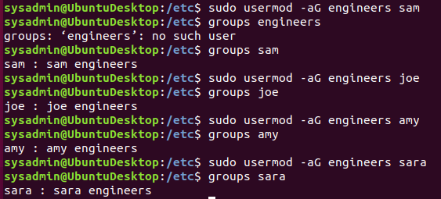

3. Create a shared folder for this group: `/home/engineers`.
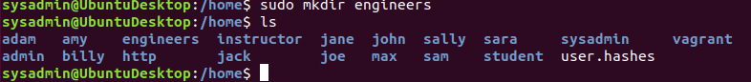

4. Change ownership on the new engineers' shared folder to the `engineers` group. 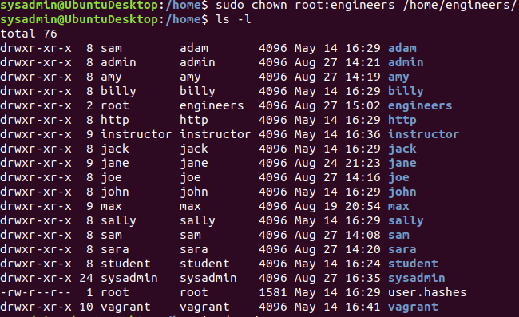

#### Step 4: Lynis Auditing

The final step on your administrator's list involves running an audit against the system in order to harden it. You'll use the system and security auditing tool Lynis to do so.

1. Install the Lynis package to your system if it is not already installed.
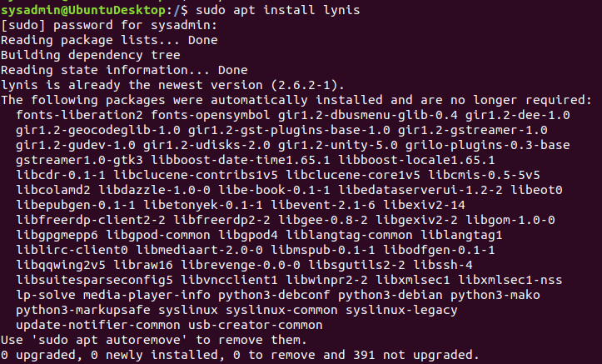
2. Check the Lynis documentation for instructions on how to run a system audit. 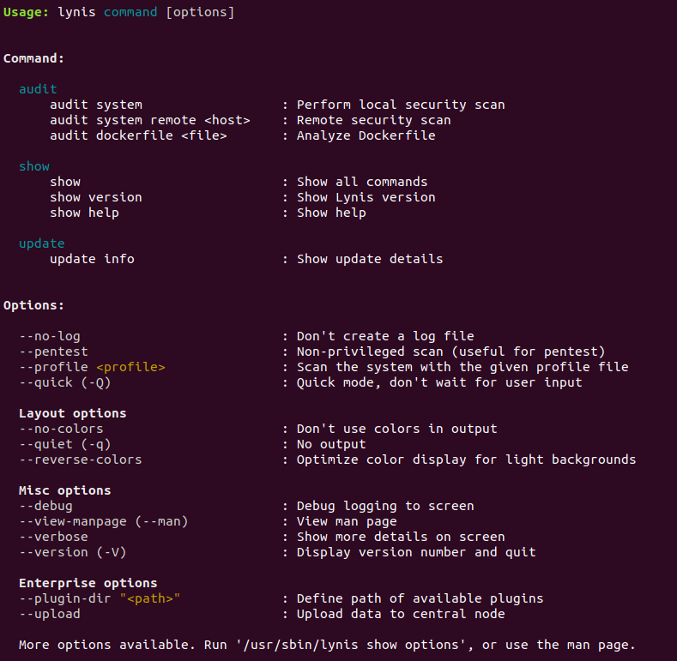

3. Run a Lynis system audit with `sudo`.

4. Provide a report from the Lynis output on what more could be done to harden the system.
- 4 Warnings Found:
- Lynis version is very old and should be updated.
- No password set for single mode.
- Found 1 or more vulnerable packages.
- Found some information disclosure in SMTP banner.
- Suggestions:
- Install libpam to enable multi factor authentication for PAM sessions.
- Install listchanges to display significant changes prior to any upgrade.
- Install listbugs to display list of critical bugs.
- Consider hardening 11 SSH configurations.

#### Bonus

Despite claims from enthusiasts, Linux is _not_ immune to malware. You will need to install and run the application chkrootkit, to search for any potential rootkits installed on the system.

1. Install the chkrootkit package to your system if it is not already installed. 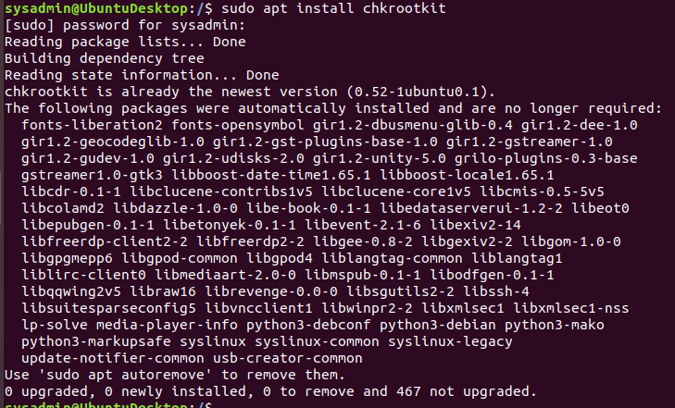

2. Check the chkrootkit documentation for instructions on how to run a scan to find system root kits. 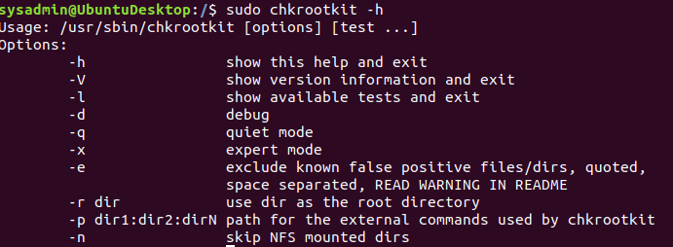

3. Run chkrootkit (with `sudo`) in expert mode to verify the system does not have a root kit installed.

4. Provide a report from chkrootkit output on what more could be done to harden the system.

### Submission Guidelines
- Use the [Submission File](SubmissionFile.md) to document your answers.

### Vagrant Update

After you complete this homework, please make sure to pull the latest Vagrant virtual machine build.

---
© 2020 Trilogy Education Services, a 2U, Inc. brand. All Rights Reserved.

