**AUS_CRICKERERS_STATS_PIPLINE**

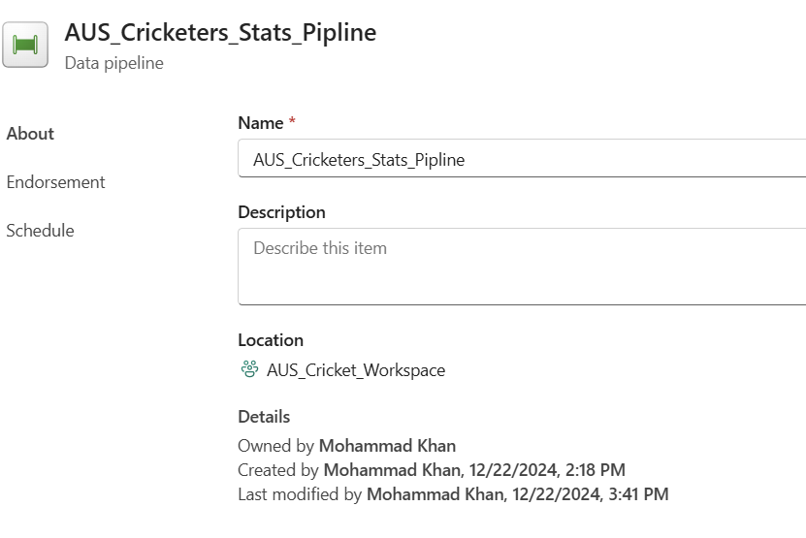

**Pipeline Description for Retrieving Player Stats from a Free API in Microsoft Fabric**

This pipeline in Microsoft Fabric is designed to retrieve player stats data from a free API, transform it, and store it in a Lakehouse table for use in creating interactive dashboards and analysis in Power BI.

**Step 1: Data Ingestion**

* The pipeline starts by accepting an array parameter containing player_ids. Each player_id corresponds to a specific player whose stats need to be retrieved.
* For each player_id, the pipeline queries the free API, passing the player ID dynamically to fetch the player’s statistics.
* The API response, which contains detailed stats for each player, is then stored in a DataFrame. This DataFrame serves as a temporary and structured storage of the data, facilitating further transformation and processing.

**Step 2: Data Transformation**

* Once the data is ingested into the DataFrame, the pipeline moves to the transformation stage.
* In this step, the raw data is processed to meet the required structure for analysis and reporting. This may include:
  + Data cleansing: Removing or correcting any incomplete or incorrect entries.
  + Data enrichment: Adding calculated fields, aggregating data, or deriving new statistics from the raw data.
  + Transformation: Standardizing formats, converting data types, or filtering irrelevant records.
* The transformed data is saved into a new DataFrame, ensuring it is structured and ready for storage and use in downstream tasks.

**Step 3: Data Storage in Lakehouse Table**

* The newly transformed DataFrame is then stored in a Lakehouse table named AUS_CricketerStatus.
* The Lakehouse table serves as a centralized and optimized storage location for player stats, making the data easily accessible for reporting, analysis, and further downstream processing.
* Storing the data in a Lakehouse table ensures scalability and supports both batch and real-time data processing.

**Step 4: Data Utilization for Dashboards and Power BI Analysis**

* The AUS_CricketerStatus Lakehouse table is used as the data source for creating dynamic and interactive dashboards within Microsoft Fabric.
* These dashboards visualize key player stats, allowing stakeholders to gain insights into player performance, rankings, and other relevant metrics.
* The dashboards are then integrated with Power BI, enabling advanced data analysis, real-time reporting, and business intelligence insights, helping decision-makers and analysts to explore and interpret player data.

This pipeline ensures seamless flow from data ingestion, transformation, and storage, to powerful data visualizations in Power BI, providing a comprehensive and interactive view of player stats for actionable insights.

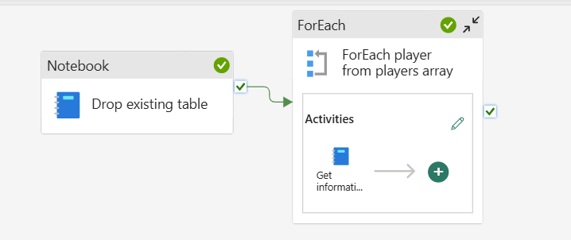

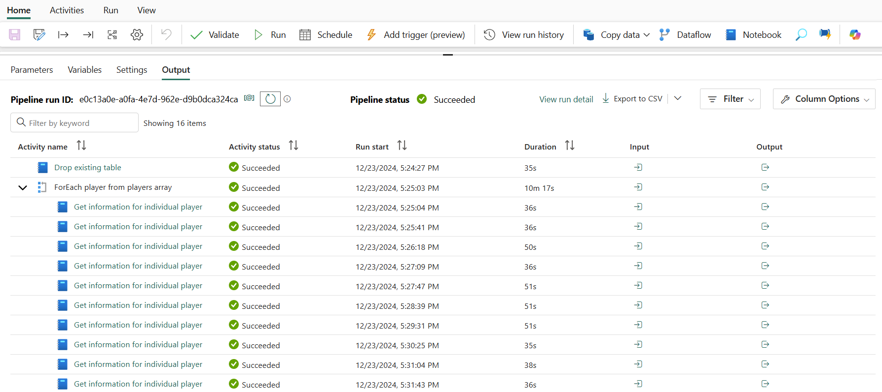

GitHub repository link : <https://github.com/mzaidikhan/AUS_CRICKET>