**Blind Opener Project Sheet**

**Required items:**

|  |  |  |  |
| --- | --- | --- | --- |
| **Part Name** | **Supplier** | **Cost ($)** | **Comments** |
| ~~1Nm Stepper Motor -> Nema 23~~  0.4Nm Stepper Motor -> Nema 17 | Ebay | 15 | Sized down to a smaller stepper motor for size, weight, cost benefits. Incorporated gear design to compensate for power loss. |
| Stepper Motor driver (5 pack) | Ebay | 10.50 |  |
| Infrared sensor with remote | Ebay | 7.50 |  |
| 2.1 DC Input power module | Jaycar | 3 |  |
| Pro Micro Arduino Board | Ebay | 15 |  |
| Smart Infrared Remote | Ebay | 20 |  |
| Capacitor | Jaycar |  |  |
| Resistor | Jaycar |  |  |
| Bearings (10 Pack) | Jaycar | 10 |  |

**Gear Design**

As calculated, the torque required to turn the blinds from a closed -> open position requires:

0.735Nm

To minimize size, cost and weight, I chose a 0.4Nm holding torque stepper motor which has a active torque of 0.34Nm. Rounding this down to ensure tolerance, we assume the stepper has a torque of 0.3Nm. To counter this loss in force, I implemented a gear design to increase output torque. The input gear will have 13 teeth to the output gear which has 36 teeth. This equates to a torque multiplication of:

36/13 = 2.76 approx.

Meaning I will receive an output torque of:

2.76 * 0.3 = 0.828Nm

Which should suffice in moving the roller blinds in both directions without the need of a counterweight.

The larger output gear will be 3D printed with a beaded circular component in which the thread of the roller blind will wrap around. This set will be rotated around a standard 22x7x8 bearing on a M8 screw acting shaft.

**Blind Opener Case Design**

The blind opener would be designed to be compact and subtle. The encloser would house the Nema17 stepper motor as well as the control electronics. It would have openings for the power supply, the USB-C port for the micro-controller as well as the RF sensor. The lid, base and motor would be joined with M3 screws. Small shelves would be designed to hold the Arduino board and the motor driver board. Below is the first assembly design of the blind opener.

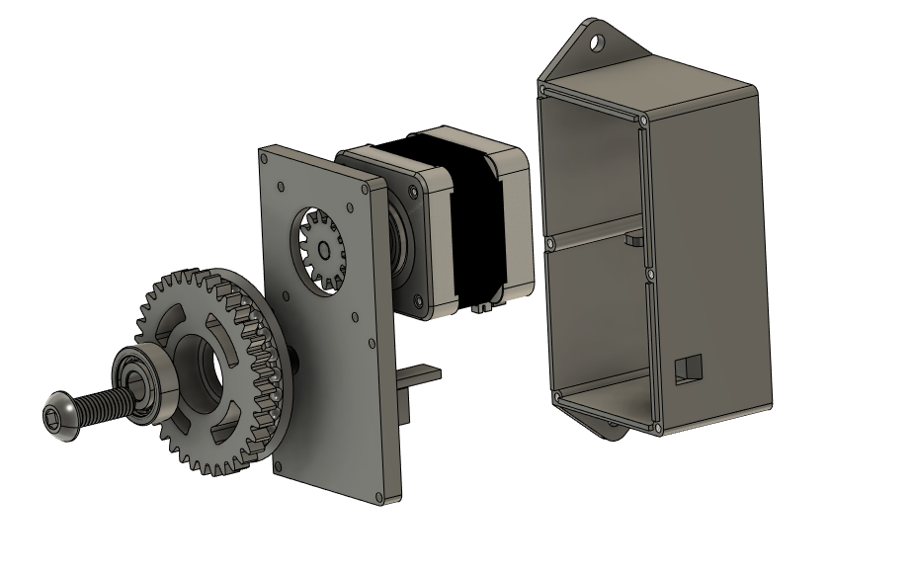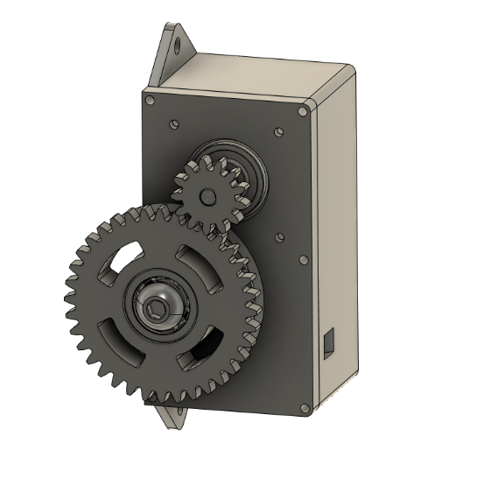

Figure 1: Blind Opener V1 Assembly.

Figure 2: Exploded view of Blind Opener Assembly.

**Torque Insufficiencies**

With the above design, the torque was adequate to close the blinds however was unable to open them. The force and friction of the gears impacts the output of force and therefore more torque is required. After acquiring a 3D printer of my own, I was able to research and experiment with various gearbox’s to maximize torque output without altering the hardware I had already purchased.

**Planetary Gearbox 3.7:1**

Utilizing the plethora of designs available online through the 3-D printing community, I began experimenting with planetary gearboxes to increase my output torque. I began by printing: <https://www.printables.com/model/281222-nema17-planetary-gearbox> which utilized hardware I already had and would theoretically increase my torque by 3.7 times. After printing and installing the gearbox, a similar issue was found where the output was still to low to open the blinds.

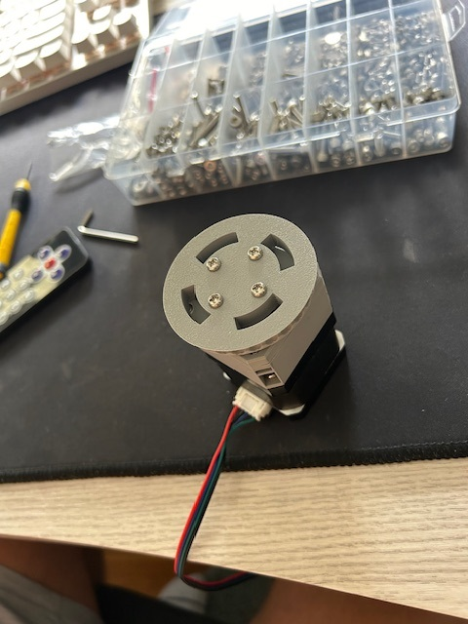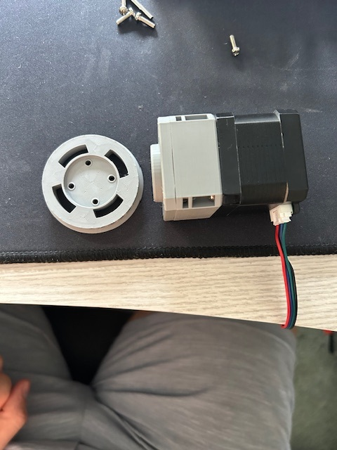

Figure 3 & 4: 3.7:1 Gearbox with custom design spool for the Nema 17 stepper motor.

**Planetary Gearbox 25:1**

After another failed design, I looked to overcompensate on the torque aspect and found an online design which amplified the torque by a ration of 25:1 (<https://www.printables.com/model/136854-25-1-ratio-planetary-gearbox-for-nema-17-stepper> ) . After purchasing some additional fasteners, I printed and assembled the gearbox for testing. Initial tests proved to be promising as the blinds were able to be opened however due to the lack of friction with the chain beads on the output spool, the chain would jump and skip output rotations. Additionally, the way the gearbox was designed, the front spool was attached to a bearing that simply clicked into the front face of the gearbox. To successfully pull the blinds open, the tension of the chain had to be quite taught which would cause the bearing to slip out of the frame.

Figure 5 & 6: 25:1 Gearbox with custom design spool for the Nema 17 stepper motor.

**Spool Design**

The initial design of the spool mimicked the size of the blind’s chain mechanism. I measured the dimensions of the beaded chain and implemented a similar pattern into a spool on Fusion 360 (Figure x). This was advantageous for initial testing however due to the skipping of beads under high load (blind opening), I sought to improve the design. I began by increasing the size of the spool as well as the distance between the bead housings within my design. This is because I noticed that when the rope was taught, the beads would not sit properly in their grooves. This improved traction however skipping was still frequent. I then turned to the design of the blind itself and replicated the box-like pattern (Figure x). This way, the beads would simply get caught instead of having to fit a groove.