Prompt Submission Form
Field | Response
Name | Muhammed Zammari
Team | ISAS
Manager | Vishal Ghosalkar
Track | [X] Automation Acceleration [ ] Documentation Efficiency
Prompt Title | C# Excel Report Parser Generator Using Structured Prompting
Problem Statement/Impact (20 pts) Keep to 3–5 sentences.
Question | Response
What recurring task does this prompt address, or what value does it bring to your work? | Our QA team regularly builds C# parsers to extract and validate data from complex Excel reports (.XLS) with hidden columns, scattered cell positions, and multi-section layouts. Manually identifying column indices and writing extraction logic for each report is time-consuming and error-prone. This prompt uses structured context, explicit constraints, and incremental tasking to generate production-ready C# parser code that correctly handles non-sequential column layouts, dynamically locates sections by header text, and produces strongly-typed models with P1/P2 plan separation. The approach reduced parser development from approximately 4 hours of manual coding to under 15 minutes of iterative prompting and validation.
The Prompt:
You are generating a C# model and parser for Section 1 of the Monthly Department Detail Comparison Report Excel file (.XLS).
Section: Department FTE Summary
Structure: Each metric appears in two consecutive rows: one for Plan 1 (P1) and one for Plan 2 (P2). Each row contains exactly 14 non-empty values: (1) Description, (2) Jan through Dec (12 monthly values), and (3) Total.
Properties (8 metrics x 2 plans = 16 rows): Employed (Productive) FTEs, Contract Labor %, Contract FTEs, Total Productive FTEs, Non-Productive %, Non-Productive FTEs, Employed (paid) FTEs, Total FTEs (Paid + Contract).
Column Layout Constraint: The Excel file contains hidden columns, so cell values are scattered across non-sequential column indices (e.g., col 3, 6, 9, 11, 14...). Do NOT use hardcoded column positions. Instead, iterate through each cell in the row and collect only non-empty/non-null values. The first non-empty value is the Description; the next 12 are monthly values; the last is the Total.
Requirements: Create a MonthlyMetricRow class with Description (string), Jan–Dec (double), Total (double). Create a DepartmentFTESummary class with P1 and P2 properties for each of the 8 metrics. Create a static parser class that extracts the rows and maps them to the model. Round all numeric values to 2 decimal places. All parser methods should be static. Take this one section at a time. This is Section 1 of 3.

Output Example of Prompt (Quality & Accuracy – 35 pts)
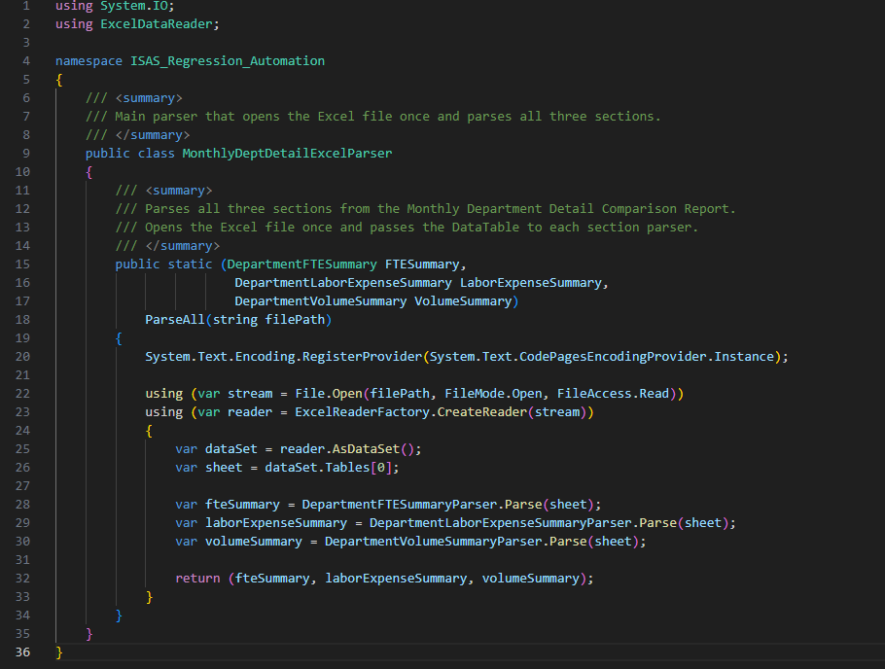
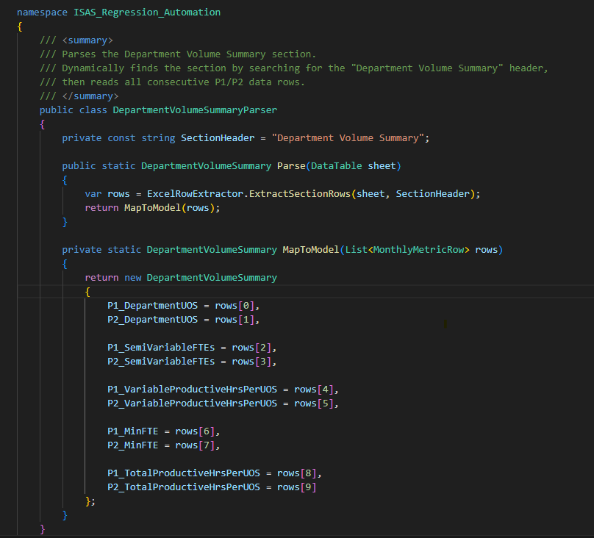
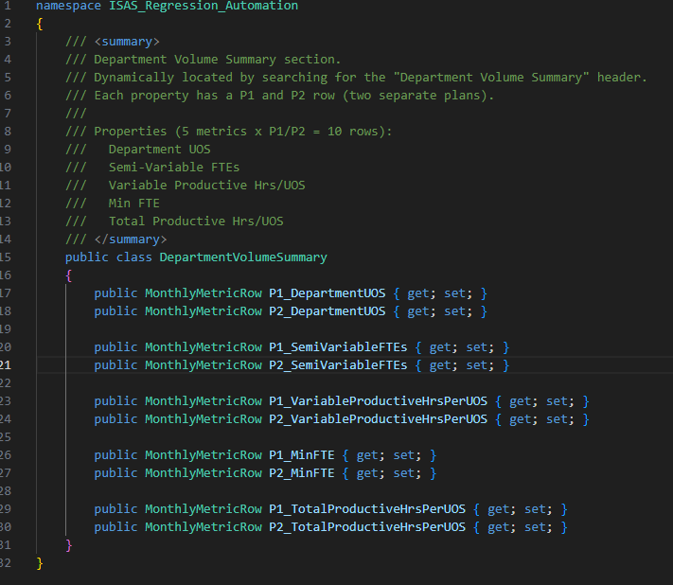
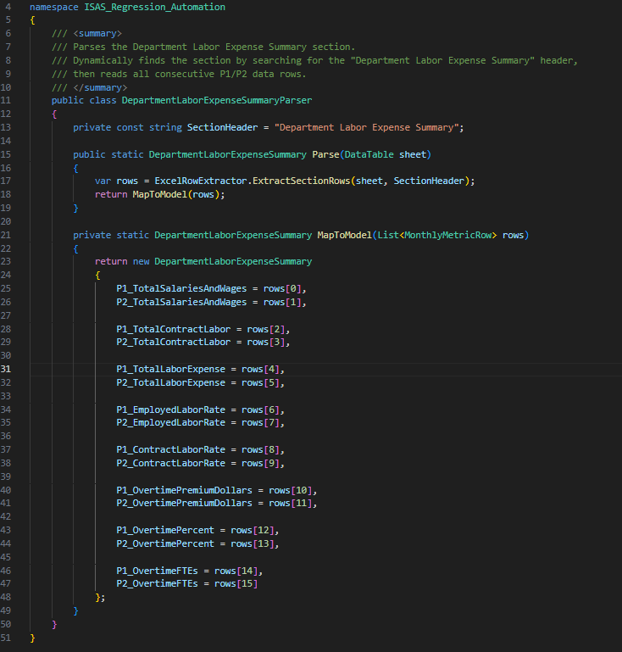

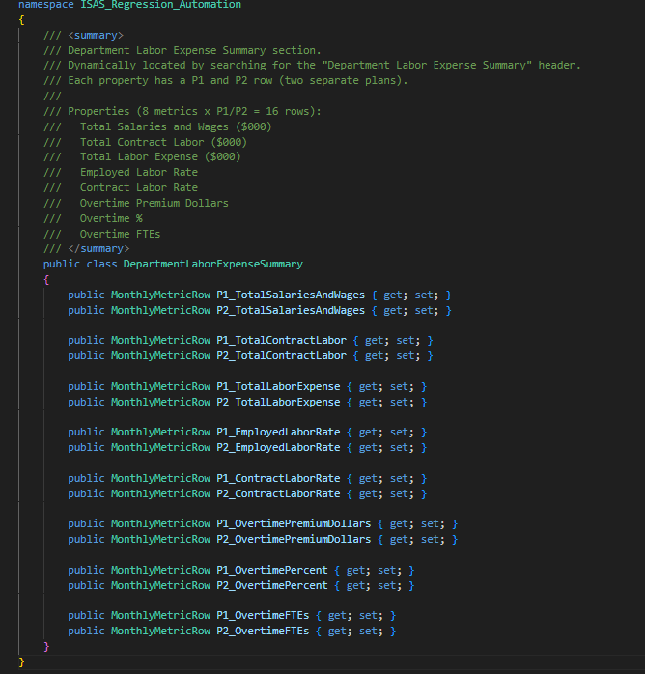

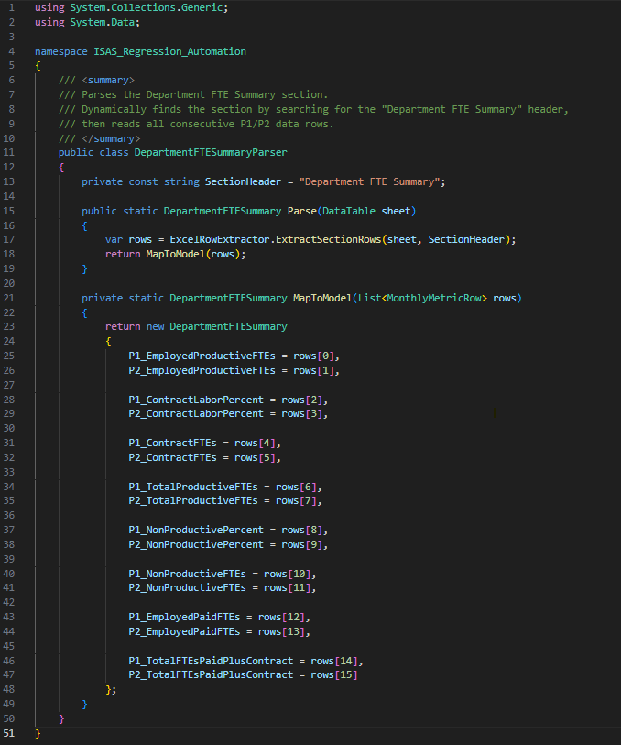
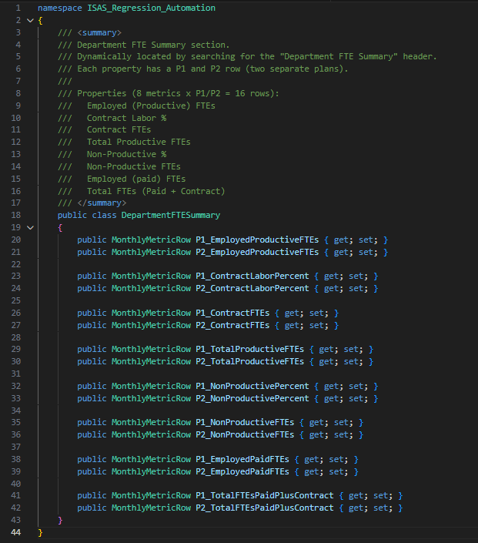
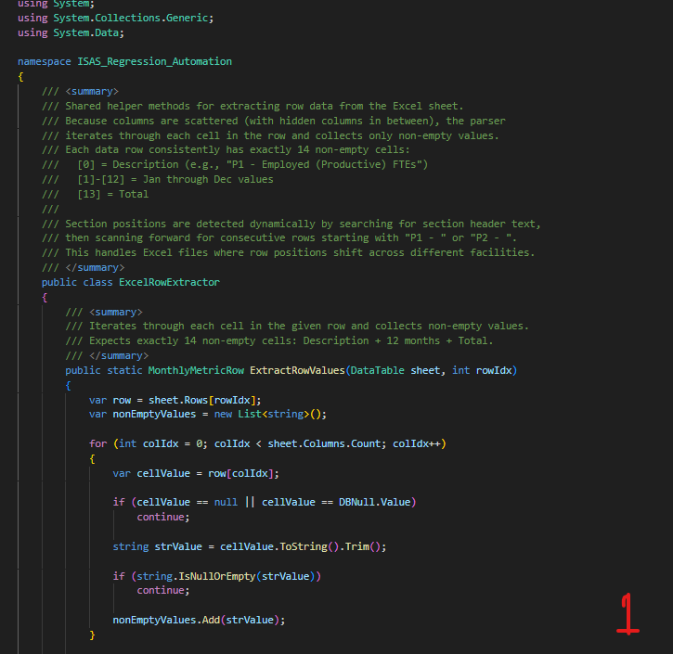
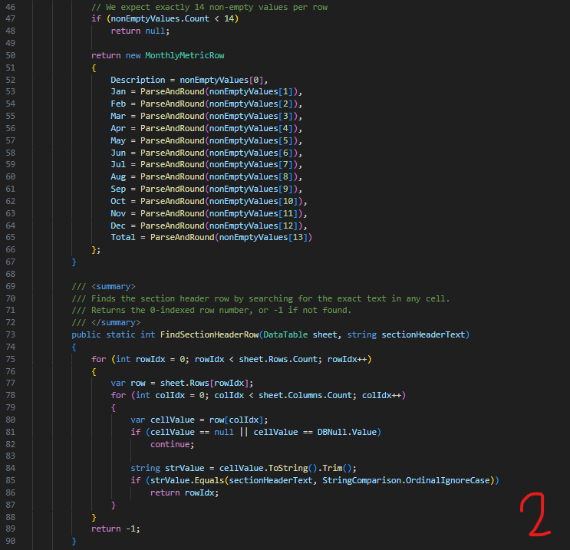
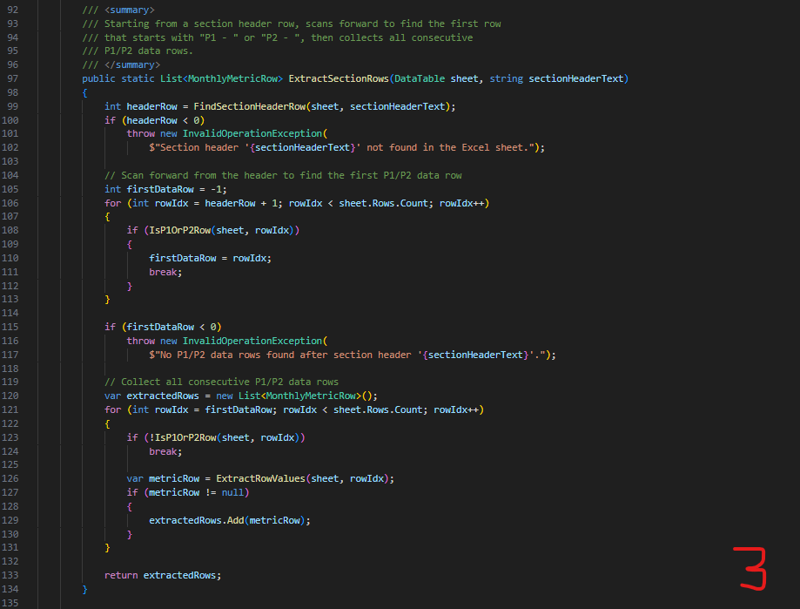
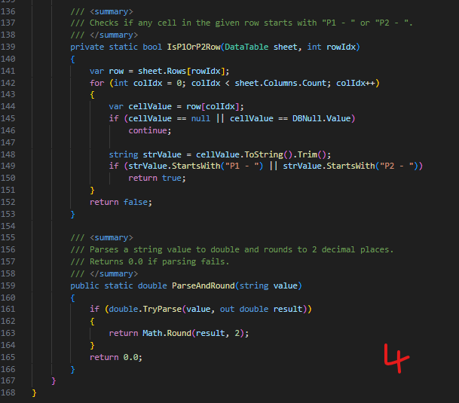

The prompt generated a complete C# parser consisting of nine classes: a reusable MonthlyMetricRow model (Description + 12 monthly doubles + Total, rounded to 2 decimals), three section models (DepartmentFTESummary, DepartmentLaborExpenseSummary, and DepartmentVolumeSummary) each with P1/P2 properties, three corresponding parser classes, a shared ExcelRowExtractor utility that dynamically locates sections by header text and iterates through non-empty cells to handle hidden columns, and a MonthlyDeptDetailExcelParser entry point that opens the file once and parses all three sections. The code compiled and validated successfully against Excel files from multiple facilities on the first iteration

Time Savings (25 pts)
Metric | Response
Time Before AI | ~4 hours
Time After AI | ~15 minutes
Frequency | 2–3 times per month
Estimated Monthly Time Saved | ~8–12 hours

Reusability (20 pts)
Question | Response
Reusability Level | [ ] Highly reusable [X] Reusable with small edits [ ] Mostly team-specific
Brief Explanation | The prompt structure is reusable for any Excel report with hidden columns and multi-section layouts. Team members can substitute the section name, property list, and row ranges to generate parsers for other WFT reports. The core techniques (structured context, explicit constraints, incremental tasking, anti-pattern prevention) apply broadly to any code-generation prompt.

Guardrail Confirmation
Confirmation | Mark X
No sensitive data used in public AI tools | [X]
Output reviewed and validated by a human | [X]

Reviewer Evaluation (For Judging Panel Use Only)
Category | Score
Time Savings (25 pts)
Output Quality & Accuracy (35 pts)
Practical Impact (20 pts)
Reusability (20 pts)
Total (out of 100)

Reviewer Notes:

