# Wikidisney

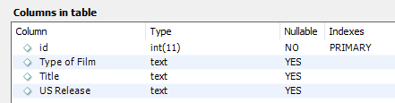

# DisneyList

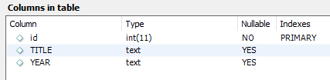

# IMDBDisney

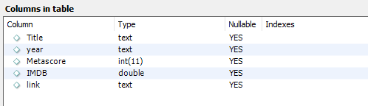

# Movie_Disney_Gross_Sales1

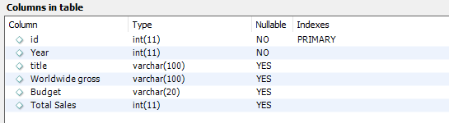

# Dis_Characters

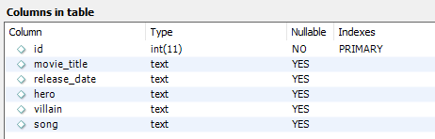

# Dis_Voices

