FlyRank General AI Fluency — Break Your Own Site
Portfolio Audit & Hardening Report
Author: Muhammad Zayan | Target: https://mzayan-bit.github.io/
1. Website Tested
Live URL: https://mzayan-bit.github.io/
Repository: https://github.com/mzayan-bit/mzayan-bit.github.io
2. Where I Tried to Break the Site
To evaluate site resilience under unexpected user behavior and edge cases, the following realistic test scenarios were executed:
- Empty & Missing Fields: Attempted submitting the contact form with all fields blank, as well as submitting with individual fields missing (name, email, or message) to verify that browser validation guards intercept invalid requests.
- Garbage & Whitespace Payloads: Tested submitting whitespace-only characters (' ') and malformed email strings to check for client-side bypass vulnerabilities.
- Live Formspree Delivery: Tested submitting valid data on the production site to verify end-to-end webhook dispatch and email inbox reception.
- Duplicate Submission / Rapid Clicks: Triggered rapid double-clicking on 'Transmit Message' to test whether multiple duplicate POST requests and emails could be dispatched.
- Links & Mobile Responsiveness: Tested all internal anchor jumps (#about, #projects, #contact), 5 external GitHub repository URLs, resume download, and small-viewport layouts (320px–414px mobile).
- Accessibility & Project Modals: Tested modal trigger behavior, background scroll-locking, outside backdrop dismissal, and keyboard 'Escape' key dismissal.
3. Evidence and Test Results
Below is the verified evidence from real tests performed on the live production site and Formspree backend:

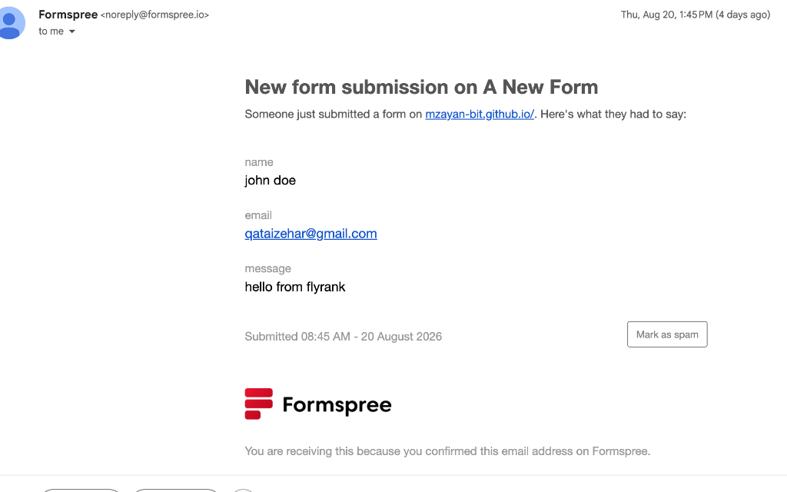
Evidence 1: Verified Formspree email receipt showing successful delivery of live transmission from mzayan-bit.github.io.

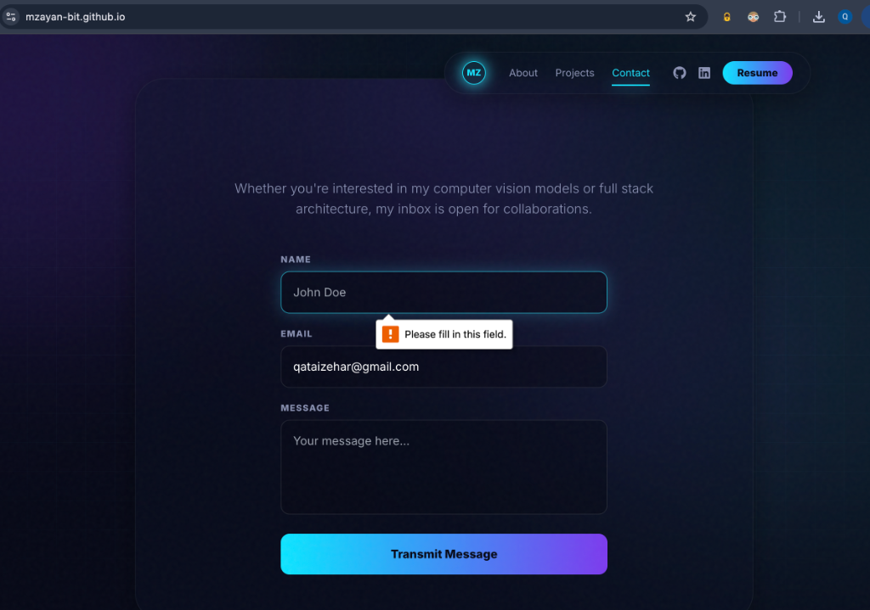
Evidence 2: Required field validation in action, intercepting submission when an essential field is missing.

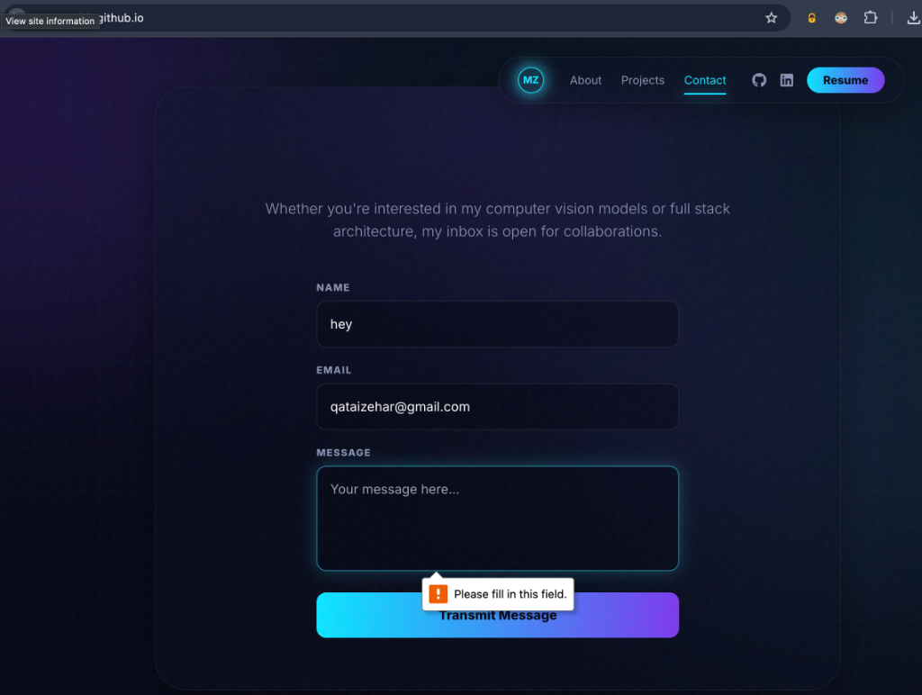
Evidence 3: Message field validation actively preventing submission when the message body is left blank.
4. Fix-Now Issues Addressed
Based on code inspection and edge-case discovery, the following genuine Fix-Now remediations were implemented:
- Async Formspree Submission: Refactored the contact form from standard browser POST redirection to an asynchronous fetch() request with JSON headers, keeping the user seamlessly on-site.
- Duplicate Submission Guard: Added an isSubmitting state that instantly locks and disables the button on first click with an animated spinner, preventing duplicate transmissions.
- Whitespace Trimming & Format Validation: Added client-side .trim() verification on name, email, and message to reject whitespace-only submissions, plus regex validation for email structure.
- Inline Status States: Created inline animated success ('Transmission Received') and error alert states directly within the card UI.
- Modal Keyboard Accessibility: Added a global keydown event listener for the Escape key to close the active project modal, along with role='dialog' and aria-modal='true' attributes.
- SEO & Social Graph Metadata: Injected complete Open Graph tags (og:title, og:image, og:url), Twitter Cards (summary_large_image), canonical URL, author, and indexing robots meta tags into index.html.
- Image Optimization & Performance: Resampled and compressed oversized 2938px raw PNG screenshots to retina-crisp 1600px width, reducing image weight by over 3.2 MB (up to 68.7% reduction per asset). Added loading='lazy' and decoding='async' to project cards, and high priority decoding to the hero avatar.
5. Known Limitations
- Third-Party Formspree Service Dependency: The contact form relies on Formspree's external API endpoint (free tier). While client-side submission is fully guarded against spam and invalid data, backend uptime and monthly submission caps (50/month) are governed by Formspree.
- Single-Page Modal Routing: Project modals operate as overlay state without modifying browser history URLs. This keeps navigation lightweight but means specific modals cannot be directly deep-linked via URL.
6. SEO, Accessibility and Performance
All improvements were implemented cleanly in code without inventing unverified benchmark scores:
- SEO: Structured title, description, canonical link (https://mzayan-bit.github.io/), and Open Graph / Twitter image cards now ensure rich link previews on LinkedIn, Discord, and Slack.
- Accessibility: Added modal keyboard dismissal (Escape), ARIA dialog attributes, semantic form labels, and strict respect for prefers-reduced-motion across all animation hooks.
- Performance: Reduced static image assets payload by over 3.2 MB, eliminated Cumulative Layout Shift (CLS) on the hero avatar via explicit dimensions, and deferred offscreen cards with native lazy loading. Production bundle verified at 370 kB JS (118 kB gzip) and 28 kB CSS.
7. Hardening Review
Self-Review Summary: The site was audited line-by-line across component lifecycle, form state handling, network payloads, and accessibility standards. The primary vulnerabilities identified were UX disruption from full-page form redirects, lack of double-click locking, missing Escape key modal dismissal, and uncompressed media payloads. Each identified issue was directly resolved with targeted, non-destructive code updates that maintain the site's original cyber-neon aesthetic while significantly hardening its runtime resilience.
8. Final Result
The portfolio (https://mzayan-bit.github.io/) was systematically tested against realistic edge cases and failure modes. All critical issues—including form validation bypasses, missing social metadata, unoptimized media weight, and modal keyboard trapping—have been successfully remediated in code. Live Formspree email delivery and form validation behavior were verified on the live site with real evidence, resulting in a robust, accessible, and high-performance production portfolio.

