**Supplementary table and figures**

Supplementary Information

Supplementary Tables S1–S2 and Figures S1–S12

Table S1. Summary of meta-analysis effect sizes and heterogeneity statistics. Effect sizes reported as log response ratios (log RR), with τ², I², Q (df), and Q p-value.

|  |  |  |  |  |  |  |  |  |
| --- | --- | --- | --- | --- | --- | --- | --- | --- |
| **Outcome** | **Effect Size (Log RR)** | **Standard Error** | **95% CI Lower** | **95% CI Upper** | **p-value** | **Tau²(τ²)** | **I² (%)** | **Q (df)** |
| Alpha Diversity (Shannon Index) | -0.472 | 0.121 | -0.71 | -0.234 | 0.0001 | 0.0279 | 16.4 | Q(df = 11) = 11.2139 |
| Firmicutes | 0.0762 | 0.0328 | 0.0119 | 0.1405 | 0.0203 | 0.0141 | 96.09 | Q(df = 18) = 544.722 |
| Bacteroidetes | -0.127 | 0.0617 | -0.248 | -0.0061 | 0.0395 | 0.0587 | 92.22 | Q(df = 18) = 286.48 |
| F:B Ratio | 0.1467 | 0.0859 | -0.0216 | 0.3149 | 0.0876 | 0.1398 | 99.91 | Q(df = 18) = 24505.1 |

Table S2: Results of Egger’s test and trim-and-fill analysis for alpha diversity and phylum-level models.

|  |  |  |  |  |  |  |  |  |
| --- | --- | --- | --- | --- | --- | --- | --- | --- |
| **Measure** | **Egger’s z** | **Egger’s p-value** | **Intercept (95% CI)** | **Missing studies (trim-and-fill)** | **τ²** | **I² (%)** | **Q (df)** | **Q p-value** |
| Alpha diversity | 0.6092 | 0.5560 | –0.6362 (–1.2311, –0.0412) | Left:1 (SE = 2.3675) | 0.0244 | 13.93 | 11.847  (12) | 0.4580 |
| Firmicutes | –2.033 | 0.0421 | 0.1276 (0.0532, 0.2020) | Right: 6 (SE = 2.83) | 0.0173 | 96.26 | 602.63 (24) | < 0.0001 |
| Bacteroidetes | 1.509 | 0.1314 | –0.2765 (–0.5021, –0.0509) | Left: 3 (SE = 2.95) | 0.0621 | 92.03 | 313.30 (21) | < 0.0001 |
| F:B Ratio | –2.650 | 0.0080 | 0.6592 (0.2531, 1.0652) | Right: 2 (SE = 2.92) | 0.1604 | 99.91 | 25 972.90 (20) | < 0.0001 |

Figure S1. Forest plot of alpha diversity (Shannon index) Hedges’ g for 12 diet comparisons in P. americana. Points = study effects; horizontal bars = 95% CI; diamond = pooled estimate.

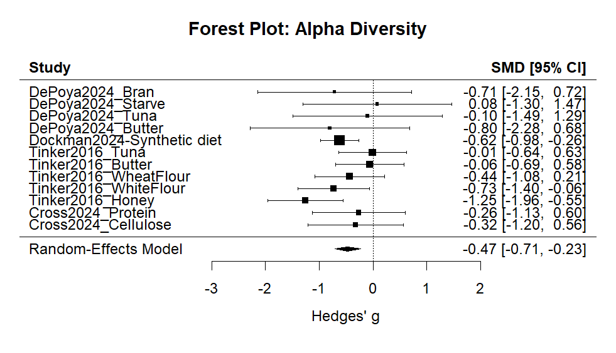

Figure S2. Funnel plot of Hedges’ g vs. SE for alpha diversity. Dashed line = pooled effect; tests for asymmetry by Egger’s regression.

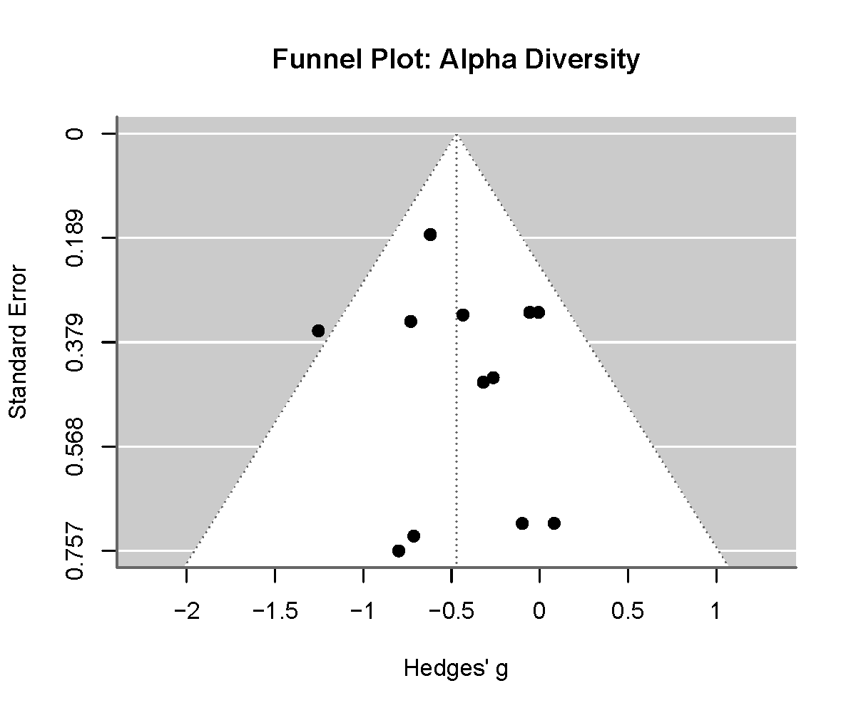

Figure S3. Leave-one-out sensitivity plot for alpha diversity. Points = pooled g after omitting each study; dashed line = original pooled g.

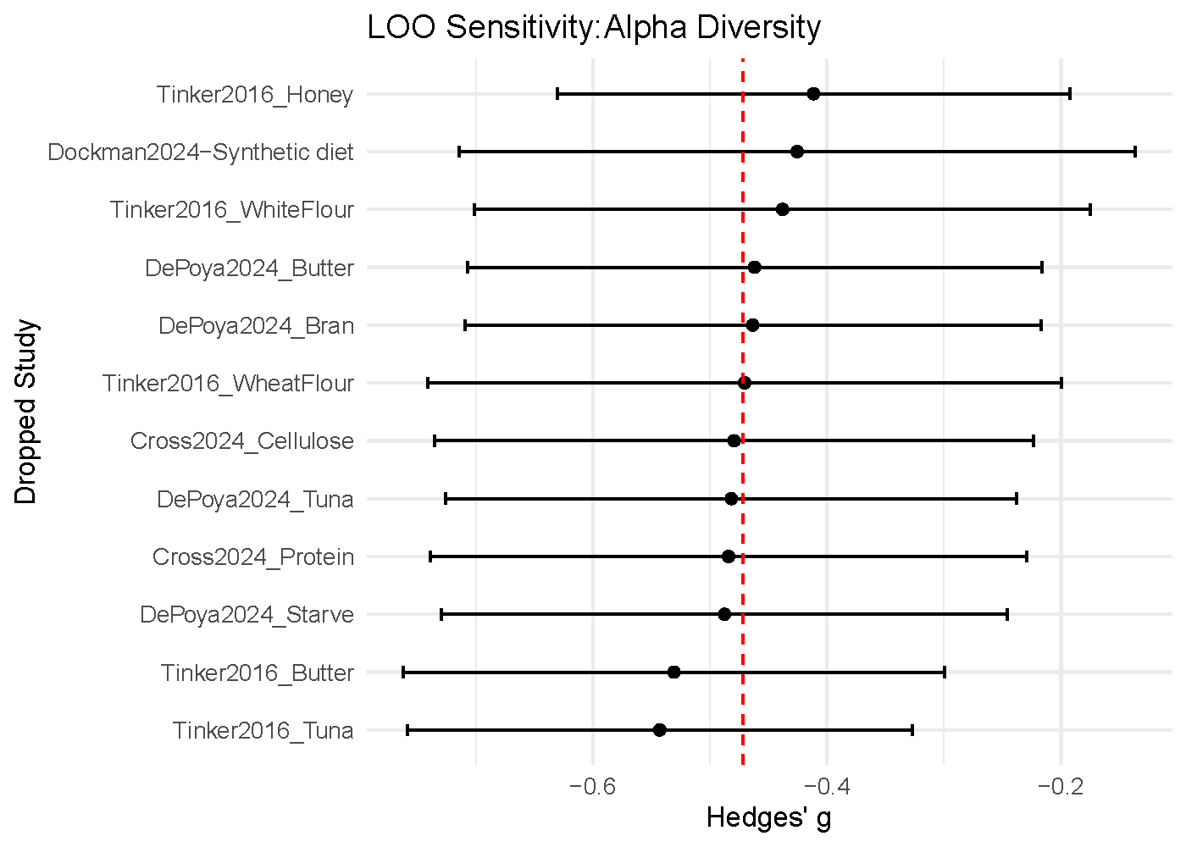

Figure S4. Forest plot of Firmicutes log-ratio for 19 diet comparisons. Points = study log RR; bars = 95% CI; diamond = pooled log RR.

Figure S5. Funnel plot of Firmicutes log RR vs. SE.

Figure S6. Leave-one-out sensitivity plot for Firmicutes log RR.

Figure S7. Forest plot of Bacteroidetes log-ratio for 19 diet comparisons.

Figure S8. Funnel plot of Bacteroidetes log RR vs. SE.

Figure S9. Leave-one-out sensitivity for Bacteroidetes log RR.

Figure S10. Forest plot of Firmicutes: Bacteroidetes ratio log-ratio.

Figure S11. Funnel plot of Firmicutes: Bacteroidetes ratio log RR vs. SE.

Figure S12. Leave-one-out sensitivity for F:B ratio log RR.

