Where severe heat and priority-population burden coincide in Kenya: a biometeorological subcounty screening analysis, 2015-2025
Felix Oluoch, Fredrick Gudda, Prissy Makena, Anthony Ngugi, Jai K Das, Zulfiqar Ahmed Bhutta
Felix Oluoch: Department of Population Health, Aga Khan University, Nairobi, Kenya; Institute for Global Health and Development, Aga Khan University, East Africa, Nairobi, Kenya.
Fredrick Gudda: Department of Population Health, Aga Khan University, Nairobi, Kenya; Institute for Global Health and Development, Aga Khan University, East Africa, Nairobi, Kenya.
Prissy Makena: Department of Population Health, Aga Khan University, Nairobi, Kenya.
Anthony Ngugi: Department of Population Health, Aga Khan University, Nairobi, Kenya.
Jai K Das: Institute for Global Health and Development, Aga Khan University, Karachi, Pakistan; Department of Paediatrics and Child Health, Aga Khan University, Karachi, Pakistan.
Zulfiqar Ahmed Bhutta: Institute for Global Health and Development, Aga Khan University, Karachi, Pakistan; Centre for Global Child Health, The Hospital for Sick Children, Toronto, Ontario, Canada.
ORCID identifiers: Not provided.
Corresponding author: Dr Felix Oluoch, Department of Population Health, Aga Khan University, Nairobi, Kenya. Email: oluoch.felix@aku.edu

Abstract
Extreme heat is an increasing public-health concern in sub-Saharan Africa, yet nationally comparable evidence on persistent severe heat exposure and priority-population burden remains limited. We characterised severe heat exposure and screening priorities across all 290 Kenyan subcounties for pregnant women, children under five years, and adults aged 60 years and older. We conducted a nationwide ecological screening analysis using annual subcounty observations from 2015 to 2025, with climatological context from 1991 to 2025. Severe heat was measured as annual days with daily maximum Universal Thermal Climate Index (UTCI) > 38 °C (H38), with each > 46 °C day adding an explicit extreme-heat severity increment. Primary screening priorities were hazard-gated: subcounties with H38=0 received a priority score of zero. Pregnancy scenarios retained the same national annual total while varying its subcounty allocation; they test ranking robustness, not the validity of local pregnancy counts. National mean annual H38 increased over 1991-2025 (Sen slope 0.97 days per year; p<0.001). In 2025, 136 subcounties had H38=0 and were not ranked for primary heat priority. Alternative pregnancy allocations retained 19 of 20 base-case priorities (rank correlations 0.9994-0.9998). These results identify robust screening-priority geographies, not causal effects, individual risks, or observed pregnancy counts. Persistent severe heat exposure and priority-population burden are concentrated in a structurally stable set of socioeconomically disadvantaged Kenyan subcounties. These findings provide nationally consistent screening evidence to support priority setting and local validation for heat-health planning; they do not constitute a locally validated vulnerability model or direct estimates of health effects.
Keywords: Universal Thermal Climate Index; Heat Index; biometeorology; heat stress; priority populations; Kenya

Introduction
Extreme heat is one of the most hazardous consequences of climate change and an increasing threat to public health in low- and middle-income countries, where adaptive capacity is often limited and populations are especially vulnerable to heat stress (Gasparrini et al. 2015; Hajat et al. 2007). Global mean surface temperature has already risen by about 1.1 °C above preindustrial levels, and all plausible emissions pathways project further increases in the frequency, intensity, and duration of extreme heat events during the twenty first century (IPCC 2021). Sub-Saharan Africa is expected to experience large increases in heat stress because many settings already have high ambient temperatures, populations are growing rapidly in exposed areas, and heat-risk reduction infrastructure remains limited (IPCC 2021; Coffel et al. 2018). Kenya is a particularly important setting in which to examine these challenges because it spans chronically arid lowlands and cooler highland zones, while marked geographic inequality and poverty remain concentrated in areas already exposed to severe heat (Kenya National Bureau of Statistics 2019).
The health effects of heat are unequally distributed across populations. Pregnant women are at increased risk of preterm birth, low birthweight, stillbirth, and maternal heat illness during sustained thermal stress, through mechanisms that may include impaired thermoregulation, placental hypoperfusion, and heat induced labour (Zhang et al. 2017; Chersich et al. 2020). Children under five years are also especially susceptible because of their high surface area to body mass ratio, limited capacity for behavioural thermoregulation, and reliance on caregivers for protective action (Xu et al. 2014). Older adults face compounded risks arising from reduced cardiovascular and thermoregulatory reserve, a greater burden of chronic disease, and a higher likelihood of social isolation or limited access to cooling (Hajat et al. 2007; Kenny et al. 2010). These groups therefore represent overlapping but distinct priorities for heat-health intervention, making geographic targeting of prevention and preparedness efforts a clear public health priority.
Despite growing recognition of heat as a health hazard in sub-Saharan Africa, the evidence base for heat vulnerability in Kenya remains limited in three important ways. First, most existing assessments rely on air temperature or apparent temperature rather than thermophysiological indices such as the Universal Thermal Climate Index, which combines air temperature, mean radiant temperature, wind speed, and relative humidity into a single measure directly linked to human thermal strain (Blazejczyk et al. 2012; Bröde et al. 2012). Temperature only metrics may underestimate physiologically meaningful heat stress in humid or high radiation environments such as Kenya’s lowlands and coastal areas, where multiple atmospheric factors combine to increase thermal burden. Second, much of the published evidence is reported at national or regional scale, averaging across climatically and demographically heterogeneous populations and obscuring the subcounty level variation most relevant to operational planning and targeted intervention (Lissner et al. 2012; Watts et al. 2019). Third, vulnerability assessments have rarely differentiated among population groups with different forms of physiological susceptibility, instead relying on composite all population measures that cannot guide group specific prioritization for pregnant women, young children, and older adults (Reid et al. 2009). As a result, Kenya lacks subnational, group specific, longitudinal evidence on heat vulnerability.
Composite heat vulnerability indices offer one way to translate multidimensional risk into actionable geographic priorities (Reid et al. 2009; Tate 2013). These frameworks typically combine hazard intensity, population exposure, and socioeconomic disadvantage, reflecting evidence that poverty shapes heat risk through residential conditions, occupational exposure, and constrained adaptive capacity (Hajat et al. 2015; Harlan et al. 2006). Recent advances in high resolution spatial demographic data, including gridded population estimates from WorldPop (Stevens et al. 2015; Tatem 2017) and fine scale wealth measures such as the Relative Wealth Index (Chi et al. 2022), have made such analyses increasingly feasible in low- and middle-income settings. However, applications in these contexts have often been geographically coarse, methodologically inconsistent, and rarely tested for temporal stability across multiple years, even though such stability is essential if indices are to support medium term planning and resource allocation (Tate 2013). To our knowledge, no published study has constructed a spatially exhaustive, group specific heat vulnerability index for all Kenyan subcounties and evaluated its stability over time.
This study addresses these gaps through a nationally complete subcounty screening analysis of heat hazard, priority-population exposure burden, and socioeconomic concentration across Kenya from 2015 to 2025, with national climatological context from 1991 onward. Using UTCI-based heat metrics from ERA5-HEAT (Hersbach et al. 2020), WorldPop population denominators (Stevens et al. 2015; Tatem 2017), and the Relative Wealth Index (Chi et al. 2022), we asked: (1) which subcounties experienced persistent severe heat exposure; (2) how concentrated was person-day exposure burden among pregnant women, children under five years, and adults aged 60 years and older; and (3) how robust was priority geography to transparent alternative prioritisation rules? We report heat hazard, exposure burden, and socioeconomic concentration as distinct dimensions and use a hazard-gated screening-priority score only as a supplementary summary tool. Together, these analyses provide nationally consistent evidence for screening and local validation, rather than definitive local vulnerability classification.

Materials and methods
Study design and setting
This was a nationwide ecological panel study of heat exposure and vulnerability across Kenya’s 290 subcounties, with annual repeated observations from 2015 to 2025 and extended climatological and trend analyses from 1991 to 2025. Kenya covers approximately 580,367 square kilometres and spans marked climatic gradients, from arid and semi-arid lowlands in the north and east to cooler highland regions in the central and western parts of the country (Kenya National Bureau of Statistics 2019). The primary analytical unit was the subcounty-year. The core panel therefore comprised 3,190 subcounty-year observations, corresponding to 290 subcounties observed annually over 11 years from 2015 to 2025. The longer 1991 to 2025 series was used to derive climatological baselines, national anomaly estimates, and long-term trend context. The study focused on three priority population groups with established physiological susceptibility to heat stress, namely pregnant women, children under five years, and adults aged 60 years and older (Gasparrini et al. 2015; Zhang et al. 2017; Xu et al. 2014; Kenny et al. 2010).
Data sources and variable definitions
Data inputs were organised into three domains: environmental heat metrics, population denominators, and socioeconomic vulnerability measures.
WorldPop population data
Population denominators for children under five years and adults aged 60 years and older were obtained from WorldPop age- and sex-structured gridded population estimates at 100-metre spatial resolution (Stevens et al. 2015; Tatem 2017). WorldPop generates these surfaces using machine learning models that integrate census data with remotely sensed and ancillary geospatial covariates (Stevens et al. 2015; Tatem 2017). Grid cell counts were aggregated to subcounty boundaries using polygon based spatial aggregation. These denominators were used to construct annual subcounty level populations for each study year.
Estimated annual pregnancies
Annual pregnancy denominators were modelled from national annual pregnancy totals and subcounty women-of-reproductive-age (WRA; 15-49 years) counts. They are exposure denominators for ecological screening, not observed local pregnancy counts.
For each year y, let P_y denote the national pregnancy total and W_i,y the WRA population in subcounty i. The WRA-share base allocation was:
$p̂ᵂᴿᴬᵢᵧ = Pᵧ × \frac{Wᵢᵧ}{∑ⱼ₌₁²⁹⁰ Wⱼᵧ}$
National annual pregnancy totals were interpolated between available anchor-year totals. This interpolation changes the national total over time but does not create independent local pregnancy observations.
As a robustness check, the same P_y total was reallocated by subcounty infant share and by a 50:50 blend of WRA-share and infant-share allocations:
$p̂ⁱⁿᶠᵃⁿᵗᵢᵧ = Pᵧ × \frac{Iᵢᵧ}{∑ⱼ₌₁²⁹⁰ Iⱼᵧ}$
$p̂ᵇˡᵉⁿᵈᵢᵧ = ½p̂ᵂᴿᴬᵢᵧ + ½p̂ⁱⁿᶠᵃⁿᵗᵢᵧ$
For every scenario, estimated H38 pregnancy-days were calculated as the scenario pregnancy denominator multiplied by annual H38 days. The scenarios retain national totals and test ranking robustness to local allocation assumptions; they do not validate subcounty pregnancy counts against administrative or survey data.
Data inputs and variable construction
Heat hazard metrics
Heat hazard was characterized using two annual threshold-exceedance metrics based on the Universal Thermal Climate Index. H38 was defined as the annual number of days with UTCI > 38 °C, corresponding to the UTCI category of very strong heat stress, and H46 as the annual number of days with UTCI > 46 °C, corresponding to extreme heat stress (Blazejczyk et al. 2012; Bröde et al. 2012). UTCI data was obtained directly from the Copernicus Climate Change Service ERA5 HEAT product, which provides UTCI derived from ERA5 meteorological inputs, including air temperature, mean radiant temperature, wind speed, and relative humidity (Bröde et al. 2021). The operational UTCI framework may be expressed as:
$$UTCI=f\left(T_{a},T_{mrt},v_{a},RH\right)$$
where Ta is air temperature, Tmrt is mean radiant temperature, va is wind speed, and RH is relative humidity (Blazejczyk et al. 2012; Bröde et al. 2012). For the core panel analyses (hazard-gated priority-score construction, hotspot classification, exposure burden, and socioeconomic gradient analyses over 2015 to 2025), heat exposure metrics were spatially aggregated over subcounty polygons rather than extracted from a single centroid. For the supplementary subcounty-level trend analysis over the extended 1991 to 2025 period, annual H38 values were extracted at subcounty centroids from the gridded ERA5 HEAT product, because the polygon-aggregated panel was constructed only for the 2015 to 2025 study window. Annual subcounty level H38 and H46 counts for the core panel were calculated from the direct UTCI product, and monthly UTCI statistics from the same product were used to characterise seasonal climatology.
A binary sustained heat indicator was defined for each subcounty year as H38 ≥ 30 days per year. No subcounty in the dataset recorded an annual H38 value of exactly 30.0, so this inclusive threshold is observationally equivalent to the strict form (H38 > 30) in the present data. Monthly mean H38 for seasonal characterization was computed by averaging monthly values across all years from 1991 to 2025 across all ERA5-HEAT grid cells within Kenya’s administrative boundary.
Socioeconomic status
Socioeconomic position was represented using the Relative Wealth Index (RWI), a model-based fine-scale measure of relative household wealth derived from geospatial microestimates for low- and middle-income countries (Chi et al. 2022). For analysis, RWI was treated as a continuous subcounty-level variable and summarised by deciles where indicated. A poverty-oriented transformation was applied in composite index construction as Pov = −RWI, such that higher values indicated greater deprivation. Administrative boundary geometries for subcounties and counties were used for spatial aggregation, mapping, and ranking.
Baseline anomalies
To contextualize recent conditions against historical climate, we calculated annual anomalies for 2015 to 2025 relative to the mean national H38 across the full 1991 to 2020 climatological baseline period, consistent with World Meteorological Organization guidance on climate normals (World Meteorological Organization 2017). Annual anomalies were calculated as:
$$Anomaly_{t}=H{38}_{t}-{\overset{‾}{H38}}_{1991\text{–}2020}$$
where $H{38}_{t}$ is the annual national mean H38 in year $t$, and ${\overset{‾}{H38}}_{1991\text{–}2020}$ is the 1991 to 2020 baseline mean.
Trend estimation and hazard footprint metrics
National level trends in annual mean H38 were assessed over both the full 1991 to 2025 period and the shorter 2015 to 2025 window using Mann-Kendall tests and Sen slope estimates (Mann 1945; Kendall 1975; Sen 1968). National annual H38 values were computed as the arithmetic mean across all ERA5-HEAT grid cells within Kenya’s administrative boundary (n = 749 cells at approximately 0.25° resolution), equivalent to an area-averaged national metric. Subcounty trend analyses were conducted for the full 1991 to 2025 period using annual subcounty H38 values extracted at subcounty centroids from the gridded ERA5 HEAT product. Trend magnitude was summarized with the Sen slope, estimated as the median of all pairwise slopes in the annual series (Sen 1968). Given the possibility of serial dependence in annual time series, lag 1 autocorrelation was assessed and p values were adjusted where autocorrelation was detected (Yue et al. 2002; Hamed and Rao 1998). Statistical significance for subcounty trend analyses was defined as p < 0.05.
Hazard footprint was described using the number and proportion of subcounties with any H38 exposure and the number and proportion meeting the sustained heat criterion.
Hotspot stability
To assess temporal persistence of high hazard, we defined hotspot stability for each subcounty as the proportion of study years in which its annual H38 fell within the top quintile of the national subcounty distribution. In each year, subcounties were classified as hotspots if their annual H38 value fell within the top quintile of the national subcounty distribution for that year. Hotspot stability was defined as the proportion of the 11 study years in which a subcounty met this criterion:
$$Hotspot Stability_{s}=\frac{1}{11}\sum_{t=2015}^{2025}{I}\left(H{38}_{s,t}≥q_{0.80,t}\right)$$
where $I$ is an indicator function and $s$ denotes subcounty. A value of 1.00 therefore indicated hotspot classification in all 11 study years.
Exposure measures
For each priority group, exposure to any heat hazard was defined as residence in a subcounty year with H38 > 0, and exposure to sustained heat was defined as residence in a subcounty year with H38 ≥ 30 days. National exposed populations were obtained by summing the relevant group specific populations across qualifying subcounties. Cumulative annual exposure burden was summarized as person days of severe heat stress, calculated for each group $g$, subcounty $s$, and year $t$ as:
Exposure Burdeng,t=s​Popg,s,t×H38s,t
This measure captures both the intensity of severe heat exposure and the size of the exposed population.
Socioeconomic gradients and exposure concentration
Socioeconomic gradients in heat hazard were examined in 2025 using the Spearman rank correlation between subcounty level RWI and H38 (Spearman 1904). Additional summaries described mean H38 and sustained heat exposure by wealth decile across the 290 subcounties. Concentration of exposure burden was assessed using Pareto style cumulative distributions, reporting the share of national person day burden accounted for by the highest burden fractions of subcounties, consistent with concentration curve approaches used in health inequality research (Wagstaff et al. 1991).
Screening-priority framework and supplementary index sensitivity
We did not interpret a single additive score as a locally validated measure of heat vulnerability. The primary analysis reports three distinct dimensions: severe heat hazard (H38, sustained-heat status, and H46 as an extreme-heat flag), group-specific exposure burden (annual H38 person-days), and relative socioeconomic position (Relative Wealth Index). For comparison with the submitted analysis, we retained the component scores described below as a supplementary prioritisation sensitivity analysis.
For each group and year, four subcounty level components were derived: group specific population magnitude $\left(N\right)$, annual H38, annual H46, and poverty $\left(Pov=-RWI\right)$. These continuous components were min max scaled to a 0 to 100 range across all 290 subcounties:
$$Score_{x}=\frac{x-x_{min}}{x_{max}-x_{min}}×100$$
A binary sustained heat component $\left(S\right)$ was then defined as 100 for subcounties with H38 ≥ 30 days per year and 0 otherwise. The hazard domain score was calculated as:
$$Haz=0.60\left(Score_{H38}\right)+0.30\left(S\right)+0.10\left(Score_{H46}\right)$$
The final hazard-gated priority score was calculated as:
$$HVI=0.55\left(Haz\right)+0.30\left(Score_{N}\right)+0.15\left(Score_{Pov}\right)$$
The submitted weights were specified a priori and were not calibrated or validated against health outcomes. In the revised primary screening framework, a subcounty with H38 =0 was classified as having no severe heat exposure and was not ranked as a heat priority, irrespective of population magnitude or socioeconomic position. Among heat-exposed subcounties, we compared the submitted weighting scheme with equal domain weights using Spearman rank correlation and top-20 overlap. All composite scores are interpreted as screening aids, not as validated local vulnerability measures.
Cross-group agreement in subcounty prioritisation
Agreement in subcounty prioritisation across the three population groups was assessed using Spearman rank correlations of subcounty hazard-gated priority ranks in 2025 for each pairwise group combination (Spearman 1904). Rank divergence was further summarised using median absolute rank differences, maximum rank differences, and identification of subcounties whose relative priority differed substantially by population group.
Sensitivity analysis for longer term prioritisation
To assess whether 2025 hazard-gated priority rankings reflected longer term vulnerability rather than a single study year, a sensitivity analysis was conducted using mean subcounty inputs averaged across 2015 to 2025 (Tate 2013; Rygel et al. 2006). Subcounty components were first computed separately for each of the 11 years, then averaged within subcounty across years. The same scaling and weighting scheme used for the 2025 hazard-gated priority score was then applied to these mean inputs to generate a mean period hazard-gated priority score for each group. Concordance between 2025 and mean period rankings was assessed using Spearman rank correlations, median absolute rank differences, and overlap in the top 20 highest priority subcounties. A Spearman correlation > 0.90 was specified a priori as the threshold for high rank stability (Tate 2013).
Robustness analyses. We applied Benjamini-Hochberg false-discovery-rate adjustment to the 290 subcounty Mann-Kendall H38 trend tests. Global Moran's I used queen-contiguity, row-standardised weights and 999 permutations. Pregnancy priorities were recalculated using an infant-share allocation and a 50:50 blend with the women-of-reproductive-age allocation, each constrained to the same national annual total. For an independent 2025 heat-metric comparison, we calculated National Weather Service Heat Index from paired hourly ERA5 2-m temperature and dew-point temperature, converted to relative humidity, aggregated daily maxima to subcounties, and used days with daily maximum Heat Index ≥ 32 °C as the alternative hazard gate.
Statistical analysis
All analyses were conducted in Python 3.10 using pandas for data management (McKinney 2010), NumPy for numerical computation (Harris et al. 2020), SciPy for statistical analysis (Virtanen et al. 2020), statsmodels for smoothing and related modelling (Seabold and Perktold 2010), and GeoPandas for spatial processing (Jordahl et al. 2020). Spatial data management, administrative boundary processing, and cartographic outputs were performed in QGIS version 3.28 (QGIS Development Team 2023). Descriptive statistics were summarized as means with standard deviations for approximately normal distributions and medians with interquartile ranges for skewed distributions. Because the analysis included all 290 Kenyan subcounties rather than a sample, no power calculation was performed.
Ethical considerations
The study used publicly available, aggregated, anonymized subcounty level data from open-access sources (Copernicus ERA5 HEAT, WorldPop, and Meta Relative Wealth Index) and did not involve individual level records. Ethical review was therefore not required.

Results
Kenya comprises 290 subcounties nested within 47 counties and eight former administrative provinces (Fig 1). These subcounties span high elevation, densely populated central and western highlands and extensive arid lowlands in the north and northeast. The arid and semi arid lands account for about 80% of national land area and are concentrated in North Eastern, Eastern, northern Rift Valley, and Coast provinces. This subcounty structure was the analytical unit for all heat exposure, hotspot, and vulnerability analyses.
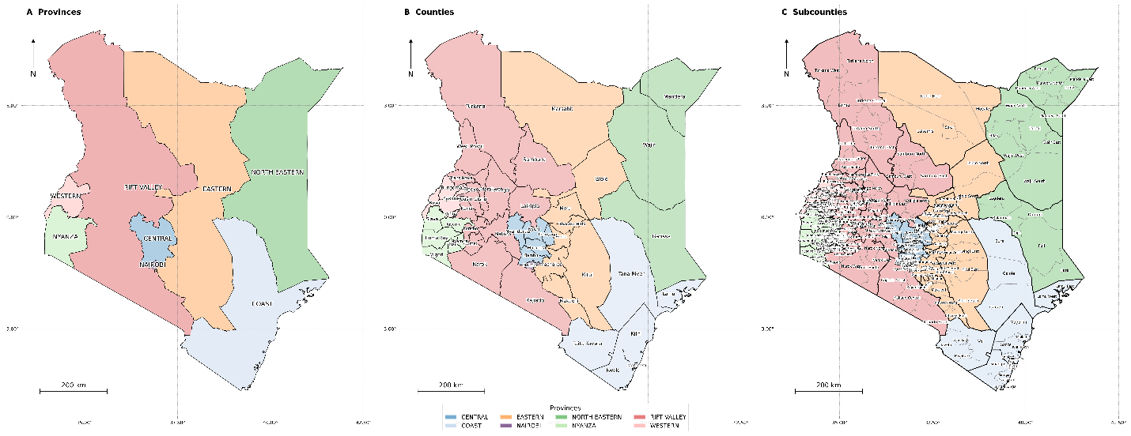
Fig 1. Administrative geography of Kenya’s 290 subcounties and 47 counties, showing the spatial framework for all heat exposure analyses.
Note: Subcounty boundaries are shown as fine grey lines; county boundaries as bold black lines. Former administrative province boundaries are shown as dashed lines. The eight provinces are labelled: North Eastern, Eastern, Coast, Rift Valley, Nyanza, Western, Central, and Nairobi. Fill shading is neutral (light grey) and serves solely to distinguish individual subcounties. A north arrow and scale bar (200 km) are included. This map establishes the 290-subcounty analytical unit used throughout the study. Source: Kenya National Bureau of Statistics administrative boundary shapefiles, 2019.
National heat trends
National area-averaged annual mean H38, defined as the mean number of days per year with UTCI > 38 °C across all ERA5-HEAT grid cells within Kenya, increased significantly over 1991 to 2025 (Mann-Kendall S = 357, Z = 5.06, p < 0.001; Sen slope = 0.97 days per year; Fig 2A; Table 1). The 1991 to 2020 WMO baseline was 73.0 days per year. Decadal mean H38 rose from 63.7 in 1991 to 2000 to 72.7 in 2001 to 2010 and 82.7 in 2011 to 2020, reaching 91.1 days per year in 2021 to 2025. The transition from predominantly below baseline to predominantly above baseline occurred around 2003, with 17 of 23 years from 2003 to 2025 above baseline. Fig 2B shows that 2024 was the most extreme year in the record at 105.0 days per year, or +32.0 days above baseline, followed by 2025 at 99.5 days per year, or +26.4 days. In contrast, 2018 recorded 66.2 days per year, or -6.8 days below baseline. National area-averaged H46 remained negligible throughout the study period.
Fig 2. National area-averaged mean H38 heat exposure trend and annual anomaly series, Kenya 1991–2025, relative to the 1991–2020 WMO reference period baseline.
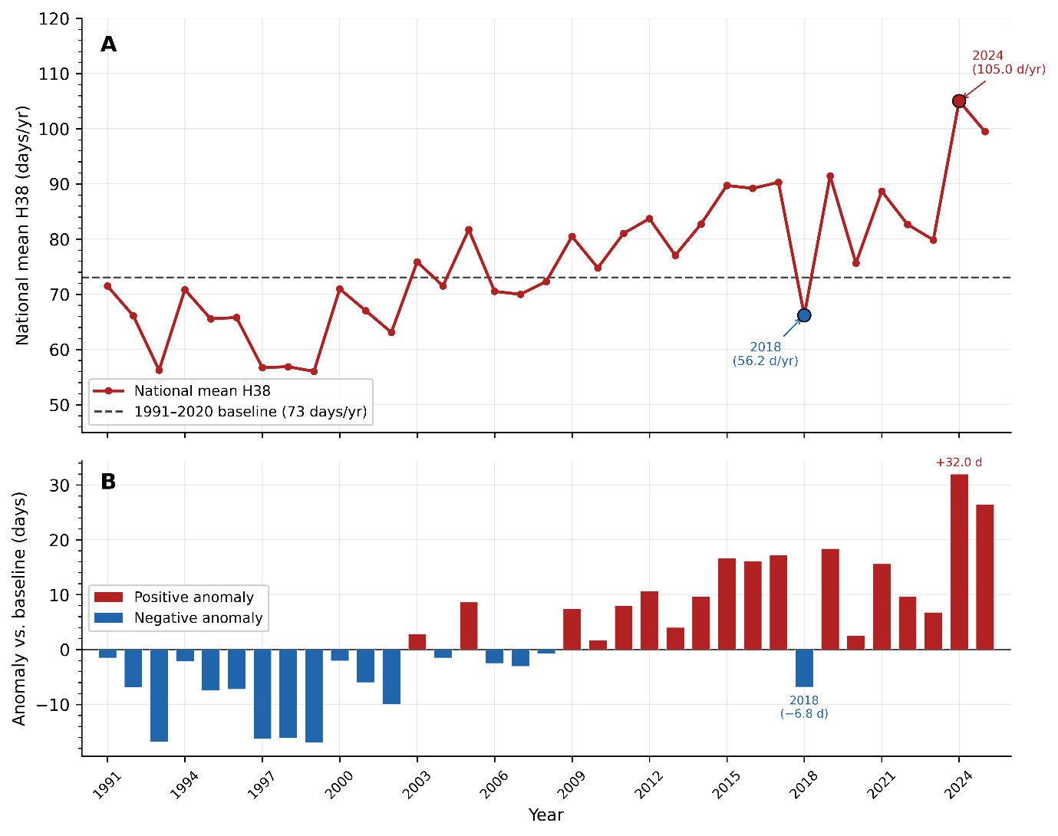
Note: Panel A: Annual time series of national area-averaged mean H38 (days per year with UTCI > 38 °C), plotted as individual data points connected by a smoothed trend line. The horizontal dashed reference line marks the 1991–2020 WMO climatological baseline mean of 73.0 days per year. Mann-Kendall test statistics (S = 357, Z = 5.06, p < 0.001) and Sen slope (+0.97 days per year) are annotated. Panel B: Annual H38 anomaly series (departure from the 1991–2020 baseline mean in days per year), with bars coloured red for positive anomalies (above baseline) and blue for negative anomalies (below baseline). The record positive anomalies of 2024 (+32.0 days) and 2025 (+26.4 days) and the negative anomaly of 2018 (-6.8 days) are labelled. The horizontal zero line corresponds to the 1991–2020 baseline mean. H38 = days per year with UTCI > 38 °C. UTCI = Universal Thermal Climate Index. National values represent the arithmetic mean across all ERA5-HEAT grid cells within Kenya’s administrative boundary (n = 749 cells).
Table 1. National mean heat exposure trend: area-averaged H38 days per year, decadal means, and Mann-Kendall trend test for Kenya, 1991–2025.
Period | Mean H38 days/year | Anomaly vs 1991–2020 baseline (days) | Mann-Kendall statistic | Trend summary
1991–2000 | 63.7 | -9.3 | — | —
2001–2010 | 72.7 | -0.3 | — | —
2011–2020 | 82.7 | 9.7 | — | —
2021–2025 | 91.1 | 18.1 | — | —
Full series (1991–2025) | 75.6 (SD 11.4) | +2.6 (mean anomaly) | S = 357, Z = 5.06 | p < 0.001, Sen slope = +0.97 days/year
Note: H38 = number of days per year with Universal Thermal Climate Index (UTCI) > 38 °C; UTCI thresholds follow Blazejczyk et al. (2012). Anomalies are expressed as the departure from the 1991–2020 WMO reference period baseline mean (73.0 days/year). The Mann-Kendall trend test and Sen slope estimator were applied to the full 35-year series (1991–2025). All results are area-averaged means across all ERA5-HEAT grid cells within Kenya’s administrative boundary (n = 749 cells at approximately 0.25° resolution). The 2021–2025 decadal mean is based on five years and should be interpreted with caution as a partial decade. Dash (–) indicates that trend statistics were computed for the full series only and are not applicable to individual decadal strata. SD = standard deviation.
Seasonal and spatial patterns
Heat exposure showed a strongly bimodal seasonal pattern in the 1991 to 2025 national climatology (S1 Fig). National mean H38 peaked in March at 13.6 days per month and February at 13.3, declined through April to June from 7.7 to 1.9 days, and reached its lowest levels in July at 1.1 days and August at 1.6 days. A secondary rise occurred in October at 5.6 days and December at 7.4 days. At subcounty level, trends were spatially heterogeneous over 1991 to 2025 (S2 Fig; S5 Table). Of 290 subcounties, 59 (20.3%) showed a significant positive trend in annual H38 at p < 0.05, and none showed a significant negative trend. Among warming subcounties, Sen slopes ranged from 0.07 to 3.72 days per year, with a median of about 0.86 days per year. The steepest increases occurred in the central arid corridor, led by Isiolo North (3.72 days per year), Lagdera (2.44), Turkana Central (2.39), and North Horr and Turkana North (both 2.29). Significant positive trends were also observed in coastal settings, including six subcounties in Mombasa and additional subcounties in Kilifi, Kwale, and Taita Taveta. Year specific anomaly maps are shown in S6 Fig.
The distribution of subcounty H38 anomalies shifted progressively rightward from 2015 to 2017, contracted sharply toward and below zero in 2018, and rebounded from 2019 onward (S5 Fig). In all years, zero exposure highland subcounties anchored the left tail, whereas sustained heat subcounties generated a long positive right tail. The largest shift occurred in 2024 and 2025, when the positive tail widened markedly and extended to about +50 days anomaly. In contrast, 2018 showed minimal above baseline mass and a dominant below baseline distribution. Overall, the ridgeline pattern indicates that year-to-year variability shifted the entire national distribution of subcounty heat exposure, rather than affecting only a small number of extreme outliers.
Heat exposure tiers and hotspot stability
Across 2015 to 2025, 136 subcounties had H38 = 0 in all 11 study years, 93 had H38 > 0 in at least one year but did not meet the sustained-heat criterion (H38 ≥ 30 days per year in the reference year), and 61 comprised the sustained-heat tier (Table 2; Fig 3). The sustained heat tier had a mean 2025 H38 of 109.0 days per year (SD 63.4; range 32.3 to 259.0) and a mean Relative Wealth Index of -0.345. These 61 subcounties spanned 18 counties, with the largest concentrations in Kilifi, Turkana, Garissa, Wajir, and Mandera.
Table 2. Classification of Kenya’s 290 subcounties by heat exposure category, based on the 11-year study period (2015–2025).
Exposure category | n subcounties | % of all subcounties | Mean H38 days/year (2025) | Description
Zero exposure | 136 | 46.9 | 0.0 | H38 = 0 in all 11 study years; predominantly highland and central rift subcounties
Intermittent heat | 93 | 32.1 | 3.1 (SD 4.9) | H38 > 0 in at least one year but below the sustained threshold; includes semi-arid transition zones
Sustained heat (any threshold) | 61 | 21.0 | 109.0 (SD 63.4) | H38 > 0 in the majority of study years across at least one hotspot threshold level
Of which: perfect stability | 50 | 17.2 | — | Classified as an H38 hotspot in all 11 study years (2015–2025); 82% of the sustained tier
Extreme heat (H46 ever detected) | 2 | 0.7 | — | Any UTCI value exceeding 46 °C recorded in at least one year; Turkana East and Samburu North
Note: Exposure-tier classification and hotspot stability are distinct constructs. Zero exposure was defined as H38 = 0 in all 11 study years. Intermittent heat indicated H38 > 0 in at least one year without meeting the sustained-heat criterion (H38 ≥ 30 days per year). Sustained heat comprised subcounties meeting the H38 ≥ 30 days per year threshold in the 2025 reference year. Perfect stability refers to subcounties classified as an H38 hotspot in all 11 consecutive study years (2015, 2016, …, 2025). The extreme heat category (H46) represents UTCI exceedance of 46 °C, corresponding to the Extreme heat stress category. The percentage column refers to the proportion of the 290 total subcounties in each category. Categories are not mutually exclusive for sustained and perfect stability rows (the 50 perfectly stable subcounties are a subset of the 61 sustained-heat subcounties). RWI = Relative Wealth Index (Meta/Chi et al.).
H46 exceedance was detected only in Turkana East and Samburu North. Hotspot stability was also high. Among the 62 subcounties classified in the top quintile heat tier in at least one year during 2015 to 2025, 50 (80.6%) remained hotspots in all 11 years, five showed high stability, and seven were intermittent, with stability scores ranging from 0.27 to 0.89 (Fig 3). No persistently classified hotspot dropped out of the hotspot tier, including in 2018. S7 Fig shows that the spatial footprint of the sustained heat tier changed little from year to year despite substantial interannual variability in exposure intensity, consistent with the distributional compression observed in 2018 in S5 Fig.
Fig 3. Subcounty heat exposure tier classification and hotspot stability scores for Kenya’s 290 subcounties, based on 11 years of annual H38 data from 2015 to 2025.
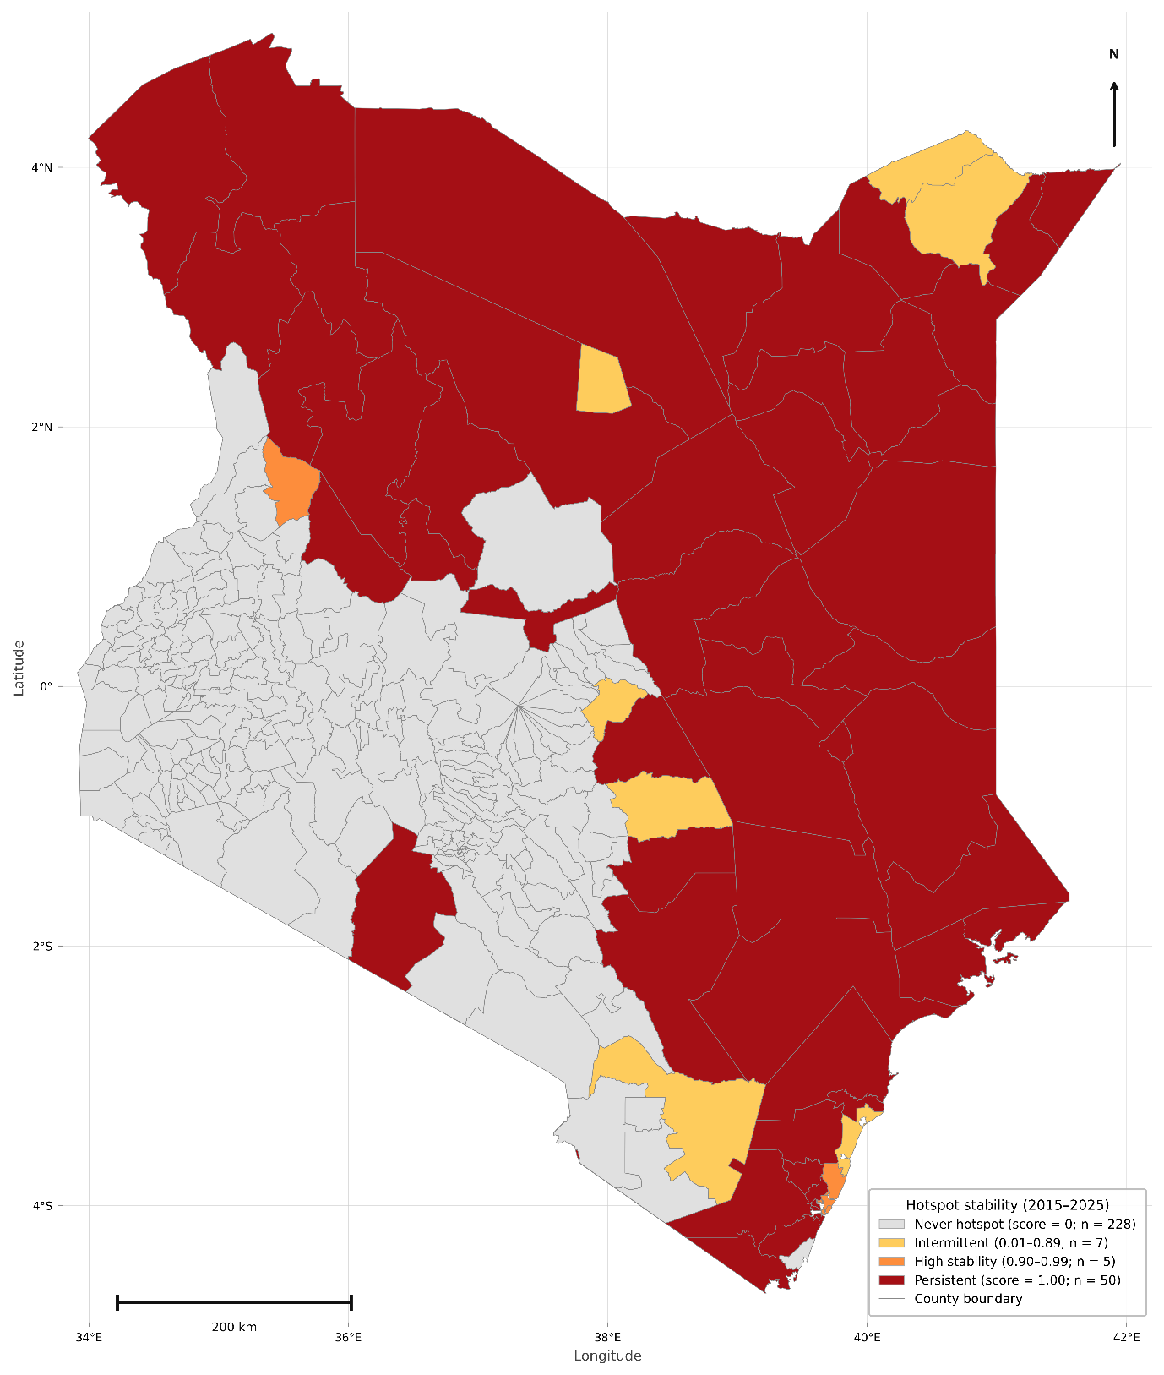
Note: The choropleth fill encodes three exposure tiers: zero exposure (white, n = 136), intermittent heat (light orange, n = 93), and sustained heat (H38 ≥ 30 days per year in 2025; n = 61). Within the sustained-heat tier, subcounties are further differentiated by hotspot stability score: perfect stability (score = 1.0, dark red, n = 50), high stability (score 0.90–0.99, orange-red, n = 5), and intermittent (score 0.27–0.89, amber, n = 7). Two subcounties with H46 exceedance (Turkana East and Samburu North) are marked with a hatched overlay. County boundaries are shown as bold black lines. Hotspot classification defined subcounties as hotspots in a given year if their H38 value fell in the top quintile (top 20%, n = 58) of the national subcounty distribution for that year; stability score = fraction of 11 years with hotspot classification. H38 = days per year with UTCI > 38 °C. Scale bar = 200 km.
Exposure burden and socioeconomic gradient
Heat burden, measured as annual person-days of H38 exposure, was highly concentrated geographically across all three priority groups (S3 Fig). In 2025, the national subcounty median H38 was 0.0 days per year, whereas the mean was 23.9. The top 5% of subcounties (n = 15) accounted for 50.3% of the national burden for pregnant women, 52.5% for children under five, and 46.5% for adults aged 60 years and older. The top 20% of subcounties (n = 58) accounted for 94.4%, 95.3%, and 92.9% of the respective national burdens. The 61 sustained heat subcounties accounted for 96.2% of the national burden for pregnant women (53,917,928 annual person days), 96.8% for children under five (167,682,419), and 95.0% for adults aged 60 years and older (41,973,583) (S4 Table). Within this tier, burden remained concentrated, with the top 10 subcounties accounting for about 60% of the sustained tier burden for pregnant women. County level analysis further showed that Turkana, Garissa, Wajir, Tana River, Kilifi, Mandera, Marsabit, and Isiolo contributed most of the national burden across all three groups (S2 Table).
Subcounty H38 exposure was inversely associated with relative wealth (Spearman rho = -0.561, p < 0.001, n = 290; Fig 4). The LOWESS curve showed a steep decline across the poorest two RWI deciles, followed by a near zero plateau across the upper seven deciles and a slight increase in the highest decile. Mean H38 was 112.6 days per year in the poorest decile, 80.1 in the second poorest, 15.1 in the third, and 5.3 in the wealthiest, a 21-fold difference between the extremes of the wealth distribution (S6 Table). The spatial co-occurrence of high heat exposure and low wealth is shown in the bivariate map in Fig 5.
Fig 4. Scatter plot of subcounty annual H38 heat exposure days against the Relative Wealth Index (RWI) for all 290 Kenya subcounties, 2025, with LOWESS smooth and wealth decile annotations.
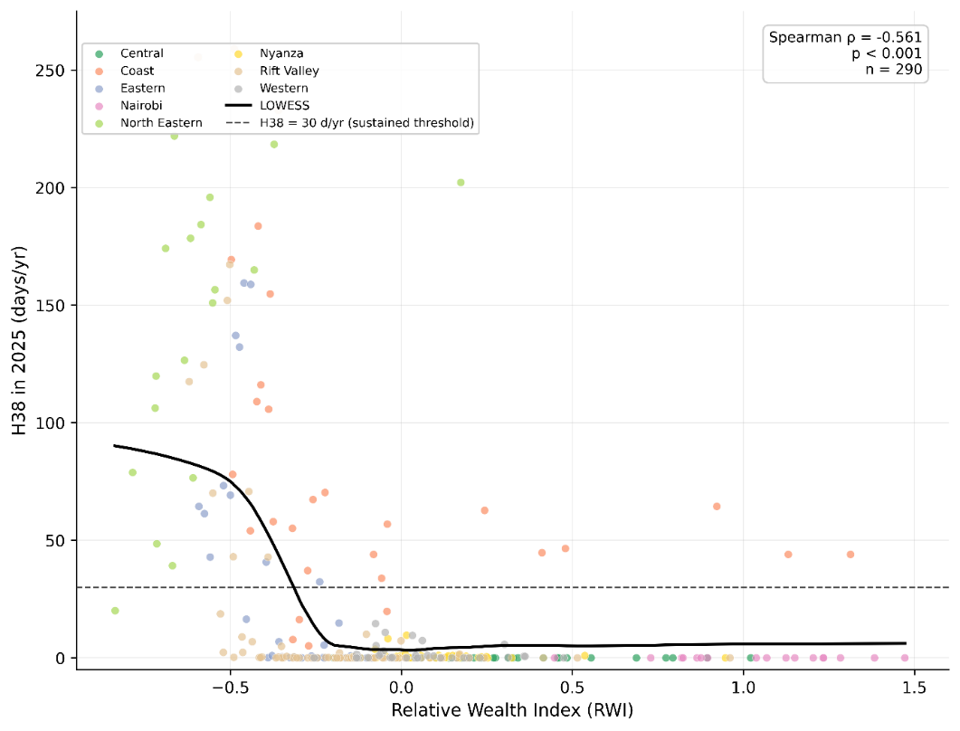
Note: Each point represents one subcounty. The x-axis shows the subcounty-level Relative Wealth Index (RWI; dimensionless asset-based index, lower values indicate greater relative poverty). The y-axis shows the annual count of H38 days in 2025. The LOWESS (locally weighted scatterplot smoothing) curve is shown as a solid red line with a shaded 95% confidence band. Vertical dotted lines delineate the RWI decile boundaries; decile mean H38 values are annotated. Subcounties are coloured by former administrative province as indicated in the legend. The horizontal dashed line marks the sustained-heat threshold (H38 = 30 days per year). Spearman rank correlation coefficient (rho = -0.561, p < 0.001, n = 290) is inset in the upper-right corner. RWI = Relative Wealth Index. H38 = days per year with UTCI > 38 °C.
hazard-gated priority rankings for 2025 identified a consistent and geographically compact priority set across all three population groups (Table 3; S3a–S3c Tables; Fig 6). For pregnant women, Turkana East ranked first nationally (hazard-gated priority score 70.9), followed by Turkana South (66.0) and Wajir South (65.9). The top 20 subcounties all came from eight arid and semi-arid land (ASAL) counties: Turkana, Garissa, Wajir, Tana River, Isiolo, Marsabit, Mandera, and Kilifi. Their scores ranged from 50.8 to 70.9, and this priority geography matched the compound poverty heat pattern shown in Fig 5.
Table 3. Hazard-gated subcounty screening priorities across three population groups, Kenya 2025.
Subcounty | Pregnancy rank | Under-5 rank | 60+ rank | Classification
Wajir South | 1 | 1 | 4 | Severe-heat screening priority
Turkana South | 2 | 2 | 1 | Severe-heat screening priority
Turkana Central | 5 | 3 | 2 | Severe-heat screening priority
Turkana East | 3 | 5 | 5 | Severe-heat screening priority
Dadaab | 4 | 4 | 3 | Severe-heat screening priority
Bura | 6 | 6 | 6 | Severe-heat screening priority
Dujis | 7 | 7 | 7 | Severe-heat screening priority
Fafi | 8 | 8 | 8 | Severe-heat screening priority
Galole | 9 | 9 | 9 | Severe-heat screening priority
Isiolo North | 12 | 11 | 10 | Severe-heat screening priority
Lagdera | 10 | 10 | 11 | Severe-heat screening priority
Turkana West | 11 | 12 | 13 | Severe-heat screening priority
North Horr | 17 | 20 | 12 | Severe-heat screening priority
Mandera East | 13 | 13 | 15 | Severe-heat screening priority
Wajir West | 14 | 14 | 17 | Severe-heat screening priority
Turkana North | 15 | 15 | 14 | Severe-heat screening priority
Ijara | 16 | 16 | 16 | Severe-heat screening priority
Wajir East | 18 | 17 | 20 | Severe-heat screening priority
Garsen | 20 | - | 18 | Severe-heat screening priority
Balambala | 19 | 18 | 19 | Severe-heat screening priority
Mandera South | - | 19 | - | Severe-heat screening priority
Note: Subcounties with H38=0 were assigned a primary heat-priority score of zero. Ranks therefore describe screening priorities among locations with severe heat exposure, group-specific exposure burden, and socioeconomic disadvantage; they are not estimates of individual vulnerability or health effects.
Hazard-gated screening priorities and sensitivity
Under the hazard-gated framework, Turkana East ranked first for pregnant women (70.9) and adults aged 60 years and older (71.4), while Wajir South ranked first for children under five (71.8). Turkana South was ranked second for pregnant women and older adults and third for children under five. These rankings identify screening-priority geographies only.
For adults aged 60 years and older, Turkana East ranked first (71.4) and Turkana South second (70.1), with four subcounties unique to the older adult top 20: Magarini, Kinango, Kitui South, and Garsen.
Across the hazard-gated mapping panels, the highest scores clustered in a continuous northern belt spanning Turkana, Marsabit, Isiolo, Wajir, Garissa, and Mandera, with additional extension into Tana River and coastal Kilifi. This geography is best interpreted as a screening-priority pattern derived from severe heat exposure, group-specific burden, and relative socioeconomic position; the revised figures use the hazard-gated ranking outputs.
Fig 5. Bivariate choropleth map simultaneously encoding subcounty-level annual H38 heat exposure and Relative Wealth Index (RWI) using a 3 x 3 colour matrix, Kenya 2025.
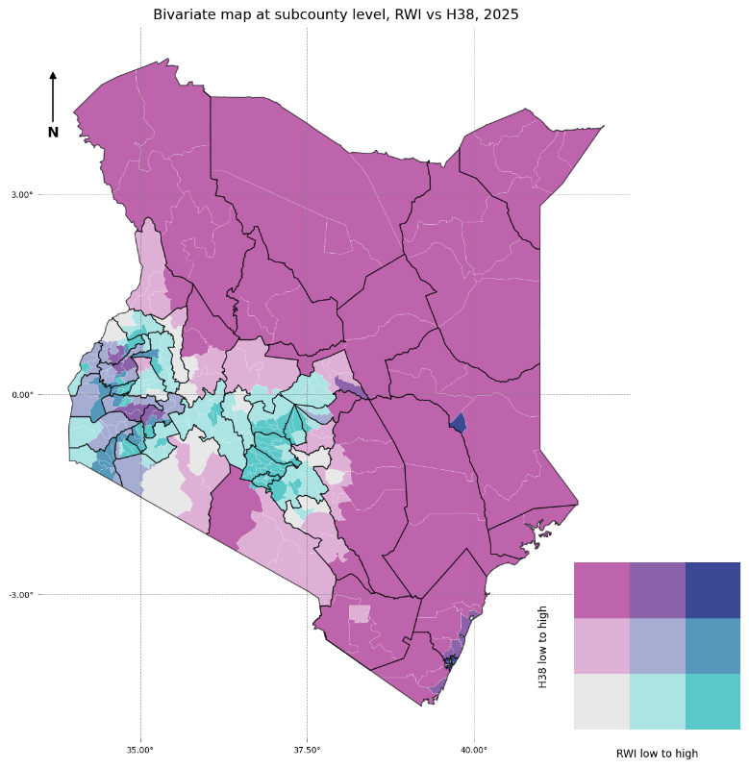
Note: The 3 x 3 bivariate legend encodes two dimensions simultaneously: H38 heat exposure (low, medium, high; x-axis of legend) and RWI (high, medium, low; y-axis of legend, inverted so low wealth is at the top). The upper-left cell of the bivariate legend represents high H38 combined with low RWI and is rendered in deep purple, marking subcounties of compound co-occurrence of extreme heat and high deprivation. The lower-right cell represents low H38 combined with high RWI and is rendered in teal, marking affluent zero-exposure subcounties. Off-diagonal cells indicate partial co-occurrence. Subcounties are classified into H38 and RWI tertiles based on the national distribution across all 290 subcounties. County boundaries are shown as bold black lines. RWI = Relative Wealth Index (Meta Data for Good). H38 = days per year with UTCI > 38 °C. Scale bar = 200 km.
Table 4. Robustness of revised hazard-gated screening priorities, Kenya 2025.
Robustness check | Rank correlation | UTCI top-20 retained | Scope
Pregnancy: infant-share allocation | 0.9994 | 19/20 | National total constrained
Pregnancy: 50:50 blended allocation | 0.9998 | 19/20 | National total constrained
Heat Index versus UTCI: pregnancies | 0.830 | 18/20 | 2025 only
Heat Index versus UTCI: under-5 | 0.822 | 18/20 | 2025 only
Heat Index versus UTCI: adults 60+ | 0.821 | 15/20 | 2025 only
Note: Spearman rank correlation (rho) was computed for all 290 subcounties. All p-values < 0.001. Top-20 overlap refers to the number of subcounties appearing in the top-20 priority tier under both group comparisons. Mean period rankings were derived from 11-year mean (2015–2025) inputs using the same scaling and weighting as the 2025 analysis. The four subcounties exclusive to the older adult top-20 were Magarini (Kilifi), Kinango (Kwale), Kitui South (Kitui), and Garsen (Tana River).
Pregnancy-denominator scenarios had very high agreement with the women-of-reproductive-age base case: rank correlations were 0.9994 for infant-share allocation and 0.9998 for the 50:50 blend, and both retained 19 of 20 base-case pregnancy priorities. Each scenario preserves the same national annual pregnancy total and changes only its subcounty allocation; this is a robustness test, not validation of local pregnancy counts. Spatial clustering was substantial (Moran's I 0.770 for H38 and 0.814-0.818 for group-specific priorities; permutation p=0.001) and is reported as a structure diagnostic rather than evidence of independent local effects.
Fig 6. Hazard-gated subcounty screening priorities, Kenya 2025. Panels show pregnant women, children under five, and adults aged 60 years and older. Subcounties with H38=0 are displayed as zero primary heat priority.
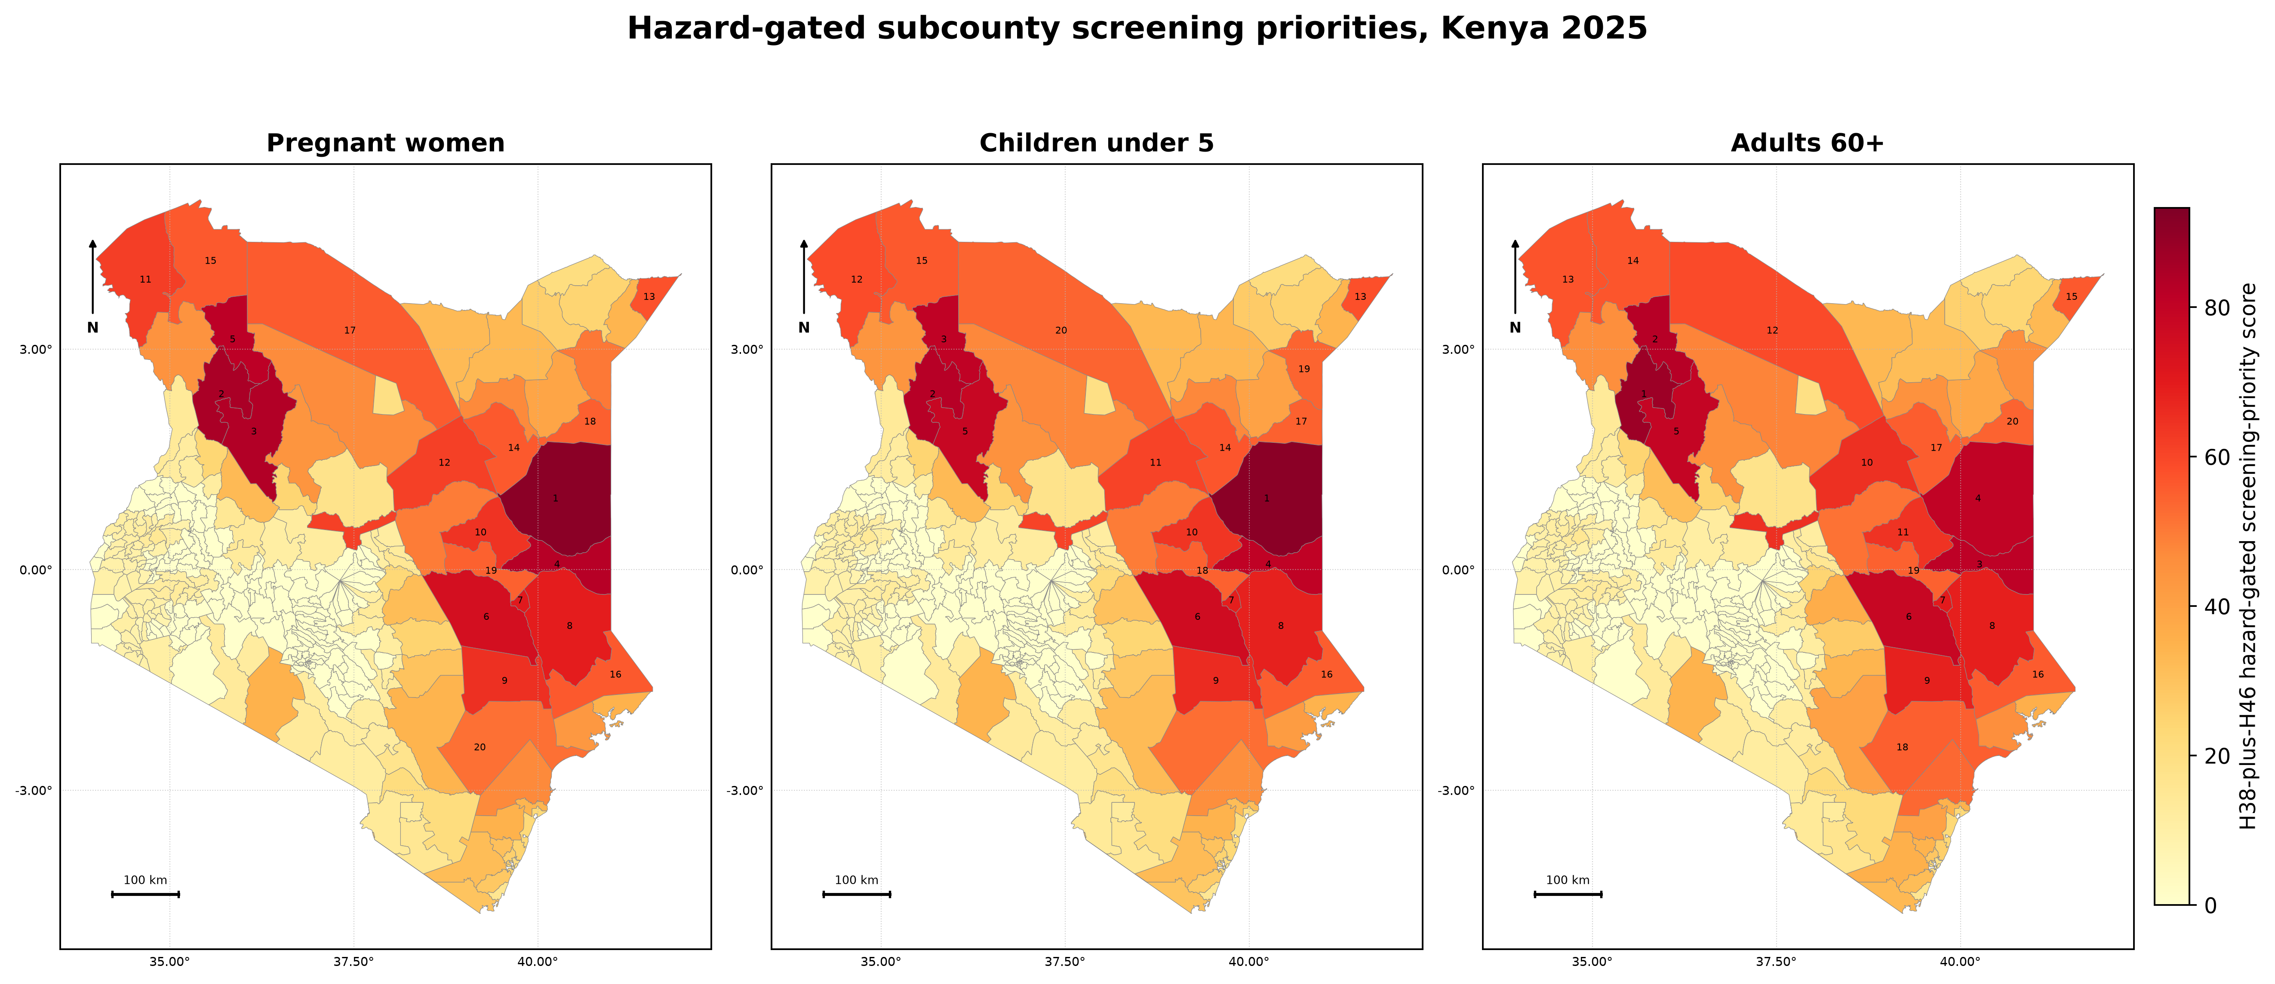
Note: Scores combine the hazard-gated severe-heat component, group-specific exposure burden, and relative socioeconomic position. The map is intended for subcounty screening and preparedness planning, not for individual risk prediction or causal inference.
The independent Heat Index comparison supported, but did not duplicate, the UTCI priorities. Rank correlations were 0.830 for pregnancies, 0.822 for children under five, and 0.821 for older adults; the UTCI top 20 retained 18, 18, and 15 subcounties, respectively. This 2025-only comparator tests cross-metric robustness of current screening priorities and does not validate the 1991-2025 UTCI trend analysis.

Detailed supplementary outputs supporting these results are provided in S1-S8 Tables, including the national heat-exposure time series, sustained-heat county summaries, 11-year top-20 priority rankings, exposure-burden concentration, subcounty trend statistics, RWI decile summaries, Heat Index robustness, and complete hazard-gated rankings.
Discussion
This nationwide ecological screening analysis identifies where severe heat, priority-population exposure burden, and relative socioeconomic disadvantage coincide across Kenya. The principal finding is not an estimate of individual vulnerability or health effect: it is a transparent subcounty screening geography intended to support preparedness and local validation.
The revised framework makes severe heat a necessary condition for primary heat priority. Subcounties with no H38 days receive a score of zero, preventing population size or poverty alone from producing a heat-priority ranking. Hazard combines H38 days with an explicit H46 severity increment: H46 days are already within H38, so they contribute an additional increment rather than being treated as an independent exposure count.
Severe heat was geographically concentrated, and the spatial diagnostics confirm that both H38 and priority scores are clustered. This clustering is expected for a climate exposure and should not be interpreted as evidence that neighbouring subcounties provide independent confirmatory observations. It instead reinforces the value of coordinated regional preparedness alongside local assessment.
Pregnancy estimates require particularly cautious interpretation. The base WRA-share allocation and alternative infant-share and blended allocations retain each year's national total and differ only in its local distribution. Their near-identical ranks show that the priority geography is robust to these allocation choices, but they do not establish the true number of pregnancies in any subcounty.
The 2025 Heat Index comparison provides an independent humidity-based check on contemporary rankings. Agreement with UTCI was strong but not complete, which is expected because the indices represent different thermal constructs. This analysis supports robustness of the 2025 screening geography only; it does not validate the 1991-2025 UTCI trend analysis.
Several limitations remain. Exposure was aggregated from gridded data to subcounty polygons, with nearest-grid-centre substitution for small units; this can affect estimates where a subcounty is smaller than a grid cell or climatically heterogeneous. The index weights are a transparent prioritisation rule rather than empirically estimated health-effect weights. Finally, the study contains no individual heat-health outcomes and cannot establish causation, predict individual risk, or replace local surveillance.
Taken together, the results support using the hazard-gated outputs as a screening layer for heat-health preparedness. Highest-priority areas should be considered candidates for further local assessment, targeted service planning, and evaluation against health and operational data rather than as fixed or definitive vulnerability classifications.
The inverse association between relative wealth and heat exposure adds a second dimension to this prioritisation problem. Poorer subcounties were not only more exposed, but often exposed under conditions of lower adaptive capacity. This heat poverty gradient is consistent with broader literature showing that the health risks of heat are shaped not only by environmental intensity but also by infrastructure, livelihood patterns, housing quality, access to cooling, and access to care (Hajat et al. 2015; Harlan et al. 2006; Turner et al. 2003; Kjellstrom et al. 2016; Ebi et al. 2021). In Kenya, these intersecting pressures are especially relevant in arid and semi arid settings, where heat exposure often coincides with outdoor livelihoods, water constraints, food insecurity, and weaker service coverage (Kenya National Bureau of Statistics 2019; Niang et al. 2014). Taken together, these patterns show why hazard alone is insufficient for targeting. The hazard-gated priority score adds value by combining hazard, persistence, population magnitude, and socioeconomic disadvantage in a single prioritisation framework (Reid et al. 2009; Tate 2013; Turner et al. 2003).
The very high concordance between hazard-gated priority rankings for pregnant women and children under five indicates that these two groups share a largely common geography of priority. In practical terms, this suggests that a unified spatial targeting strategy could efficiently serve both groups within existing maternal and child health delivery structures (Zhang et al. 2017; Chersich et al. 2020; Xu et al. 2014; Sheffield and Landrigan 2011). The close correspondence also supports the interpretation that, in this setting, the hazard geography is sufficiently dominant that differences in population structure affect rank order more than core membership of the top priority tier. The older adult pattern was different. Although older adult rankings remained significantly correlated with those of the other groups, the lower concordance and the appearance of four subcounties unique to the older adult top 20 indicate that demographic structure can shift vulnerability priorities in meaningful ways. This matters because older adults have distinctive heat related risks linked to impaired thermoregulation, chronic disease burden, and reduced mobility (Hajat et al. 2007; Kenny et al. 2010; Bobb et al. 2014; Ebi et al. 2021). These findings support explicit age stratification within heat health planning rather than assuming that maternal and child priority geographies will automatically capture older adult risk.
The divergence seen near the lower end of the rank distribution also reinforces an important interpretive point. In zero hazard subcounties, hazard-gated priority score variation is driven by population and poverty rather than by heat exposure itself. The index is therefore most meaningful as a prioritisation tool within the heat exposed tier, not as a universal ranking of vulnerability across all subcounties (Reid et al. 2009; Tate 2013; Turner et al. 2003). The close agreement between rankings based on 2025 conditions and those based on mean conditions over 2015 to 2025 further supports the robustness of the index. For all three groups, rank correlations were high and top 20 overlap was complete or near complete, indicating that the priority geography is driven mainly by slowly changing climatic, demographic, and socioeconomic structure rather than by a single study year (Tate 2013; Rygel et al. 2006). The limited discordance in the older adult rankings is better interpreted as marginal sensitivity at the edge of the priority tier than as instability of the index itself.
Several strengths support confidence in these findings. The use of UTCI improves on air temperature only metrics by incorporating the environmental drivers most relevant to physiological heat strain, including humidity, radiation, and wind (Blazejczyk et al. 2012; Bröde et al. 2012; Hajat et al. 2015). The 35-year record supports baseline estimation, anomaly assessment, and long-term trend detection more robustly than the shorter time series used in many African studies (Harrington and Otto 2020; World Meteorological Organization 2023). The use of subcounty geography captures heterogeneity that would be obscured at county scale and is directly relevant to Kenya’s devolved planning context (Kenya National Bureau of Statistics 2019). The parallel analysis of three distinct vulnerable groups using a common framework allows comparison across demographic priorities and reveals differences that would be missed in a single group analysis (Zhang et al. 2017; Chersich et al. 2020; Xu et al. 2014; Kenny et al. 2010). Finally, the hazard-gated priority score remains interpretable because its component domains are transparent and policy relevant (Reid et al. 2009; Tate 2013; Turner et al. 2003).
Several limitations should also be acknowledged. First, exposure was estimated using polygon-based aggregation of gridded UTCI data rather than fully population-weighted within-subcounty exposure surfaces. Second, the screening index combines hazard, group-specific exposure burden, and relative socioeconomic position; it is not a validated prediction model and cannot establish causal health effects or individual risk. Third, pregnancy estimates are modelled denominators rather than observed pregnancies, although the two tested alternative allocations retained the base-case priority set. Finally, Heat Index sensitivity was limited to 2025 because it required hourly paired meteorological inputs; it should be interpreted as a cross-metric robustness check, not a replacement for the 35-year UTCI analysis.
These findings can support screening and prioritisation for heat-health planning, subject to local validation. The 61 sustained-heat subcounties identify locations where more detailed local assessment of surveillance, early warning, risk communication, clinical preparedness, and facility resilience may be warranted. The persistent hotspot geography supports sustained attention, while the partly distinct older-adult pattern indicates that ageing and non-communicable disease planning should be considered explicitly. These are screening implications, not direct evidence of intervention effectiveness or a basis for automatic resource allocation.
Physiologically severe heat stress increased across Kenya over 1991-2025 and was concentrated in a stable set of arid and coastal subcounties where severe heat overlapped with group-specific exposure burden and socioeconomic disadvantage. A hazard-gated framework avoids assigning primary heat priority to locations with no observed H38 exposure. The resulting geographies were robust to tested pregnancy denominators and broadly consistent under a 2025 Heat Index comparator, supporting their use for targeted preparedness and further local assessment.

Acknowledgments
The authors acknowledge the Copernicus Climate Change Service for providing the ERA5 HEAT UTCI dataset, WorldPop for gridded population estimates, and Meta Data for Good for the Relative Wealth Index.

Statements and declarations
Funding: The authors received no funding for this study.
Competing interests: The authors declare no competing interests.
Author contributions: Felix Oluoch conceptualised the study, led the analysis, and drafted the manuscript. Fredrick Gudda, Prissy Makena, Anthony Ngugi, Jai K Das, and Zulfiqar Ahmed Bhutta contributed to interpretation, critical revision, and approval of the final manuscript.
Availability of data and materials: All public source datasets used in this study are available from the providers cited in the manuscript. The derived subcounty-year analytical dataset, analysis code, and revised robustness outputs are available through the Zenodo record for this study (DOI: https://doi.org/10.5281/zenodo.19200614). Third-party input datasets, including Copernicus/ERA5, WorldPop, Relative Wealth Index, and administrative-boundary source files, are not redistributed in the public deposit and should be obtained from their original providers or relevant data custodians under their respective data-access terms.
Ethics approval: Not applicable; this ecological study used aggregated, publicly available or third-party gridded and administrative data and did not involve individual participants.
Consent to participate: Not applicable.
Consent for publication: Not applicable.
References
Blazejczyk K, Epstein Y, Jendritzky G, Staiger H, Tinz B (2012) Comparison of UTCI to selected thermal indices. Int J Biometeorol 56(3):515-535. doi:10.1007/s00484-011-0453-2.
Bobb JF, Obermeyer Z, Wang Y, Dominici F (2014) Cause-specific risk of hospital admission related to extreme heat in older adults. JAMA 312(24):2659-2667.
Bröde P, Fiala D, Blazejczyk K, Holmér I, Jendritzky G, Kampmann B, et al (2012) Deriving the operational procedure for the Universal Thermal Climate Index (UTCI). Int J Biometeorol 56(3):481-494. doi:10.1007/s00484-011-0454-1.
Bröde P, Fiala D, Kampmann B, Havenith G (2021) UTCI-A: Universal Thermal Climate Index for All. Copernicus Climate Change Service Climate Data Store. Reading: European Centre for Medium-Range Weather Forecasts; . doi:10.24381/cds.553b7518.
Chersich MF, Pham MD, Areal A, Haghighi MM, Manyuchi A, Swift CP, et al (2020) Associations between high temperatures in pregnancy and risk of preterm birth, low birth weight, and stillbirths: systematic review and meta-analysis. BMJ 371:m3811.
Chi G, Han H, Bhatt DL, Guo J, Yarlagadda B, Baucum M, et al (2022) Microestimates of wealth for all low- and middle-income countries. Proc Natl Acad Sci U S A 119(3):e2113658119. doi:10.1073/pnas.2113658119.
Coffel ED, Horton RM, de Sherbinin A (2018) Temperature and humidity based projections of a rapid rise in global heat stress exposure during the 21st century. Environ Res Lett 13(1):014001.
Ebi KL, Capon A, Berry P, Broderick C, de Dear R, Havenith G, et al (2021) Hot weather and heat extremes: health risks. Lancet 398(10301):698-708.
Gasparrini A, Guo Y, Hashizume M, Lavigne E, Zanobetti A, Schwartz J, et al (2015) Mortality risk attributable to high and low ambient temperature: a multicountry observational study. Lancet 386(9991):369-375.
Hajat S, Kovats RS, Lachowycz K (2007) Heat-related and cold-related deaths in England and Wales: who is at risk? Occup Environ Med. 64(2):93-100.
Hajat A, Hsia C, O’Neill MS (2015) Socioeconomic disparities and air pollution exposure: a global review. Curr Environ Health Rep 2(4):440-450.
Hamed KH, Rao AR (1998) A modified Mann-Kendall trend test for autocorrelated data. J Hydrol 204(1-4):182-196.
Harlan SL, Brazel AJ, Prashad L, Stefanov WL, Larsen L (2006) Neighborhood microclimates and vulnerability to heat stress. Soc Sci Med 63(11):2847-2863.
Harrington LJ, Otto FEL (2020) Reconciling theory with the reality of African heatwaves. Nat Clim Change 10(9):796-798.
Harris CR, Millman KJ, van der Walt SJ, Gommers R, Virtanen P, Cournapeau D, et al (2020) Array programming with NumPy. Nature 585(7825):357-362.
Hersbach H, Bell B, Berrisford P, Hirahara S, Horányi A, Muñoz-Sabater J, et al (2020) The ERA5 global reanalysis. Q J R Meteorol Soc 146(730):1999-2049. doi:10.1002/qj.3803.
Intergovernmental Panel on Climate Change (2021) Climate Change 2021: The Physical Science Basis. Contribution of Working Group I to the Sixth Assessment Report of the Intergovernmental Panel on Climate Change. Cambridge: Cambridge University Press.
Jordahl K, Van den Bossche J, Fleischmann M, McBride J, Wasserman J, Gerard J, et al (2020) geopandas/geopandas. Zenodo. . doi:10.5281/zenodo.3946761.
Kendall MG (1975) Rank Correlation Methods. 4th ed. London: Charles Griffin.
Kenny GP, Yardley J, Brown C, Sigal RJ, Jay O (2010) Heat stress in older individuals and patients with common chronic diseases. CMAJ 182(10):1053-1060.
Kenya National Bureau of Statistics (2019) 2019 Kenya Population and Housing Census. Nairobi: KNBS.
Kjellstrom T, Briggs D, Freyberg C, Lemke B, Otto M, Hyatt O (2016) Heat, human performance, and occupational health: a key issue for the assessment of global climate change impacts. Annu Rev Public Health 37:97-112.
Lissner TK, Holsten A, Walther C, Kropp JP (2012) Towards sectoral and standardised vulnerability assessments: the example of heatwave impacts on human health. Clim Change 112(3-4):687-708.
Mann HB (1945) Nonparametric tests against trend. Econometrica 13(3):245-259.
McKinney W (2010) Data structures for statistical computing in Python. In: Proceedings of the 9th Python in Science Conference. . p. 51-56.
Niang I, Ruppel OC, Abdrabo MA, Essel A, Lennard C, Padgham J, et al (2014) Africa. In: Barros VR, Field CB, Dokken DJ, Mastrandrea MD, Mach KJ, Bilir TE, et al., editors. Climate Change : Impacts, Adaptation, and Vulnerability. Part B: Regional Aspects. Contribution of Working Group II to the Fifth Assessment Report of the Intergovernmental Panel on Climate Change. Cambridge: Cambridge University Press; . p. 1199-1265.
QGIS Development Team (2023) QGIS Geographic Information System. Beaverton (OR): Open-Source Geospatial Foundation Project.
Reid CE, O’Neill MS, Gronlund CJ, Brines SJ, Brown DG, Diez-Roux AV, et al (2009) Mapping community determinants of heat vulnerability. Environ Health Perspect 117(11):1730-1736.
Rygel L, O’Sullivan D, Yarnal B (2006) A method for constructing a social vulnerability index: an application to hurricane storm surges in a developed country. Mitig Adapt Strateg Glob Change 11(3):741-764.
Seabold S, Perktold J (2010) Statsmodels: econometric and statistical modeling with Python. In: Proceedings of the 9th Python in Science Conference. . p. 57-61.
Sen PK (1968) Estimates of the regression coefficient based on Kendall’s tau. J Am Stat Assoc 63(324):1379-1389.
Sheffield PE, Landrigan PJ (2011) Global climate change and children’s health: threats and strategies for prevention. Environ Health Perspect 119(3):291-298.
Spearman C (1904) The proof and measurement of association between two things. Am J Psychol 15(1):72-101.
Stevens FR, Gaughan AE, Linard C, Tatem AJ (2015) Disaggregating census data for population mapping using random forests with remotely sensed and ancillary data. PLoS One 10(2):e0107042.
Tate E (2013) Social vulnerability indices: a comparative assessment using uncertainty and sensitivity analysis. Nat Hazards 63(2):325-347.
Tatem AJ (2017) WorldPop, open data for spatial demography. Sci Data 4:170004.
Turner BL 2nd, Kasperson RE, Matson PA, McCarthy JJ, Corell RW, Christensen L, et al (2003) A framework for vulnerability analysis in sustainability science. Proc Natl Acad Sci U S A 100(14):8074-8079.
Virtanen P, Gommers R, Oliphant TE, Haberland M, Reddy T, Cournapeau D, et al (2020) SciPy 1.0: fundamental algorithms for scientific computing in Python. Nat Methods 17(3):261-272. doi:10.1038/s41592-019-0686-2.
Wagstaff A, Paci P, van Doorslaer E (1991) On the measurement of inequalities in health. Soc Sci Med 33(5):545-557.
Watts N, Amann M, Arnell N, Ayeb-Karlsson S, Belesova K, Berry H, et al (2019) The 2019 report of The Lancet Countdown on health and climate change: ensuring that the health of a child born today is not defined by a changing climate. Lancet 394(10211):1836-1878. doi:10.1016/S0140-6736(19)32596-6.
World Meteorological Organization (2017) Guidelines on the Calculation of Climate Normals. WMO No. 1203. Geneva: WMO.
World Meteorological Organization (2023) State of the Climate in Africa 2023. WMO No. 1354. Geneva: WMO; 2024.
Xu Z, Sheffield PE, Su H, Wang X, Bi Y, Tong S (2014) The impact of heat waves on children's health: a systematic review. Int J Biometeorol 58(2):239-247. doi:10.1007/s00484-013-0655-x.
Yue S, Pilon P, Cavadias G (2002) Power of the Mann-Kendall and Spearman’s rho tests for detecting monotonic trends in hydrological series. J Hydrol 259(1-4):254-271.
Zenodo (2026) Kenya heat-exposure screening reproducibility package. doi:https://doi.org/10.5281/zenodo.19200614.
Zhang Y, Yu C, Wang L (2017) Temperature exposure during pregnancy and birth outcomes: an updated systematic review of epidemiological evidence. Environ Pollut 225:710-721.
Supplementary Information
S1 Fig. Monthly climatology of area-averaged mean H38 heat exposure across all ERA5-HEAT grid cells within Kenya and all 35 years from 1991 to 2025.
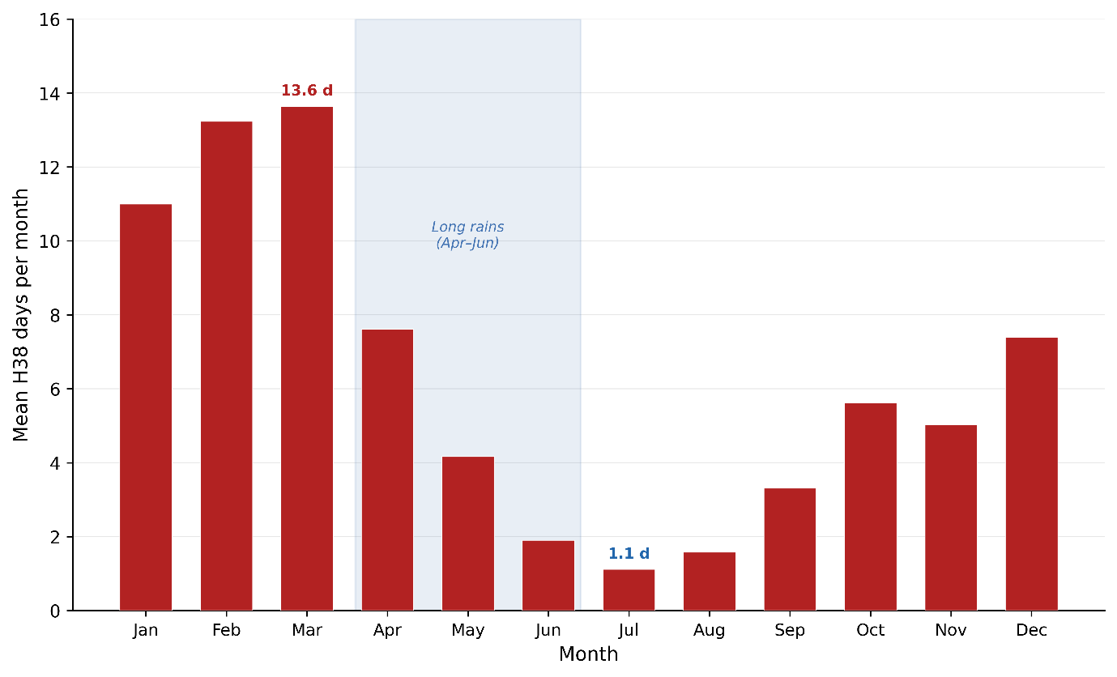
Note: The bar chart shows mean H38 days per month for each calendar month, averaged across all 35 years (1991 to 2025) and all ERA5-HEAT grid cells within Kenya’s administrative boundary. Error bars represent the interannual standard deviation of the monthly mean across years. Month labels on the x-axis use three-letter abbreviations. The bimodal seasonal structure is evident, with primary peaks in February and March and a secondary shoulder in October–December, separated by pronounced troughs during the long rains (April to June) and the cool dry season (July to August). H38 = days per year with UTCI > 38 °C.
S2 Fig. Spatial distribution of Theil-Sen slope estimates for the Mann-Kendall trend test applied to annual H38 heat exposure at each of Kenya’s 290 subcounties over the 35-year period 1991–2025, distinguishing statistically significant from non-significant positive trends.
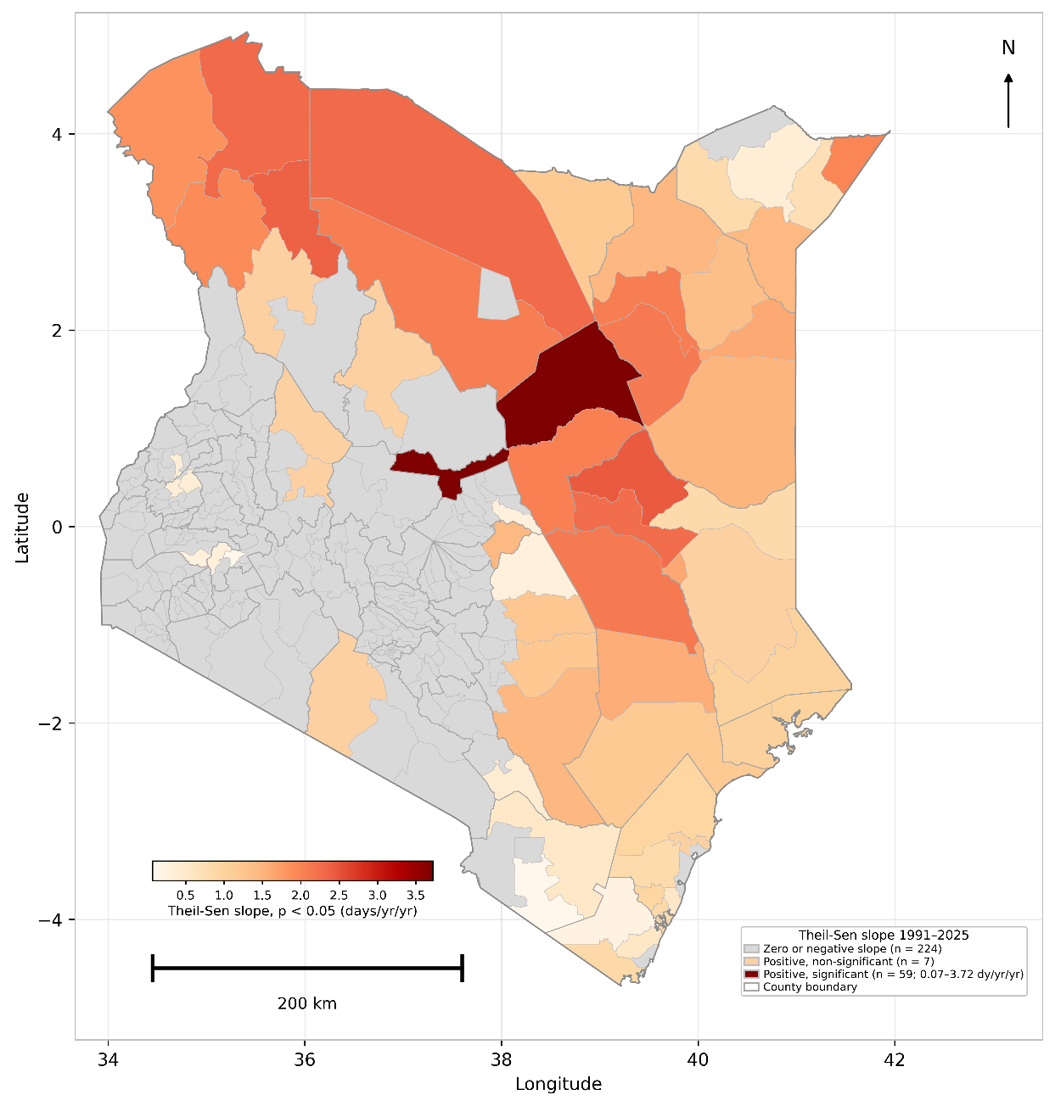
Note: The choropleth fill corresponds to the Theil-Sen slope in annual H38 days per year, shown for subcounties with statistically significant positive trends at the two-sided p < 0.05 level, with colour intensity ranging from pale cream (0.07 days per year) to very dark red (3.72 days per year) as shown in the continuous gradient legend. Three additional categories are identified: zero or negative slope (n = 224; grey), indicating subcounties with no detectable positive trend, predominantly zero-exposure highland units; positive, non-significant trend (n = 7; light peach), indicating subcounties with a positive Sen slope that did not achieve p < 0.05; and positive, significant (n = 59; continuous red gradient; observed range 0.07 to 3.72 days per year). County boundaries are shown as thin grey lines overlaid on the subcounty fill. The highest Sen slopes are spatially concentrated in the central ASAL corridor spanning Isiolo, Garissa, and northern Wajir counties, with Isiolo North recording the national maximum of 3.72 days per year. A secondary cluster of moderate but statistically significant coastal trends (Sen slopes 0.22 to 0.94 days per year) is visible in Mombasa, Kilifi, and Kwale counties. The Mann-Kendall test was applied independently to the full 35-year annual H38 time series for each of the 290 subcounties, using centroid-extracted subcounty values from the gridded ERA5 HEAT product as described in the Materials and methods. Scale bar = 200 km.
S3 Fig. Concentration curves (Lorenz-type) showing the cumulative proportion of national population-weighted H38 person-day heat burden attributable to subcounties ranked from highest to lowest burden, for three priority population groups, Kenya 2025.
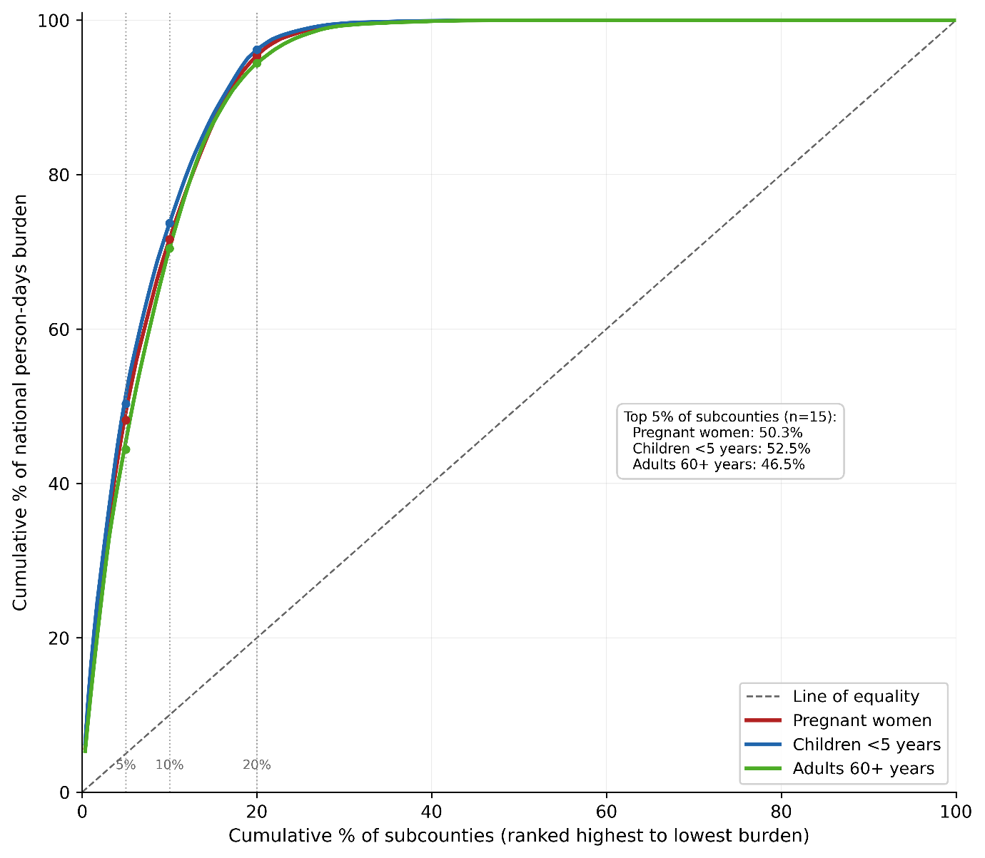
Note: The x-axis represents the cumulative percentage of Kenya’s 290 subcounties ranked from the highest to the lowest annual H38 person-day burden for each group. The y-axis represents the corresponding cumulative percentage of the total national person-day burden for that group. The diagonal dashed line represents the line of equality. Vertical dotted reference lines mark the 5th, 10th, and 20th percentile subcounty thresholds. The annotated inset reports that the top 5% of subcounties (n = 15) account for 50.3% of national pregnant women burden, 52.5% of children under-5 burden, and 46.5% of adults-60-plus burden. The strong upward convexity of all three curves relative to the line of equality confirms extreme spatial concentration of heat burden in a small number of subcounties. The three curves are nearly coincident, indicating that the degree of burden concentration is essentially identical across the three priority groups. Annual person-days of exposure were calculated as H38 days per year multiplied by the estimated population at risk per subcounty, summed within each priority group. H38 = days per year with UTCI > 38 °C.
S4 Fig. Pairwise scatter plots of hazard-gated priority score rank positions for all 290 Kenya subcounties across three priority population group comparisons, 2025.
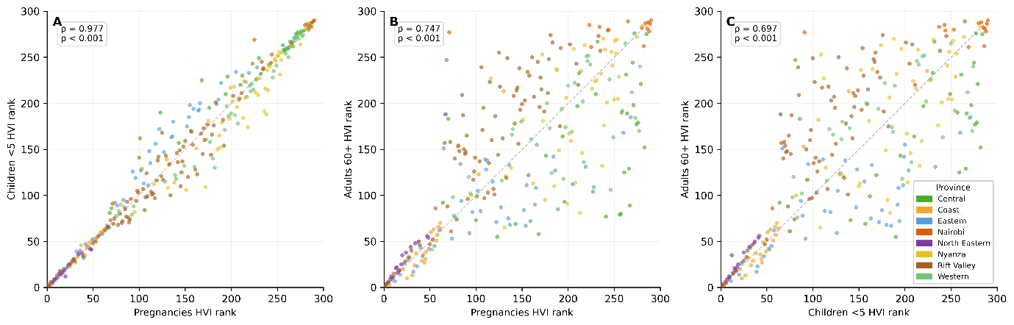
Note: Each panel plots the hazard-gated priority rank of one group on the x-axis against that of a second group on the y-axis for all 290 subcounties, where rank 1 = highest vulnerability and rank 290 = lowest vulnerability. Panel A: pregnant women versus children under-5 (Spearman rho = 0.977, p < 0.001). Panel B: pregnant women versus adults aged 60 and older (rho = 0.747, p < 0.001). Panel C: children under-5 versus adults aged 60 and older (rho = 0.697, p < 0.001). Points are coloured by former administrative province as shown in the shared legend. The diagonal dashed reference line represents perfect concordance. Departure from the diagonal indicates discordant ranking between groups; the greater scatter in panels B and C compared to panel A reflects the systematically lower concordance between the reproductive-age groups and the older adult group, driven principally by differences in subcounty-level age structure and the larger relative weight of the population size component for older adults in transitional peri-urban subcounties. The tight clustering of North Eastern province subcounties near the origin (rank 1 to approximately 30 on both axes) in all three panels confirms that the northernmost ASAL subcounties are consistently prioritised across all group comparisons. All p-values < 0.001. n = 290 subcounties.
S5 Fig. Year-by-year kernel density distributions of subcounty-level H38 anomalies (departure in days per year from the 1991–2020 WMO reference period baseline mean) across all 290 Kenya subcounties for each year from 2015 to 2025.
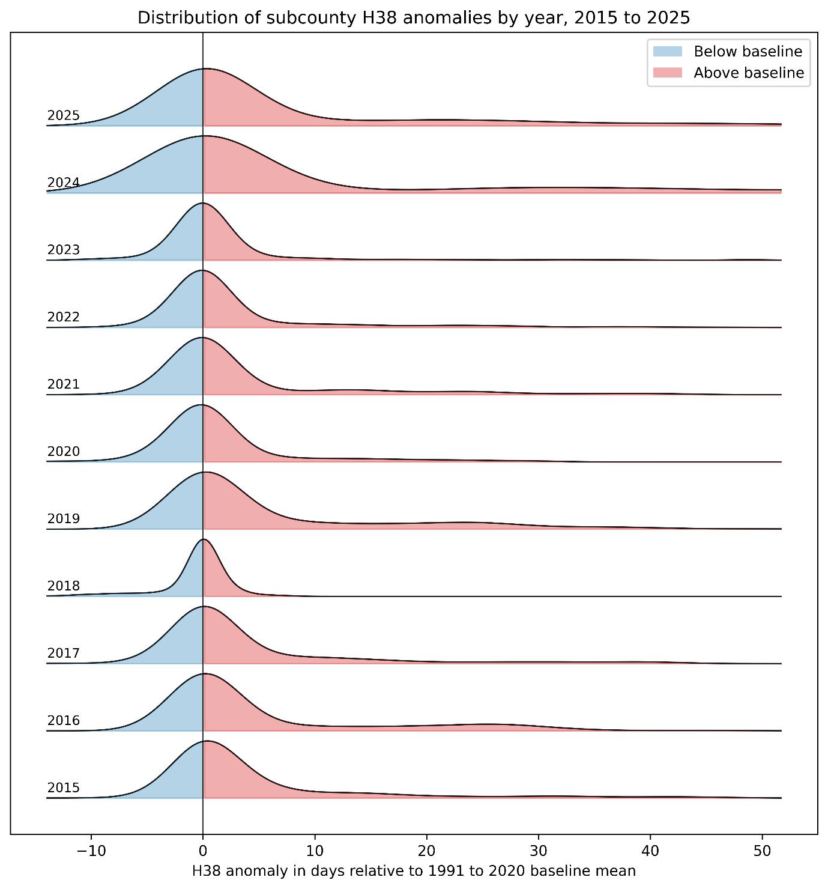
Note: Each ridge represents the kernel density estimate of the cross-sectional distribution of H38 anomalies across all 290 subcounties in a given year. Years are arranged chronologically from 2015 (bottom ridge) to 2025 (top ridge). The vertical black line at anomaly = 0 marks the 1991–2020 WMO baseline mean. Blue-shaded area to the left of the zero line represents subcounties with below-baseline H38 exposure; pink-shaded area to the right represents subcounties with above-baseline H38 exposure. The large concentration of density near and below zero in every year reflects the 136 zero-exposure highland subcounties. The 2018 ridge shows the most pronounced leftward displacement and the smallest above-baseline area, consistent with the nationally anomalous La Nina-suppressed year (national aggregate anomaly -6.8 days). The 2024 and 2025 ridges display the most pronounced rightward shift and the widest positive tails, extending to approximately +50 days anomaly, consistent with record national anomalies of +32.0 days (2024) and +26.4 days (2025). Kernel density estimation used a Gaussian kernel with Silverman bandwidth selection. Anomaly = subcounty annual H38 minus the subcounty-specific 1991–2020 WMO baseline mean. H38 = days per year with UTCI > 38 °C.
S6 Fig. Year-by-year subcounty choropleth maps of annual H38 heat exposure anomaly (departure in days per year from the 1991–2020 WMO reference period baseline mean) for each year from 2015 to 2025, Kenya.
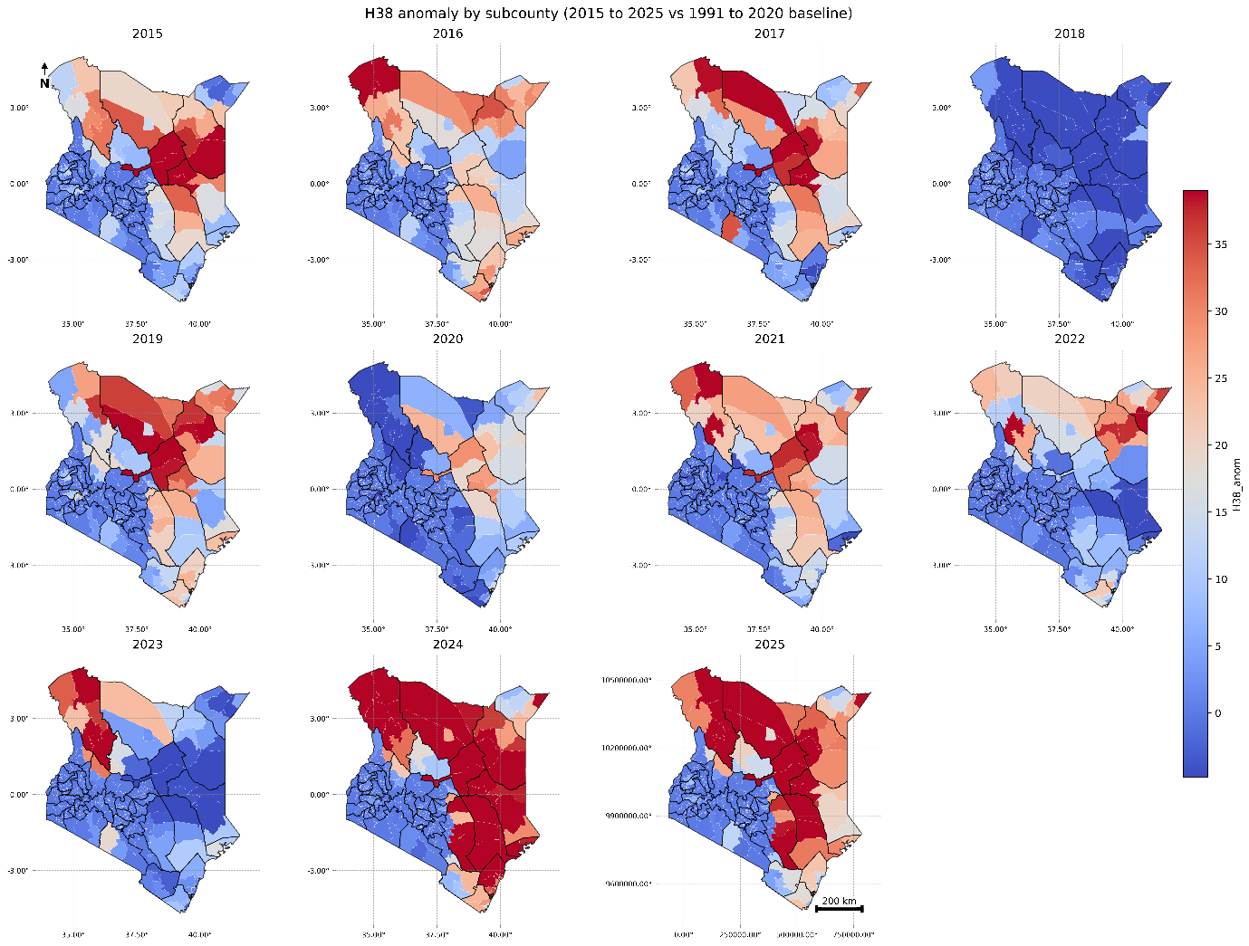
Note: Each panel displays the subcounty-level H38 anomaly for the labelled calendar year using a diverging colour scale: blue shades indicate below-baseline values (negative anomaly) and red to dark red shades indicate above-baseline values (positive anomaly), with near-white representing values close to zero. The colour scale spans from 0 to approximately 35 days of positive anomaly, with the most deeply red subcounties exceeding +35 days above the baseline. County boundaries are shown as bold black lines. The 2018 panel shows the most spatially widespread and intense below-baseline pattern of the study period, consistent with La Nina-driven temperature suppression. The 2024 and 2025 panels show the most spatially extensive and deeply positive anomaly patterns across the full 11-year series, concentrated across the northern arid lowlands and extending southward through eastern Kenya to the coast. These spatial maps provide the geographic complement to the distributional year-by-year ridgeline perspective in S5 Fig and to the national aggregate series shown in Fig 2. Anomaly = subcounty annual H38 minus the subcounty-specific 1991–2020 WMO baseline mean. H38 = days per year with UTCI > 38 °C. Scale bar = 200 km.
S7 Fig. Year-by-year subcounty maps of the binary sustained H38 heat hotspot indicator for each year from 2015 to 2025, Kenya, showing the spatial footprint and inter-annual consistency of the sustained-heat tier.
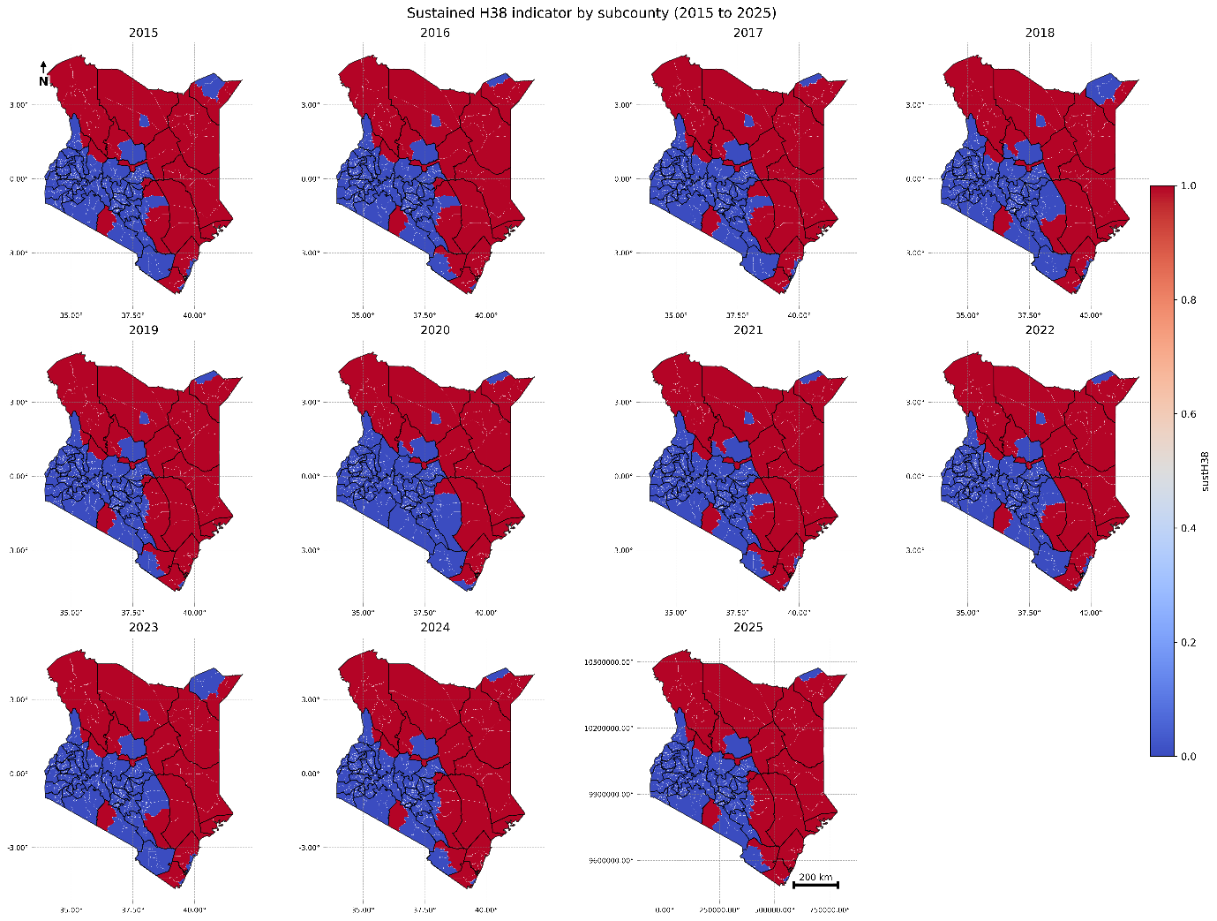
Note: Each panel displays a binary classification for the labelled calendar year: red subcounties met the sustained-heat hotspot criterion in that year; blue subcounties did not. County boundaries are shown as bold black lines. The spatial consistency of the red footprint across all 11 panels, including the anomalously cool year 2018 in which national aggregate heat exposure was substantially below baseline, provides the primary visual evidence for the exceptional hotspot stability quantified in Fig 3 and Table 2. Minor inter-panel variation is visible at the margins of the sustained-heat tier, corresponding to the seven intermittent and five high-stability subcounties identified in the stability analysis. The 50 persistent tier subcounties (stability = 1.00) appear red in every single panel without exception, confirming that their classification is invariant to interannual climate fluctuation. Taken together with S6 Fig (anomaly magnitudes) and S5 Fig (distributional structure), this panel series confirms that the spatial geography of the sustained-heat tier is structurally determined by topographic and land surface factors. H38 = days per year with UTCI > 38 °C. Scale bar = 200 km.
S1 Table. Complete national annual time series of area-averaged mean heat exposure (H38 and H46 days per year) and anomaly from the 1991–2020 WMO baseline, Kenya, 1991–2025.
Year | H38 mean days/year | H38 anomaly vs 1991–2020 baseline (days) | H46 mean days/year | Contextual annotation
1991 | 71.5 | -1.5 | 0.003 | Below-baseline; early-period cooling in eastern arid lowlands
1992 | 66.1 | -6.9 | 0.000 | Below-baseline
1993 | 56.2 | -16.8 | 0.000 | Strongest negative anomaly of record; La Nina-related cooling
1994 | 70.8 | -2.2 | 0.000 | Near-baseline
1995 | 65.6 | -7.5 | 0.000 | Below-baseline
1996 | 65.8 | -7.2 | 0.000 | Below-baseline
1997 | 56.7 | -16.3 | 0.000 | Below-baseline; ENSO cooling phase
1998 | 56.9 | -16.2 | 0.000 | Below-baseline
1999 | 56.0 | -17.0 | 0.000 | Below-baseline
2000 | 71.0 | -2.1 | 0.000 | Near-baseline; transition year
2001 | 67.0 | -6.0 | 0.000 | Below-baseline
2002 | 63.1 | -9.9 | 0.000 | Below-baseline
2003 | 75.9 | +2.8 | 0.000 | First above-baseline year in the record
2004 | 71.5 | -1.5 | 0.000 | Near-baseline
2005 | 81.7 | +8.7 | 0.015 | Above-baseline; H46 first detected nationally
2006 | 70.5 | -2.5 | 0.000 | Near-baseline
2007 | 70.0 | -3.1 | 0.000 | Near-baseline
2008 | 72.3 | -0.7 | 0.000 | Near-baseline
2009 | 80.5 | +7.4 | 0.000 | Above-baseline
2010 | 74.8 | +1.7 | 0.005 | Near-baseline; marginal H46 detection
2011 | 81.0 | +8.0 | 0.000 | Above-baseline; sustained warming phase begins
2012 | 83.7 | +10.7 | 0.000 | Above-baseline
2013 | 77.1 | +4.0 | 0.000 | Above-baseline
2014 | 82.7 | +9.7 | 0.007 | Above-baseline; H46 marginal detection
2015 | 89.7 | +16.7 | 0.000 | Markedly above-baseline; strong El Nino influence
2016 | 89.2 | +16.2 | 0.170 | Above-baseline; H46 spike (0.17 days/year) nationally
2017 | 90.3 | +17.3 | 0.000 | Above-baseline
2018 | 66.2 | -6.8 | 0.000 | Below-baseline; La Nina-associated suppression
2019 | 91.4 | +18.4 | 0.008 | Above-baseline; new record at the time
2020 | 75.6 | +2.6 | 0.004 | Near-baseline; COVID-19 year; marginal H46
2021 | 88.7 | +15.6 | 0.000 | Markedly above-baseline
2022 | 82.7 | +9.6 | 0.000 | Above-baseline
2023 | 79.8 | +6.8 | 0.000 | Above-baseline
2024 | 105.0 | +32.0 | 0.068 | Record high H38; highest positive anomaly in 35-year record; H46 detected at 0.07 days/year
2025 | 99.5 | +26.4 | 0.006 | Second-highest H38; second-largest positive anomaly; H46 0.006 days/year
Note: H38 = days per year with UTCI > 38 °C (Very strong heat stress); H46 = days per year with UTCI > 46 °C (Extreme heat stress). Anomalies represent the departure of each year’s national mean from the 30-year WMO reference period baseline mean (1991–2020 H38 baseline = 73.0 days/year; H46 baseline = 0.008 days/year). All values are area-averaged means across all ERA5-HEAT grid cells within Kenya’s administrative boundary (n = 749 cells at approximately 0.25° resolution). Contextual annotations are indicative of the dominant large-scale climate driver and are not inferred from formal attribution analysis. ENSO = El Nino-Southern Oscillation. H46 values of 0.000 indicate no subcounty recorded a UTCI exceedance of 46 °C in that year at the area-averaged national level.
S2 Table. County-level summary characteristics of the 61 sustained-heat subcounties, including mean and maximum H38 exposure, mean Relative Wealth Index, and annualised population burden by priority group, Kenya 2025.
County | n subcounties | Mean H38 (days/year) | Max H38 (days/year) | Mean RWI | Pregnant women burden (person-days, x1000) | Children <5 burden (person-days, x1000) | Adults 60+ burden (person-days, x1000)
Turkana | 6 | 197.4 | 259.0 | -0.51 | 8,781 | 25,728 | 6,109
Garissa | 6 | 188.6 | 218.4 | -0.43 | 8,729 | 27,789 | 6,032
Tana River | 3 | 169.3 | 183.6 | -0.43 | 4,875 | 17,577 | 4,296
Isiolo | 2 | 148.3 | 159.4 | -0.47 | 2,386 | 7,956 | 2,139
Wajir | 6 | 145.8 | 221.9 | -0.61 | 5,732 | 20,150 | 2,934
Lamu | 2 | 110.9 | 116.1 | -0.40 | 728 | 1,998 | 791
Marsabit | 4 | 98.1 | 158.8 | -0.41 | 2,310 | 7,779 | 2,124
Mandera | 5 | 87.5 | 151.0 | -0.69 | 3,183 | 13,045 | 1,694
Samburu | 2 | 83.7 | 124.6 | -0.48 | 803 | 3,044 | 712
Kilifi | 7 | 65.6 | 109.0 | -0.23 | 4,860 | 13,257 | 5,052
Kitui | 4 | 60.4 | 73.2 | -0.56 | 1,819 | 4,130 | 2,539
Kwale | 3 | 55.7 | 57.9 | -0.38 | 1,967 | 6,332 | 2,150
Mombasa | 6 | 51.1 | 64.5 | +0.75 | 3,732 | 7,376 | 1,714
Kajiado | 1 | 70.7 | 70.7 | -0.45 | 813 | 2,530 | 557
Baringo | 1 | 70.1 | 70.1 | -0.55 | 468 | 1,683 | 259
West Pokot | 1 | 43.0 | 43.0 | -0.49 | 207 | 913 | 208
Tharaka-Nithi | 1 | 40.7 | 40.7 | -0.40 | 247 | 513 | 299
Taita Taveta | 1 | 37.1 | 37.1 | -0.27 | 212 | 453 | 251
Note: Sustained-heat subcounties are those meeting the sustained hotspot classification criterion across the 11-year study period. Burden is expressed as total annual person-days of H38 UTCI exposure (days/year multiplied by estimated population at risk). Population-days are in thousands (x1,000). Mean RWI values below zero indicate below-average relative wealth; Mombasa’s positive mean RWI (+0.75) reflects the county’s predominantly urban character despite its coastal heat exposure. Counties are sorted in descending order of mean H38 exposure. RWI = Relative Wealth Index; H38 = UTCI days per year > 38 °C.
S3a Table. Top 20 subcounties by hazard-gated priority score for pregnant women, Kenya: 11-year mean (2015–2025).
Rank | Subcounty | County | hazard-gated priority score score (0–100) | Mean H38 days/year | Population (N) | Poverty score (0–100)
1 | Turkana East | Turkana | 70.9 | 233.5 | 66,588 | 84.9
2 | Wajir South | Wajir | 69.9 | 209.7 | 143,964 | 92.5
3 | Dadaab | Garissa | 67.5 | 207.9 | 117,954 | 79.8
4 | Turkana South | Turkana | 66.2 | 227.6 | 74,139 | 89.5
5 | Turkana Central | Turkana | 62.8 | 210.3 | 91,944 | 79.3
6 | Fafi | Garissa | 61.7 | 185.9 | 81,306 | 88.0
7 | Turkana West | Turkana | 58.3 | 143.2 | 116,740 | 85.8
8 | Bura | Garissa | 58.2 | 143.1 | 163,804 | 85.3
9 | Galole | Tana River | 56.6 | 163.8 | 81,123 | 81.9
10 | Lagdera | Garissa | 56.0 | 161.5 | 69,237 | 89.1
11 | Dujis | Garissa | 55.9 | 183.6 | 102,715 | 56.2
12 | Turkana North | Turkana | 55.2 | 155.9 | 50,444 | 85.5
13 | Ijara | Garissa | 54.0 | 150.2 | 66,412 | 87.4
14 | Mandera East | Mandera | 53.5 | 136.5 | 87,801 | 87.6
15 | Wajir East | Wajir | 53.1 | 154.9 | 51,464 | 82.4
16 | North Horr | Marsabit | 52.8 | 141.9 | 65,654 | 82.8
17 | Balambala | Garissa | 52.7 | 149.9 | 23,853 | 93.6
18 | Wajir West | Wajir | 52.3 | 149.1 | 28,722 | 90.4
19 | Mandera South | Mandera | 51.4 | 112.9 | 95,518 | 94.8
20 | Isiolo North | Isiolo | 50.9 | 119.4 | 101,223 | 83.7
Note: Population (N) represents the cumulative 11-year person-year total for pregnant women, summed across the 2015 to 2025 study period. Mean H38 represents the arithmetic mean of annual H38 days per year for the subcounty across 2015 to 2025, derived from polygon-based aggregation of gridded UTCI data. The Spearman rank correlation between 2025 hazard-gated priority rankings (Table 3) and 11-year mean rankings (this table) is rho = 0.999 (p < 0.001), with complete top-20 overlap (20/20). Poverty score is the min-max scaled transformation of -RWI across all 290 subcounties (0 = least deprived, 100 = most deprived). H38 = days per year with UTCI > 38 °C.
S3b Table. Top 20 subcounties by hazard-gated priority score for children under-5, Kenya: 11-year mean (2015–2025).
Rank | Subcounty | County | hazard-gated priority score score (0–100) | Mean H38 days/year | Population (N) | Poverty score (0–100)
1 | Wajir South | Wajir | 75.8 | 209.7 | 505,718 | 92.5
2 | Dadaab | Garissa | 71.5 | 207.9 | 384,003 | 79.8
3 | Turkana East | Turkana | 71.5 | 233.3 | 157,236 | 84.9
4 | Turkana South | Turkana | 68.1 | 227.3 | 221,277 | 89.5
5 | Turkana Central | Turkana | 66.3 | 210.1 | 315,900 | 79.3
6 | Bura | Garissa | 65.4 | 143.1 | 599,826 | 85.3
7 | Fafi | Garissa | 64.4 | 186.0 | 263,878 | 88.0
8 | Turkana West | Turkana | 61.2 | 143.0 | 342,433 | 85.8
9 | Galole | Tana River | 60.4 | 163.8 | 308,063 | 81.9
10 | Dujis | Garissa | 59.3 | 183.6 | 335,249 | 56.2
11 | Lagdera | Garissa | 58.6 | 161.5 | 237,934 | 89.1
12 | Mandera South | Mandera | 58.2 | 112.9 | 450,436 | 94.8
13 | Turkana North | Turkana | 57.1 | 155.6 | 178,164 | 85.5
14 | Mandera East | Mandera | 57.1 | 136.3 | 314,564 | 87.6
15 | Ijara | Garissa | 56.3 | 150.2 | 222,958 | 87.4
16 | Wajir East | Wajir | 54.8 | 154.9 | 168,537 | 82.4
17 | Isiolo North | Isiolo | 54.5 | 119.2 | 340,637 | 83.7
18 | North Horr | Marsabit | 54.3 | 141.8 | 193,298 | 82.8
19 | Wajir West | Wajir | 53.8 | 148.9 | 117,956 | 90.4
20 | Balambala | Garissa | 53.4 | 149.9 | 80,049 | 93.6
Note: Population (N) represents the cumulative 11-year person-year total for children under-5. The Spearman rank correlation between 2025 hazard-gated priority rankings (Table 3) and 11-year mean rankings (this table) is rho = 0.999 (p < 0.001), with complete top-20 overlap (20/20). All other footnotes as in S3a Table.
S3c Table. Top 20 subcounties by hazard-gated priority score for adults aged 60 years and older, Kenya: 11-year mean (2015–2025).
Rank | Subcounty | County | hazard-gated priority score score (0–100) | Mean H38 days/year | Population (N) | Poverty score (0–100)
1 | Dadaab | Garissa | 71.4 | 207.8 | 68,840 | 79.8
2 | Turkana East | Turkana | 71.2 | 234.4 | 28,805 | 84.9
3 | Wajir South | Wajir | 70.5 | 209.6 | 57,182 | 92.5
4 | Turkana South | Turkana | 70.0 | 229.0 | 51,868 | 89.5
5 | Bura | Garissa | 67.9 | 143.4 | 115,649 | 85.3
6 | Turkana Central | Turkana | 67.0 | 211.3 | 59,591 | 79.3
7 | Fafi | Garissa | 64.1 | 186.1 | 47,529 | 88.0
8 | Galole | Tana River | 61.4 | 164.4 | 61,011 | 81.9
9 | Turkana West | Turkana | 60.1 | 143.8 | 53,229 | 85.8
10 | Dujis | Garissa | 59.8 | 183.9 | 61,434 | 56.2
11 | Magarini | Kilifi | 59.6 | 100.6 | 107,117 | 82.0
12 | Lagdera | Garissa | 58.5 | 161.7 | 43,111 | 89.1
13 | Kinango | Kwale | 58.1 | 48.9 | 140,108 | 82.9
14 | North Horr | Marsabit | 57.7 | 142.7 | 55,810 | 82.8
15 | Isiolo North | Isiolo | 57.7 | 120.2 | 77,810 | 83.7
16 | Turkana North | Turkana | 57.4 | 156.8 | 34,809 | 85.5
17 | Ijara | Garissa | 56.3 | 150.3 | 40,825 | 87.4
18 | Mandera East | Mandera | 56.0 | 137.4 | 48,150 | 87.6
19 | Garsen | Tana River | 54.5 | 142.1 | 43,574 | 80.4
20 | Wajir East | Wajir | 54.2 | 155.0 | 29,009 | 82.4
Note: Population (N) represents the cumulative 11-year person-year total for adults aged 60 and older. The Spearman rank correlation between 2025 hazard-gated priority rankings (Table 3) and 11-year mean rankings (this table) is rho = 0.997 (p < 0.001), with 19/20 top-20 overlap; the single discrepancy reflects Kitui South (2025 only) and Wajir East (11-year mean only) exchanging positions at the margin of the 20th rank. All other footnotes as in S3a Table.
S4 Table. Concentration of annual heat exposure burden (H38 person-days) by cumulative subcounty tier, for three priority populations, Kenya 2025.
Priority group | Total annual person-days of H38 exposure (2025) | % attributable to top 61 subcounties (sustained tier) | % attributable to top 20% of subcounties by H38 | % attributable to top 10% of subcounties by H38
Pregnant women | 53,917,928 | 96.2% | 94.4% | 67.9%
Children under-5 | 167,682,419 | 96.8% | 95.3% | 71.7%
Adults aged 60+ | 41,973,583 | 95.0% | 92.9% | 63.6%
Note: Person-days of exposure = H38 days/year multiplied by estimated population at risk per subcounty, summed across subcounties within each tier. The sustained tier comprises the 61 subcounties classified as sustained-heat hotspots. The top 20% tier comprises the 58 subcounties with the highest H38 values (20% of 290). The top 10% tier comprises the 29 subcounties with the highest H38 values. Percentages may not sum to 100% across tiers because tiers overlap (the top 10% is a subset of the top 20%, which largely overlaps with the sustained tier). The high concentration of burden in the upper tier reflects the strongly right-skewed distribution of H38 values (national median = 0.0 days/year; national mean = 23.9 days/year in 2025).
S5 Table. Subcounty-level Mann-Kendall trend statistics and Sen slope estimates for H38 heat exposure, for all 59 subcounties with statistically significant positive trends (p < 0.05), Kenya 1991–2025.
Subcounty | County | Sen slope (days/year) | MK Z-statistic | p-value | Mean H38 (days/year) | Max H38 (days/year)
Isiolo North | Isiolo | 3.72 | 4.46 | < 0.001 | 166.0 | 255.0
Lagdera | Garissa | 2.44 | 4.45 | < 0.001 | 137.7 | 201.0
Turkana Central | Turkana | 2.39 | 4.76 | < 0.001 | 157.3 | 254.0
North Horr | Marsabit | 2.29 | 4.79 | < 0.001 | 144.5 | 207.0
Turkana North | Turkana | 2.29 | 4.63 | < 0.001 | 139.8 | 212.0
Balambala | Garissa | 2.26 | 4.74 | < 0.001 | 135.7 | 197.0
Bura | Garissa | 2.12 | 4.03 | < 0.001 | 122.1 | 171.0
Wajir West | Wajir | 2.11 | 4.94 | < 0.001 | 113.4 | 167.0
Laisamis | Marsabit | 2.08 | 4.73 | < 0.001 | 65.2 | 140.0
Eldas | Wajir | 2.07 | 5.71 | < 0.001 | 83.5 | 133.0
Isiolo South | Isiolo | 2.05 | 4.62 | < 0.001 | 50.5 | 128.0
Mandera East | Mandera | 1.97 | 4.29 | < 0.001 | 124.0 | 177.0
Loima | Turkana | 1.92 | 3.74 | < 0.001 | 153.7 | 232.0
Turkana West | Turkana | 1.83 | 2.88 | 0.004 | 200.3 | 268.0
Dujis | Garissa | 1.63 | 4.54 | < 0.001 | 168.0 | 221.0
Wajir East | Wajir | 1.61 | 4.03 | < 0.001 | 142.2 | 178.0
Galole | Tana River | 1.57 | 4.05 | < 0.001 | 161.4 | 217.0
Wajir South | Wajir | 1.50 | 3.45 | 0.001 | 197.9 | 250.0
Kitui South | Kitui | 1.48 | 4.25 | < 0.001 | 56.5 | 128.0
Wajir North | Wajir | 1.47 | 4.57 | < 0.001 | 60.7 | 105.0
Tharaka | Tharaka-Nithi | 1.46 | 4.47 | < 0.001 | 32.2 | 76.0
Mandera South | Mandera | 1.46 | 4.59 | < 0.001 | 92.8 | 142.0
Tarbaj | Wajir | 1.38 | 4.18 | < 0.001 | 51.3 | 95.0
Mwingi East | Kitui | 1.21 | 3.71 | < 0.001 | 29.6 | 79.0
Kitui East | Kitui | 1.20 | 4.23 | < 0.001 | 29.0 | 76.0
Garsen | Tana River | 1.17 | 3.34 | 0.001 | 147.8 | 194.0
Moyale | Marsabit | 1.17 | 3.75 | < 0.001 | 41.8 | 75.0
Lamu West | Lamu | 1.05 | 3.74 | < 0.001 | 89.8 | 129.0
Ijara | Garissa | 1.00 | 3.68 | < 0.001 | 147.6 | 170.0
Lamu East | Lamu | 1.00 | 3.51 | < 0.001 | 134.5 | 164.0
Kaloleni | Kilifi | 0.94 | 3.61 | < 0.001 | 49.7 | 81.0
Magarini | Kilifi | 0.94 | 2.54 | 0.011 | 92.9 | 142.0
Jomvu | Mombasa | 0.86 | 3.64 | < 0.001 | 59.4 | 85.0
Changamwe | Mombasa | 0.86 | 3.64 | < 0.001 | 59.4 | 85.0
Lunga Lunga | Kwale | 0.86 | 3.75 | < 0.001 | 33.9 | 61.0
Rabai | Kilifi | 0.86 | 3.64 | < 0.001 | 59.4 | 85.0
Dadaab | Garissa | 0.85 | 2.64 | 0.008 | 206.7 | 236.0
Mandera West | Mandera | 0.83 | 3.34 | 0.001 | 36.9 | 72.0
Ganze | Kilifi | 0.83 | 3.05 | 0.002 | 62.0 | 100.0
Nyali | Mombasa | 0.78 | 3.95 | < 0.001 | 22.0 | 55.0
Likoni | Mombasa | 0.78 | 3.95 | < 0.001 | 22.0 | 55.0
Kisauni | Mombasa | 0.78 | 3.95 | < 0.001 | 22.0 | 55.0
Mvita | Mombasa | 0.78 | 3.95 | < 0.001 | 22.0 | 55.0
Lafey | Mandera | 0.74 | 2.93 | 0.003 | 33.6 | 64.0
Matuga | Kwale | 0.56 | 3.65 | < 0.001 | 22.6 | 57.0
Kilifi South | Kilifi | 0.54 | 3.11 | 0.002 | 24.3 | 58.0
Voi | Taita Taveta | 0.54 | 3.21 | 0.001 | 14.7 | 47.0
Kibwezi East | Makueni | 0.41 | 4.06 | < 0.001 | 9.9 | 47.0
Mandera North | Mandera | 0.36 | 2.43 | 0.015 | 15.2 | 43.0
Malava | Kakamega | 0.36 | 3.27 | 0.001 | 8.3 | 29.0
Navakholo | Kakamega | 0.36 | 3.27 | 0.001 | 8.3 | 29.0
Webuye West | Bungoma | 0.36 | 3.27 | 0.001 | 8.3 | 29.0
Mwingi North | Kitui | 0.28 | 4.15 | < 0.001 | 5.7 | 24.0
Sigowet/Soin | Kericho | 0.27 | 3.11 | 0.002 | 6.4 | 27.0
Nyakach | Kisumu | 0.27 | 3.11 | 0.002 | 6.4 | 27.0
Igembe South | Meru | 0.27 | 3.47 | 0.001 | 5.5 | 22.0
Kinango | Kwale | 0.22 | 3.03 | 0.002 | 6.7 | 19.0
Ainamoi | Kericho | 0.07 | 1.97 | 0.048 | 5.1 | 31.0
Mwatate | Taita Taveta | 0.07 | 3.22 | 0.001 | 1.7 | 8.0
Note: Trend analysis was conducted on the full 35-year time series (1991–2025) of annual H38 days per year derived from centroid-extracted ERA5-HEAT UTCI reanalysis data for each of the 290 subcounties. The centroid-based extraction was used for this supplementary trend analysis because the polygon-aggregated panel was constructed only for the 2015 to 2025 study window; see Materials and methods for details. The Mann-Kendall (MK) test was applied as a non-parametric test for monotonic trend; the Sen slope estimator provides the median rate of change in days per year. Of 290 subcounties, 59 (20.3%) showed a statistically significant positive trend at p < 0.05; none showed a statistically significant negative trend. The remaining 231 subcounties had non-significant trends, predominantly subcounties with zero or near-zero H38 values across the study period. Subcounties are sorted in descending order of Sen slope magnitude. MK = Mann-Kendall; Z = standardised MK statistic; p-values < 0.001 are reported as < 0.001.
S6 Table. Mean H38 heat exposure (days per year) by Relative Wealth Index decile across 290 subcounties, Kenya 2025, illustrating the heat-poverty gradient.
RWI decile | Mean H38 days/year (2025) | % of subcounties in decile with H38 > 0 | Mean RWI score (range) | Dominant geographic profile
1 (poorest) | 112.6 | 100% | < -0.55 | Predominantly Turkana, Wajir, Garissa arid lowlands
2 | 80.1 | 100% | -0.55 to -0.40 | ASAL transition zones; Marsabit, Tana River
3 | 15.1 | 72% | -0.40 to -0.25 | Semi-arid mixed zones
4 | 4.4 | 48% | -0.25 to -0.12 | Transitional agro-pastoral zones
5 | 2.8 | 41% | -0.12 to -0.01 | Mixed highland-lowland transition
6 | 5.3 | 45% | -0.01 to +0.10 | Moderate elevation; scattered coastal exposure
7 | 0.8 | 24% | +0.10 to +0.22 | Primarily highland subcounties
8 | 7.2 | 38% | +0.22 to +0.38 | Peri-urban and coastal lowlands with moderate income
9 | 5.6 | 31% | +0.38 to +0.62 | Predominantly urban and highland
10 (wealthiest) | 5.3 | 34% | > +0.62 | Urban centers: Nairobi, Mombasa, Kisumu cores
Note: Subcounties were ranked by Relative Wealth Index (RWI; Chi et al., 2022) and divided into deciles (n approximately 29 subcounties per decile). RWI scores are unitless; negative values indicate below-average wealth relative to the national distribution. The percentage of subcounties with H38 > 0 in each decile is derived from the 2025 subcounty H38 values. The Spearman rank correlation between subcounty H38 and RWI across all 290 subcounties is rho = -0.561 (p < 0.001), confirming a strong, statistically significant inverse wealth-heat gradient. The non-monotonic pattern in deciles 6–10 partly reflects the presence of peri-urban coastal subcounties (Mombasa, Kilifi coast) with moderate-to-high RWI but elevated H38 exposure. RWI = Relative Wealth Index; H38 = days/year with UTCI > 38 °C.
S7 Table. Heat Index priority robustness summary for the 2025 independent heat-metric sensitivity analysis.
Note: This table compares 2025 hazard-gated priority rankings based on UTCI-derived H38 with rankings based on daily maximum National Weather Service Heat Index ≥ 32 °C. It reports rank correlations and top-20 overlap for the three priority population groups.
S8 Table. Complete hazard-gated subcounty priority rankings for pregnant women, children under five years, and adults aged 60 years and older, Kenya 2025.
Note: This table contains the full 290-subcounty ranked output underlying Table 3 and Fig 6. Subcounties with H38 = 0 are retained with zero primary heat-priority score to preserve the national denominator and make the hazard gate transparent.
S9 Table. Reference reconciliation register.
Note: This table records the citation audit, source-verification status, and manuscript-use status for the reference list after reconciliation.

