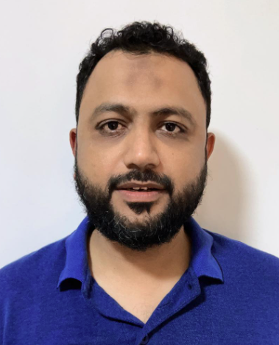
MUHAMMAD ZEESHAN
Solutions Architect
Ezdan Oasis, Al-Wukair, Doha, Qatar
+974-33937436 | zeeshanse@gmail.com
LinkedIn : www.linkedin.com/in/muhammad-zeeshan-2a698b2a GitHub: https://github.com/mzeeshanse
Nationality: Pakistani | DOB: Apr 18, 1982

PROFILE
A strategic and results-driven Solutions Architect with 21+ years of experience delivering enterprise-scale, secure, and highly available software solutions across government and Oil & Gas sectors in the Gulf.
Expert in translating complex business requirements into robust architecture with specialization in ANPR, Access Control, Security Systems, and mission-critical applications.
Proven track record of leading cross-functional teams, designing scalable solutions, and deploying national-level systems for industry giants including MOI Qatar, Saudi Aramco, and Qatar Gas.

CORE COMPETENCIES
Solution Design & Architecture
Requirements Analysis • Technical Design • System Integration • Scalability & Performance • Microservices • Event-Driven Architecture
Cloud & DevOps
Cloud-Native (Docker, Kubernetes) • AWS S3 • AI/ML on SageMaker • Load Balancing (Nginx, HAProxy) • CI/CD Automation
AI & Data-Driven Solutions
Computer Vision • Object Detection • LLMs • Generative AI • LSTM Forecasting • TensorFlow • SQL/NoSQL/Elasticsearch
Enterprise Security Systems
ANPR • RFID Access Control • PSIM • CCTV/VMS • Physical Security Hardware • High-Availability Architecture
Leadership & Stakeholder Management
Cross-functional Leadership • Technical Consultancy • Pre-Sales • Vendor Management • Client Collaboration

TECHNICAL SKILLS
- Architecture & Development: .NET Core, ASP.NET MVC/Web API, Microservices, REST/SOAP, Angular, Node.js, Python, Rust
- AI/ML & Data: TensorFlow, SageMaker, Computer Vision, NLP/LLMs, Time-Series Prediction, Generative AI
- Data & Caching: Oracle, MS SQL Server, MySQL, MongoDB, Elasticsearch, Redis
- Cloud & Infrastructure: Docker, Kubernetes, AWS S3, VMware, Hyper-V, Ubuntu Linux, Windows Server
- Networking & Messaging: Nginx, HA-Proxy, Load Balancers, RabbitMQ, Kafka, Domain Controllers, DHCP
- Industrial & Security IoT: Modbus, PLCs, RFID, Loop/Laser Detectors, Barrier/Hardware Integration

PROFESSIONAL EXPERIENCE
Solutions Architect
Traffic Tech, Doha, Qatar | Dec 2018 – Present
- Lead end-to-end architecture, system integration, and design of large-scale ANPR & access control solutions across highly regulated government and Oil & Gas clients.
- Work with senior stakeholders to define architecture roadmaps and transform business needs into secure, scalable technical solutions.
- Provide expert consultancy for national-level security systems ensuring compliance, performance, and high availability.
- Drive cross-functional teams for successful implementation and continuous improvement of enterprise systems.
- Designed integrated ITS and security solutions, including ANPR, parking, and access control systems for MOI Qatar, UDC, Ashghal, and others.
- Built scalable architecture using .NET Core and Angular with Nginx + HAProxy for high availability.
- Key Achievement: Led the technical evaluation, architectural design, and full deployment of the National ANPR Project for MOI Qatar, handling mission-critical, high-volume traffic data.

Senior Software Engineer & Security System Integrator
Fore-Vision Business Solutions, Jeddah, Saudi Arabia | Dec 2006 – Dec 2018
- Client: Saudi Aramco – Led full lifecycle of the Plate Recognition System (PRS) deployed across 34 sites and 70+ lanes.
- Designed and implemented high-availability infrastructure with a 6-year 24/7 maintenance contract ensuring maximum system uptime.
- Acted as the main technical consultant for Aramco’s SSMD, troubleshooting, enhancing, and integrating enterprise security systems.

Software Engineer
y-Evolve (Pvt.) Ltd, Karachi, Pakistan | Mar 2006 – Dec 2006
Software Developer (Project In-Charge)
A.I.D.M, Karachi, Pakistan | Jan 2005 – Mar 2006

EDUCATION & CERTIFICATIONS
- B.S. Computer Engineering – Bahria University, Karachi, Pakistan (CGPA 3.46)
- PIAIC – Cloud Native, Generative AI, IoT Courses (2023–2024)
- Pearson PTE – English Proficiency
- 2nd Prize – FAST ProCom National Programming Competition (2005)

LANGUAGES & INTERESTS
- Languages: English (Fluent), Urdu (Native), Arabic (Conversational)
- Interests: Technology Research, Reading, Swimming, News & Current Affairs

