

ATIQ-UR-REHMAN | CERTIFIEDD ETHICAL HACKER | 31-JULY-2024

WIRESHARK, NCBAE.EDU.PK GIVE PRIVATA IP, WHY?

[Report Subtitle]

### STEP 1: OPEN THE WIRESHARK

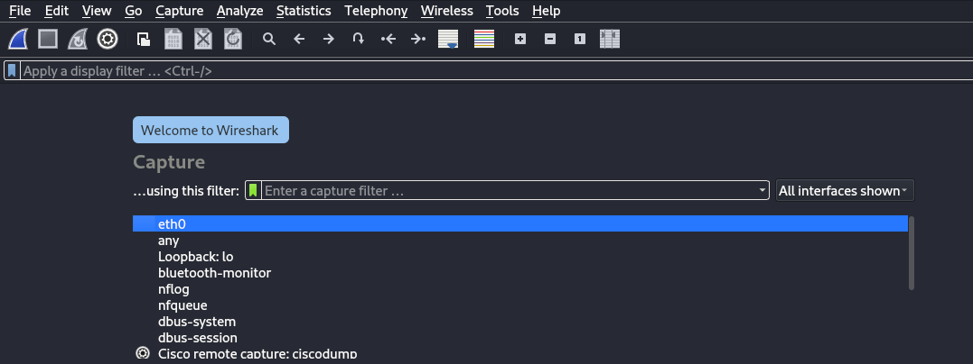

### STEP 2: SELECT THE TYPE

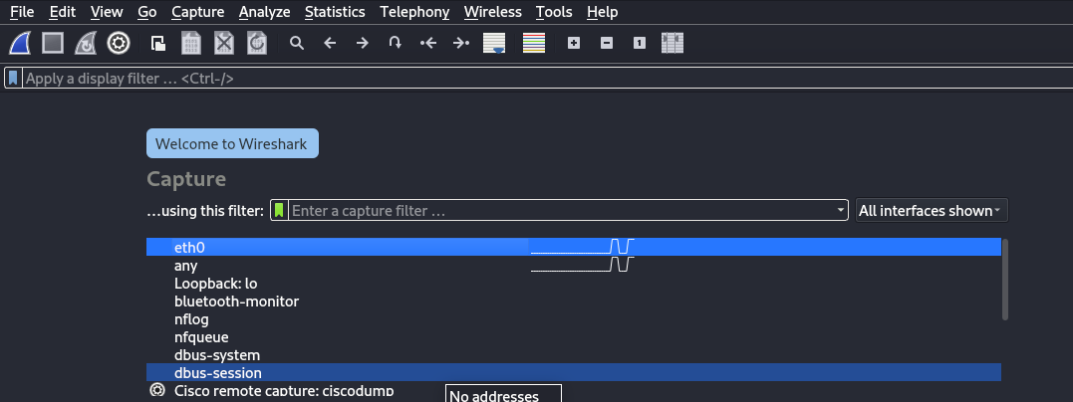

### STEP 3: USE HTTP LOGIN PAGE

### STEP 4: CAPTURE THE PACKETS FROM NETWORK THAT RECEVE AND SEND

### STEP 5: FILTER THE HTTP PROTOCOL AND CHEAK DATA

# 

THE DATA THAT I ENTER IN LOGIN PAGEE IS SHOWN IN THE CAPTURING DATA THAT IS

ASGAR AND PASSWORD IS ASGARBHAI.

SO, I SUCCESSFULLY DO IT.

# WHEN I PING THE GOOGLE.COM IT SHOW THE PRIVATE IP BUT WHEN I PING IN THE NCBAE.EDU.PK WEBSIITE IT ALSO GIVE THE PRIVATE IP, WHY?

# Reason:

“The most likely reason you're getting a private IP address when pinging ncbae.edu.pk is that the DNS server you're using is configured to resolve that domain to an internal IP address for network management or access control purposes.”

"configured" means that the DNS server has been set up or adjusted to return a specific IP address for the domain ncbae.edu.pk, which in this case is a private IP address rather than a public one. This configuration could be done for reasons such as network routing, security, or internal resource access.

SOURCE: CHATGPT