Running Calendly API

Purpose: using the Calendly API is an alternative to using the report export—it gives us more fine-grained control over the report and allows us to drop it into any folder or send it to any email.

Installation:

1. Download cmder (full) if you’re on windows: <https://cmder.net/>
2. Ensure you have python installed (see Michael Z)
3. Open cmder and move to the folder where you’d like to drop the code
4. Copy and paste:
   1. git clone <https://github.com/mzelenetz/calendly_api.git>
5. cd into Calendly_api
6. Type:
   1. mkdir data
   2. This is where your outputs will go

Running:

1. To run the application you need the calendly_secrets.ini in your /Calendly_api folder (see Michael Z)
2. Cd into calendly_api
3. Type: python calendly.py
4. You will likely see a URL and you’ll be prompted for a code. Paste the URL into your browser.
5. You will get back a code in the URL bar. It will say “page cannot be reached” and look like an error. LOOK IN THE URL. Paste that URL into the cmder prompt. See below.
6. 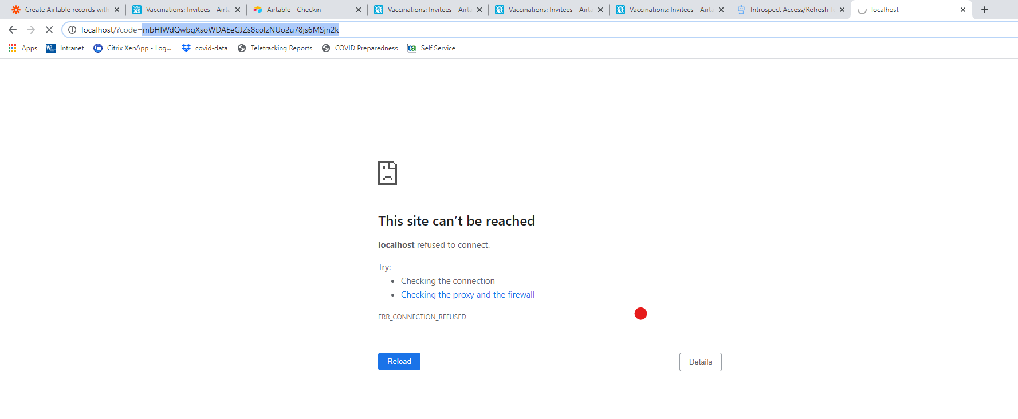
7. Copy and pasted that URL into the code below:
8. 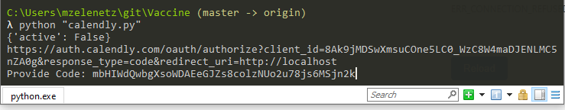

The output will be in /data

