1.0

1.1



2.1

2.2

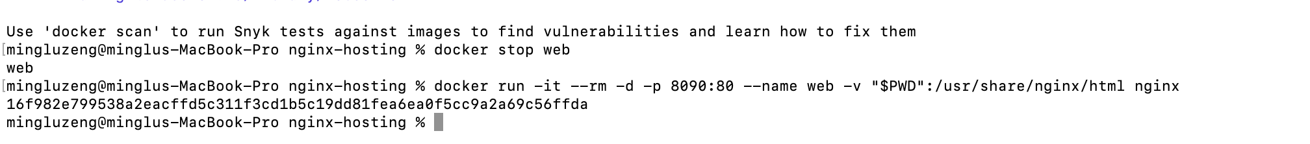

3.0

