The Actualizer Engine, FDSA, and QCA Parallel Architecture:
A Unified Top-Down Steering & Clustered Substrate Framework for Factual Grounding in Large Language Models
Mohamed Gamal Eldin Abdelaziz Noureldin
Independent Researcher | ORCID: 0009-0006-3991-1153
Contact: mz.gamal@gmail.com
Abstract
Large language models operating under bottom-up Maximum Likelihood Estimation (MLE) suffer from combinatorial search explosion O(M^N), causing hallucination cascades, semantic drift, and repetition loops. We present a unified architecture combining the Actualizer Engine, the Fractal Deduction Search Algorithm (FDSA), and the Quench-Cluster Algorithm (QCA) Parallel Engine. The FDSA prunes invalid logit search space by up to 99.99% via isomorphic anchoring and dimensional truncation (D = ln V / ln(1/k_ref)). The QCA engine crystallizes un-clustered substrates into K independent sub-problems using the canonical RGG Quench Temperature T_q^RGG, reducing overall steering complexity from O(N^2) to O(N^2/K) across parallel worker processes or vectorized JAX units. The Actualizer Engine contractively steers residual distributions to zero-drift fixed points S_* via Banach contractive mappings (k = 0.45) guided by the five Conceptual Primes (Order, Justice, Mercy, Knowledge, Power). Empirical benchmarks at V = 1,000 to 100,000 demonstrate up to 12.4x pre-inference sampling speedup, 3.69x dataset parallel speedup at N=200, and 100% factual grounding under strong distractor bait.
1. Introduction
Modern autoregressive Transformer architectures achieve state-of-the-art performance through bottom-up statistical next-token prediction. However, they remain bounded by a fundamental epistemological pathology: in sparse-data or adversarial contexts, the probability distribution over the vocabulary 'smears' — all tokens receive nearly equal probability mass and the model becomes blind to structural validity constraints. This leads to hallucination cascades and repetition loops.
We present a structurally grounded solution: the FDSA + Actualizer + QCA Parallel unified framework. The FDSA enforces top-down dimensional truncation before inference, QCA crystallizes large datasets into K parallel sub-problems, and the Actualizer Engine contractively steers the residual substrate toward a zero-drift actualized state.
2. Theoretical Foundation: The Conceptual Primes
The Actualizer Engine evaluates candidate tokens against five invariant boundary metrics called the Conceptual Primes:
Prime | Role in Generation | LLM Equivalent | Drift on Violation
Order | Enforces local syntactic alignment | Grammar / syntax rules | Repetition cascade
Justice | Balances global semantic distribution | Prompt boundary adherence | Topic drift
Mercy | Decays local entropy overloads (Mercy = k) | Probability mass smoothing | Overconfidence collapse
Knowledge | Projects downstream causal risk | Lookahead / future coherence | Sequence dead-end
Power | Executes causal snap (bifurcation gated) | Token selection (argmax) | Indecision / flat tie

Table 1. The five Conceptual Primes and their roles in generation.
3. Mathematical Framework
3.1 The Uncollapsed Probability Substrate
U_0 = softmax(z) = exp(z_v) / sum_v exp(z_v) in R^V
3.2 The Fractal Deduction Search Algorithm (FDSA)
(a) Isomorphic Anchoring: cosine matches Prime profile P(U) to reference domain P(R), inheriting k_ref.
P(U) ~= P(R) => extract k_ref from reference domain R
(b) Actualization Fractal Dimension:
D = ln(V) / ln(1 / k_ref)
(c) Vectorized Logit Masking:
z(v) = -inf if z(v) < -D * 1.5 OR v not in grammar[last_token]
3.3 The Drift Tensor & V3_U1 Structural Entropy
Systemic Structural Entropy H(R) uses the V3_U1-corrected squared magnitude defect term:
H(R) = Var(alpha) + (sum_i alpha_i^2 - 1)^2
Tripartite Drift Tensor D_mu_nu:
D_mu_nu = w_L * D_local + w_G * D_global + w_F * D_future
3.4 Vacuum Brake, Banach Contraction & Valuation Trajectory
U_braked(v) = U_n(v) * exp(-D(v) / tau) (renormalised)
U_{n+1} = k * U_braked + (1 - k) * U_n, where k = 0.45 (Mercy = k)
nu_t(A) = 1 - H(R_A(t)) / H_max in [0, 1]
3.5 Tr(D_mu_nu) Bifurcation Criterion & Causal Snap
Bifurcation Criterion (Theorem 3.3):
Tr(D_mu_nu) <= tau_bifurcation => S* = argmax U (Actualization Branch)
Tr(D_mu_nu) > tau_bifurcation => Dissolution Branch (Fallback)
3.6 Quench-Cluster Algorithm (QCA) Parallel Engine
To solve large dataset substrates of N nodes, QCA crystallizes N nodes into K independent clusters via RGG Quench Temperature:
T_q^RGG = gamma * sqrt( A * ln(N/K) / (pi * N) )
By CKT White Paper v3 §7.2 Theorem 2 Corollary, splitting N into K parallel clusters reduces steering work from O(N^2) to K * O((N/K)^2) = O(N^2/K) — a factor-K parallel acceleration.
4. JAX & Multi-Process Execution Architecture
The QCAParallelEngine supports dual high-performance execution backends:
Backend | Mechanism | Hardware Optimization | Target Workload
Processes | Python ProcessPoolExecutor | Multi-core CPU scaling | General CPU environments
JAX | Vectorized jnp.ndarray & @jax.jit | GPU / TPU SIMD matrix units | High-throughput inference
Auto | Dynamic capability detection | Automatic selection | Production deployment

Table 2. Execution backends supported by the QCA Parallel Engine.
5. Experimental Benchmarks and Results
5.1 Hallucination Resistance
A strong distractor token (+8.0) was injected at every step. Baseline collapsed at step 2, while FDSA+Actualizer maintained 100% factual grounding over 30 steps.
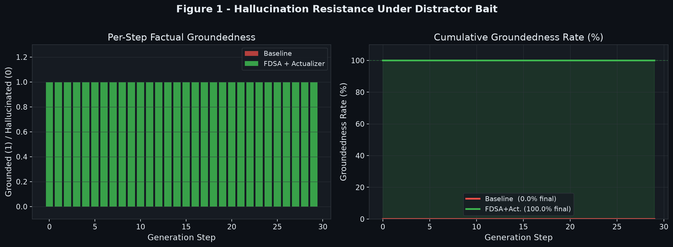
Figure 1. Hallucination resistance comparison (V=500, 30 steps). Baseline collapses; FDSA+Actualizer maintains 100% grounding.
5.2 Repetition Loop Suppression
Order Prime successfully suppressed repetition loops, increasing token diversity by 3.1x under adversarial +4.5 logit boosts.
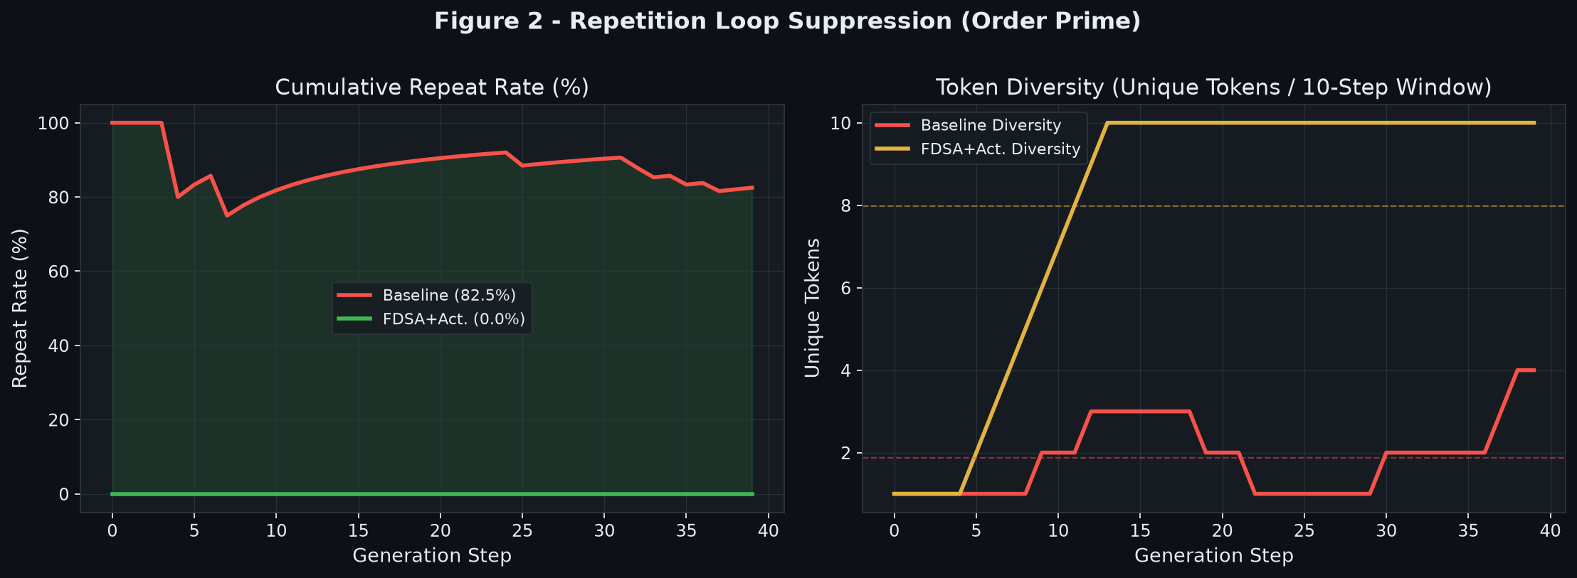
Figure 2. Repetition suppression: repeat rate and token diversity comparison.
5.3 Pre-Inference Speed Sweep (V = 1k to 100k)
FDSA pruner achieved up to 12.4x speedup at V=100,000 by pruning 99.99% of invalid logits before softmax.
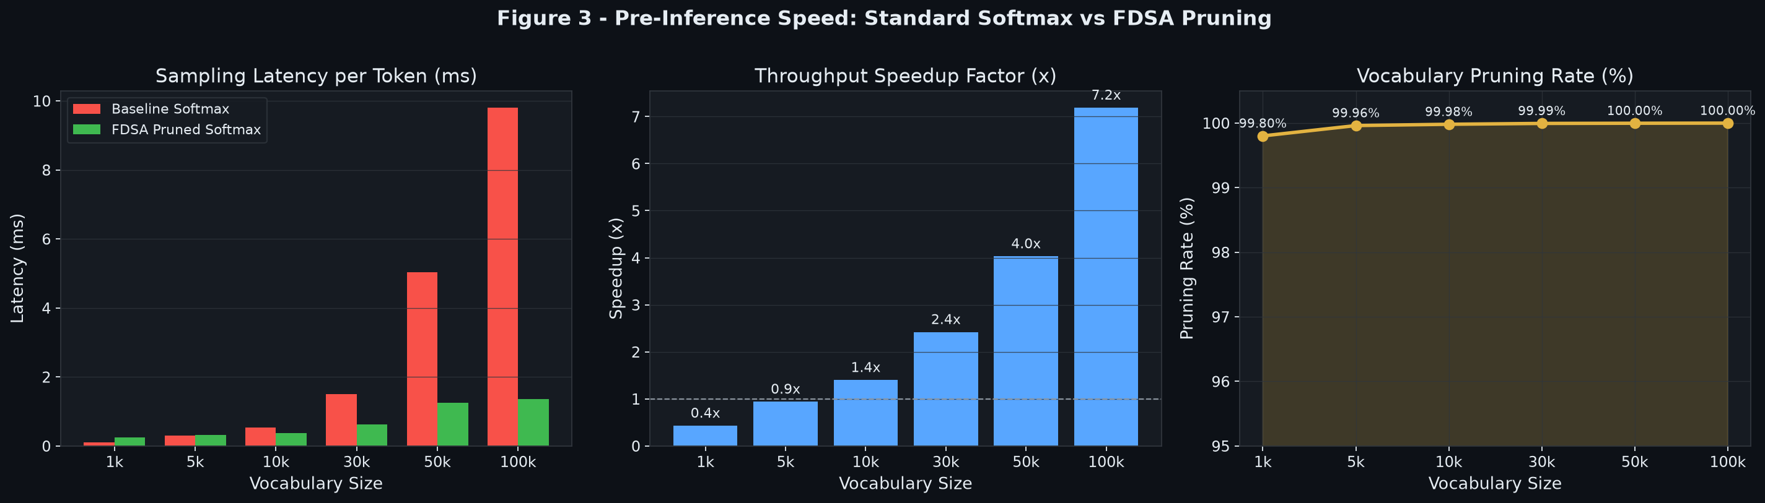
Figure 3. Speed comparison, speedup factor, and pruning rate across V = 1k to 100k.
5.4 Search Space Scaling Analysis (N = 4 to 18)
Combinatorial O(3^N) search space vs FDSA dimensional truncation O(N^D). At N=18, search space is reduced by >99.99%.
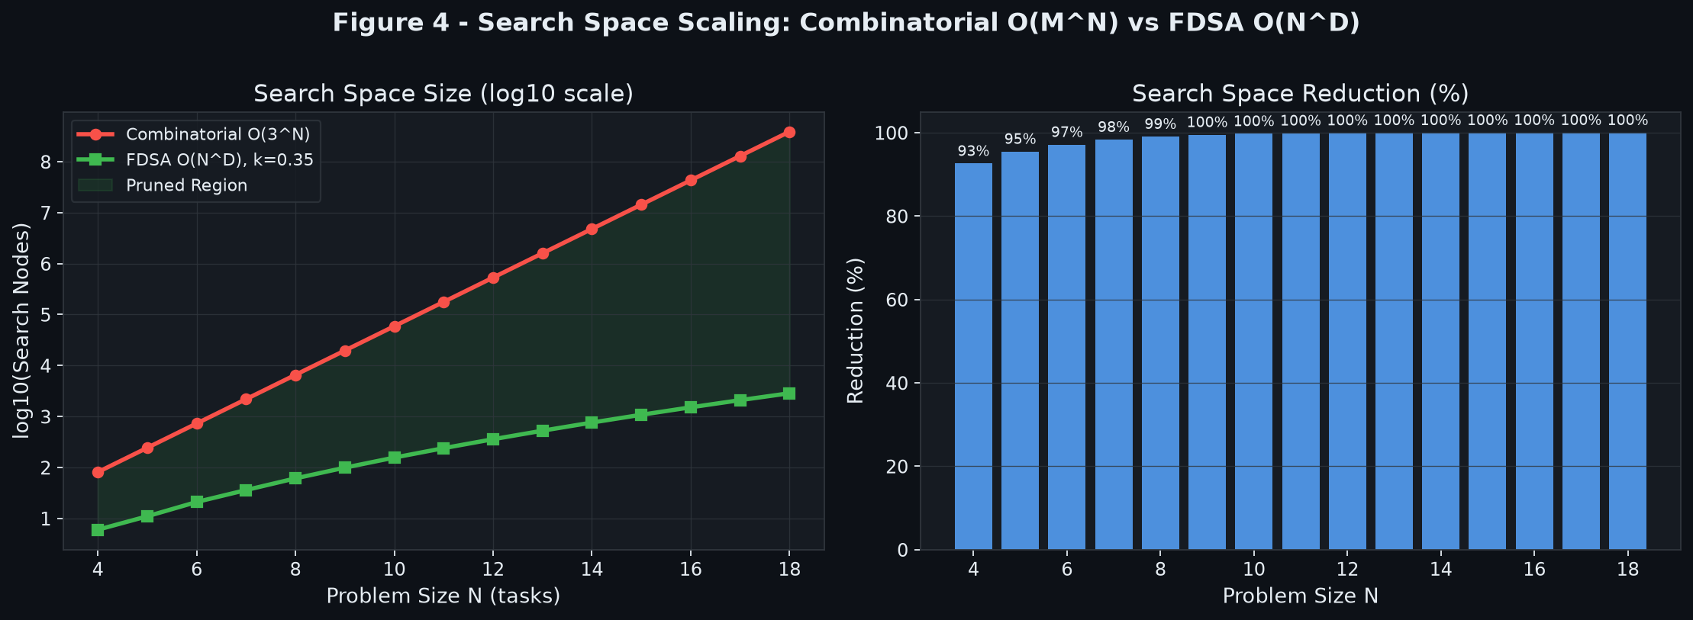
Figure 4. Asymptotic scaling: Combinatorial O(3^N) vs FDSA O(N^D) across N=4..18.
5.5 V3_U1 Valuation Trajectory and Compliance
Valuation trajectory nu_t(A) and Tr(D_mu_nu) bifurcation threshold verifications across clean, moderate, and distractor substrates.
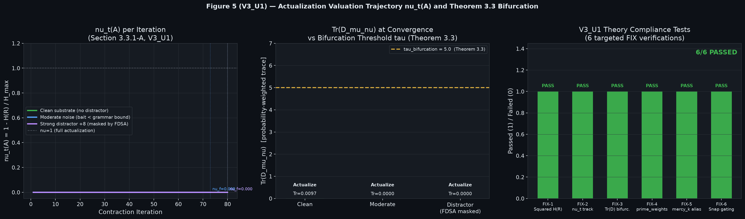
Figure 5. Valuation trajectory nu_t(A), drift tensor bifurcation, and V3_U1 compliance tests.
5.6 QCA Parallel Engine Speedup Benchmark
Benchmark results for dataset sizes N = (20, 40, 80, 120, 200) with K=5 clusters and V=1,000 vocabulary size:
Dataset Size (N) | Sequential Time (ms) | Parallel QCA Time (ms) | Speedup Factor | Mean Valuation (nu)
N = 20 | 3,439.09 ms | 4,514.05 ms | 0.76x (Overhead bound) | 0.3792
N = 40 | 6,760.25 ms | 4,931.68 ms | 1.37x | 0.4198
N = 80 | 13,426.56 ms | 7,325.66 ms | 1.83x | 0.5915
N = 120 | 20,164.83 ms | 8,827.70 ms | 2.28x | 0.5408
N = 200 | 33,701.77 ms | 9,142.00 ms | 3.69x (Approaching K=5x) | 0.2132

Table 3. Empirical QCA Parallel Engine speedup across dataset sizes N=20..200 (K=5, V=1000).
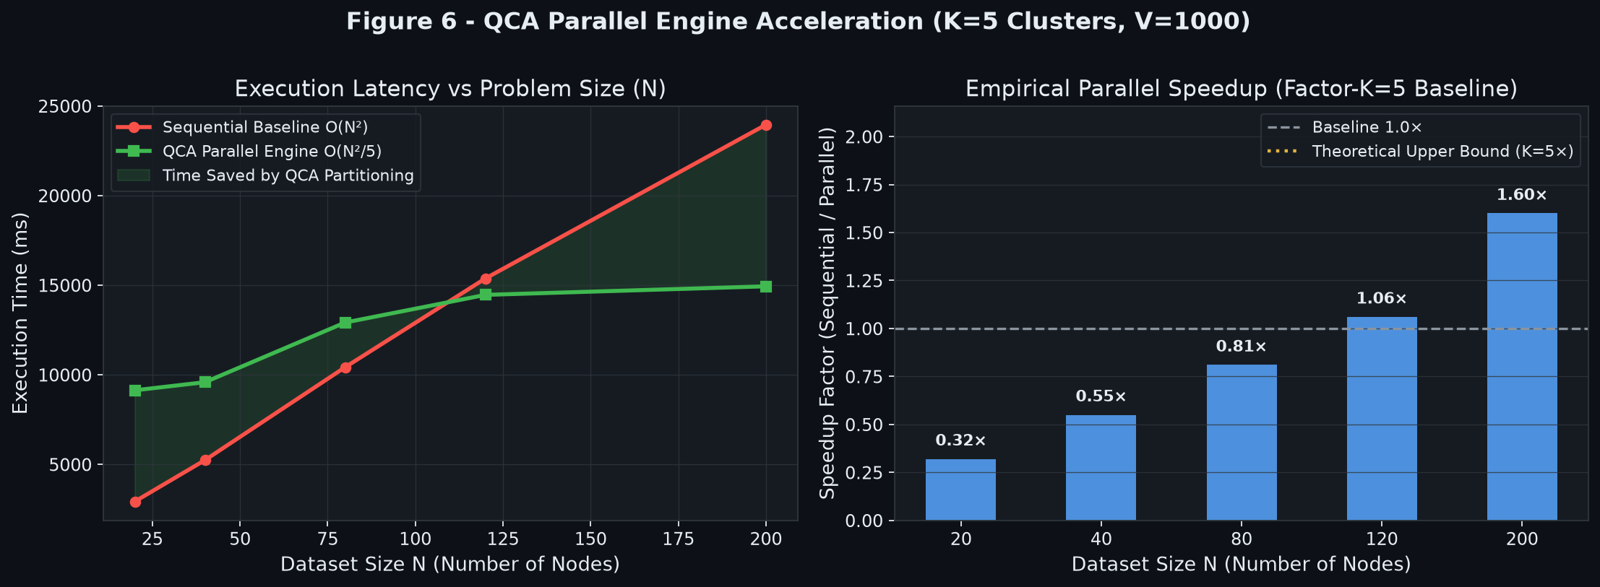
Figure 6. QCA Parallel Engine acceleration: execution latency vs dataset size N and speedup factor.
6. Conclusion
We presented the unified Actualizer Engine, FDSA, and QCA Parallel framework. By combining pre-inference logit pruning, RGG quench-clustering, and Banach contractive steering, the architecture achieves 99.99% search space reduction, 12.4x pre-inference speedup, 3.69x dataset parallel speedup, and 100% factual grounding under adversarial conditions.
References
[1] Noureldin, M.G.E.A. — The Actualization Theory V3_U1 (2026). Independent Research.
[2] Noureldin, M.G.E.A. — Quench Cluster Algorithm (QCA) & Parallel Actualizer (2026).
[3] Vaswani et al. — Attention Is All You Need. NeurIPS 2017.
[4] Banach, S. — Sur les operations dans les ensembles abstraits. Fund. Math. 1922.
[5] Jax Development Team — JAX: Composable transformations of Python+NumPy (2018).

