Design and Evaluation of a BI Data Mart for Order Fulfilment
  - Portfolio report | English
Ming Zhao
Business Intelligence and Data Warehousing
Data Management and Analysis Project
2 October 2026
This document records verified technical work and its limitations.

Executive Summary
A reliable delivery dashboard first requires a consistent measurement method. This project uses Olist's historical Brazilian e-commerce data to establish an auditable order-fulfilment data mart (a focused collection of data for analysing order completion and delivery). The transformation process generates five cleaned business tables, and the SQLite database build process provides data integrity controls (checks that keep records valid and consistent), repeatable loading, database restoration verification and clear analytical grain (what each row represents). The integrated order view (a query-defined representation of the data) has 99,441 records and 29 fields. Among the 96,470 delivered orders that met the analysis conditions, 6,534 were delayed, with a on-time delivery rate of 93.23%. The calculation of the delivery time reveals an important problem: the simple average of each state is 18.78 days, and the correct order-weighted mean is 12.56 days. The database and calculation have been verified, and the Power BI Desktop refresh and four-page representative filter and reset tests have also passed; the narrated demonstration still needs to be completed.

Introduction and Dataset Justification
The problem solved by this project is the dispersion of evidence of order fulfilment. The operation manager needs to know where the delay is concentrated, distinguish between the processing time before handover to the carrier and transit time after handover, and judge whether the observed difference comes from the operational situation or the metric definitions. The decision-making supported by the system is to prioritize which stages and where to carry out the improvement pilot, rather than predicting which order will be delayed. Therefore, this project focuses on data integration, reliable measurement and operational business intelligence.
The data released by Olist includes anonymised marketplace transactions and related business records (Olist, n.d.). This project selects orders, order items, customers, sellers, products and category translation data. The actual document inspection confirmed that there were 99,441 orders, 112,650 order-item records, 99,441 customer records, 3,095 sellers and 32,951 products. The purchase period covers from September 2016 to October 2018. The number of fields in each original file is different. There are 29 columns in the integrated order view, which exceeds the higher-level requirements for scale and number of fields in the scoring table at the analytical view level.
These data are different business data sets provided by the same publisher. Through clear identifier association, they are consistent with the example of the integration of customer data and transaction data in the brief, but they are not equivalent to obtaining corroboration from multiple independent institutions. The original file and source metadata (information describing the data and its origin) are retained, and the SHA-256 hash (a digital fingerprint used to check file consistency) of the copied file is consistent with the source file. The publisher's license metadata shows CC BY-NC-SA 4.0. You still need to retain attribution to the data publisher and check the license conditions before further distribution.
The data is suitable for historical performance measurement and system design, but it cannot prove the current performance of Olist, nor can it be used as a New Zealand delivery benchmark. The missing carrier identification, intervention cost, inventory balance and supplier lead time (the time between placing a supplier order and receiving it) make the carrier ranking, inventory optimization and causal estimates of cost savings unfounded.

Methodology and Rationale
The process starts from retaining the original source, and through reproducible cleaning and relational validation (checks on links between database tables), it forms order-grain analysis (one row per order) and dashboard preparation. The project retains the original Olist CSV (comma-separated values) files and records the cleaning rules and SQL (Structured Query Language) views. Relational constraints and independent SQL and pandas calculations (using the Python data-analysis library) jointly verify business tables and indicators.
Declare the grain before aggregation: each row of the orders table represents an order, and each row of the order_items table represents a combination of order ID and item sequence number; the grain of the corresponding entity is the customer record, seller and product table. Kimball (2008) emphasizes that the declared grain of the fact table (a table that stores measurable events) is the basis of dimensional design. customer_id is the customer record key, and customer_unique_id is used to identify the same customer across orders.
The evaluation also includes valid-data checks and deliberately constructed invalid input. Tests cover key uniqueness, parent-child record matching, metric reconciliation (checking that independently calculated results agree), database recovery and transaction rollback (undoing all changes in a failed transaction). Duplicate orders, order items without matching sellers and negative prices are all rejected. Two successful rebuilds obtained the same analysis results.

Data Storage and Management Evaluation
This project compares three schemes from the perspectives of reproducibility, collaboration, scalability, cost and governance. SQLite is suitable as a current prototype because it provides database files that are easy to deliver and has a low management burden. The foreign key constraint (a rule requiring a referenced record to exist in the related table) must be explicitly enabled, which has been verified in this project. Its limitations include concurrent writing and shared network access; SQLite officially suggests that many clients should use the client-server database (a database managed by a server for multiple clients) (SQLite, n.d.-a, n.d.-b) when accessing the database directly through the network. Therefore, file permissions and device security are still very important.
PostgreSQL is a follow-up plan for team sharing scenarios. Constraints and row-level security policies (rules controlling which records each user can access) can support centralized data integrity management and restricted access (PostgreSQL Global Development Group, n.d.-a, n.d.-b). The migration requires a clear person in charge of deployment, backup, account and recovery drill. This project does not claim that PostgreSQL has been installed or its production security configuration has been completed.
When the demand for historical data and concurrent analysis is large enough, BigQuery can be considered. Partition filtering (restricting a query to relevant data partitions), query planning (choosing how a database executes a query) and cost control will become important factors (Google Cloud, n.d.-a, n.d.-b). It also brings cloud management, data residency (where data is stored) and expenditure that changes with usage. This project lacks actual workload forecasts and supplier quotations, so the numerical total-cost ranking cannot be fabricated.
SQLite best meets the portability requirements of the current project; re-evaluate PostgreSQL when multiple people need to access under control; the cloud data warehouse should be driven by the measured analysis needs.
The comparison must also distinguish between the implementation cost and the opportunity cost. Cloud services may reduce some infrastructure maintenance, but increase the responsibility of procurement, monitoring and data transmission. Local files that seem to be free also require personnel to check failed tasks, protect copies and verify recovery.

Technical Implementation Overview
The database contains customers, sellers, products, orders and order_items. The primary key (a unique record identifier) prevents entity duplication; the order_items table uses a composite primary key (a combined identifier) consisting of order_id and order_item_id. The four foreign key relationships connect orders with customers, as well as order items with orders, sellers and products. Indexes (structures that speed up data retrieval) support customer joins, purchase-time queries and seller/order and product/order lookups. Figure 1 shows the implemented relationships using UML (Unified Modeling Language) classes and multiplicities (the allowed number of related records).
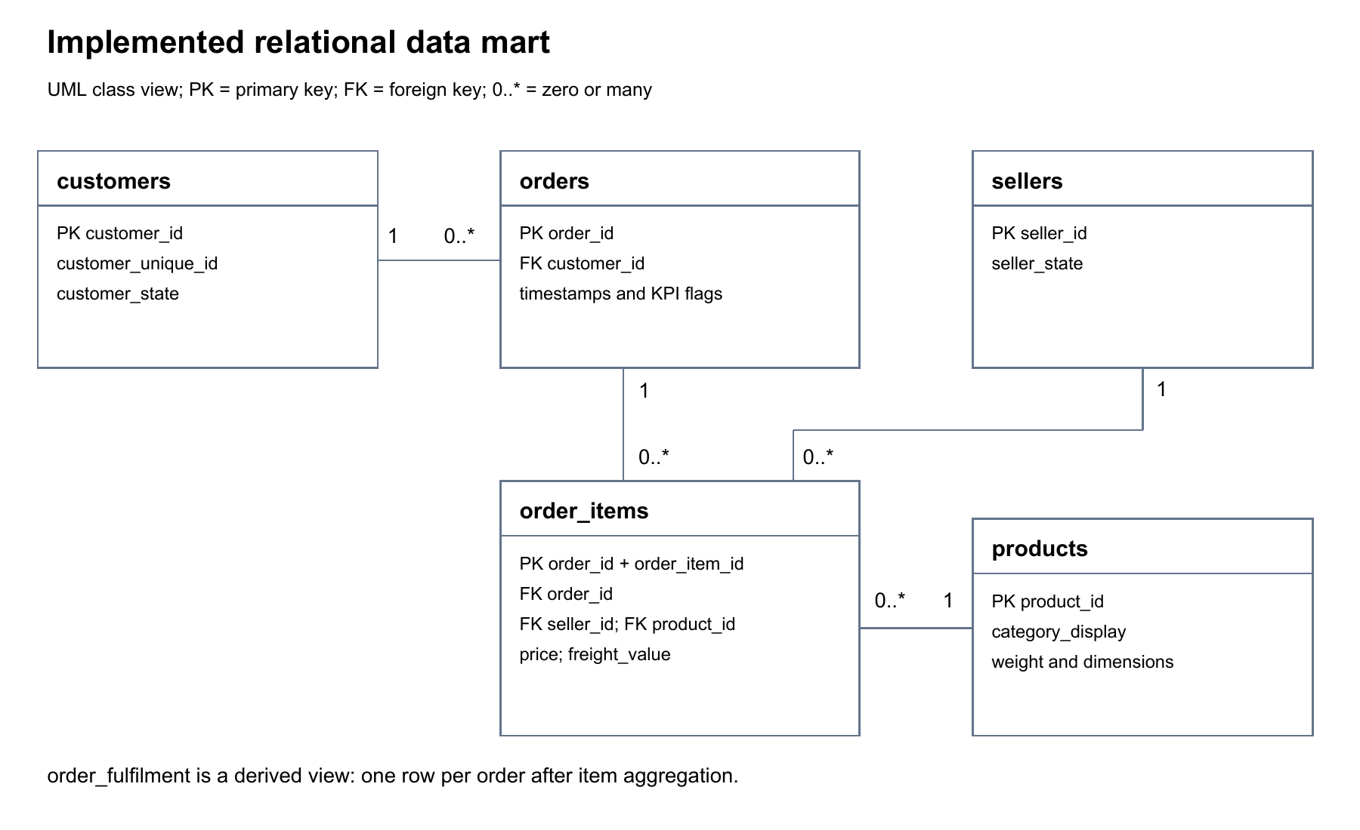
Figure 1. Implemented data relationships and multiplicities.
The three SQL performance views summarize the performance of the state, seller and category respectively. The order_fulfilment view first aggregates order items by order, and then left-joins the result to orders (retaining every order even when no matching item exists) to keep all 99,441 orders, including 775 orders without order-item records. Retaining these records can show insufficient coverage and avoid the inner join (which retains only matching records) from shrinking the overall.
Build the process into a candidate SQLite file (a temporary database validated before publication), check the integrity and foreign keys, test the SQL restoration script, and then replace the final database to avoid adding records to the existing database. Log the execution and failure of the record. Independent pipeline_audit.sqlite saves batch ID, UTC (Coordinated Universal Time) start and end times, status, time consumption, source hash, output row count and error information. Test confirmation failure will be recorded and raised to the calling process. This is full-refresh batch tracking (recording runs that rebuild the complete dataset), not change data capture (tracking individual inserted, updated or deleted records) or automatic scheduling. The candidate file policy can protect the published database before replacement, but each CSV export is not an atomic multi-file release (updating all output files together or none of them). Production extensions should adopt a versioned manifest (a list identifying the files in one release), and the database and dashboard data should be released as the same version.
Desktop is refreshed successfully, three aggregation pages and new order exploration pages are displayed normally, and the representative selection and reset test of states, sellers and categories are passed. PBIX (Power BI report file) and the running screenshots with the date have been saved.

Data Transformation Process Analysis
The extraction stage retains the original CSV and records the source. Clean and retain the string identifier and postal code leading zero, parse the date, and unify the analysis timestamp into a minute-level precision, so that the duration calculation adopts consistent rules. The original file still retains the second-level precision. This conversion may affect the duration of less than one minute and will not improve the accuracy of the original data.
Completeness and temporal validity (whether timestamps are usable and logically consistent) are handled separately. 8 delivered orders lack the actual delivery date; 184 orders have temporal-error flags; 118 orders have extreme-duration flags. These categories may overlap and cannot be directly added to the total number of different abnormal orders. The missing actual date is reserved as unknown, and the expected date is not used to fill in. Extreme observations are retained because deleting the slowest orders will only improve the superficial service level, not the actual service.
Each metric has its own denominator. The on-time delivery metric requires that the order has been delivered, the purchase and actual delivery time are valid, the delivery interval is not negative, and the expected date exists. When the actual calendar date of delivery is later than the expected date, the order is judged to be delayed. In this way, it is possible to avoid misjudging the delivery of the promised afternoon as a delay because the expected date is stored at midnight. The total delivery time, processing time and transit time have eligibility flags (indicators of whether a record meets each metric’s requirements) corresponding to the required date respectively.
The join method changes the effectiveness of the analysis. Join order items directly to orders to get a 6.59% item-weighted late-delivery rate; the result of the correct order grain is 6.77%. The difference comes from the higher weight of multi-item orders, not from business improvement. Seller analysis first deduplicates seller/order pairs (keeps one record per seller and order combination); 100,010 associations cannot be called the number of distinct orders on the platform, because multi-seller orders can legally appear in the associated order population of multiple sellers.
Power BI metric verification identifies aggregation problems. The simple average of the average delivery days in each state is 18.78 days, while the weighted result of the correct order is 12.56 days. The analysis data is exported to increase the accurate sum of duration and the number of eligible records, and the measure divides the summed numerator by the summed denominator. This is in line with the modeling principle that facts are used for summary and dimensions (descriptive business entities) are used for filtering (Microsoft, n.d.). The seller and category duration measures also adopt the same modification under the declared association grain to improve the comparability without changing the delivery record itself.

Risk Identification and Management
Integrity risk is controlled through primary key, foreign key check, non-negative price verification, and independent pandas/SQL metric reconciliation. The unknown date is reflected by the coverage rate. The person in charge of the data should review the failed batch before release.
The integration risk comes from the valid tables at different grains that are inappropriately associated. Automatic order-row-count preservation checks and association deduplication rules to reduce the risk. The analyst is responsible for the metric definitions, and the operation manager confirms its business meaning. Eligibility, precision and changes in grouping rules require version management.
The current scale is suitable for full rebuild, but repeated full refresh after scale expansion may be inefficient. Refresh time, query latency (the time needed to return query results) and concurrent demand should be measured before migration. Partitioned ingestion (loading data in defined subsets), incremental updates (loading only new or changed records) and server deployment are the recommended response methods, and the recovery mechanism that is checked with the full rebuild is retained.
Security and ethical risks include uncontrolled copies, identifier exposure, and unfounded regional comparisons. It is recommended to restrict folder access, encrypt device storage, implement least-privilege access (granting only the permissions each user needs) after migrating the server, and provide aggregated views to business users. These are recommended controls, not verified configurations.
Continuity requires a verifiable recovery path. The SQL export has successfully restored the database, and the duplicate key transaction test also confirms that the rollback is valid. The person in charge of backup and recovery from off-device backups and the recovery target still need to be implemented in business.

Data Analysis and Visualization Results
The eligible order population is 96,470 delivered orders, of which 6,534 are delayed, with a on-time delivery rate of 93.23%. 2,971 orders other than the denominator cannot be automatically marked as delayed or on time. The average delivery time is 12.56 days, the median is 10.22 days, and the 90th percentile (the duration within which 90% of eligible deliveries were completed) is 23.10 days. The long right tail (a small proportion of much longer delivery times) shows that the fluctuation of the investigation is as important as the average speed.
Figure 2 compares the number of delays and the delay rate of key states at the same time. São Paulo State has 1,820 delays out of 40,494 eligible orders with a delay rate of 4.49%; Rio de Janeiro State has 1,495 delays out of 12,350 orders with a delay rate of 12.11%. The two states have a total of 3,315 late orders, accounting for about 50.73% of the total 6,534 delayed orders. Ranking by ratio alone will underestimate the workload of São Paulo, and ranking only by quantity will underestimate the reliability of Rio de Janeiro, so both need to be observed at the same time.
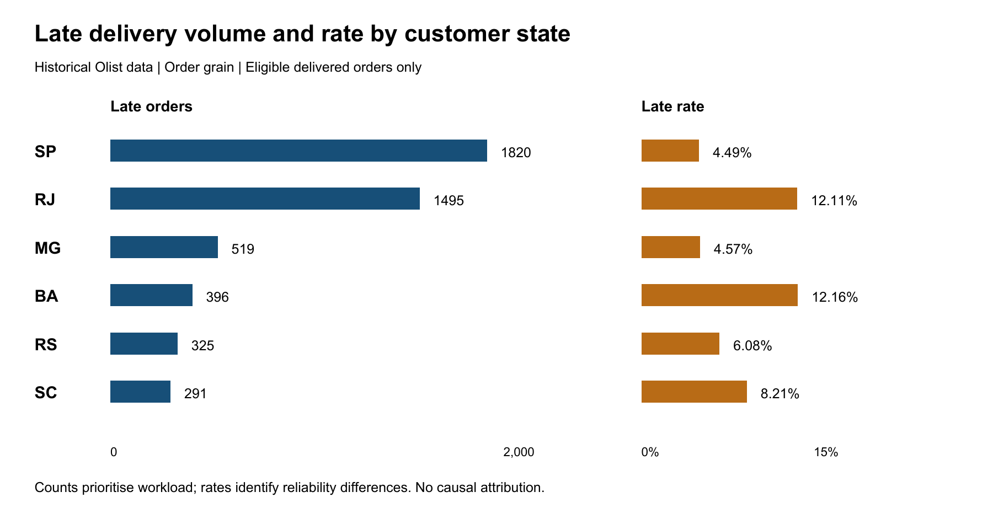
Figure 2. Late volume and rate for selected states. Source: revalidated SQL outputs.
Stage analysis also needs to be compared using a common cohort (the same set of eligible orders). When calculating the processing and transit time respectively, the eligible records are 97,497 and 96,452, and the two overall averages cannot be directly added. Among the 96,286 completed orders that meet the conditions together, the average processing time is 3.23 days, and the average transit time is 9.33 days. Transportation accounts for most of the total time, but there is a lack of carrier, route and service level information, which cannot be attributed to a certain carrier.
The dashboard design includes overview, seller and category pages. State filtering supports regional surveys; sellers and category pages use association-grain labels. Low sample rankings need to show the sample size and review threshold. Figure 3 shows the actual operation overview. The scatter chart reference line has been recalculated: states with at least 300 eligible orders have a delivery-time benchmark of 12.48 days, which is different from the average of 12.56 days for all orders.
The overview, seller and category pages display whole-period aggregated summaries. Operations Explorer imports 99,441 distinct orders, supports the filtering of the purchase month and the customer's state, the monthly delay rate and the trend of the eligibility coverage rate, and the order details. The coverage rate is equal to the number of eligible orders divided by the total number of orders; the delay rate is not calculated for months without eligible delivery records. The records in the first and last months of the historical snapshot may be incomplete and should be compared carefully. The filter will not be synchronized with the other three aggregate pages, and the historical data cannot be used for real-time monitoring.

Recommendations and Strategic Insights
First of all, before operation and use, the analyst will release the confirmed metric dictionary (documented definitions and calculation rules) to clarify the denominator, calendar date delay rules and association grain. The revised aggregation measures and SQL total provide testable acceptance values. The business manager should randomly check the excluded records, especially the delivered orders with missing delivery dates.
Secondly, priority should be given to investigating the relatively high delay rate in Rio de Janeiro and the large number of delays in São Paulo. Before attributing to logistics execution, it is stratified according to the month of purchase, seller and product mix. The sample pilot can compare matching routes or randomly assign eligible orders, while recording delays, audit workload, customer contact and intervention costs.
Finally, after passing the local refresh and representative filter test, the project leader should complete the prescribed screen recording and then run the whole set of files in a clean environment. It can only be released if the dashboard totals reconcile, the instructions are operable and the recovery is successful. If there is a need for shared access, evaluate PostgreSQL according to the actual requirements.

Conclusion
The main contribution of the project is the verified data management basis required for delivery decisions. The source data can be reproduced and converted, the relational integrity is checked, and the aggregation risk is also clearly explained. The results support targeted operational surveys, while retaining uncertainty about the causes and benefits. The remaining narrated demonstration and clean-environment testing are indispensable steps.

References
Google Cloud. (n.d.-a). Estimate and control costs. https://docs.cloud.google.com/bigquery/docs/best-practices-costs
Google Cloud. (n.d.-b). Introduction to optimizing query performance. https://docs.cloud.google.com/bigquery/docs/best-practices-performance-overview
Kimball, R. (2008, November 5). Fact tables. Kimball Group. https://www.kimballgroup.com/2008/11/fact-tables/
Microsoft. (n.d.). Understand star schema and the importance for Power BI. Microsoft Learn. https://learn.microsoft.com/en-us/power-bi/guidance/star-schema
Olist. (n.d.). Brazilian e-commerce public dataset by Olist [Data set]. Kaggle. https://www.kaggle.com/datasets/olistbr/brazilian-ecommerce
PostgreSQL Global Development Group. (n.d.-a). Constraints. https://www.postgresql.org/docs/current/ddl-constraints.html
PostgreSQL Global Development Group. (n.d.-b). Row security policies. https://www.postgresql.org/docs/current/ddl-rowsecurity.html
SQLite. (n.d.-a). Appropriate uses for SQLite. https://www.sqlite.org/whentouse.html
SQLite. (n.d.-b). SQLite foreign key support. https://www.sqlite.org/foreignkeys.html
Yoobee Colleges. (2025). Assignment 1 MBI807B Business intelligence and data warehousing [Assessment brief, version 1].

Appendix: Desktop runtime evidence
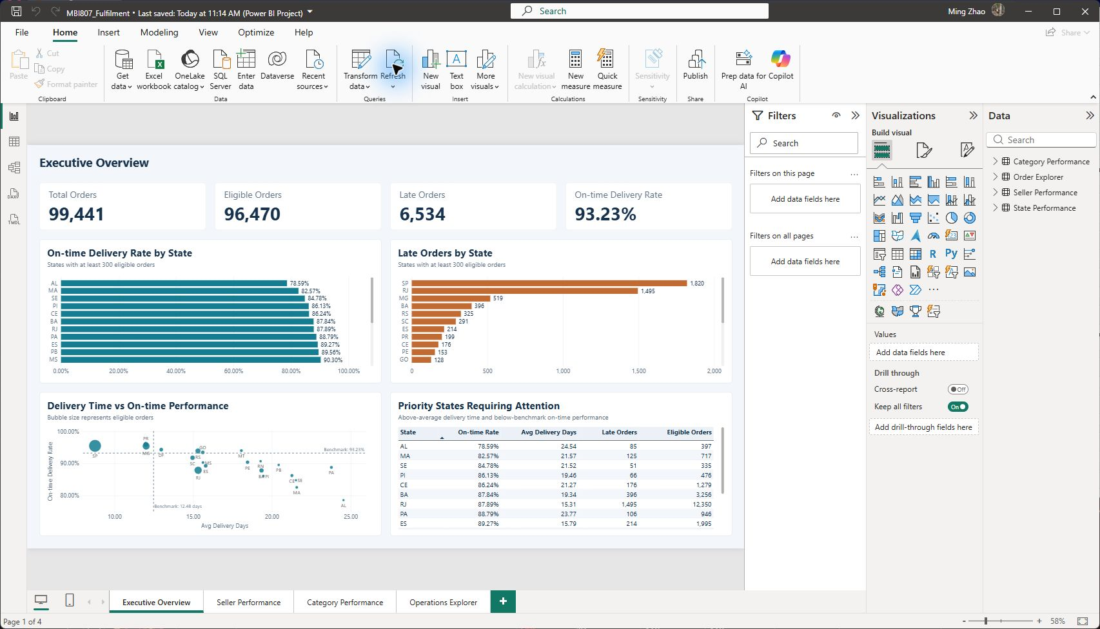
Figure 3. Refreshed Power BI Desktop overview. Other pages and filter/reset evidence are included in the technical portfolio.
Captured during local acceptance on 28 September 2026. The state delivery benchmark includes states with at least 300 eligible orders. Representative interaction tests do not establish production deployment.
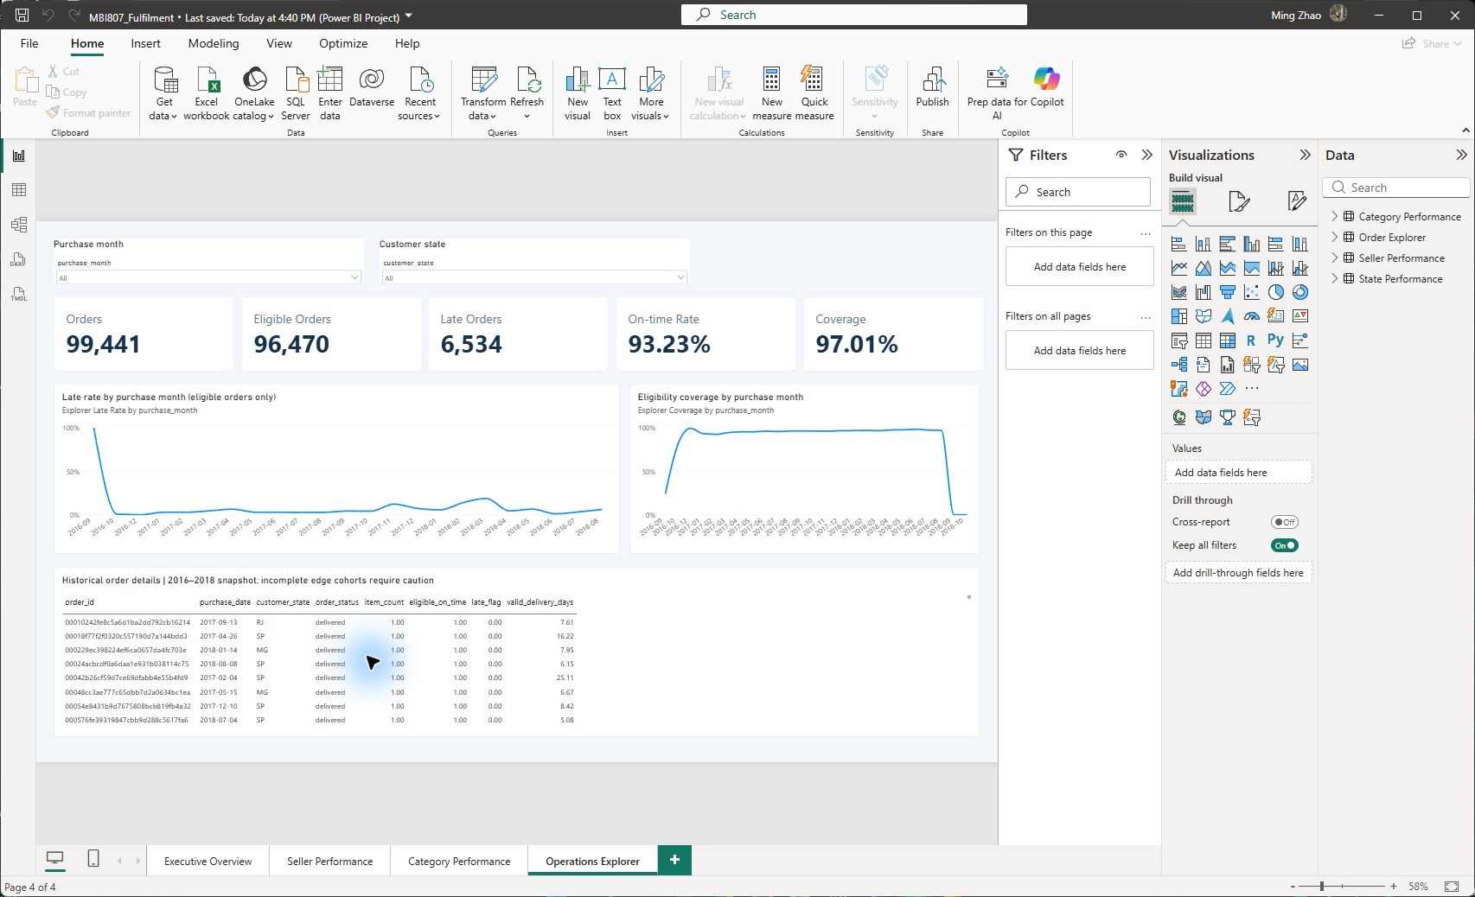
Figure 4. Operations Explorer adds month/state slicing and eligibility coverage.

