PROG 6212

POE Part 1

Halalisile Mzobe

ST10355256

<https://github.com/mzhala/PROG6212_POE_P1_CONTRACT_MONTHLY_CLAIM_SYSTEM.git>

**Contract Monthly Claim System**

Table of Contents

Introduction 2

UML Class Diagram 3

Project Plan 4

GUI IU 5

# Introduction

This project is a WPF system that allows lecturers to submit claims for payment by entering details such as the program, module, rate per hour, and hours worked. Lecturers can also upload supporting documents like class registers. Reviewers can log in to the system to review and either approve or reject these claims. The system is designed with clear roles for lecturers and reviewers, simplifying the process of claim submission and review. The following report outlines the design choices, database structure, and assumptions made for this project.

# Design Choices, Database Structure, and GUI Layout

**Design Choices:**

* **Role-based Access:**
  + **Lecturers:** After logging in with their existing school credentials, lecturers are taken to a page where they can enter claims. They can add multiple claims, upload supporting documents (like a class register), and submit everything. They can also view their previous claims with filters for easier searching.
  + **Reviewers:** Reviewers log in and are directed to a page where they can approve or reject claims submitted by lecturers. They can also review the documents uploaded with the claims and access a history of claims they’ve already reviewed.
* **Database Structure:**
  + **Employee Class:** Holds general information about all employees. Both the Lecturer and Reviewer classes inherit from this, meaning they share common data like name, ID, etc.
  + **Lecturer and Reviewer Classes:** These classes inherit from the Employee class, containing specific details for each role.
  + **Modules and Programmes Classes:** Contain a list of available modules and programs for lecturers to choose from, ensuring data is valid.
  + **Claims Class:** Contains all details of the claim (like rate per hour, hours worked, and status). It’s connected to lecturers, reviewers, modules, and programs.
* **Graphical User Interface (GUI) Layout:**
  + **Login Page:** Simple page asking for email and password. Users are redirected to the relevant page depending on whether they’re a lecturer or a reviewer.
  + **Lecturer Claims Page:** Lecturers can submit multiple claims, upload documents, and use filters to view their previous claims.
  + **Reviewer Claims Page:** Reviewers can approve or reject claims and see previously reviewed claims using filters.
  + **Design:** The system uses a simple black-and-white colour scheme with a consistent design across all pages. This helps keep everything clean and easy to follow.

**Rationale for Design Decisions:**

* **Role-based Navigation:** This ensures users only see the features relevant to them, making it easier to use.
* **Dropdown Lists for Modules and Programs:** By using dropdowns, lecturers can’t enter invalid data, reducing errors.
* **Clean UI Design:** A simple and consistent design helps users focus on the important tasks without distractions.

# Assumptions and Constraints

**Assumptions:**

* **Existing Database:** The system assumes that lecturers and reviewers are already registered in the school’s database, so they can log in without needing to create a new account.
* **Distinct Roles:** The system assumes that users are either lecturers or reviewers, not both.
* **Predefined Programs and Modules:** The list of programs and modules is already defined in the system, so lecturers will select from a dropdown instead of typing them in.

**Constraints:**

* **Limited Role Flexibility:** Since the system assumes a user can’t be both a lecturer and a reviewer, it might not work if someone has both roles.
* **Dependence on Existing Database:** If there’s an issue with the school’s database, it could affect the login process or the accuracy of user data.
* **Fixed Design:** The simple black-and-white colour scheme is fixed, which may not appeal to all users or fit specific accessibility needs.

# UML Class Diagram

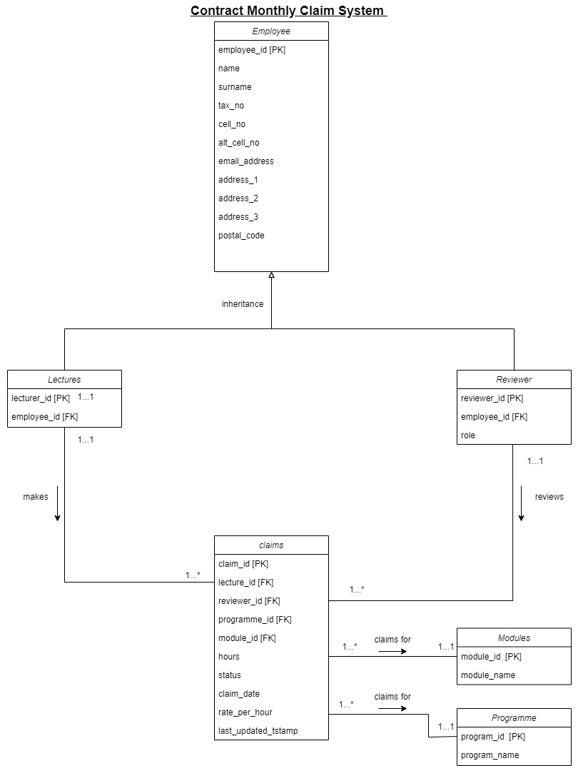

# Project Plan

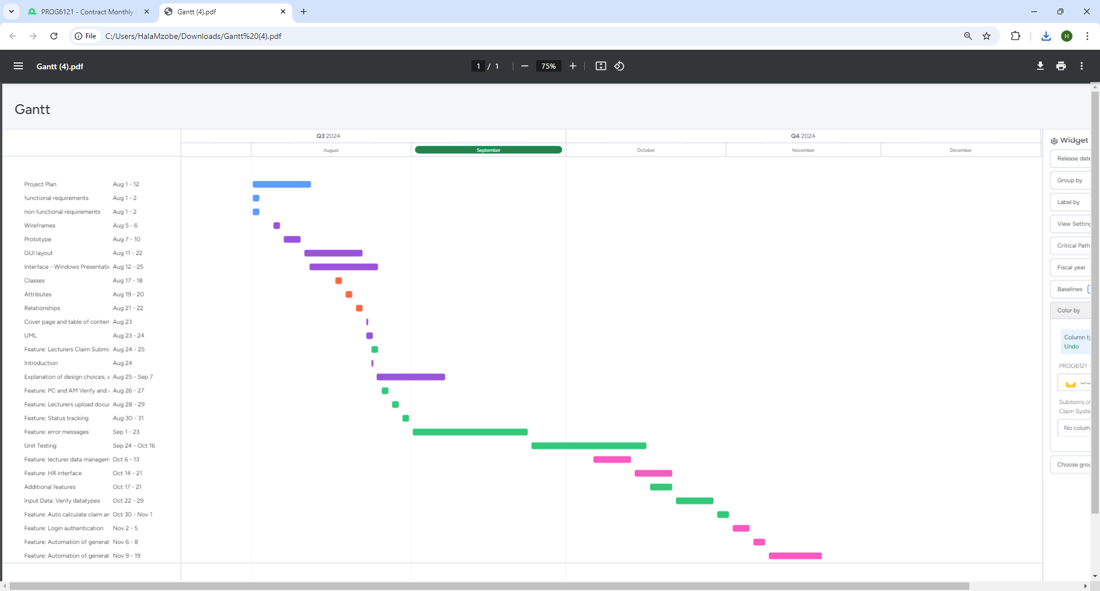

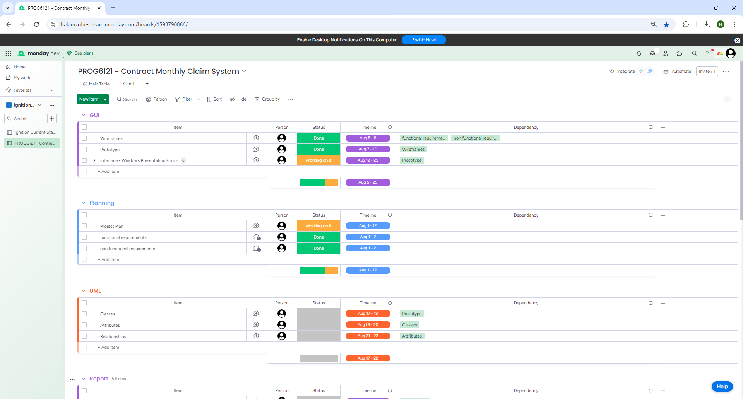

<https://halamzobes-team.monday.com/boards/1593790866/views/17981237>

# GUI IU

