Homework 1

Michael Zhang

# Exploratory Analysis

Let's take a look at Georgia's county-level voting data from the 2000 presidential election and investigate vote undercount.

Specifically, let's examine the below issues:

1) Whether voting on certain kinds of voting equipment lead to higher rates of undercount 2) If so, whether we should worry that this effect has a disparate impact on poor and minority communities

georgia <- read.csv("../data/georgia2000.csv", row.names=1)  
  
georgia$undercountpct <- 1 - georgia$votes/georgia$ballots  
georgia$undercount <- georgia$ballots - georgia$votes  
  
boxplot(undercountpct~equip, data = georgia, main = "Voting Equipment Undercount %", xlab = "Voting Equipment", ylab = "Undercount %")

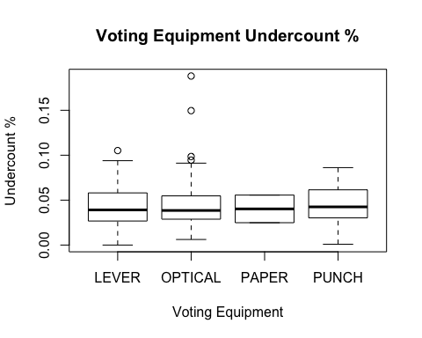

boxplot(undercount~equip, data = georgia, main = "Voting Equipment Undercounted Votes", xlab = "Voting Equipment", ylab = "Undercounted Votes")

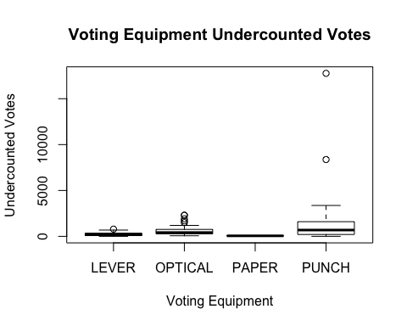

Looking at these boxplots, we see that the undercount % is fairly consistent across voting equipments. However, when we look at undercounted votes as a number, there are two counties with a large number of undercounted votes, and both of these counties used "Punch" equipment.

aggregate(georgia[, 4], list(georgia$equip), mean)

## Group.1 x  
## 1 LEVER 0.6081081  
## 2 OPTICAL 0.2727273  
## 3 PAPER 1.0000000  
## 4 PUNCH 0.4117647

aggregate(georgia[, 7], list(georgia$equip), mean)

## Group.1 x  
## 1 LEVER 0.2762432  
## 2 OPTICAL 0.1860455  
## 3 PAPER 0.4195000  
## 4 PUNCH 0.2984706

boxplot(perAA~equip, data = georgia, main = "African-American % vs. Voting Equipment", xlab = "Voting Equipment", ylab = "African-American %")

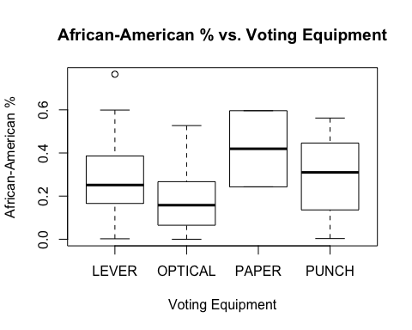

boxplot(poor~equip, data = georgia, main = "Poor vs. Voting Equipment", xlab = "Voting Equipment", ylab = "Poor")

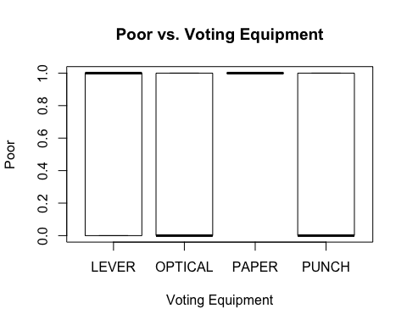

When we look at the boxplots and means for African-American % and Poor vs. Voting Equipment, we do not see a disproportionate representation of these two variables in counties using "Punch" equipment.

Therefore, while there may be slight variations in vote undercounting among voting equipment, we should not worry that this effect has a disparate impact on poor and minority communities.

# Bootstrapping

Considering the below five asset classes:

* US domestic equities (SPY: the S&P 500 stock index)
* US Treasury bonds (TLT)
* Investment-grade corporate bonds (LQD)
* Emerging-market equities (EEM)
* Real estate (VNQ)

Let's take a look at the risk/return properties. To estimate variability, we use CAPM and standard deviations.

library(mosaic)

## Loading required package: car  
## Loading required package: dplyr  
##   
## Attaching package: 'dplyr'  
##   
## The following objects are masked from 'package:stats':  
##   
## filter, lag  
##   
## The following objects are masked from 'package:base':  
##   
## intersect, setdiff, setequal, union  
##   
## Loading required package: lattice  
## Loading required package: ggplot2  
## Loading required package: mosaicData  
##   
## Attaching package: 'mosaic'  
##   
## The following objects are masked from 'package:dplyr':  
##   
## count, do, tally  
##   
## The following object is masked from 'package:car':  
##   
## logit  
##   
## The following objects are masked from 'package:stats':  
##   
## binom.test, cor, cov, D, fivenum, IQR, median, prop.test,  
## quantile, sd, t.test, var  
##   
## The following objects are masked from 'package:base':  
##   
## max, mean, min, prod, range, sample, sum

library(fImport)

## Loading required package: timeDate  
## Loading required package: timeSeries

library(foreach)  
etfs = c("SPY", "TLT", "LQD", "EEM", "VNQ")  
etfprices = yahooSeries(etfs, from='2010-01-01', to='2015-07-30')  
  
# A helper function for calculating percent returns from a Yahoo Series  
YahooPricesToReturns = function(series) {  
 mycols = grep('Adj.Close', colnames(series))  
 closingprice = series[,mycols]  
 N = nrow(closingprice)  
 percentreturn = as.data.frame(closingprice[2:N,]) / as.data.frame(closingprice[1:(N-1),]) - 1  
 mynames = strsplit(colnames(percentreturn), '.', fixed=TRUE)  
 mynames = lapply(mynames, function(x) return(paste0(x[1], ".PctReturn")))  
 colnames(percentreturn) = mynames  
 as.matrix(na.omit(percentreturn))  
}  
  
# Compute the returns from the closing prices  
etfreturns = YahooPricesToReturns(etfprices)  
  
# Standard deviations of the asset classes  
sigma_SPY = sd(etfreturns[,1])  
sigma_TLT = sd(etfreturns[,2])  
sigma_LQD = sd(etfreturns[,3])  
sigma_EEM = sd(etfreturns[,4])  
sigma_VNQ = sd(etfreturns[,5])  
  
# First fit the market model to each asset class  
lm_TLT = lm(etfreturns[,2] ~ etfreturns[,1])  
lm_LQD = lm(etfreturns[,3] ~ etfreturns[,1])  
lm_EEM = lm(etfreturns[,4] ~ etfreturns[,1])  
lm_VNQ = lm(etfreturns[,5] ~ etfreturns[,1])  
  
# The estimated beta for each asset class based on daily returns  
coef(lm_TLT); coef(lm_LQD); coef(lm_EEM); coef(lm_VNQ)

## (Intercept) etfreturns[, 1]   
## 0.0007008087 -0.5476286621

## (Intercept) etfreturns[, 1]   
## 0.0002551472 -0.0381982702

## (Intercept) etfreturns[, 1]   
## -0.0006397898 1.2434317239

## (Intercept) etfreturns[, 1]   
## 4.319518e-05 1.029497e+00

# The standard deviations for each asset class based on daily returns  
sigma_SPY; sigma_TLT; sigma_LQD; sigma_EEM; sigma_VNQ

## [1] 0.00977304

## [1] 0.009694163

## [1] 0.003548176

## [1] 0.01427438

## [1] 0.01263622

From the CAPM, we see that both treasury bonds (TLT) and investment-grade corporate bonds (LQD) have slightly negative betas, meaning that they tend to go down when the market goes up, and vice versa. This means that the expected return on these investments is less than the riskfree rate. We also see that emerging-market equities (EEM) is more volatile than the total market. Finally, real estate (VNQ) follows the market closely and can be considered a representative stock.

Looking at the standard deviations, we rank the asset classes in order of least volatile to most volatile:

1. LQD
2. TLT
3. SPY
4. VNQ
5. EEM

What if we consider these asset classes together in a single portfolio?

First, let's assume an even split (20% of assets in each of the five ETFs above).

n_days = 20  
  
set.seed(2015)  
  
sim_equal_dist = foreach(i=1:5000, .combine='rbind') %do% {  
 totalwealth = 100000  
 weights = c(0.2, 0.2, 0.2, 0.2, 0.2)  
 holdings = weights * totalwealth  
 wealthtracker = rep(0, n_days) # Set up a placeholder to track total wealth  
 for(today in 1:n_days) {  
 return.today = resample(etfreturns, 1, orig.ids=FALSE)  
 holdings = holdings + holdings*return.today  
 totalwealth = sum(holdings)  
 holdings = weights * totalwealth  
 wealthtracker[today] = totalwealth  
 }  
 wealthtracker  
}

hist(sim_equal_dist[,n_days], 25)

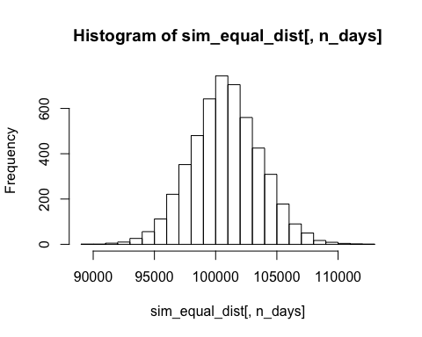

# Profit/loss  
hist(sim_equal_dist[,n_days]- 100000)

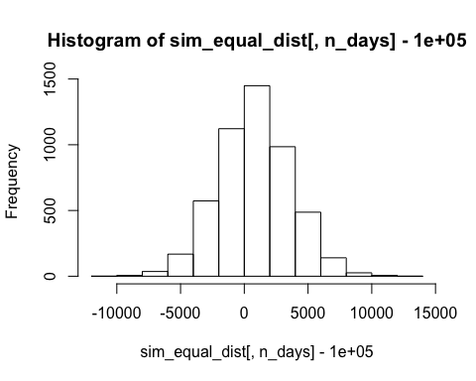

# Calculate 5% value at risk  
abs(quantile(sim_equal_dist[,n_days], 0.05) - 100000)

## 5%   
## 3772.192

We see that the value at risk (VaR) at the 5% level for this portfolio is $3,772. In other words, we can say with a 95% confidence level that the most money this portfolio will lose over a 4-week trading period is $3,772.

What if we want a portfolio that's "safer"? Let's allocate more of the portfolio to LQD and TLT and remove EEM.

Let's take a look at the VaR associated with this portfolio.

set.seed(2015)  
  
sim_safe = foreach(i=1:5000, .combine='rbind') %do% {  
 totalwealth = 100000  
 weights = c(0.4, 0.3, 0.25, 0, 0.05)  
 holdings = weights * totalwealth  
 wealthtracker = rep(0, n_days) # Set up a placeholder to track total wealth  
 for(today in 1:n_days) {  
 return.today = resample(etfreturns, 1, orig.ids=FALSE)  
 holdings = holdings + holdings*return.today  
 totalwealth = sum(holdings)  
 holdings = weights * totalwealth  
 wealthtracker[today] = totalwealth  
 }  
 wealthtracker  
}

hist(sim_safe[,n_days], 25)

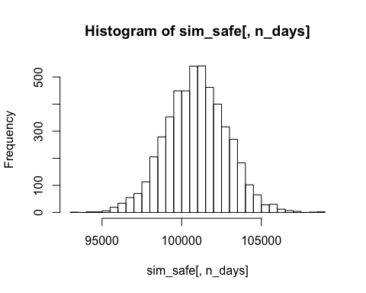

# Profit/loss  
hist(sim_safe[,n_days]- 100000)

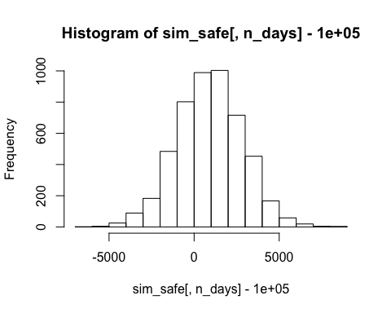

# Calculate 5% value at risk  
abs(quantile(sim_safe[,n_days], 0.05) - 100000)

## 5%   
## 2201.501

With this "safer" allocation, the VaR at the 5% level is $2,202. What about a portfolio that's considered more "aggreesive"? Let's allocate the portfolio to only include SPY and EEM, with 70% weight on EEM.

set.seed(2015)  
  
sim_aggressive = foreach(i=1:5000, .combine='rbind') %do% {  
 totalwealth = 100000  
 weights = c(0.3, 0, 0, 0.7, 0)  
 holdings = weights * totalwealth  
 wealthtracker = rep(0, n_days) # Set up a placeholder to track total wealth  
 for(today in 1:n_days) {  
 return.today = resample(etfreturns, 1, orig.ids=FALSE)  
 holdings = holdings + holdings*return.today  
 totalwealth = sum(holdings)  
 holdings = weights * totalwealth  
 wealthtracker[today] = totalwealth  
 }  
 wealthtracker  
}

hist(sim_aggressive[,n_days], 25)

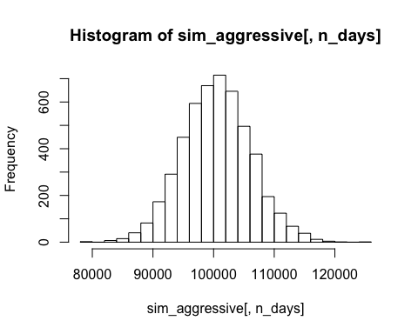

# Profit/loss  
hist(sim_aggressive[,n_days]- 100000)

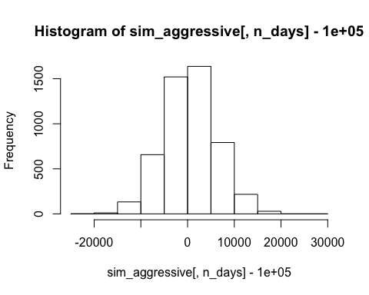

# Calculate 5% value at risk  
abs(quantile(sim_aggressive[,n_days], 0.05) - 100000)

## 5%   
## 8681.392

Now, our VaR is much higher: $8,681.

So what does this all mean? Well, depending on your risk tolerance, one of these portfolios is more preferable than the other two.

# Profit/loss  
hist(sim_aggressive[,n_days]- 100000)



hist(sim_safe[,n_days]- 100000)



hist(sim_equal_dist[,n_days]- 100000)



quantile(sim_aggressive[,n_days], 0.025); quantile(sim_aggressive[,n_days], 0.975)

## 2.5%   
## 89673.57

## 97.5%   
## 111942.1

quantile(sim_safe[,n_days], 0.025); quantile(sim_safe[,n_days], 0.975)

## 2.5%   
## 97043.26

## 97.5%   
## 104676.8

quantile(sim_equal_dist[,n_days], 0.025); quantile(sim_equal_dist[,n_days], 0.975)

## 2.5%   
## 95286.13

## 97.5%   
## 106458.6

Taking a look at the 90% confidence intervals for each of these portfolios, we see that in the span of a 4-week trading period, the value of...

* the aggressive portfolio can range from as little as $89,674 to as large as $111,942
* the safe portfolio can range from as little as $97,043 to as large as $104,677
* the equally distributed portfolio can range from as little as $95,286 to as large as $106,459

Which would you choose?

# Clustering and PCA

We have a dataset of 6,500 different bottles of vinho verde wine from Portugal that contains information on 11 chemical properties for each wine, whether the wine is red or white, and the quality score of the wine.

Let's run PCA and a clustering algorithm on this dataset to see what we can learn.

library(ggplot2)  
vinho_full <- read.csv("../data/wine.csv")  
vinho = vinho_full[,(1:11)]  
  
# Running PCA, basic plotting and summary methods  
pca_vinho = prcomp(vinho, scale = TRUE)  
  
pca_vinho

## Standard deviations:  
## [1] 1.7406518 1.5791852 1.2475364 0.9851660 0.8484544 0.7793021 0.7232971  
## [8] 0.7081739 0.5805377 0.4771748 0.1811927  
##   
## Rotation:  
## PC1 PC2 PC3 PC4  
## fixed.acidity -0.23879890 0.33635454 -0.43430130 0.16434621  
## volatile.acidity -0.38075750 0.11754972 0.30725942 0.21278489  
## citric.acid 0.15238844 0.18329940 -0.59056967 -0.26430031  
## residual.sugar 0.34591993 0.32991418 0.16468843 0.16744301  
## chlorides -0.29011259 0.31525799 0.01667910 -0.24474386  
## free.sulfur.dioxide 0.43091401 0.07193260 0.13422395 -0.35727894  
## total.sulfur.dioxide 0.48741806 0.08726628 0.10746230 -0.20842014  
## density -0.04493664 0.58403734 0.17560555 0.07272496  
## pH -0.21868644 -0.15586900 0.45532412 -0.41455110  
## sulphates -0.29413517 0.19171577 -0.07004248 -0.64053571  
## alcohol -0.10643712 -0.46505769 -0.26110053 -0.10680270  
## PC5 PC6 PC7 PC8  
## fixed.acidity -0.1474804 -0.20455371 -0.28307944 0.401235645  
## volatile.acidity 0.1514560 -0.49214307 -0.38915976 -0.087435088  
## citric.acid -0.1553487 0.22763380 -0.38128504 -0.293412336  
## residual.sugar -0.3533619 -0.23347775 0.21797554 -0.524872935  
## chlorides 0.6143911 0.16097639 -0.04606816 -0.471516850  
## free.sulfur.dioxide 0.2235323 -0.34005140 -0.29936325 0.207807585  
## total.sulfur.dioxide 0.1581336 -0.15127722 -0.13891032 0.128621319  
## density -0.3065613 0.01874307 -0.04675897 0.004831136  
## pH -0.4533764 0.29657890 -0.41890702 -0.028643277  
## sulphates -0.1365769 -0.29692579 0.52534311 0.165818022  
## alcohol -0.1888920 -0.51837780 -0.10410343 -0.399233887  
## PC9 PC10 PC11  
## fixed.acidity 0.3440567 -0.281267685 -0.3346792663  
## volatile.acidity -0.4969327 0.152176731 -0.0847718098  
## citric.acid -0.4026887 0.234463340 0.0011089514  
## residual.sugar 0.1080032 -0.001372773 -0.4497650778  
## chlorides 0.2964437 -0.196630217 -0.0434375867  
## free.sulfur.dioxide 0.3666563 0.480243340 0.0002125351  
## total.sulfur.dioxide -0.3206955 -0.713663486 0.0626848131  
## density 0.1128800 -0.003908289 0.7151620723  
## pH 0.1278367 -0.141310977 -0.2063605036  
## sulphates -0.2077642 0.045959499 -0.0772024671  
## alcohol 0.2518903 -0.205053085 0.3357018784

summary(pca_vinho)

## Importance of components:  
## PC1 PC2 PC3 PC4 PC5 PC6  
## Standard deviation 1.7407 1.5792 1.2475 0.98517 0.84845 0.77930  
## Proportion of Variance 0.2754 0.2267 0.1415 0.08823 0.06544 0.05521  
## Cumulative Proportion 0.2754 0.5021 0.6436 0.73187 0.79732 0.85253  
## PC7 PC8 PC9 PC10 PC11  
## Standard deviation 0.72330 0.70817 0.58054 0.4772 0.18119  
## Proportion of Variance 0.04756 0.04559 0.03064 0.0207 0.00298  
## Cumulative Proportion 0.90009 0.94568 0.97632 0.9970 1.00000

sum((pca_vinho$sdev)^2)

## [1] 11

plot(pca_vinho)

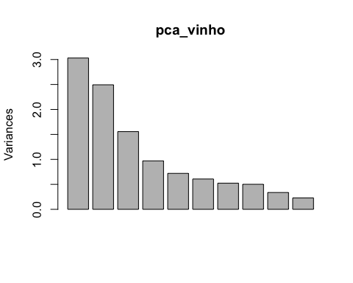

biplot(pca_vinho)

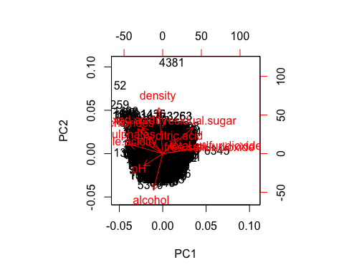

Can we use PCA to distinguish reds from whites? What about to sort the higher from the lower quality wines?

# Looking to see if the first two principal components can distinguish reds from whites and sort higher from lower quality wines  
loadings = pca_vinho$rotation  
scores = pca_vinho$x  
qplot(scores[,1], scores[,2], color=vinho_full$color, xlab='Component 1', ylab='Component 2')

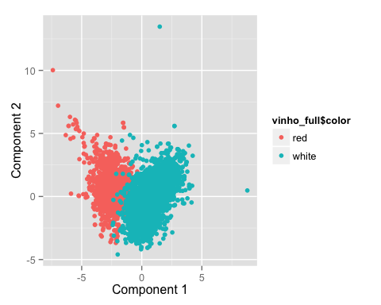

qplot(scores[,1], scores[,2], color=vinho_full$quality, xlab='Component 1', ylab='Component 2')

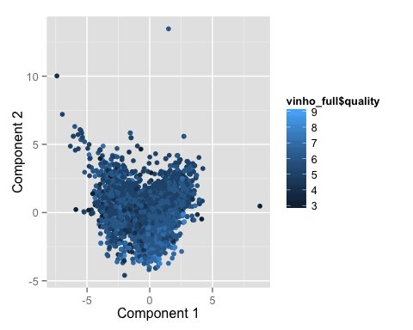

It looks like we can distinguish reds from whites pretty well, but not higher quality from lower quality.

Now, let's run k-means clustering on the dataset, and see if we can use this method to distinguish reds from whites.

# K-means clustering  
vinho_scaled <- scale(vinho)  
vinho_cluster_2 <- kmeans(vinho_scaled, centers=2, nstart=50)  
  
qplot(volatile.acidity, sulphates, data=vinho_full, color=factor(vinho_cluster_2$cluster))

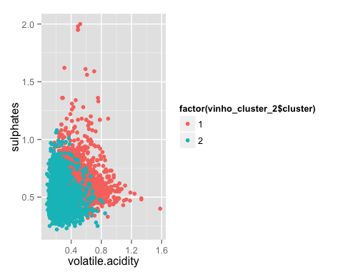

color_table = table(vinho_full$color, vinho_cluster_2$cluster)  
prop.table(color_table, margin = 1)

##   
## 1 2  
## red 0.98499062 0.01500938  
## white 0.01388322 0.98611678

It does! What about distinguishing quality?

vinho_cluster_3 <- kmeans(vinho_scaled, centers=3, nstart=50)  
  
quality_table = table (vinho_cluster_3$cluster, vinho_full$quality)  
prop.table(quality_table, margin = 1)

##   
## 3 4 5 6 7  
## 1 0.0026586906 0.0332336324 0.2120305749 0.4556331007 0.2459288800  
## 2 0.0063324538 0.0253298153 0.4242744063 0.4448548813 0.0828496042  
## 3 0.0062774639 0.0426867546 0.4369114878 0.3904582549 0.1142498431  
##   
## 8 9  
## 1 0.0491857760 0.0013293453  
## 2 0.0158311346 0.0005277045  
## 3 0.0094161959 0.0000000000

Oh no, not at all. The three clusters are not very helpful in terms of distinguishing different quality wines.

For this data, using k-means clustering with k = 2 makes more sense than PCA because we are trying to group the wines into 2 clusters (red and white), and we are able to successfully do so. 98.5% of the red wines are in Cluster 1, and 98.6% of the white wines are Cluster 2. However, we can consider using PCA before clustering.

# Market Segmentation

Given social media conversation data gathered from the followers of "NutrientH20," let's take a look at the data and try to identify any interesting market segments. What can we do with these market segments? We can use them to better tailor the social content strategy to engage with the Nutrient H20 community.

tweets <- read.csv("../data/social_marketing.csv", row.names=1)  
  
tweetsdf <- as.data.frame(tweets)  
  
tweetsdf_clean <- tweetsdf[,-c(1, 4, 5, 35, 36)]  
tweetsdf_clean_scaled <- scale(tweetsdf_clean)  
  
tweet_clusters <- kmeans(tweetsdf_clean_scaled, centers=6, nstart=50)  
  
mu = attr(tweetsdf_clean_scaled,"scaled:center")  
sigma = attr(tweetsdf_clean_scaled,"scaled:scale")

colSums(tweetsdf)

## chatter current_events travel photo_sharing   
## 34671 12030 12493 21256   
## uncategorized tv_film sports_fandom politics   
## 6408 8436 12564 14098   
## food family home_and_garden music   
## 11015 6809 4104 5354   
## news online_gaming shopping health_nutrition   
## 9502 9528 10951 20235   
## college_uni sports_playing cooking eco   
## 12213 5038 15750 4038   
## computers business outdoors crafts   
## 5116 3336 6169 4066   
## automotive art religion beauty   
## 6541 5713 8634 5558   
## parenting dating school personal_fitness   
## 7262 5603 6051 11524   
## fashion small_business spam adult   
## 7855 2651 51 3179

#Multi-faceted  
rbind(tweet_clusters$centers[1,],tweet_clusters$centers[1,]* sigma + mu)

## current_events travel tv_film sports_fandom politics  
## [1,] -0.06068533 -0.213106 -0.04263903 -0.2861432 -0.2562403  
## [2,] 1.44925934 1.097944 0.99955782 0.9756799 1.0119390  
## food family home_and_garden music news  
## [1,] -0.3537408 -0.2550026 -0.1128540 -0.1213488 -0.2448602  
## [2,] 0.7694008 0.5750608 0.4375415 0.5542781 0.6911342  
## online_gaming shopping health_nutrition college_uni sports_playing  
## [1,] -0.2334385 -0.05159407 -0.3283642 -0.2246898 -0.2286812  
## [2,] 0.5814725 1.29604245 1.0908689 0.8985187 0.4160955  
## cooking eco computers business outdoors crafts  
## [1,] -0.3371854 -0.1557282 -0.2325845 -0.1233630 -0.3147823 -0.1849265  
## [2,] 0.8416980 0.3924386 0.3747513 0.3378289 0.4019456 0.3648021  
## automotive art religion beauty parenting dating  
## [1,] -0.1793921 -0.06503471 -0.2953001 -0.2731218 -0.3029224 -0.09467412  
## [2,] 0.5847889 0.61883706 0.5299580 0.3424718 0.4623038 0.54211806  
## school personal_fitness fashion small_business  
## [1,] -0.2432415 -0.3334818 -0.2682625 -0.09916295  
## [2,] 0.4786646 0.6599602 0.5060800 0.27503869

#Outdoorsy health nuts  
rbind(tweet_clusters$centers[2,],tweet_clusters$centers[2,]* sigma + mu)

## current_events travel tv_film sports_fandom politics  
## [1,] -0.00465003 -0.0124447 0.4650048 -0.1126063 -0.160907  
## [2,] 1.52036199 1.5565611 1.8416290 1.3506787 1.300905  
## food family home_and_garden music news  
## [1,] -0.06586381 0.1841234 0.1346961 0.3772801 -0.1861461  
## [2,] 1.28054299 1.0723982 0.6199095 1.0678733 0.8144796  
## online_gaming shopping health_nutrition college_uni  
## [1,] 3.077550 -0.005129062 -0.1910742 3.072237  
## [2,] 9.479638 1.380090498 1.7081448 10.450226  
## sports_playing cooking eco computers business  
## [1,] 1.997974 -0.1459169 -0.03950252 -0.06309127 0.03897203  
## [2,] 2.588235 1.4977376 0.48190045 0.57466063 0.45022624  
## outdoors crafts automotive art religion beauty  
## [1,] -0.1046404 0.09691369 0.05332457 0.2896561 -0.1313516 -0.1953830  
## [2,] 0.6561086 0.59502262 0.90271493 1.1968326 0.8438914 0.4457014  
## parenting dating school personal_fitness fashion  
## [1,] -0.1541265 0.003553956 -0.1986304 -0.1902262 -0.05628343  
## [2,] 0.6877828 0.717194570 0.5316742 1.0045249 0.89366516  
## small_business  
## [1,] 0.2501255  
## [2,] 0.4909502

#College students and online gamers  
rbind(tweet_clusters$centers[3,],tweet_clusters$centers[3,]* sigma + mu)

## current_events travel tv_film sports_fandom politics  
## [1,] 0.1189579 -0.1031972 -0.005041735 2.003580 -0.2054111  
## [2,] 1.6772069 1.3491436 1.061923584 5.923584 1.1660079  
## food family home_and_garden music news online_gaming  
## [1,] 1.78927 1.439395 0.1731272 0.06707076 -0.08215687 -0.07917604  
## [2,] 4.57444 2.494071 0.6482213 0.74835310 1.03293808 0.99604743  
## shopping health_nutrition college_uni sports_playing cooking  
## [1,] 0.0498717 -0.1569304 -0.1205377 0.1024611 -0.1051163  
## [2,] 1.4795784 1.8616601 1.2002635 0.7391304 1.6376812  
## eco computers business outdoors crafts automotive  
## [1,] 0.2005394 0.06853509 0.1270346 -0.07739242 0.7136648 0.1631118  
## [2,] 0.6666667 0.72990777 0.5111989 0.68906456 1.0988142 1.0527009  
## art religion beauty parenting dating school  
## [1,] 0.09286884 2.185003 0.3103454 2.074241 0.05651762 1.638026  
## [2,] 0.87615283 5.279315 1.1172596 4.064559 0.81159420 2.714097  
## personal_fitness fashion small_business  
## [1,] -0.1132285 0.02132924 0.1123700  
## [2,] 1.1897233 1.03557312 0.4057971

#Political and news-interested travelers  
rbind(tweet_clusters$centers[4,],tweet_clusters$centers[4,]* sigma + mu)

## current_events travel tv_film sports_fandom politics  
## [1,] 0.01408452 -0.1523202 -0.05517042 -0.2050859 -0.1772404  
## [2,] 1.54413408 1.2368715 0.97877095 1.1508380 1.2513966  
## food family home_and_garden music news  
## [1,] 0.416738 -0.06823015 0.1744041 0.05646613 -0.0441181  
## [2,] 2.137430 0.78659218 0.6491620 0.73743017 1.1128492  
## online_gaming shopping health_nutrition college_uni sports_playing  
## [1,] -0.1317530 0.04602798 2.09573 -0.2031600 -0.02870754  
## [2,] 0.8547486 1.47262570 11.98994 0.9608939 0.61117318  
## cooking eco computers business outdoors crafts  
## [1,] 0.3800218 0.5377902 -0.07192148 0.06486851 1.612500 0.09480003  
## [2,] 3.3016760 0.9262570 0.56424581 0.46815642 2.732961 0.59329609  
## automotive art religion beauty parenting dating  
## [1,] -0.1224577 0.0152829 -0.1746962 -0.2028739 -0.1080918 0.1891801  
## [2,] 0.6625698 0.7497207 0.7608939 0.4357542 0.7575419 1.0480447  
## school personal_fitness fashion small_business  
## [1,] -0.1448908 2.060419 -0.1038445 -0.05607079  
## [2,] 0.5955307 6.417877 0.8067039 0.30167598

#Fashionistas  
rbind(tweet_clusters$centers[5,],tweet_clusters$centers[5,]* sigma + mu)

## current_events travel tv_film sports_fandom politics food  
## [1,] 0.1148271 1.760370 0.07959171 0.1878778 2.348126 0.02192452  
## [2,] 1.6719653 5.608382 1.20231214 2.0000000 8.906069 1.43641618  
## family home_and_garden music news online_gaming  
## [1,] 0.04874622 0.1327789 -0.0351506 1.940355 -0.1363161  
## [2,] 0.91907514 0.6184971 0.6430636 5.281792 0.8424855  
## shopping health_nutrition college_uni sports_playing cooking  
## [1,] 0.01961876 -0.2029778 -0.0764354 -0.01231167 -0.2038201  
## [2,] 1.42485549 1.6546243 1.3280347 0.62716763 1.2991329  
## eco computers business outdoors crafts automotive  
## [1,] 0.1229399 1.554606 0.3550546 0.1103906 0.1539572 1.109329  
## [2,] 0.6069364 2.482659 0.6690751 0.9161850 0.6416185 2.345376  
## art religion beauty parenting dating school  
## [1,] 0.01368073 -0.03699587 -0.1621102 0.01280996 0.2043846 -0.0270559  
## [2,] 0.74710983 1.02456647 0.4898844 0.94075145 1.0751445 0.7355491  
## personal_fitness fashion small_business  
## [1,] -0.1915067 -0.1585677 0.2624279  
## [2,] 1.0014451 0.7066474 0.4985549

#Family first, religion and sports second  
rbind(tweet_clusters$centers[6,],tweet_clusters$centers[6,]* sigma + mu)

## current_events travel tv_film sports_fandom politics  
## [1,] 0.1649388 -0.05979689 -0.02547995 -0.2157259 -0.1405788  
## [2,] 1.7355517 1.44833625 1.02802102 1.1278459 1.3625219  
## food family home_and_garden music news  
## [1,] -0.205126 0.0119561 0.1252624 0.5341213 -0.08949935  
## [2,] 1.033275 0.8774081 0.6129597 1.2294221 1.01751313  
## online_gaming shopping health_nutrition college_uni sports_playing  
## [1,] -0.05620051 0.2504434 -0.08136767 -0.02705292 0.1885559  
## [2,] 1.05779335 1.8423818 2.20140105 1.47110333 0.8231173  
## cooking eco computers business outdoors crafts  
## [1,] 2.574942 0.00562663 0.0287747 0.2461837 0.01606654 0.1060087  
## [2,] 10.830123 0.51663748 0.6830123 0.5936953 0.80210158 0.6024518  
## automotive art religion beauty parenting dating  
## [1,] 0.01044364 0.1269550 -0.1449444 2.416619 -0.084465 0.1278336  
## [2,] 0.84413310 0.9316988 0.8178634 3.914186 0.793345 0.9387040  
## school personal_fitness fashion small_business  
## [1,] 0.1630726 -0.05813289 2.495112 0.2123521  
## [2,] 0.9614711 1.32224168 5.558669 0.4676007

tweet_clusters$size

## [1] 4523 442 759 895 692 571

After removing some prevalent and not very informative conversation topics such as chatter, photo sharing, spam, etc and running k-means clustering with a k of 6, we some interesting segments of the Nutrient H20 followers.

For example, 11% of the followers are in the "Outdoorsy Health Nuts" cluster, meaning that they enjoy talking about fitness, health, and the outdoors. This is not too surprising given the probable target market for H20, but clustering quantifies the proportion of its followers that are especially into these topics--the "health nuts."

Given that health/nutrition is the top conversation category (besides photo sharing and chatter), there is strong evidence that social content with a health/nutrition/fitness focus would resonate well with the Nutrient H20 community. For example, Nutrient H20 could post some healthy recipes or workout routines on their social platforms.

Additionally, we see 10% of the followers fall into the "Family First, Religion and Sports Second" cluster. These individuals enjoy participating in social conversation about family-oriented topics like parenting, school, religion, and food. They can also be classified as sports fans. Knowing this, we can envision a mom or dad who is constantly juggling work, raising a family, and enjoying watching sports. Nutrient H20 can offer value by delivering social content that highlights the role of the product in a hectic lifestyle both for parents and their children.

One way we could improve this analysis is to include follower counts for each individual in the analysis. This way, we could identify influentials (those with high follower counts) that Nutrient H20 could leverage as brand advocates. This is a great first step though.