SOLID: The First 5 Principles of Object Oriented Design

SOLID stands for:
- Single Responsibility Principle (SRP)
- Open-Closed Principle (OCP)
- Liskov Substitution Principle (LSP)
- Interface Segregation Principle (ISP)
- Dependency Inversion Principle (DIP)

Single Responsibility Principle:

Every class must perform a single functionality.

public class Student {
public void printDetails();
{
//functionality of the method
}
pubic void calculatePercentage();
{
//functionality of the method
}
public void addStudent();
{
//functionality of the method
}
}
The above code snippet violates the single responsibility principle.

We can achieve the this by separating the functions.

public class Student {

public void addStudent();
{
//functionality of the method
}
};

public class PrintStudentDetails {
public void printDetails();
{
//functionality of the method
}
};

public class Percentage {
public void calculatePercentage();
{
//functionality of the method
}
};

Hence, we have achieved the goal of the single responsibility principle by separating the functionality into three separate classes.

Open-Closed Principle:
Module should be open for extension but closed for modification. The extension allows us to implement new functionality to the module.
Suppose, VehicleInfo is a class and it has the method vehicleNumber() that returns the vehicle number.

public class VehicleInfo {
public double vehicleNumber(Vehicle vcl)
{
if (vcl instanceof Car) {
return vcl.getNumber();
}
if (vcl instanceof Bike) {
return vcl.getNumber();
}
}
};
If we want to add another subclass named Truck, simply, we add one more if statement that violates the open-closed principle. The only way to add the subclass and achieve the goal of principle by overriding the vehicleNumber() method.

public class VehicleInfo {
public double vehicleNumber()
{
//functionality
}
}

public class Car extends VehicleInfo {
public double vehicleNumber()
{
return this.getValue();
}
}

public class Car extends Truck {
public double vehicleNumber()
{
return this.getValue();
}
}

Similarly, we can add more vehicles by making another subclass extending from the vehicle class. the approach would not affect the existing application.

Liskov Substitution Principle:

The derived classes must be completely substitutable for their base classes.
If class A is a subtype of class B, then we should be able to replace B with A without interrupting the behavior of the program.
It extends the open-close principle and also focuses on the behavior of a superclass and its subtypes.
public class Student {
private double height;
private double weight;

public void setHeight(double h)
{
height = h;
}

public void setWeight(double w)
{
weight= w;
}
}

public class StudentBMI extends Student {
public void setHeight(double h)
{
super.setHeight(h);
super.setWeight(w);
}

public void setWeight(double h)
{
super.setHeight(h);
super.setWeight(w);
}
};

The above classes violated the Liskov substitution principle because the StudentBMI class has extra constraints i.e. height and weight that must be the same. Therefore, the Student class (base class) cannot be replaced by StudentBMI class (derived class).
Hence, substituting the class Student with StudentBMI class may result in unexpected behavior.

Interface Segregation Principle:
The principle states that the larger interfaces split into smaller ones. Because the implementation classes use only the methods that are required. We should not force the client to use the methods that they do not want to use.
The goal of the interface segregation principle is similar to the single responsibility principle. Let's understand the principle through an example.
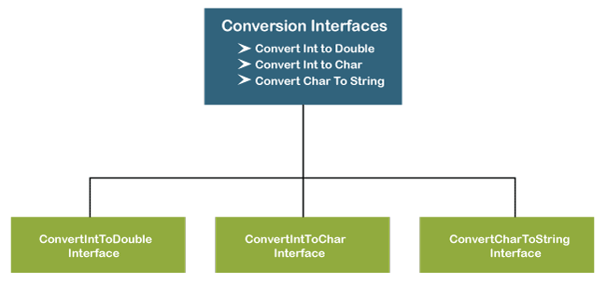

Suppose, we have created an interface named Conversion having three methods intToDouble(), intToChar(), and charToString().
public interface Conversion {
public void intToDouble();
public void intToChar();
public void charToString();
}

The above interface has three methods. If we want to use only a method intToChar(), we have no choice to implement the single method. To overcome the problem, the principle allows us to split the interface into three separate ones.
public interface ConvertIntToDouble {
public void intToDouble();
}

public interface ConvertIntToChar {
public void intToChar();
}

public interface ConvertCharToString
{
public void charToString();
}

Now we can use only the method that is required.

public class DataTypeConversion implements ConvertIntToDouble, ConvertCharToStrig{
public void intToDouble()
{
//conversion logic
}

public void charToString()
{
//conversion logic
}
}

Dependency Inversion Principle:
We must use abstraction (abstract classes and interfaces) instead of concrete implementations.
High-level modules should not depend on the low-level module but both should depend on the abstraction. Because the abstraction does not depend on detail but the detail depends on abstraction. It decouples the software.

public class WindowsMachine {
//functionality
}

If we have not keyboard and mouse to work on Windows. To solve this problem, we create a constructor of the class and add the instances of the keyboard and monitor. After adding the instances, the class looks like as:
public class WindowsMachine
{
public final keyboard;
public final monitor;
public WindowsMachine()
{
monitor = new monitor(); //instance of monitor class
keyboard = new keyboard(); //instance of keyboard class
}
}

Now we can work on the Windows machine with the help of a keyboard and mouse. But we still face the problem. Because we have tightly coupled the three classes together by using the new keyword. It is hard o test the class windows machine.
To make the code loosely coupled, we decouple the WindowsMachine from the keyboard by using the Keyboard interface and this keyword.
public interface Keyboard
{
//functionality
}
public class WindowsMachine
{
private final Keyboard keyboard;
private final Monitor monitor;
public WindowsMachine(Keyboard keyboard, Monitor monitor)
{
this.keyboard = keyboard;
this.monitor = monitor;
}
}

In the above code, we have used the dependency injection to add the keyboard dependency in the WindowsMachine class. Therefore, we have decoupled the classes.
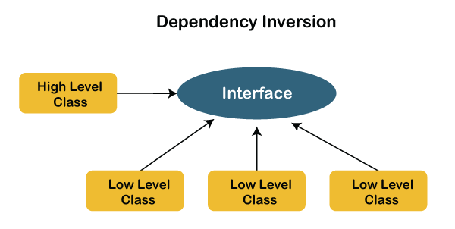

Why should we use SOLID principles?
- It reduces the dependencies so that a block of code can be changed without affecting the other code blocks.
- The principles intended to make design easier, understandable.
- By using the principles, the system is maintainable, testable, scalable, and reusable.
- It avoids the bad design of the software.

