**B.Sc (HONS.) IN ECE PART III SIXTH SEMESTER EXAMINATION, 2021**  
COMPUTER PERIPHERALS AND INTERFACING  
Subject Code : ECE-315  
Examination Code : 5626  
Time – 3 hours  
Full marks – 80

[N.B. : The figures in the right margin indicate full marks. Answer any five questions.]

**1 (a) Define Peripheral. Roles of Computer Peripherals (4 Marks)**

* **A computer peripheral is any external device connected to a computer system that expands its functionality but is not part of the CPU or main memory.**

**Roles of peripherals:**

1. **Input Devices – allow user to enter data (keyboard, mouse, scanner, microphone).**
2. **Output Devices – display or produce results (monitor, printer, speakers).**
3. **Storage Devices – store data permanently (hard disk, CD/DVD, USB drive).**
4. **Communication Devices – enable data transfer (network card, modem).**

**Conclusion:**

* **Without peripherals, a computer would not be able to interact with the external environment.**

**1 (b) Meaning of Interfacing & Basic Interfacing Unit (6 Marks)**

* **Interfacing is the method of connecting the microprocessor/CPU with external devices (I/O or memory) so that they can exchange information correctly.**

**Need for Interfacing:**

* **CPU works at high speed while I/O devices are slower → mismatch.**
* **Interfacing provides the proper handshake and control for smooth operation.**

**Basic Interfacing Unit Includes:**

* **Data Bus – transfers data.**
* **Address Bus – selects device or memory location.**
* **Control Bus – provides control signals (RD, WR, IO/M).**
* **Buffers and Latches – store/hold signals temporarily.**
* **Decoder – selects correct device.**
* **Status Register – indicates device status.**

**Diagram hint:**

**CPU → Data/Address/Control bus → Interface Logic (Decoder, Buffer, Latch) → I/O Device**

**1 (c) Requirements for Proper Interface (6 Marks)**

1. **Electrical Compatibility – Voltage/current levels must match.**
2. **Speed Matching – CPU and device speed must be synchronized.**
3. **Data Format Compatibility – Both must use the same data word size.**
4. **Address Decoding – Each device must have a unique address.**
5. **Control Signals – RD, WR, Interrupt, DMA should be supported.**
6. **Error Handling/Status Monitoring – Interface must handle busy/ready/error conditions.**

**Diagram hint: CPU ↔ Interface circuit ↔ I/O Device**

**2 (a) DMA and DMA Controller (6 Marks)**

**Definition:**

* **Direct Memory Access (DMA) allows peripherals to directly transfer data to/from main memory without CPU involvement, improving system efficiency.**

**Working:**

1. **CPU initializes DMA by providing memory address, transfer size, and control signals.**
2. **DMA controller takes over system buses from CPU.**
3. **Data transfers directly between I/O device and memory.**
4. **After completion, DMA generates an interrupt to inform CPU.**

**DMA Controller Block Diagram Components:**

* **Address Register – stores memory location.**
* **Word Count Register – number of bytes/words to transfer.**
* **Control Logic – controls bus and transfer mode.**
* **Data Bus Buffer – temporary storage during transfer.**

**Applications:**

* **High-speed data transfer in disk drives, graphics, and communication systems.**

**2 (b) Synchronous vs Asynchronous Interfacing (4 Marks)**

| **Feature** | **Synchronous** | **Asynchronous** |
| --- | --- | --- |
| **Clock** | **Uses a common clock** | **No common clock, uses handshake signals** |
| **Speed** | **Faster** | **Slower** |
| **Control** | **Simple design** | **Complex design** |
| **Example** | **Memory access** | **Keyboard, printer** |

**2 (c) Memory Mapped I/O vs Peripheral I/O (4 Marks)**

**Memory Mapped I/O:**

* **I/O devices are assigned addresses in memory space.**
* **Same instructions (MOV, ADD) can access both memory and I/O.**
* **Disadvantage: consumes memory address space.**

**Peripheral (Isolated) I/O:**

* **I/O devices have separate I/O address space.**
* **Special instructions (IN, OUT) are required.**
* **Advantage: preserves memory address space.**

**3 (a) Sensor & Types (5 Marks)**

* **A sensor is a device that detects or measures a physical quantity (temperature, pressure, light, etc.) and converts it into an electrical signal.**

**Types of Sensors:**

1. **Temperature Sensors – Thermistor, Thermocouple.**
2. **Pressure Sensors – Piezoelectric sensors.**
3. **Light Sensors – LDR, photodiodes.**
4. **Motion Sensors – Infrared sensors, accelerometers.**
5. **Magnetic Sensors – Hall-effect sensor.**

**Applications:**

* **Used in automation, robotics, environmental monitoring, medical devices.**
  1. **(b) 8255A Programmable Peripheral Interface (5 Marks)**

**8255A is a Programmable Peripheral Interface (PPI) IC that provides 24 I/O lines divided into 3 ports (Port A, B, C).**

**Features:**

* **Port A (8-bit), Port B (8-bit), Port C (8-bit, split into C upper & C lower).**
* **Operates in 3 modes:**
  + **Mode 0: Simple I/O.**
  + **Mode 1: Strobed I/O.**
  + **Mode 2: Bidirectional I/O.**

**Block Diagram Hint:**

* **Data Bus Buffer, Read/Write Control Logic, Group A (Port A + Port C upper), Group B (Port B + Port C lower).**

**Applications:**

* **Keyboard interface, display interface, industrial automation.**

**3 (c) OMR vs OCR (2 Marks)**

* **OMR (Optical Mark Recognition): Detects marks on paper (MCQ exams, surveys).**
* **OCR (Optical Character Recognition): Detects printed/typed characters and converts them into editable text.**

**3 (d) Interrupt (2 Marks)**

* **An interrupt is a signal from hardware or software that temporarily halts CPU execution and diverts control to an Interrupt Service Routine (ISR).**

**4 (a) Dot-Matrix Printer Principle (4 Marks)**

**Principle:**

* **An impact printer where a print head containing pins strikes an ink ribbon, creating dots on paper.**
* **Combination of dots forms characters or graphics.**

**Features:**

* **Prints text and simple graphics.**
* **Low cost, rugged.**
* **Disadvantages: noisy, low resolution.**

**Applications:**

* **Bill printing, POS terminals, multipart forms.**

**4 (b) Successive Approximation ADC (6 Marks)**

**Principle:**

* **Uses Successive Approximation Register (SAR) and a DAC to convert analog input to digital form.**

**Working:**

1. **SAR sets MSB = 1.**
2. **DAC output compared with input voltage.**
3. **If DAC > Vin → bit cleared; else bit kept.**
4. **Process continues until all bits are checked.**
5. **Final SAR content = digital output.**

**Diagram hint: Comparator, DAC, SAR, Register, Digital Output.**

**Advantages:**

* **Fast conversion, high resolution.**
* **Used in digital oscilloscopes, data acquisition systems.**

**5 (a) Impact vs Non-Impact Printers (3 Marks)**

| **Impact Printer** | **Non-Impact Printer** |
| --- | --- |
| **Uses mechanical strike on ribbon** | **No physical contact** |
| **Slower, noisy** | **Faster, quiet** |
| **Example: Dot-matrix** | **Example: Laser, Inkjet** |

**5 (b) Laser Printer – Working (7 Marks)**

**Principle:**

* **Works on the concept of electro-photography using a laser beam.**

**Working Steps:**

1. **Drum surface is charged.**
2. **Laser beam discharges selected areas → forms latent image.**
3. **Toner particles adhere to discharged areas.**
4. **Paper contacts drum → toner transferred.**
5. **Heat and pressure fuse toner permanently on paper.**

**Diagram hint: Drum, Laser unit, Toner cartridge, Paper feed.**

**Advantages:**

* **High speed, high quality, low noise.**

**5 (c) Encoding & Keyboard Encoder (4 Marks)**

**Encoding:**

* **The process of converting information into coded binary form.**

**Keyboard Encoder:**

* **Detects which key is pressed.**
* **Generates binary code (ASCII or scan code).**
* **Sends code to CPU through I/O interface.**

**Applications:**

* **Used in all computer keyboards, calculators, ATM machines.**

**Q6 (a) Transducer & Types (4 Marks)**

**A transducer converts one form of energy into another, usually physical → electrical.**

**Types:**

* **Active Transducer: Generates output directly (thermocouple, piezoelectric sensor).**
* **Passive Transducer: Requires external power (RTD, LDR).**

**Applications:**

* **Temperature sensing, pressure measurement, sound detection.**

**6 (b) IEEE-488 / GPIB Bus (6 Marks)**

**IEEE-488 (General Purpose Interface Bus) is a standard parallel interface for connecting instruments.**

**Structure:**

* **24 lines total → 8 data lines, 8 control lines, 8 ground lines.**
* **Supports up to 15 devices in a system.**

**Features:**

* **Device addressing capability.**
* **Transfer rate up to a few MB/s.**
* **Widely used in instrumentation.**

**Applications:**

* **Oscilloscopes, signal generators, laboratory test equipment.**

**6 (c) Parallel Data Transfer (6 Marks)**

**Data transfer method in which multiple bits are sent simultaneously through multiple lines.**

**Working:**

* **Typically 8 or 16 bits transferred at once.**
* **Uses strobe/acknowledge signals for synchronization.**
* **Much faster than serial transfer.**

**Example: Centronics parallel printer interface, system buses.**

**Advantages: High speed.**

**Disadvantages: More lines needed, expensive, not suitable for long distance.**

**7. (i) Seven Segment Display (4 Marks)**

* A seven-segment display is an electronic display device made of **seven LEDs** (segments) arranged in a way that can display decimal digits (0–9) and some alphabets.

**Types:**

* **Common Anode (CA):** All anodes are tied together; segments glow when cathode is connected to logic LOW.
* **Common Cathode (CC):** All cathodes are tied together; segments glow when anode is given logic HIGH.

**Working Principle:**

* By turning ON/OFF different segments (a–g), numbers are displayed.
* Example: To display digit **2**, segments a, b, g, e, d are turned ON.

**Applications:**

* Digital clocks, calculators, meters, counters.

**Diagram hint:** 7 LED arrangement in “8” shape.

**(ii) Stepper Motor (4 Marks)**

A stepper motor is an electromechanical device that converts **digital pulses into discrete mechanical steps** (angular rotation).

**Working Principle:**

* The rotor moves in fixed angular steps when stator windings are energized in sequence.
* Step angle = 360° / (number of steps per revolution).

**Features:**

* Open-loop control.
* High positional accuracy.
* Speed depends on input pulse frequency.

**Applications:**

* Printers, CNC machines, robotics, disk drives.

**Diagram hint:** Rotor with teeth + multiple stator coils.

**(iii) Plotter (4 Marks)**

A plotter is an **output device** used to produce **high precision graphics, drawings, and diagrams** on paper.

**Types:**

1. **Drum Plotter** – paper moves over rotating drum.
2. **Flatbed Plotter** – pen moves over fixed paper sheet.

**Features:**

* Can draw continuous lines unlike printers (which use dots).
* Uses one or multiple pens of different colors.

**Applications:**

* Engineering drawings, maps, architectural plans, circuit layouts.

**Diagram hint:** Pen carriage + paper movement system.

**(iv) Floppy Disk Controller (FDC) (4 Marks)**

FDC is an interface circuit that controls the read/write operations of a floppy disk drive.

**Functions:**

* Provides command to disk drive (read/write/format).
* Transfers data between CPU and floppy disk.
* Controls spindle motor and head movement.

**Block Components:**

* Data register, Control register, Status register, Command register.

**Applications:**

* Old storage systems in computers, BIOS updates.

**(v) GPIB / IEEE-488 Bus (4 Marks)**

General Purpose Interface Bus (GPIB), also known as **IEEE-488**, is a standard parallel communication interface.

**Structure:**

* 24 lines: 8 data lines, 8 control lines, 8 ground lines.
* Supports multiple instruments (up to 15 devices).

**Features:**

* Provides device addressing.
* Data transfer rate up to few MB/s.

**Applications:**

* Widely used in laboratories and instrumentation systems for connecting oscilloscopes, signal generators, multimeters.

**(vi) PCI Bus (4 Marks)**

Peripheral Component Interconnect (PCI) bus is a **high-speed parallel bus** used to connect peripherals to the computer’s motherboard.

**Features:**

* 32-bit or 64-bit data bus.
* Clock speeds: 33 MHz or 66 MHz.
* Plug-and-play capability.
* Supports multiple peripherals.

**Applications:**

* Connecting graphics cards, sound cards, network cards, storage controllers.

**Diagram hint:** CPU ↔ PCI Bus ↔ Expansion cards.

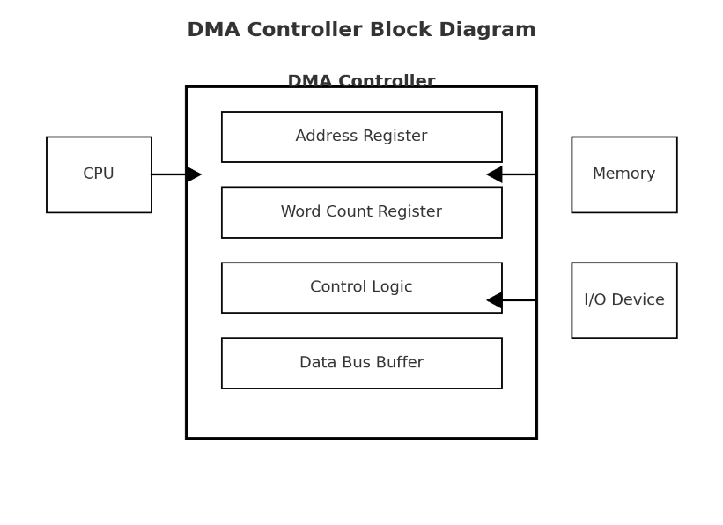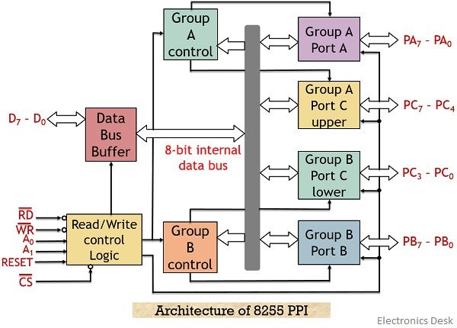2(a)

3©

1(b)

