**COPYCAT**

Fast Food

Franchise Fries

Total Time: 1 hr 15 mins



Ingredients

8 kentang, ->12000/kg (isi 8)

3 sdm gula putih -> 1000/ 3 saset 8gr

2 sdm sirup jagung -> 5000/100ml

Directions

1. Kupas dan potong kentang menjadi potongan kentang goreng setebal 1/4 inci
2. Siapkan mangkuk untuk kentang dan biarkan terendam dalam air selama 15 menit, lalu keluarkan cairannya dan keringkan kentang.
3. Sekarang rendam kentang dalam air mendidih secukupnya lalu tambahkan sirup jagung dan gula dan aduk semuanya. Lakukan ini dalam mangkuk logam. Masukkan semuanya ke dalam lemari es selama 10 menit. Keluarkan cairan dan keringkan kentang dengan tisu.
4. Siapkan kotak makan dan taruh kentang goreng di atasnya, letakkan plastik penutup di atas piring dan masukkan semuanya ke dalam freezer selama 45 menit.
5. Sekarang panaskan minyak untuk menggoreng sekitar 350 hingga 360 derajat dan setelah minyak panas mulai 1,3 kentang goreng dalam minyak selama 3 menit. Tempatkan kentang goreng di atas piring dengan handuk kertas untuk dikeringkan dan biarkan selama sekitar 10 menit. Terus bekerja dalam batch sampai semua kentang goreng selesai.
6. Sekarang goreng kembali kentang goreng untuk kedua kalinya 1/3 setiap kali selama 6 menit setiap batch kemudian bumbui kentang goreng dengan sedikit garam.
7. Nikmati.

Pear

Salad

Total Time: 3 mins

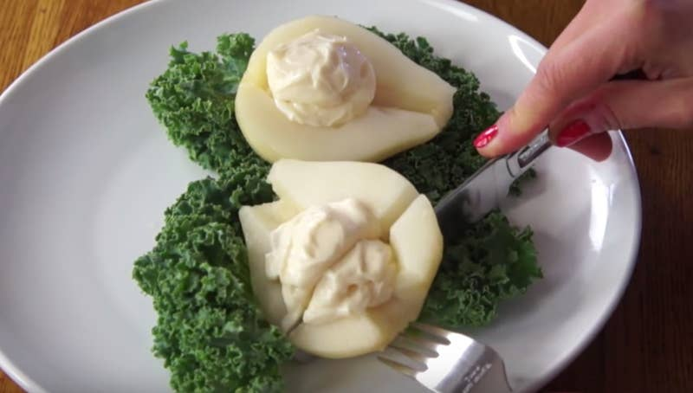

Ingredients

1 daun selada -> 3000/100gr

1 buah pir, kalengan dan tiriskan -> 3000/buah

1 sdm Mayonaise -> 1000 ->10gr

1 sejumput paprika -> 5000/20gr

Directions

1. Potong buah pir

2. Susun daun selada di piring saji, diikuti dengan buah pir dan Miracle Whip.

3. Nikmati dengan taburan paprika.

**$2**

Sandwiches

Total Time: 5 mins

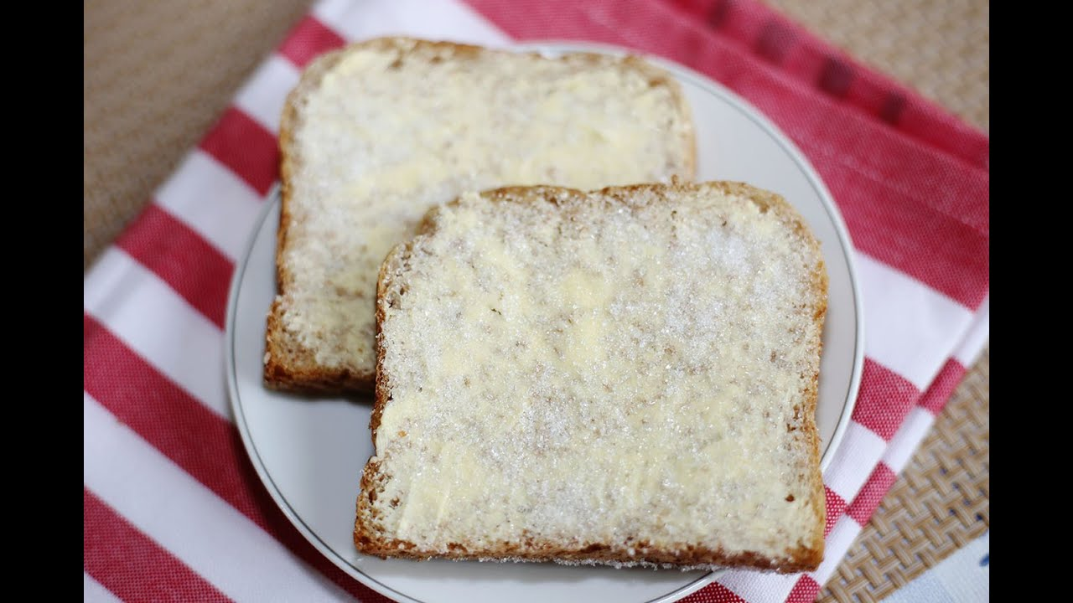

Ingredients

2 sdt margarin -> 5000/200gr

2 potong roti putih -> 4000/ 2 potong

2 sdt gula -> 500 (2 saset 8gr)

Directions

1. Oleskan margarin pada kedua irisan roti secara merata dan taburi dengan gula.

2. Nikmati.

**I ♥**

Pancakes

Total Time: 20 mins



Ingredients

1 cangkir tepung beras (155 grams) -> 6000/500gr

½ sdt garam -> 1000/100gr

1 telur, kocok -> 2000

1 sdm minyak goreng -> 500 / 1 sdm

1 sdm air-> 500/ segelas

Directions

1. Dalam mangkuk, campur tepung beras dan garam.

2. Buat lubang di tengah campuran tepung.

3. Tambahkan telur yang telah dikocok, minyak sayur dan air secukupnya ke dalam sumur dan aduk hingga adonan kalis.

4. Olesi wajan anti lengket dengan cooking spray dan panaskan dengan api sedang.

5. Tambahkan sekitar 1/4 C. dari campuran dan miringkan panci untuk menutupi bagian bawah dengan panekuk tipis.

6. Masak sekitar 1 menit per sisi.

7. Ulangi dengan sisa campuran.

Tropical

Coconut Pancakes

Total Time: 10 mins

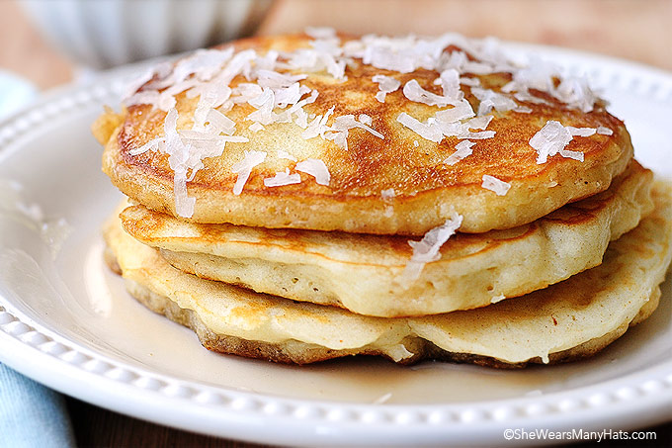

Ingredients

2 telur -> 4000/2 telur

4 sdm tepung kelapa -> 5000/100gr

2 sdm minyak kelapa, lelehkan -> 1000/25ml

1 1/8 sdm pemanis bubuk -> 1000/saset

1/2 sdt ekstrak vanilla -> 7500->60ml

1 sdt minyak kelapa -> 1000/25ml

Directions

1. Dalam mangkuk, tambahkan telur, tepung kelapa, 2 sdm minyak goreng, pemanis stevia, dan ekstrak vanila, lalu kocok hingga rata.

2. Dalam wajan besar, lelehkan 1 sdt minyak kelapa dengan api sedang.

3. Tambahkan campuran yang cukup ke dalam wajan dan masak selama sekitar 2-3 menit per sisi.

**INDIAN STYLE**

Fritters II

Total Time: 35 mins

Ingredients

2 C. all-purpose flour

1 tsp curry powder, or more to taste

1 egg

1/2 C. soy milk

salt

1 (16 oz.) can whole kernel corn

olive oil for frying, as needed

Directions

1. Get a bowl, sift: curry and flour.

2. Now slowly add in your salt, milk, and eggs.

3. Beat the mix until it is smooth then place it to the side for 20 mins.

4. Now add your oil to a pan and get it hot.

5. Once the oil is hot, fry large dollops of your mix for 3 mins each side.

6. Enjoy.

**DOUGH**

Fritters

Total Time: 35 mins

Ingredients

3 eggs

1 1/2 C. all-purpose flour

1 tsp salt

2 C. canola oil for frying

Directions

1. Whisk your eggs in a bowl then slowly add in your flour and salt.

2. Stir the mix into a dough then flatten the dough into 1/8 of an inch.

3. Now slice everything into strips.

4. Get 2 inches of oil hot to 375 degrees before doing anything else.

5. Once the oil is hot begin to fry your dough in batches until golden on all sides.

6. Enjoy.

**BELGIAN**

Waffles 101

Total Time: 50 mins

Ingredients

2 C. flour

4 tsp baking powder

1/2 tsp salt

1/4 C. sugar

2 eggs

1/2 C. vegetable oil

2 C. milk

1 tsp vanilla

Directions

1. Set your waffle iron to medium-high heat and lightly, grease it.

2. In a bowl, add the flour, sugar, baking powder and salt and mix well.

3. Now, sift the flour mixture into another bowl.

4. In another bowl, add the oil, milk, egg yolks and vanilla and beat until well combined.

5. Add the flour mixture and mix until well combined.

6. In a glass bowl, add the egg whites and beat until stiff peaks form.

7. Gently, fold the whipped egg whites into the flour mixture.

8. Add desired amount of the mixture in waffle iron and cook for about 6-10 minutes.

9. Repeat with the remaining mixture.

10. Enjoy warm.

Madison

Oat Waffles

Total Time: 50 mins

Ingredients

3/4 C. oat bran

1/2 C. whole wheat flour

1/2 C. all-purpose flour

2 tsp baking powder

1/2 tsp salt

1 1/2 C. skim milk

3 tbsp vegetable oil

1 egg yolk, beaten

2 egg whites

Directions

1. In a bowl, add the flours, oat bran, baking powder and salt and mix well.

2. In another bowl, add the egg yolk, oil and milk and beat until well combined.

3. Add the flour mixture and mix until just combined.

4. In a glass bowl, add the egg whites and with an electric mixer, beat on high speed until

stiff peaks form.

5. Gently, fold the whipped egg whites into the flour mixture.

6. Add desired amount of the mixture in waffle iron and cook as suggested by the

manufacturer.

7. Repeat with the remaining mixture.

8. Enjoy warm.

**ENHANCED**

Toasted Waffles

Total Time: 5 mins

Ingredients

8 frozen waffles, toasted

3 oz. cream cheese

14 oz. canned peaches

1 tbsp brown sugar

whipped cream

Directions

1. Spread cream cheese over each toasted waffle, followed by the fruit, brown sugar and whipped cream.

2. Enjoy.

Ice Cream

Waffle Sandwiches

Total Time: 7 mins



Ingredients

2 toasted hot waffles

1 C. ice cream

Toppings

1 -2 tbsp decorative candies

1 -2 tbsp crushed nuts

1 -2 tbsp toasted coconut

1 -2 tbsp granola cereal

1 -2 tbsp praline

peanut butter spread on before ice cream

Directions

1. Place a thin layer of the peanut butter over each waffle evenly.

2. Put the ice cream onto inner part of each waffle.

3. Place your favorite topping beside the ice cream.

4. Enjoy.

**COUNTRY**

Cottage Waffles

Total Time: 20 mins

Ingredients

4 tbsp unsalted butter, melted

1 3/4 C. all-purpose flour

2 tsp baking powder

1/4 tsp baking soda

1/2 tsp salt

1 C. cottage cheese

1 C. milk

2 large eggs

2 1/2 tbsp honey

Directions

1. Set your waffle iron and lightly, grease it.

2. In a bowl, add the flour, baking powder, baking soda and salt and mix well.

3. In another bowl, add the honey, eggs, milk and cottage cheese and beat until just

combined.

4. Slowly, add the flour mixture and mix until just combined.

5. Add the butter and stir to combine.

6. Add desired amount of the mixture in waffle iron and cook as suggested by the

manufacturer.

7. Repeat with the remaining mixture.

8. Enjoy warm.

Sweetened

Flax Waffles

Total Time: 20 mins

Ingredients

1 1/2 C. whole wheat flour

1 1/2 C. white flour

1/2 tsp powdered stevia

6 tsp baking powder

4 tbsp flax seeds

1/2 tsp salt

4 eggs

3 C. milk

1/4 C. olive oil

Directions

1. In a bowl, add the flours, flax seed, stevia, baking powder and salt.

2. In another bowl, add the remaining ingredients and beat until well combined.

3. Add the flour mixture and mix until just combined.

4. Add 3/4 C. of the mixture in waffle iron and cook as suggested by the manufacturer.

5. Repeat with the remaining mixture.

6. Enjoy warm.

**VICTORIAN**

Waffles

Total Time: 45 mins

Ingredients

1 1/2 C. white flour

1 1/2 C. whole wheat flour

1/4 C. flax seed

2 tbsp sugar

1 tbsp baking powder

1 tsp salt

3 C. soy milk

1 large banana, mashed

1/4 C. canola oil

2 tsp vanilla extract

Directions

1. In a bowl, add the flours, flax seed, sugar, baking powder and salt.

2. In another bowl, add the remaining ingredients and beat until well combined.

3. Add the flour mixture and with a hand mixer, beat on a low setting well combined.

4. Heat a waffle iron and spray with oil.

5. Add desired amount of the mixture in waffle iron and cook as suggested by the

manufacturer.

6. Repeat with the remaining mixture.

7. Enjoy warm.

Yam

Waffles

Total Time: 40 mins

Ingredients

1 C. whole wheat flour

1 C. all-purpose flour

4 tsp baking powder

1/2 tsp cinnamon

1/4 tsp clove

2 eggs, separated

1 1/2 C. skim milk

1 C. pureed cooked sweet potato

3 tbsp oil

2 tsp grated orange rind

1 tbsp granulated sugar

Directions

1. In a bowl, add the flour, spices and baking powder.

2. In another bowl, add the oil, milk, egg yolks, orange rind and sweet potato and beat until

well combined.

3. Add the flour mixture and mix until just combined.

4. In a glass bowl, add the egg whites and with an electric mixer, beat until soft peaks form.

5. Add the sugar and beat until stiff peaks form.

6. Gently, fold the whipped egg whites into the flour mixture.

7. Add desired amount of the mixture in waffle iron and cook for about 5 minutes.

8. Repeat with the remaining mixture.

9. Enjoy warm.

**FETA SPINACH**

Burgers

Total Time: 25 mins

Ingredients

2 lbs ground turkey

1 1/2 C. fresh bread crumbs

1 1/2 C. chopped baby spinach

1/2 C. light Greek dressing

5 oz. feta cheese, cubed

1/4 large onion, finely chopped

1 egg

Salt and ground black pepper to taste

Directions

1. Before you do anything preheat the grill.

2. Get a mixing bowl: Add all the ingredients. Mix them well. Shape the mix into 8 burger

cakes. Grill them for 8 min on each side.

3. Assemble your burgers with your favorite toppings.

4. Enjoy.

Nuts

Burger

Total Time: 25 mins

Ingredients

1 C. chopped onion

2 tbsps minced garlic

1 tbsp olive oil

3 tbsps chopped fresh basil or 2 tsp dried

basil

2 C. cooked brown rice

1/3 C. cashews

1/3 C. walnuts

1/3 C. almonds

1/3 C. sunflower seeds

1/4 C. tamari soy sauce

2/3 C. tahini

Directions

1. Place a skillet on medium heat. Heat half tbsp of oil in it. Add the onion and cook it for 4

min. Stir in the basil with rice and mix them well.

2. Get a food processor! Add the sunflower seeds with cashews, walnuts and almonds.

Process them until they become finely chopped.

3. Spoon the chopped nuts to the rice with tamari and tahini. Mix them well. Form the mix

into 6 burgers.

4. Place a large skillet on medium heat. Heat in it half tbsp of oil Add the burgers and cook

them for 6 min on each side.

5. Assemble your burgers with your favorite toppings. Serve them right away.

6. Enjoy.

Chili Corn

Burgers

Total Time: 21 mins

Ingredients

1 carrot, sliced

1 (15 ounce) cans garbanzo beans

2 C. store-brand fresh salsa

1 C. crushed corn flakes

1/2 C. whole wheat flour

1/2 tsp fresh pepper

Salt

1 pinch chili powder

Directions

1. Fill 1/4 inch of a bowl with water. Add the carrot. Cook it in the microwave for 3 min.

discard the water.

2. Get a mixing bowl: Add the beans with carrot. Press them with a fork until they become

finely mashed. Add the salsa with corn flakes, flour, salt, chili powder and pepper. Mix

them well.

3. Shape the mix into 8 burgers. Grease a skillet and put it on medium heat. Add the burgers

and cook them for 9 min on each side.

4. Assemble your burgers with your favorite toppings. Serve them right away.

5. Enjoy.

**AMERICAN**

Bologna Rolls

Total Time: 15 mins

Ingredients

1/2 lb. of your favorite bologna,

quartered

6 oz. packages sliced American cheese,

Quartered

1/4 C. sweet pickle relish

1/4 C. real mayonnaise

Directions

1. Get a blender: Place in it the cheese and bologna. Pulse them several times until they

become chunky.

2. Place it in a mixing bowl with relish, a pinch of salt and pepper. Mix them well.

3. Stir in the mayonnaise. Spread the mixture over crackers then serve them.

4. Serve your sandwiches right away.

5. Enjoy.

**CREAM**

on Marmalade

Sandwiches

Total Time: 25 mins

Ingredients

2 (3 oz.) packages cream cheese,

softened

1/4 C. orange marmalade

16 slices white bread

Directions

1. Get a mixing bowl: Cream in it the marmalade with cream cheese until they become

smooth.

2. Place the bread slices on a cutting board. Use a cookie cutter in the shape of a heart to cut

them into 16 hearts.

3. Place them on a serving plate. Spoon the marmalade mix over the bread slices.

4. Serve your marmalade sandwiches right away.

5. Enjoy.