Split
2260 Hayward
Ann Arbor, MI 49109
Date: 25 November 2009
To: Rod Johnson, Instructor, University of Michigan
From: Split-Dev
Michael Lee, Developer
Robert Steen, Developer
Ben Montgomery, Developer
Jim Brusstar, Developer
Subject: Architecture Document for Split
CC: Elliot Soloway, Instructor, University of Michigan
Version Box
Version | Date and Time | Performed By | Changes Made
0.1 | 11 Nov 2009 4:30 pm | rdsteen | Initial draft – overview, project management, structure
0.2 | 12 Nov 2009 11:30 am | Mzlee | Added changes in project scope and global design strategy
0.3 | 13 Nov 2009 4:10 pm | jimbru, mzlee, rdsteen | Added diagrams, project management, conclusion
1.0 | 14 Nov 2009 4:30 pm | benmonty | Added to several sections, proofread document
1.1 | 20 Nov 2009 9:00 am | mzlee | Laid out necessary changes
Overview
Today, most people use tabbed web browsers to access information online. Using tabs increases efficiency and allows a user to view web content more effectively; however, the power of tabbed browsing has reached a limit. The amount of information amassed in a browsing session has become too much for a user to easily control. We are proposing a project that demonstrates a new style of browsing. This new style allows users to manage their web content by viewing solely the information they wish to see.
This document defines how our project works in greater detail. It starts out by providing a little history and explaining why we believe the project is worth completing. Following that are discussions about the changes of scope, our design strategy, and our progress to date. The section on system architecture contains multiple diagrams which display how our software functions from various perspectives. The document wraps up with an update on our use of third party resources.
Project Definition
Web browsers have been an ever-evolving form of communication and information distribution. They have evolved from the old days of AOL, with the single box and cascading screens to Internet Explorer, which allowed for many windows in a desktop and now to Firefox, with tabbed browsing. We are now reaching the point of information saturation where none of these models is efficient enough. The biggest problem is that it is not the user who really decides what he or she wants to see; it's the content provider. You may be able choose to look at whatever pages you want, but do you do not have control over the ads, flash, and other distractions. We will create a platform that allows users to decide what they want to see and how they want to see it.
good enough? SCREENSHOT 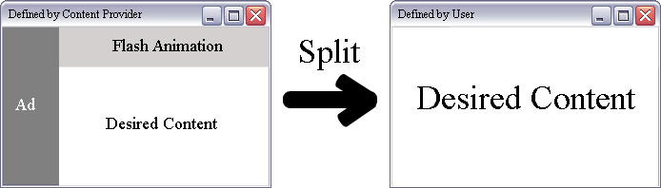
The objective of this project is to create a proof of concept system to demonstrate our technology and its usefulness in the web browser space. It is not to try to actively compete with other web browsers, that market is already saturated. Instead, we wish to show innovation so that we may be able to patent and later develop a better business model. The primary stakeholders of this project are our team members as we will be investing the time, energy, and work into the project. Additionally, the end users will have some stake in our continued development and innovation after our first alpha release. Finally, the University will have a marginal stake in our success as our success leads to furthering the reputation of the University of Michigan.
Changes in Scope
Our team has been hard at work making improvements and changes to the design. The scope of the project has changed slightly; it has expanded despite the fact that we are just a day or two behind schedule.
We are currently behind schedule due to unforeseen issues with how WebKit and Qt ROD CIRCLED THESE he circled them because this was one of the few places we mentioned Qt/WebKit, the core of our project interact. Having now identified these issues, we have been forced to make these corrections and add additional components while removing some of the other originally planned pieces. As a result, we will end up with a greater quantity of rich features and a more streamlined application. Fortunately, during our planning stages, we factored in more than enough time for handling difficulties like this.
Global Design Strategy EXPLAIN HOW COMPONENTS ARE BEING USED
The core of our project is a fully functional web browser, which has the ability to perform actions that most users are accustomed to (e.g. stop, reload, navigate) and interact with the web in a standards compliant manner. The user interface that is built upon this core is what makes this project unique; users will be able to request content from the Internet and then redefine the view of the content to suit their needs.
This system was designed with user interaction in mind. Our goal was not to create a new web-rendering engine, but rather it was to create a new way to view already rendered content. As such, our user-centric design is one of simplicity and ease of use.
To this end, we have tried to reduce the number of distinct objects and have tried to reuse the UI components provided to us by Qt. The result is a very sparse object model and very few user interaction states. Not only does this simplify the user experience because there are fewer distinct states, but it also simplifies our job of programming.
The primary component of the project is built on the QWebKit module provided from Qt and WebKit. This allows for fast development on a stable platform without having to worry about the details of fetching and displaying a normal webpage. This has allowed us to free our time so we can just worry about the interface modifications to make our product simple yet powerfully useful.
System Architecture
Global System Description
Figure 1, the context diagram, is a high level view of the external entities and how they interact with the system.
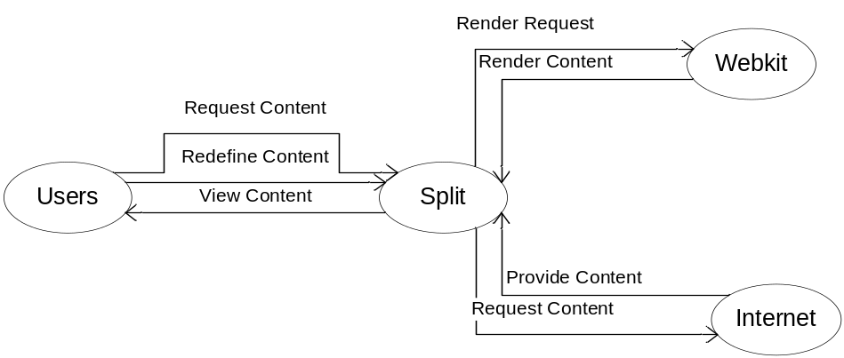
Figure 1. Context Diagram (This is now out of date)
As a user, she first makes a request to Split for new content from a site. Split then makes a request to WebKit, which in turn fetches it from the Internet. Because it is already a fully featured web rendering engine, it can display most web compliant HTML, JavaScript, and other web documents. Once WebKit has finished rendering the content, it is then returned to Split to paint – now, the user can interact with and redefine the content. The basic operation is to request Split to display only a rectangular portion of the content and when the user has finished redefining the view, Split will only display that portion.
Structural View
Figure 2, the class diagram, describes the structure of the Split web browser.
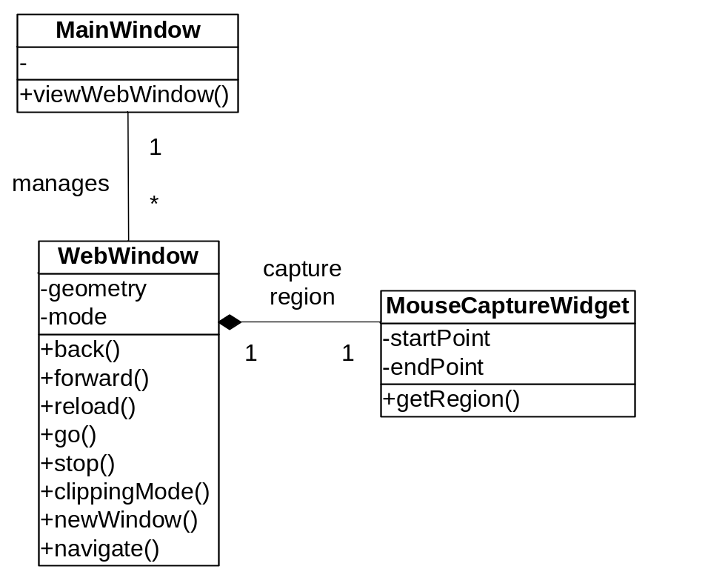
Figure 2. Class Diagram (This is now out of date)
EXPLAIN
The main interaction is within the WebWindow class. Here, we have explicitly linked our public interface with actions in the QWebView object, the QMainWindow object, and the object’s private state. Part of the state controls the MouseCaptureWidget. This second object is used to encapsulate the clip definition process and separate that from the normal processes of the WebWindow.
Behavioral View
Figure 3, the state diagram, describes the behavior and transitions of the Split web browser.
After the initialization state, users drive the application event loop through three different states: Web Mode, Definition Mode, and Clip Mode. Web Mode is the main navigation mode; users are able to navigate the Internet as they would in any other web browser. This is the most basic state and the user interaction does not deviate much from a standard web browser.
From here, the user may now enter Definition Mode. This is a transitional mode where the user defines the clip. She may draw a clip on the canvas of the webpage to define the clip. Upon normal exit, she moves to Clip Mode otherwise she returns to Web Mode.
Clip Mode is the driving feature of our project. It is a fixed size view of the web content centered on only what the user wants to see. From the clip, she may still interact with the page as if it was visible but any link clicked will open up in a new Web Mode page. The purpose is to display static or dynamic content in a user defined region. This state can return to either Web Mode or Clip Mode and could possibly also spawn a parallel event loop.

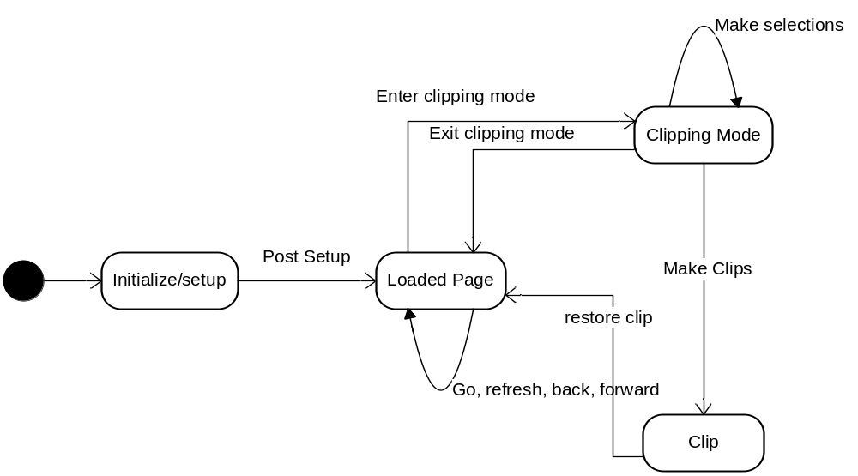
Figure 3. State Diagram
EXPLAIN diagram needs update, right?
Project Management
Schedule
Our original project roadmap is visible in Figure 4. We are currently a little bit behind schedule due to unforeseen issues, but this has not stopped us from pushing forward on non-blocking issues.
The advanced clipping features are being developed and we have made great progress in this area. Additionally, the web browsing features are being improved upon daily. The blocking issue is actually the integration of browsing and clipping. We have learned a few things about how QT handles objects and its parent-child relations and are forced to develop an internal manager for the program. Because this was not in our original roadmap, we have been delayed a bit; however, our general development has been faster than expected thus we are barely behind schedule.
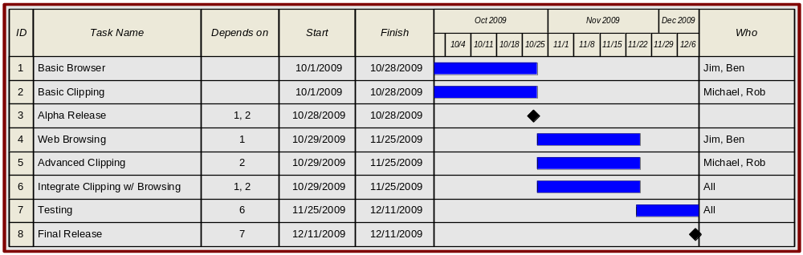 Figure 4: Project Roadmap
Resources
Our team consists of four software engineers with extensive programming experience, UI design knowledge, and team collaboration skills. Additionally, individuals bring knowledge about specific tools such as Git, a version control system, Trac, a project management system, and LaTeX, a document typesetting system. These have helped with both our development process and our communication process with external parties.
The main external resources our team is using are Qt, WebKit, Git, and Trac. For programming, Qt and WebKit give us a basis to work from and a simple UI interface to build cross-platform applications. For project management, Git and Trac let us keep tickets about what is being worked on and what bugs exist while also allowing us to quickly switch development between product features.
Conclusion
The architecture for the Split project has been clearly laid out. We continue to use Qt and WebKit frameworks to implement our unique and flexible user interface for browsing the web. Since, basic functionality has been integrated, adding both window and session management facilities will constitute the next steps. Our current status is slightly behind schedule due to minor unforeseen complications, but we are confident the project will ultimately be completed on time. The developers of this project will be happy to field any questions and can be reached over email at split-dev@umich.edu.

