- RAD
- Convention OVER configuration
- Sensible defaults
- DRY
- Extensibility

Grubby , Spring,sime mach , prototime , hibernate , ruby , java

Grubby and Java are interchangeable; java can implement a grubby interface
And grubby interface can implement a java interface and they can extend each other and they can use libraries of each other.

0-configuration articulation or mapping
JNDI
Web –flow
Not server restart
Templates
Java integrations – largest set of 3 parter libraries.

Dynamic Languages- It will create unit, testing integration testing adn fulctional testing

Plugins – Dojo , Amazon , JMS , openLaszlo, wiki , plugins..

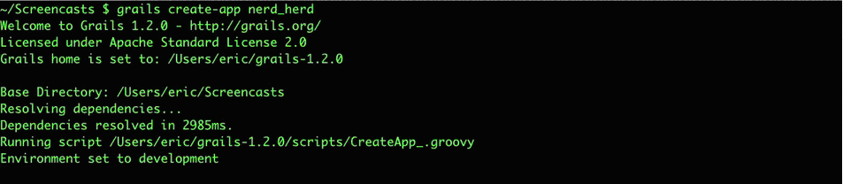

There is no need to create basic build commands, for example, create application, run application, add controller, add domain-object, generate views all this commands can be run from the grails console. On each project you have a script folder where you can customize the build scripts they are not standard ‘Ant’ build scripts but they uses a specific scripting language called ‘grant. All the scripts by default accept different configuration depending on the environment i.e. ‘dev’ , ‘test’ or ‘prod’.

Proposal of change - Improving build capabilities
We could create more build commands for example one to clone our application, although this could look very difficult because the different system that need to interact in our case. But we could try to think a way to make this automatic. This would save us a lot of time. Then other commands like remove/un-deploy application, branch application, could be needed too.

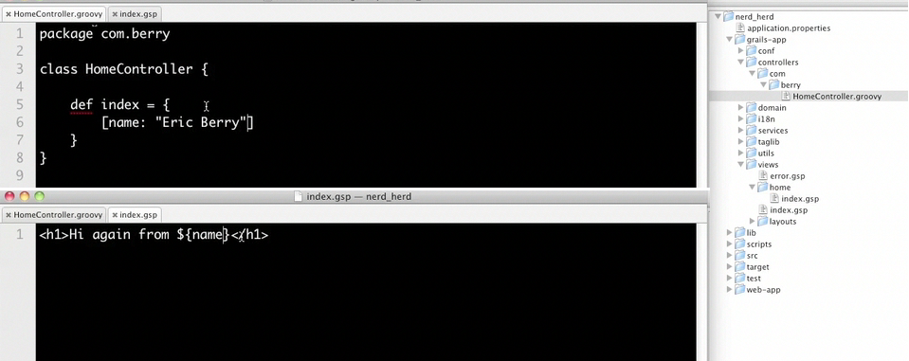

When a controller is generated a view also is generated by default, this view could be seen as a template, when the web application URL points to the controller name, for example /application/order, the flow goes first to the controller ,in this case ‘order’ and because we have not specify and action then the controller will execute the ‘index’ action .Once inside the ‘index’ method you can change the flow or process parameters or add parameters or do whatever business logic is required, and then you may redirect to the default generated view, and use it as a template, or render a specific output from the controller method it self, like JSON for example. The default logic is that you redirects to the default view.
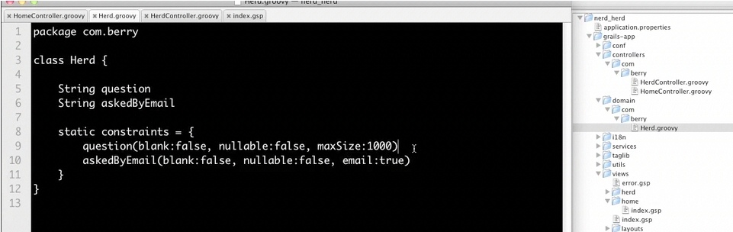

The domain-objects are defined in a unique file, here you define attributes and relationships in the form of normal class attributes and validation in the form of constrains, things like setting the order of the attributes in views or define a fix set of different options for a specific attribute can be done here too. Middleware (logic attributes) would actually be place here also.

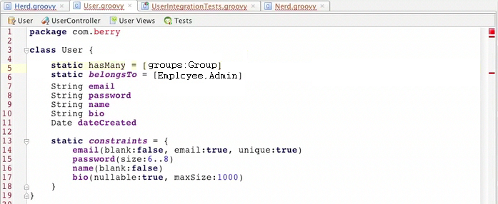
Here are can se how relationships are created through static hasMany or belongsTo attributes, this will handler automatically the reverse linking of the entities as well a the deletion of orphan entities in deleting the father entity, normally knows as ‘referential constraints’. For example a Employee has one user. When ever you set Employee.setUser a reverse link should be created like the following user.setEmployee. And if the employee is deleted then the user will be deleted also.
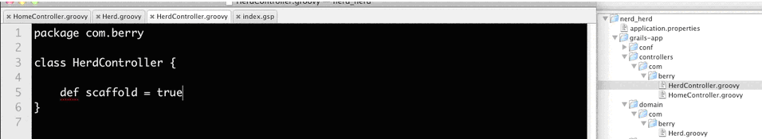
“Generated” and “Generic Life-Cycle” views.
After creating a domain-Object (what we call business object) if you want to expose it on the web, then the least you need to do is create a controller (you can use a build command) then in the controller you decide if you want to use the default generic views, in witch case the views will not be generated or generate them (based on the generic) and latter customize them.If you want to use the defaults then you the static variable in the controller ´scaffold´ to true (see above example).

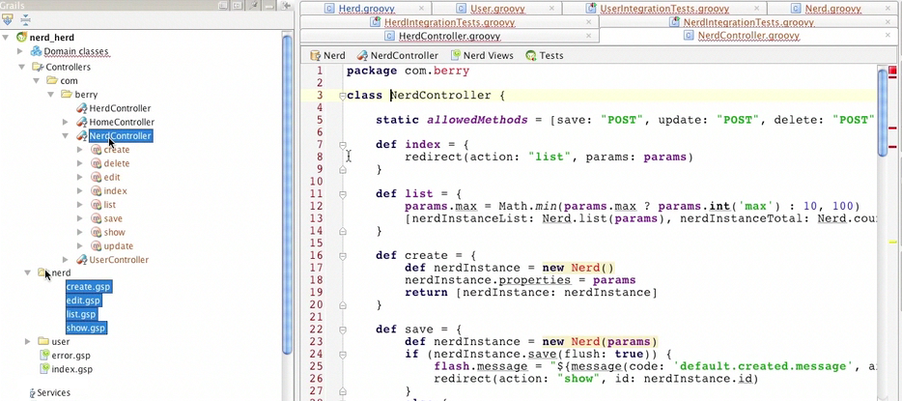
As we have mentioned if you decide to customize the views then you generate them using the ‘generate all’ command and then one controller with 8 concept gets created a well as 4 views (create, edit, list, show)(our equivalents are create, modify, select, view) . Note that ‘search’ view is not implemented (although a proposal is on place) and the only option I found is using the ‘searchable plugging’ that allows you to search on all the attributes of a domain-class or even across multiple domain classes. The generated views use tags to output the different attributes so they are easy to read and modify. This allows the use of any other javascript frameworks like dojo.

Proposal of change - Generic not generated Life-Cycle views
The template engine should be clever enough, based on the metadata(DM,VM), to generate decent generic Life-Cycle views. Currently we do not have a template engine but we could have a generic filter that will redirect to a custom default servlet/jsp that will generate the views on the fly based on the information stored on the view manager and data-manager. It will generate the view based on widgets encapsulated on tags(so understanding the code and reuse will be easy). Then the logic that is currently encapsulated in our current VM, i.e. to control the flow, bean management, presentation, should have to be moved controller. Our current use of VM to control the flow, bean management, presentation should be migrated to the concept of controller.

Proposal of change - Merging DM/VM
In addition we could think on merging them both (DM/VM) if we create a GUI to create custom processes/controllers…

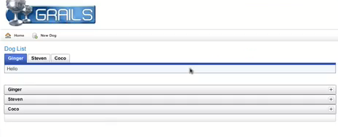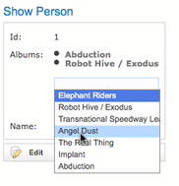
GrailsUI comes like an integrated plugging with some UI javascript artefacts like expandable panel, accordion, tabs and others so you can customize the generated views or your custom views. In the case of ajax widgets, like autocomplete, they will communicate directly to the application through JSON.

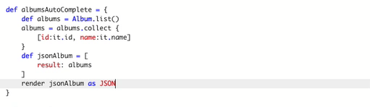
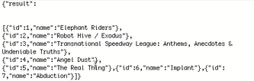

This is an example of an action (what is for us a ‘concept’ in VM) of a controller that will return a JSON object. In particular, it will return a list of domain-objects of type Album but restricting the attributes to show to only “Album.id” and “Album.name”. This resembles to the DWR framework functionality.

Proposal of change – Add a JSON converter
Our framework could benefit also of a standard way converting the output to JSON, methods. In order to do this we could further integrate DWR over the framework allowing us to use in our controllers (views, servlets and handers). For example like follows: return toJSON(Collection|Map|Object).

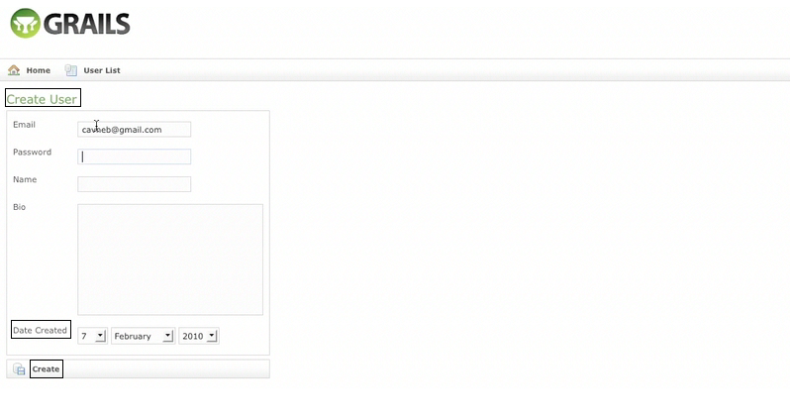
Labels defaults are quite sensibly extracted from the attributes of the domain-object, it capitalize the first letter and add spaces on name convention. There are also defaults icons and defaults names of the view. Nevertheless it allows the customization of labels and error messages in the i18n folder that already contains files for many different languages. So changing the default labels (not the attribute based ones) to any other language is out of the box.

Proposal of change – Make label defaults more adequate.
Currently the label defaults are good enough, and when shown in the page, transmit the feeling of `work not finished` to the customer. The current defaults use notations like : Class.attribute, View/Class.attribute and Class.concept. We could easily try to improve the defaults and save us, the developers, quite amount of time.

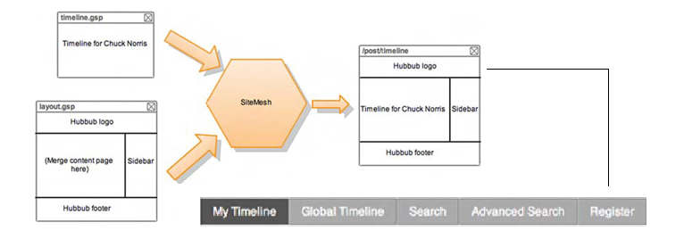
Site Structure and Layout
In order to set the layout of the application this framework uses a set of different technologies. First, to merge the layout with the target pages it uses ‘SiteMesh’ which does transparent merging of the pages with the specified layouts. Second, to create complex layouts browser compatible, it suggest the use of “YUI Grids Builder” from Yahoo. Third, in order to include contents in the layout ,that contain any kind of logic or are likely to be reused (like a small logic form on the top) the framework suggest the use of templates, that could receive any kind of parameters and can be render even from inside controllers. And finally to create side menus or top menus associated with a specific controller action it provides with a plugging called ‘navigation’ that will handler the css colour change when the action rendered is the active one. In addition there are plugging to integrate the ‘CMS Weceem’ in the application as well of other plugging to provide out of the box skinning.

Proposal of change – Integrate Site mesh
We could try to integrate ‘Site Mesh’ in our application instead of including the header and footer , presumably this could replace the homepage filter that change the layout of he page if it has some parameters. This would be great improvement in regards of removing complexity. We could try to implement then the side menus and tabs as tags or jsp includes.

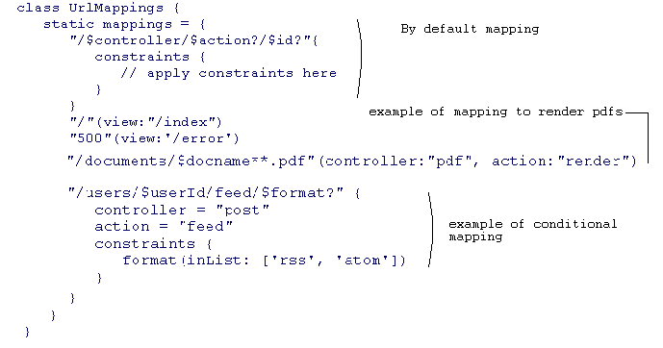
URL mapping
By default this framework provides URL mapping based on convention like follows: /${controllerName}/${action}/${id} but this URL mapping can be easily changed too.

Proposal for change – Add configurable URL mapping
Adding a configurable URL mapping all over the application could facilitate the integration of other systems and the use of search engine friendly urls.

Services
Groovy facilitates the use of services inside the application, services looks like any other ruby class , with normal methods all the exporting to xml it is done automatically and it is hidden (except in the case you want to customized) The design patters suggested by rubies states that all the atomic business logic should be coded in services. But using services from inside the code is as simple as using any other class this is called ‘dependency injection’.

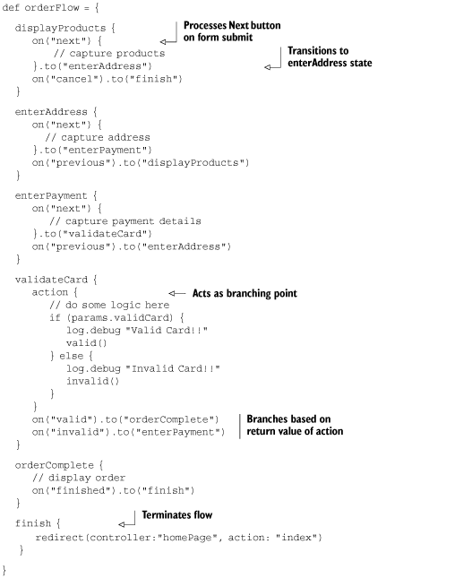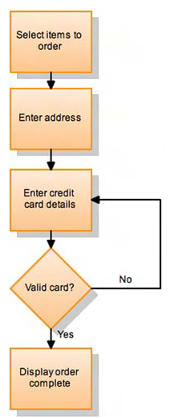

Flow control
With the plugging ‘webflow’ this framework allows you to define very detailed workflows like wizards encapsulated in only one action of the controller. This plugging also use to create flow-scope status services.

Storage
It relays on Hibernate, so you can configure legacy databases for production and use a in memory (HSQL DB) database for quick development. Only one configuration file for the three environments (dev, test, prod).

Proposal of change – Consolidating dev, test, prod configuration files.
We could also merge the configuration files for our three environments in only one this will make more straight forward the building process and reduce the risk of errors on deployment.
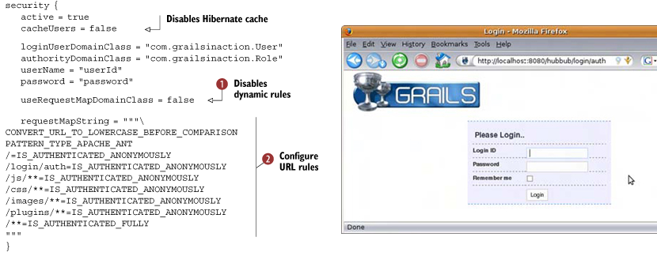
Security plugging
The security is based on Spring Security basically in the plugging configuration you need to tell the plugging which of you domain-class represents the ‘user’ and which one represents the ‘group’. The plugging will provide you with a login screen and then you need to configure the access as in the example of above. More advances configurations, like per-role access are also done here.

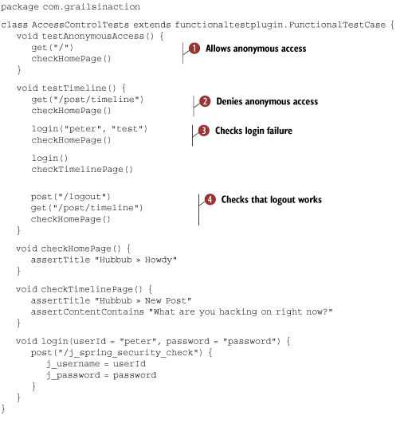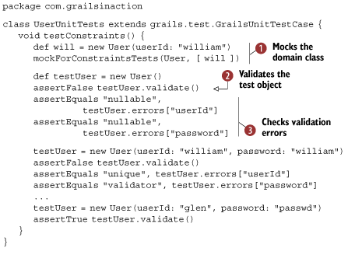

Test creation
Being ruby a not typed dynamic language testing becomes very important. This framework provides ‘backed right in´ testing capabilities to create functional, integration and unit tests. By default the framework would create a test class whenever you create an artefact, i.e. domain-class, controller, services, tags, etc.. Then the build script would run every test and produce a html report of the results. The only task leaved to the programmer is the actual writing of the test logic. But libraries are ready out-of-the-box to facilitate the task of writing test, in the above picture we can see a functional test on the left and a unite test on the right. Methods like login, get, post, assertTitle and assertContentContains abstracts all the underlying complex logic. In addition additional plugging provides tools to more easily create web interfaces functional tests tests.

Bad:
No search generated view

