WaveMaker

History -
Pattern - It is a framework that is based on the MVC programming pattern, but its implementation is a bit special because of the greater focus on the presentation layer, (the graphic interfaces or views) and less focus on the model or the controller, as opposite to the ‘naked objects’ approach were the main focus is mainly on the domain model.
Based on - WaveMaker it is build upon the foundation of other open source technologies like ‘hibernate’, ‘spring’, ‘spring security’, ‘dojo’ and apache server to run the application.
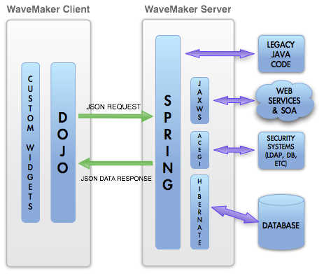

Objective - It aims to provide the developer with a tool for RAD (Rapid application development) of RIA (Rich Internet Applications) applications. Other notable features that provides are:
- Possibility to deploy the applications in a computer cloud witch is a version of 4GL that runs on Amazon EC2.
- An integrated IDE that is it self a web application, this main tool to use the framework. It runs in a web browser, it is based on Ajax and actually is the interface that triggers all the code generations, complications and deployments that run on the server. But with the great advantage that the generated source code is standard clear code for the mentioned frameworks and so can be customized to obtain the best of them.
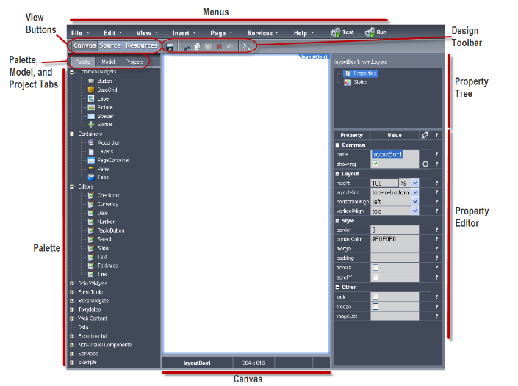

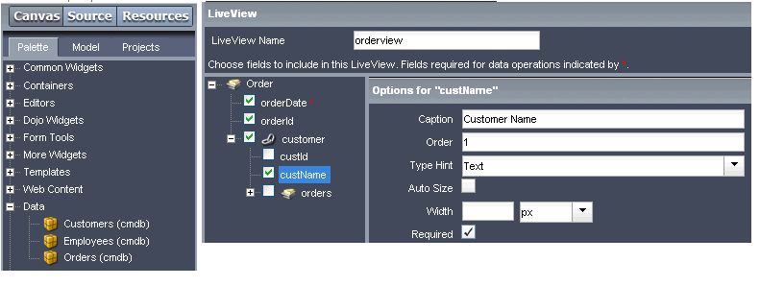
Domain Model Creation
Wave maker is based on Hibernate. By default, if provided with an existing database, it generates all the classes needed to access the database through Hibernate framework. By default there is not a clear way to do domain modelling from the framework it self, there are not POGO type classes where you can define the anatomy of the domain objects an the constrains for validation or presentation. Although the basic domain objects are created by Hibernate, the framework it self make more use of the classic database modelling based on ERD (Entity-relationship diagram) in expense of the more modern object oriented modelling. A clear example of this is the need of the creation of an object called ‘liveView’ in order to execute CRUD operations from the user interface. Having mention that because this framework is based on Hibernate the whole of the domain business logic can developed and integrated at the middleware layer with hibernate tools(including UML database modelling), and use services to interact with the wavemaker’s generated interface. Although this option requires customization it would keep the advantages of using domain-modelling techniques for complex applications.
In terms of validation the responsibility can be split between database(hibernate) validation, for complex domain rules depending validation, and GUI for a simpler validation (like mandatory fields or format).

Site configuration or layout
This framework offers inside the GUI development studio a complete set of widgets that allows you to create any kind of layout in a drag and drop fashion connecting actions to user interface objects through events, in the same way when creating java client applications. In addition the framework comes with a variety of templates that can be use as a staring point and also allows you to create and save you own templates.As you can seen on the image below.

Storage configuration – Database refreshing.
As mentioned earlier this framework relays only in hibernate of database access and there is nothing yet implemented to dynamically update the database when the domain model changes. This is mainly because it is not domain model oriented.

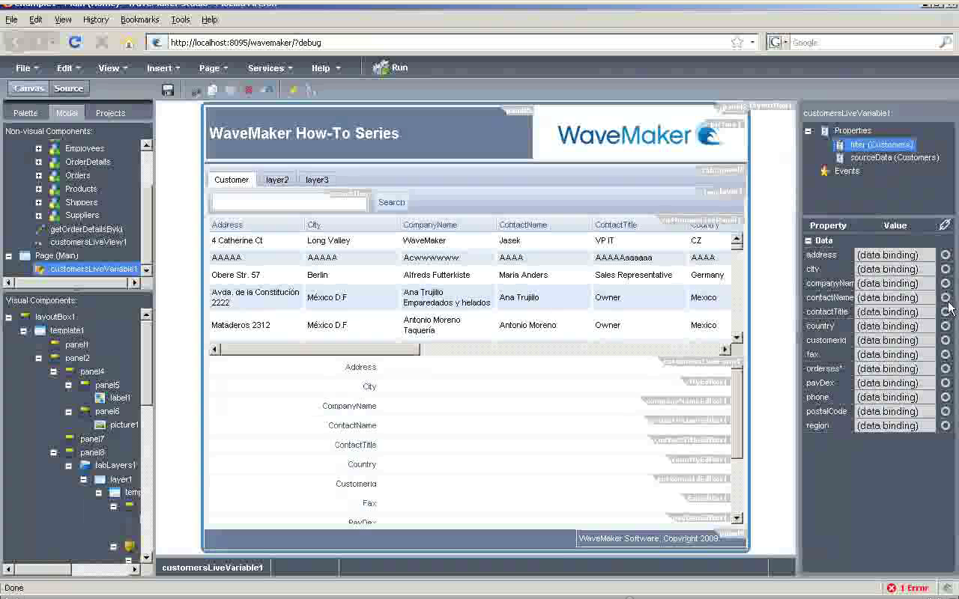
Generated Live-cycle views CRUD + search
The framework does not generated CRUD views for you but it gives you a special widgets that linked to the correct life view will provide CRUD functionality. The configuration is minor and along with the styling should not take more that few minutes. In order to implement the search feature, the life view needs to be linked to a service action (operation) that will received the search criteria from a element inside the GUI and will populate the results inside another element , normally a datagrid, or even a editable datagrid what will implement the functionality of you worksheet view. Also all this can be set up very easily.

Labels in form fields, from names and bottoms
Labels are intelligently derived from the life view column names. Although it does not split by convention i.e. the column ‘targetDate’ will not be splitted as “Target Date” but it will show as “TargetDate”.

Architectural Elements
The main different with other frameworks like Grails is that that this framework does not use an intermediate controller to govern the presentation (this role is ebbed on the client GUI) instead it communicate directly with the services which in this framework have and additional role that is of main data providers.
The services are the interface between the GUI and the database or external SOA services and also they are the holders of the business logic. In order to interact with the GUI the services has got operations that could receive parameters and return parameters. All the communications between the GUI and the services are based on JSON than means that service operations accept only JSON and returns only JSON.

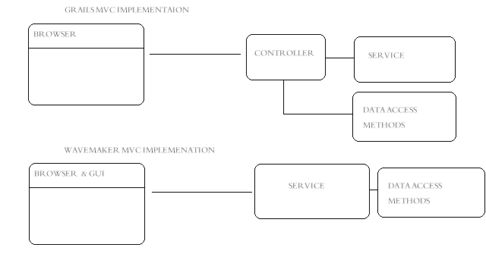

Custom views (widget, validation, errors ...)
This is where this framework shows this major strength, the web GUI builder, is specially created to allow the developer the creation of much customized views providing a better user experience in both graphical design and usability. It allow you to use templates and tight together all sort of widgets, like grids, graphs tab layouts, all this with the less possible effort with great flexibility.

Flow Control, process oriented programming (limited scope, and step back)
There is nothing in the framework specially designed for developing flow control processes i.e. a wizard. Alternatively it provides mechanism to navigate between different pages, or different layers in the same page. Depending which is used the logic of the flow control process can be coded in different way. In the first case where the navigation is from one page to the other, the client context is replaced so the use of a state-full service is required to keep the information of the process between pages. In the second case because the page layers share the same context all the variables of one layer are accessible even though it is hidden and another layer is visible, consequently in theory a flow control process could be coded and the ‘step-back’ functionality would be present, all without the need of a state-full service. But this has some security considerations that would need to be addressed, especially when intermediate validations between steps are needed.

Deployment / build commands
All the building process it effectively automated and compilation, execution, debugging and deployment are all available through the GUI designer. In addition to speed up the development process this also permits the developers to work remotely without the need of any kind of VPN system from any kind of system (even light clients with the only capability of internet browsing). A third capability that this framework provides is the deployment on a computer cloud managed by “Wave-Maker” hosted in Amazon.

Testing (unit testing, integration testing, functional testing)
This MVC patter does not provide any testing feature. But at the integration level at least you can use any of the web free JSON testers.

