CMS/MVC Web Development Framework.
Project Abstract by Omar Nahhas Sanchez
1-Project Overview and concepts
The project consists on improving a proprietary MVC framework ,which my company has been using now for 10 years . In order to do that need to explore and study the different approaches that we can take. Having already built some CMS for several clients, the more strong option we perceive (prior to the study) is to using the concept of Content Management Systems . Giving features to the framework based on CMS,like user management and content management, it would allow the creation and modification of the live web applications through a complete GUI that will generate the source code. Using code generators we expect to improve the performance, the quality and the adaptability of our software development process.
Content Management System (CMS)
“A content management system (CMS) is a system used to manage the content of a web site. A CMS allows the content manager or author to manage the creation, modification, and removal of content from a Web site without needing the expertise of a Webmaster”
More sophisticated (CMS) enables companies to build, deploy, and maintain highly dynamic websites. It allows managers with little knowledge of HTML and web publishing in general to quickly build web pages and post them on the site. Also allows different levels of authority for different sections of the website. It normally allows the use of pre-designed layouts or provide different design stiles.

Behind to the standard concept, in our future Content Management System the
Presentation layer is also managed and stored as Data, and the fix code is limited to an interpreter that read from the database how it has to build the application and it creates it at the run level.

Web Content is defined as a peace of information that is managed in a Content Management System. We also extend this definition and classify it in two groups:
Standard Web Contents: is standard html composed web content, it does not contain any logic inside it; it is only information to be shown. Some examples of these ones would be news, pictures, documents, etc...
Logic Web Content: is a web Content that is generated dynamically following the logic of any server scripting languages like: JSP, ASP, PHP, etc... Some example of these content are blog , communities , dynamic maps . In our case we also consider Logic Web Contents the basic elements that compose a web application, for example: header , side menu , footer , pages , etc … In our case we thing that the set of views and forms that compose the core of web application can considered Logic Contents and it could be managed(created,modified and located) by a specialized GUI-CMS like.

2 - Current Situation and Motivation
We are a Software application Provider company specialized on providing solutions for the Property Management Market , we have already delivered several applications for different kind of companies , State agencies , Hosting Providers , Builders , etc.
After creating working with different clients and having building several CMS systems for them we have recognize a similitude in the way CMS create a web site and the way we create the web application for our clients. We want to use the expertise we have accumulated to create a system that will bring us more effectiveness and will allow us a better implementation of RAD(Rapid application development) and Agile software methodologies in addition the system could be eventually used by skilled clients to extend their own applications in a flexible and adaptive way. We believe that this will increase the quality of the final product and consequently client satisfaction.
From the technical point of view we provide Java web applications using a proprietary MVC (Model-view-controller) framework (see point 3 for more information) that generates up to 60% of the application source, the rest of the functionality has to be implemented as bespoke.
Model-view-controller (MVC) is an architectural pattern, which main motivation is to separate data (model) and user interface (view), so that changes to the user interface will not affect data handling, and that the data can be reorganized without changing the user interface. The model-view-controller solves this problem by decoupling data access and business logic from data presentation and user interaction, by introducing an intermediate component: the controller.
Besides providing our client with a solution that fulfills his expectations we want to create a reusable product, able to be use to build any other web application.
Knowing the existence of many open source CMS ( “Joomla” , “Drupal” , “CMS made simple” ),and other full-stack web development frameworks like Django ,Plone , Spring and others , we decided to extend our MVC frameworks for the following reasons:
1 – We use of JSP technology in all our applications. Prior to the research , it looks like there are not good mature full-stack frameworks written for Java , at least not a mature as our framework.
2 - We want to capitalize the knowledge we already have using our framework and avoid a normal long learning curve associated with this kind of web application frameworks.
3 - The use of a proprietary technology will also provide us with a more client fidelity because the difficulty to migrate to another architecture or get support outside our organization. This along with the fact that we have already many client applications running over that frameworks are the more decisive factors to choose not to change.

3- Detailed description of the Project
Our project mainly consists in defining a set of improvements(features) for our MVC framework encapsulated on a web GUI, and also carry out with the high level design (and prototyping) of these features . The posterior implementation of these features will be carry out by another project (being an internal project the schedule will be subject to the business demand). Our requirements for this project can be summarized as follows:
- A initial research needs to be carry out in order to find the more useful approach to improve our MVC frameworks , one example of these research could be analyzing features and usability of other full-stack framework that exist on the market. The idea is to gather ideas and later choose some of them and discard others.
- In the case we opt to build a CMS-like set of features : The new version of the MVC framework would have to provide the capability of creating and managing new contents (standard and logic) .In addition the framework would allow the user management of the whole site(web application).
- Simplicity and integrity : The system will be provided with a friendly interface ,probably two levels of access will be needed so some of the non IT staff of our clients could create and customize contents, without imply a risk for the System integrity while more advanced user (us) could execute structural changes to the web application.
- The system will be provided with a set basic Web Contents, generic (Headers , side menus , Standard Pages) and more complex Logic Web Contents like (Tenancy availability grids , Tenancy Information , Street Maps , etc ..). So the application will be ready to be used and released to our client’s clients at the delivery date.
- Build a reusable framework, the framework should be problem domain independent and we should be able to use in future projects not necessary inside the Property Management Business.
- Along with the implementation of the feature we aim to create a complete knowledge base that would contain the following elements :
  - User Guides, for the client point of view.
  - Framework Internal Documentation , explaining how the framework has been build , and how it works from inside out (used design patters, pluggin points , etc , information for developers ), that will guide on future Improvements/Customizations/Extensions of the framework.
  - Framework External Documentation will show how to interact with the coded API of the framework as well as instructions of how to integrate it into current applications, or how to set up new application with it.
Our framework is a MVC framework developed during the last 10 years by the company I work for , It is mainly be composed by 3 elements:
- Data Model Generator: Is as web based application that generates sources for java classes that represent entities or business objects from a Data Model. All the entities of the business domain are generated with this application.
- View Model Generator: Is a web based application that generate all JSP files (views) to navigate (create, modify, search, list and delete) and manipulate the entities(or business objects) generated by the Data Model Generator.
- Data Model Container Framework : This is the actual web application used by the clients , It use of a set of libraries (what we call the core DM) to integrated between the generated views , the generated java files and the bespoke code in order to run the client web application (in our case the Property Management web app). The architecture formed adapts the web server (Tomcat ) to be an Entity (Business Object ) container , that resembles an EJB container (Db persistence , transactions , concurrency ) , and host the JSP generated views , and application specific configuration files.
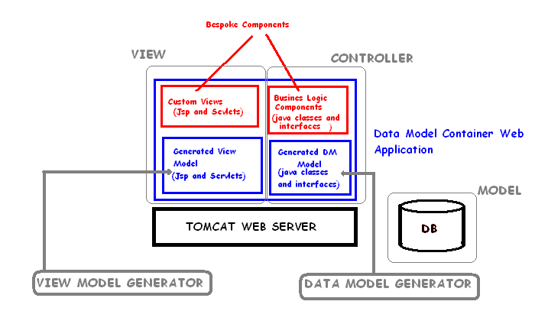
In summary, once the data model is generated, the view model is also generated we put both together along with the core DM libraries and the bespoke code inside standard WAR web application and we run it in tomcat.
The general objective is to integrate the View Model Generator, the Data Model Generator and the Data Model Container in one application and provide a CMS-like interface that will allow not only to manage content but it will be capable of generating them (views forms and data model) in other words an application able to extend itself.

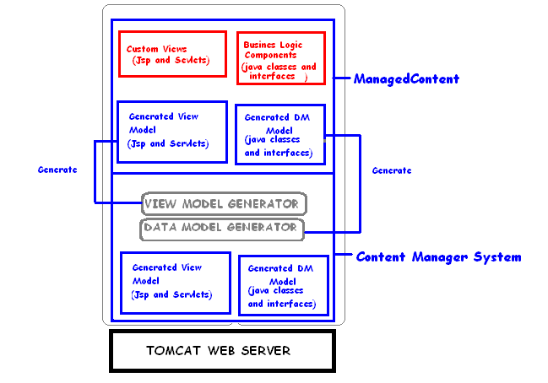
- The proposed improvement in MVC framework would reduce the bespoke coding required to build a new application from 40% to 25%. Allowing us to further focus our programming effort in the Business Domain Specific issues or client specific customizations.

In order to deploy the application, the following infrastructure requirements are required:
- Unix , Linux or Windows based with at least 2 GB of ram and a basic server processing power.
- A Java web server ,a free version like Tomcat or a commercial one like Web Logic, although keeping in mind that only standard JSP and Servlet technology is used we definitely will opt for Tomcat.

In order to develop the application the followings tools will be used :
- Net Beans IDE
- Java sdk 1.6
- Tomcat
- Our proprietary MVC framework.
4-Project Plan
The project actually has started already. Being an internal project it is no subject to a formal schedule. But as it is also my CNAM project the most probably thing is that the schedule will be link to my personal schedule.
- From now to May Research and document the conclusion of the research.
- From May to July design and prototype the new GUI.
- August finish the project with the final presentation.
5 - Roles and Project Responsibilities
In this project are involved different roles:
1-Project Manager: Its responsibilities are to ensure the on time delivery of the project . Monitor the performance of the project, detect possible project risks and possible delays and act consequently to ensure the smooth execution of the project. Along with this responsibilities this project manager is responsible of the functional testing ensuring the complete fulfillment of the client requirements .
2 –Application Architect: Its responsibilities are to perform the initial Requirement Analysis, Prototyping, Analyze phase, Design and Application Documentation. Along with these responsibilities the architect will implement a big portion of the applications and manager the other programs involved in the application implementation.
3 - Software developers: Its responsibilities would be implement code following the modeling documentation provided by the Architect. And Unit test of implemented work peaces.
My role in this project is as Application Architect and Software Developer.
6-References

http://www.eduka.com/News/Glossary-of-Terms.aspx

http://www.opensourcecms.com/

