Dependency Injection

It is very often that objects use other objects in order to accomplish the object task. This are called dependencies. The example of the car is simple; an object car needs an object engine to move. The car is the depended the engine is the dependency. This can be code following much coupled style of programming where the car implementation handles the life cycle of the engine object. An example if this is the code bellow.

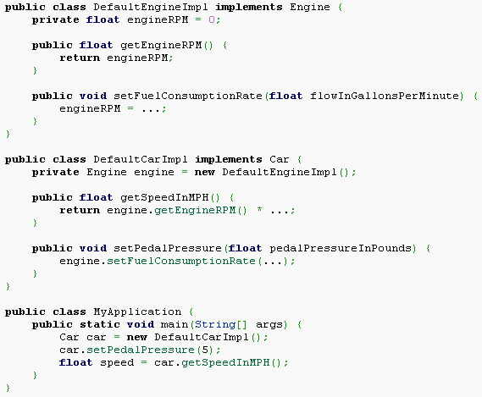
The alternative is extracting the responsibility of instantiate the engine object (the dependency) out of the car object(the dependent) and add the role of injector (provider or container) which is the responsible of managing the life cycle of the decencies and provide a reference to them to the dependent objects.

This can be implemented mainly in two ways:
- In the constructor: it requires as a parameter and instance of the dependency object.
- Through a getMethod() inside the dependent object. It relies on this method in order to access the instance of the dependency object.

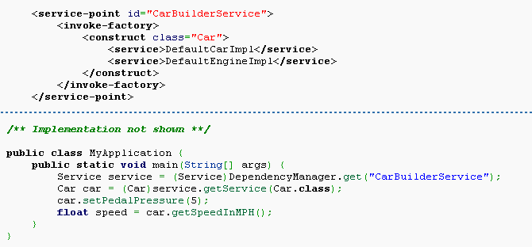

The source of the injection is mainly of two types:

- Manually injection – our application code is responsible to instantiate the dependency objects (services) and then we pass over those services to the dependent objects.
- Framework injection – The container injects the reference to the service when ever a dependent object is instantiated. Normally the details of the implementation of the services are kept in the framework configuration files. See the figure.

