Change Memory

15_04_2010

Inexistent foreign keys
The first difficulty we have found in the process is that the current db has not any relationship created between tables, our Framework manage the relations on the model it self at the application layer so the database is not aware of any of these relationships. Although we could change the database script generators in order to create the relationships also in the form of foreign keys, as a starting point we have decided to created them manually. This is an extract of the Contactable table after adding the relationships as in the domain model. Another difficulty with this task is that our framework codes the “one to many” and “many to many” relationships in the same way witch is the creation of an intermediary table. One example of this in the picture is the table “com_fpdsavills_pr_Contactable$To$ContactEvent”. (See annexes for more information about this issue)

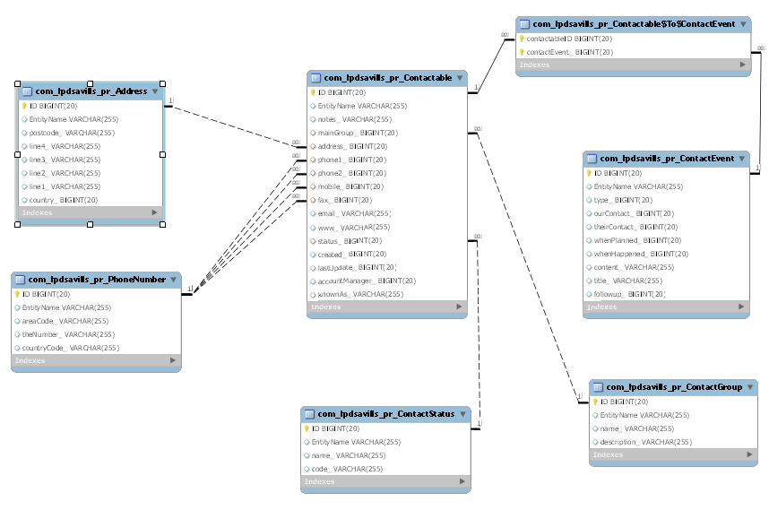

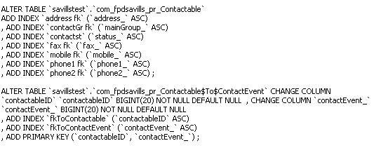

16_04_2010
The database engine issue
Currently, our framework is coupled to mysql, generates the tables with an old db engine that does not allow foreign keys, the engine name is “MyISAM”. Another problem with that engine is that it does not allows transactions, In order to allow the code generation tools to work correctly we need to change that engine to “InnoDb”.
The ID issue

Another problem is that in our framework all the entities has got and id that is an object of class ID although in the database it is save a primitive BIGINT. We needed to use something called composite-id in hibernate mapping files so hibernate will create this kind of objects on the spot when getting the entities from the database, also it allows searches on this composite-id.

Contactable instance = (Contactable) getSession()
.get(Contactable.class, new ID(“123123123”));

<composite-id name="ID" class="domain.ID">
<key-property name="identifier" column="ID" type="java.lang.Long"/>
</composite-id>

<property generated="never" lazy="false" name="identifier" type="java.lang.Long" insert="false" update="false" >
<column name="ID" />
</property>

The restriction is that if we want to map the column ID to a non-object attribute like for example “Contactable.indentifier” (which is of type Long) we need to declare the second mapping of the property as a read only.

17_04_2010
One-to-One Relationships
In hibernate, there are two types of one-to-one associations: “by primary key” and “by unique foreign key”. The first one only can be use when the two entities share the same Identifier (ID) .For example if Employee has a Person and then if the ID are the same on both tables i.e. “employee_table” and “person_table” then you can use the hibernate mapping “one-to-one”.
In our case the IDs do not have to be equal, in fact, they will not be equal on any one to one association. They will only be equal in the case inheritance relation, i.e. Person extends Contactable.
Because of that we need to represent this kind of relationships like many-to-one relationships witch actually works perfectly fine in both cases :many-to-one and one-to-one.

